Afeefah Manzoor

ITN261:

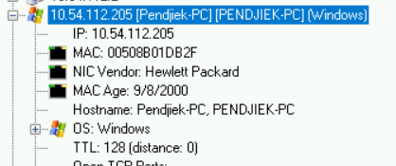In Class Exercise 4a

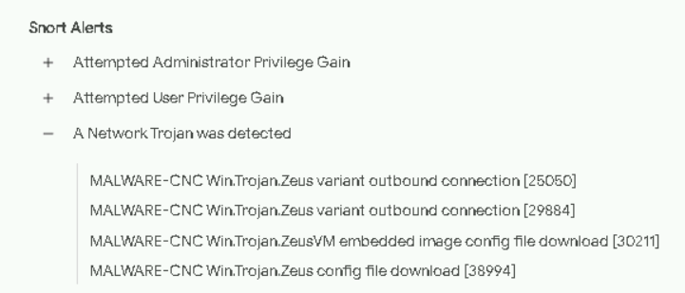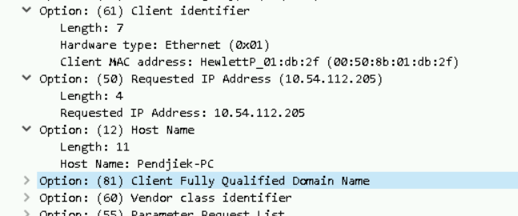

IP of infected machine: 10:54:112:205

MAC : 00:50:8b:01:db:2f

Host name: Pendjiek-PC

OS: Windows

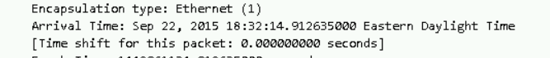

Date/time: September 22, 2015 between 6:32:14pm-6:57:28pm EDT

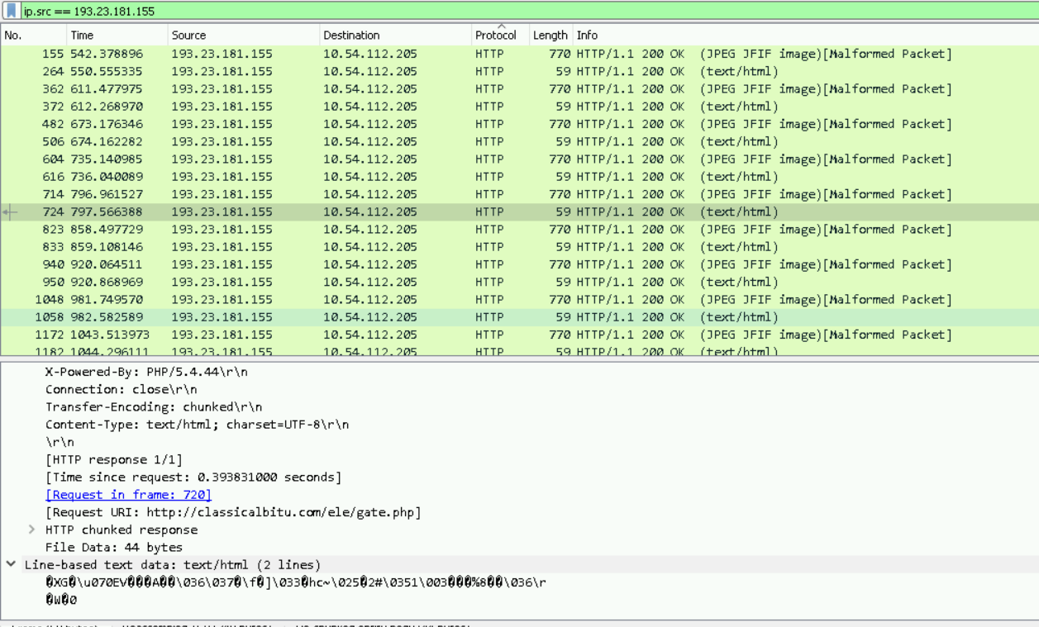

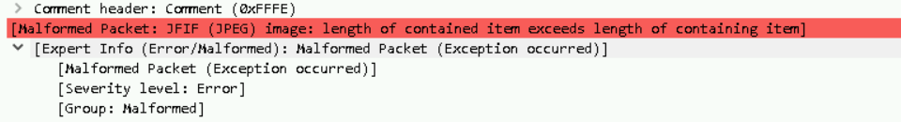

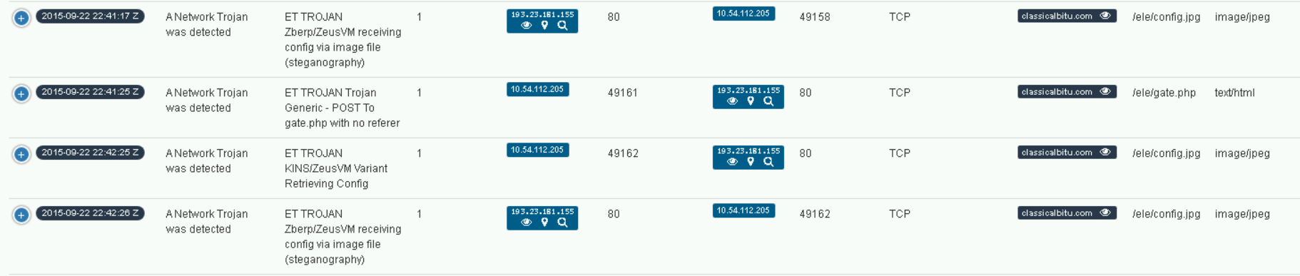

Domain & IP of infected traffic: 193.23.181.155, classicalbitu.com

They used a Trojan Zeus on the user and seem to have user some type of software to lock something of importance on their machine from noting that the steganography the Trojan Zeus is receiving via Image file.