Afeefah Manzoor

ITN 277- Forensics 2

Class Assignment 1

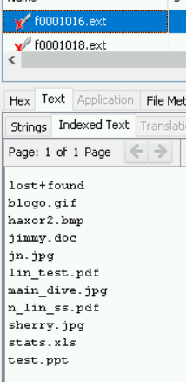3 JPG

2 PDFs

.DOC

.XLS

.PPT

.GIF

.BMP

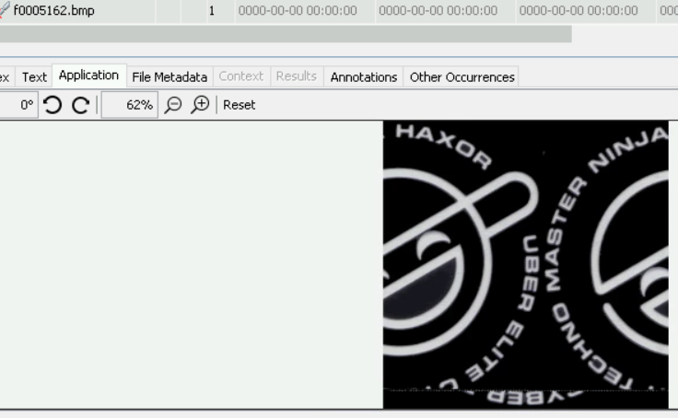haxor2.bmp

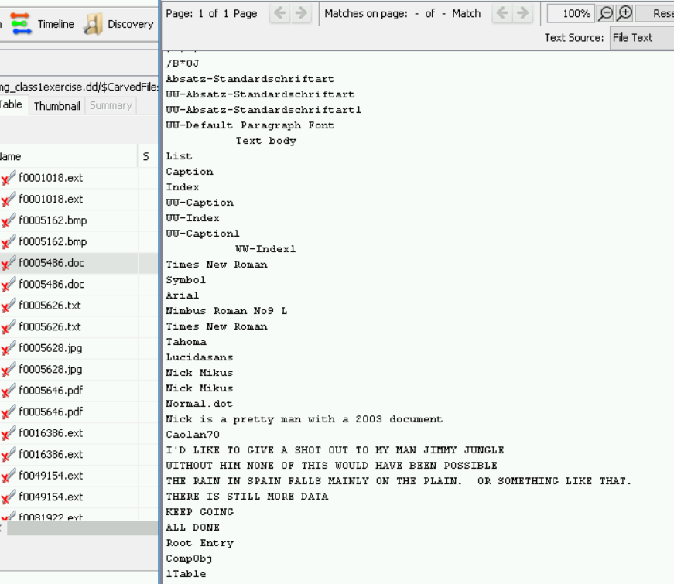 jimmy.doc

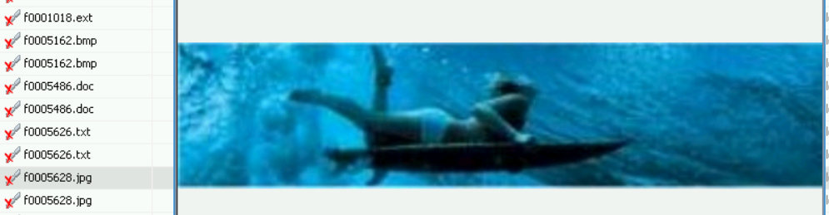.jpg

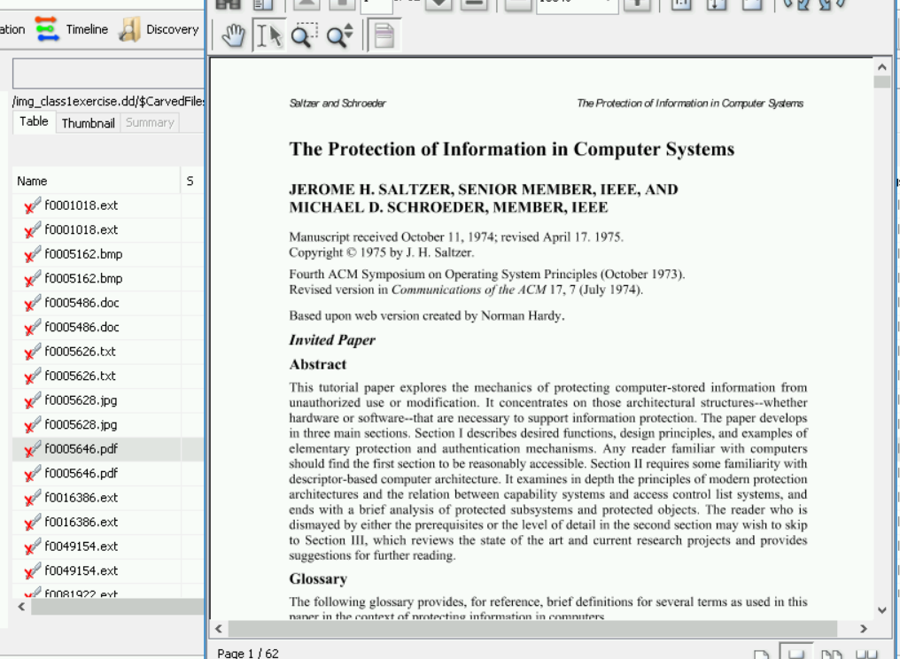n_lin_ss.pdf

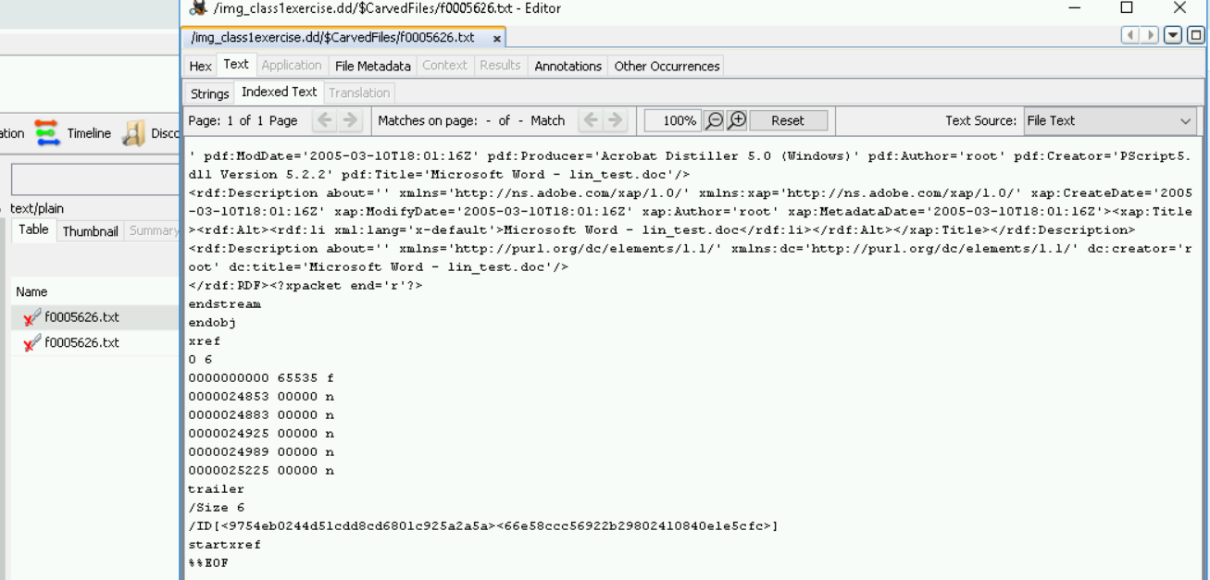lin_test.pdf

I could not seem to find any of the other files on the machine