Afeefah Manzoor

INT 277: Forensics 2

Arms Deals Case

The only connections to Smurf Celtic was an email that seems to have a date, time and a number which I am assuming is money(255). I was also able to find a message about Viktor about a stephan contacting him about some rockets, and as well as uranium. I also found google searches for Thorium, different types of uranium. I found an email to a RipTide101@rocketmail, stating what seems to be a date, time, 2 55 11 255 false false. I also found emails similar with [a.DunkinBlue@hotmail](mailto:a.DunkinBlue@hotmail), grassyjansen@yahoo. I also found what seems to be an IP address but found nothing on the address.

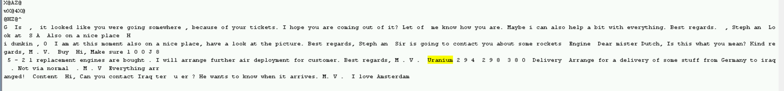

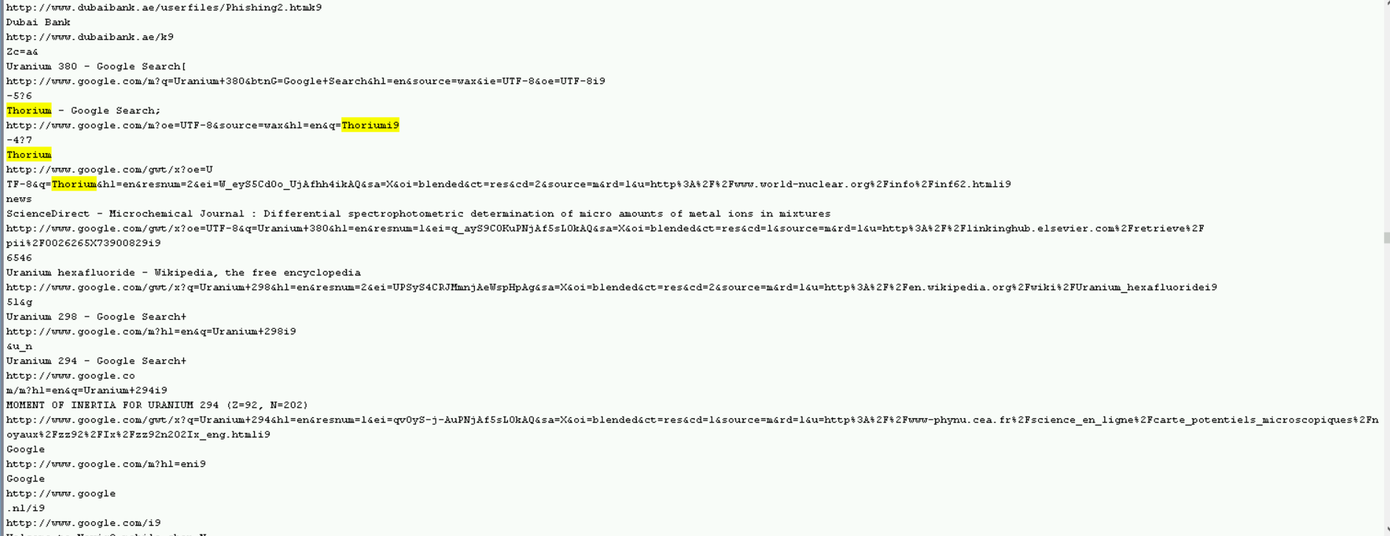

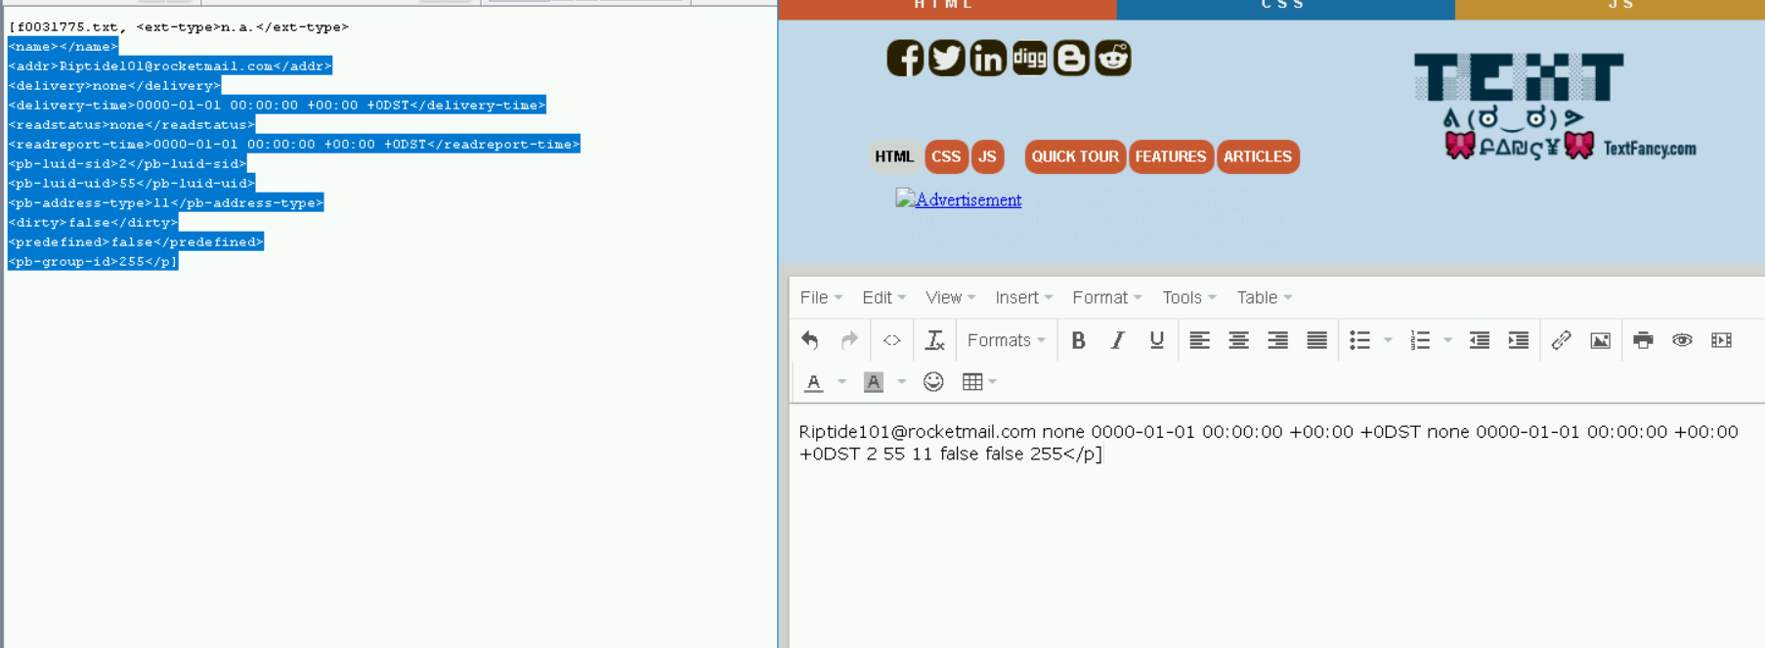

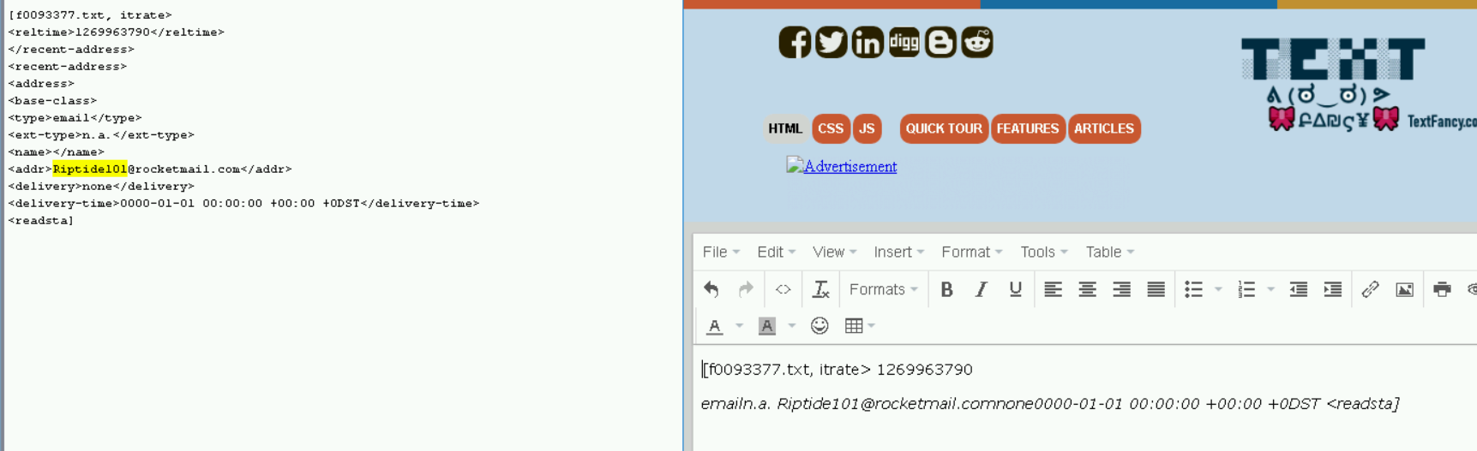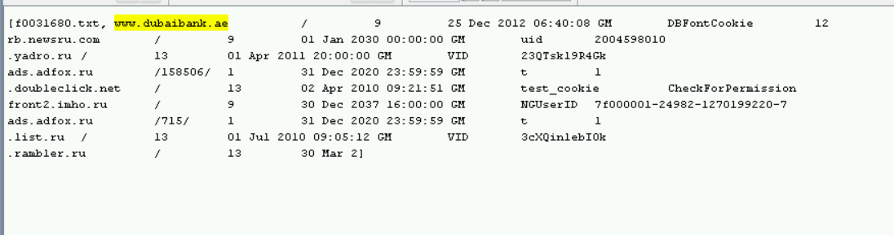

a.Dunkinblue@hotmail