Afeefah Manzoor

ITN 277: Forensics 2

Cellebrite Reader and Mobile Images

Device 1:

1. Who is the phone's owner?

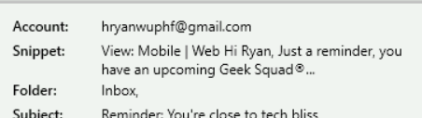

Ryan Howard

1. What games are of interest?

Call of Duty, Watch Dog, Breath of the Wild, Minecraft, Grand Theft Auto, the Division, Battlefields, Doom, Let’s Go Fishing

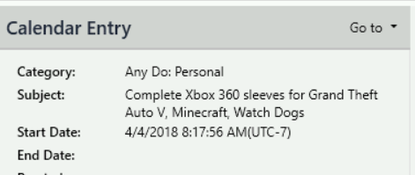

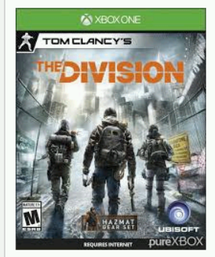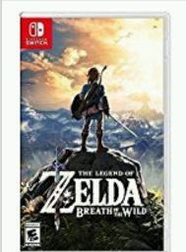

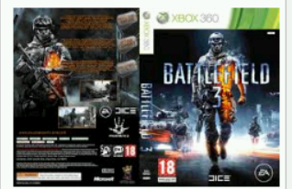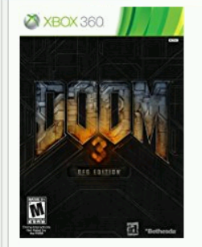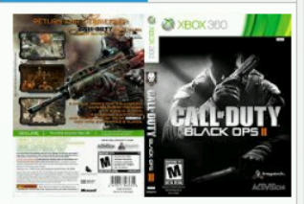

3. Where is the phone located?

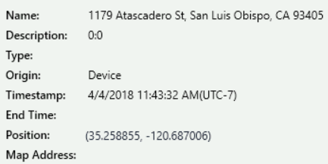

1179 Atascadero St. San Obispo, CA 93405

4. Which TV show series is this phone associated with? Show multiple screenshots of evidence.

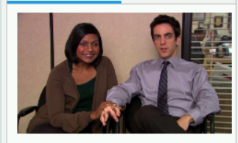

The office

Device 2:

1. What store was the device purchased and what is the carrier?

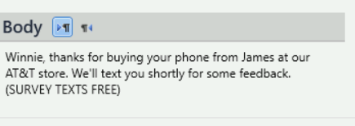

AT&T for both

2. What kind of computer might have synchronized with this device?



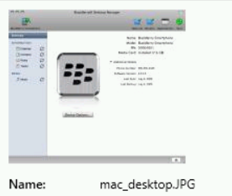

MacOS Device

3. Where is the meeting?

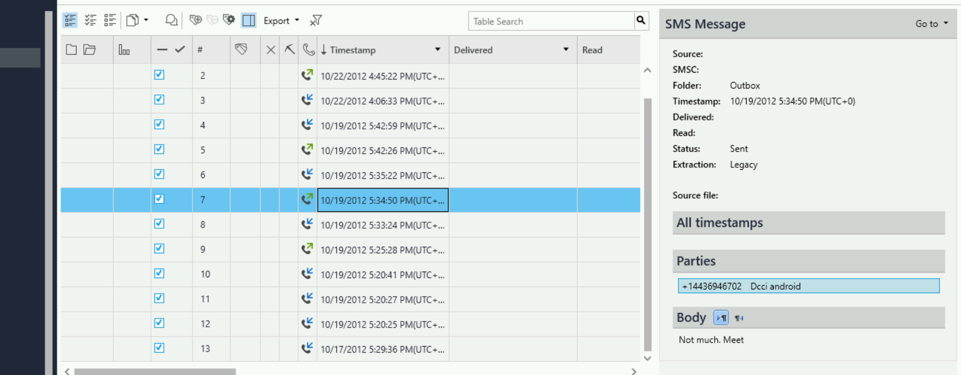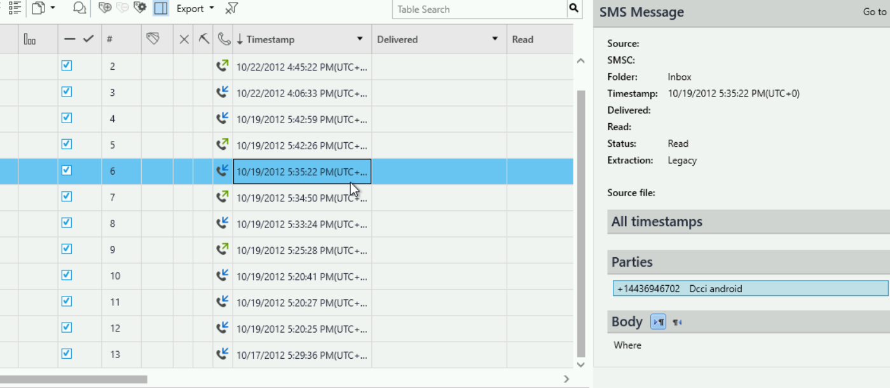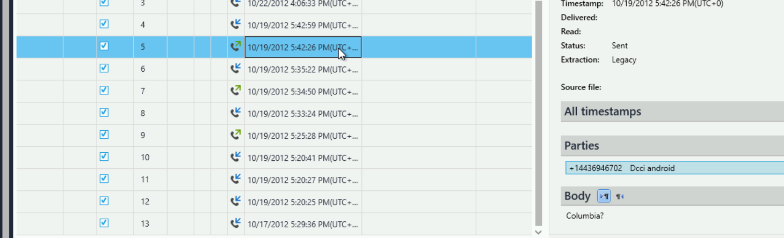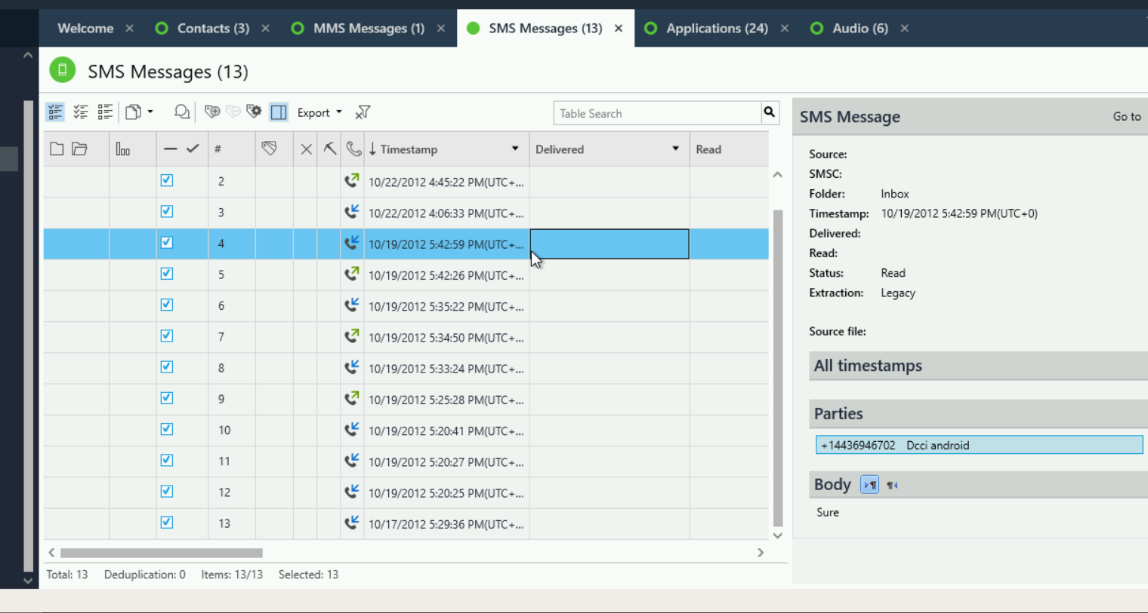

Columbia

The users phone number?

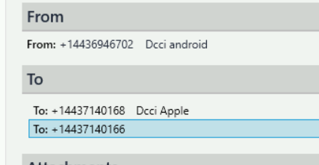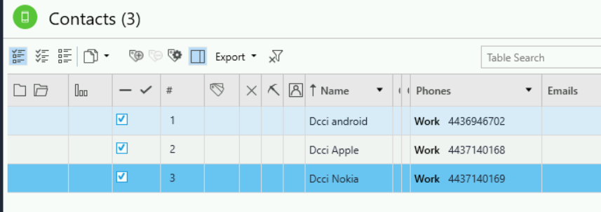

+14437140166