Afeefah Manzoor

INT277: Forensics 2

Class Scenario- Crook

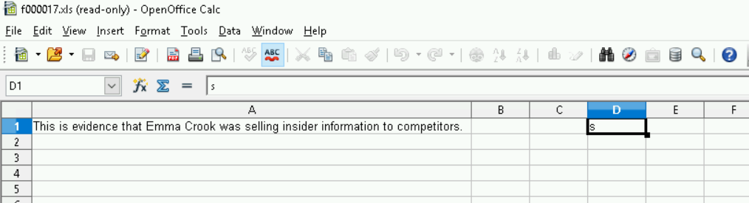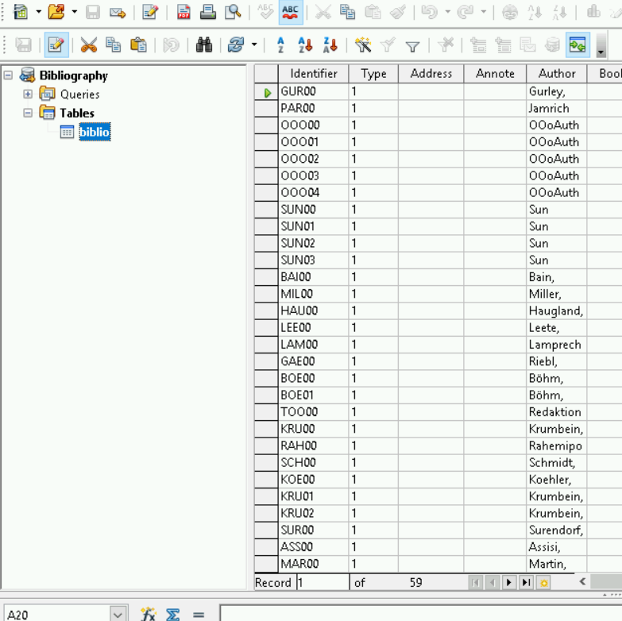 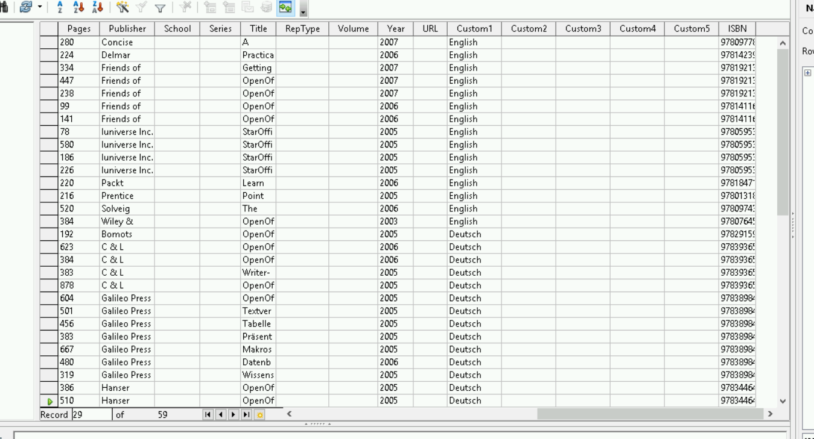

Above is proof of Crook selling information

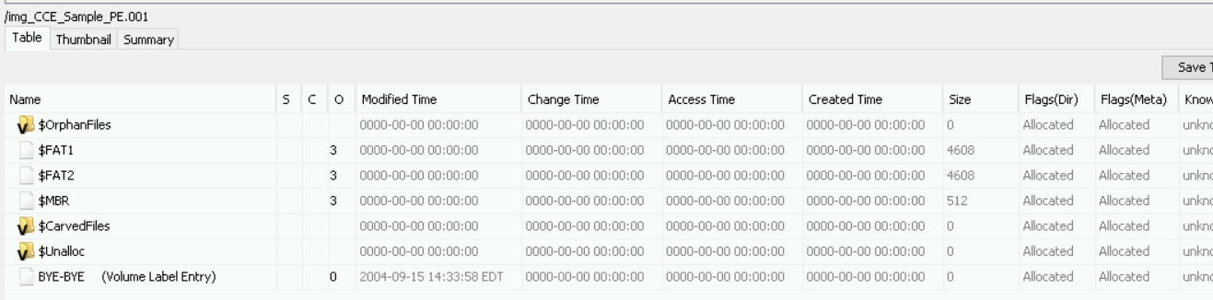

The disk was formatted on 09-15-2005

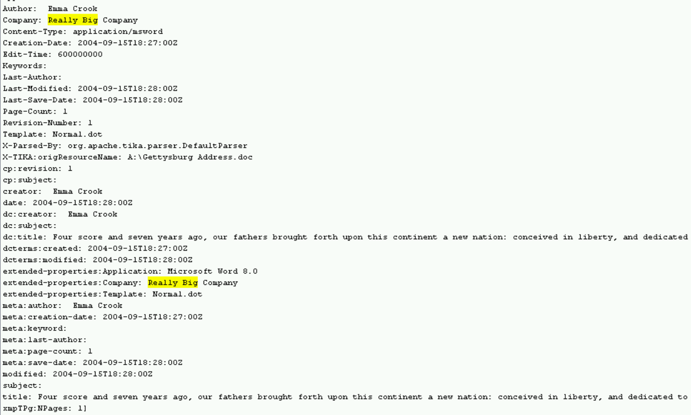

The Author that Emma Cook Plagiarized from is Abraham Lincoln.