Afeefah Manzoor

ITN 277: Forensics 2

Email Practice

Record the IP address of the sending computer: _ [69.163.26.172 __

Record the hostname of the sending computer: __djmuray________

Additional questions:

1. DHCP is a protocol enables an automatic collection and assigning IP Addresses. It is useful to help making identifying IP addresses.
2. 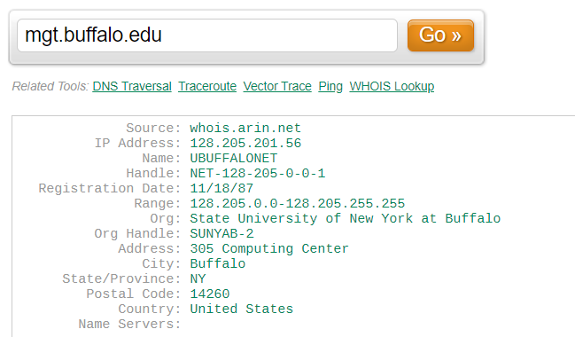

The range of Ips for mgt.buffalo.edu is 128.205.0.0-128.205.255.255 and I found this information on UltraTools WHOIS IP Lookup Table.

1. 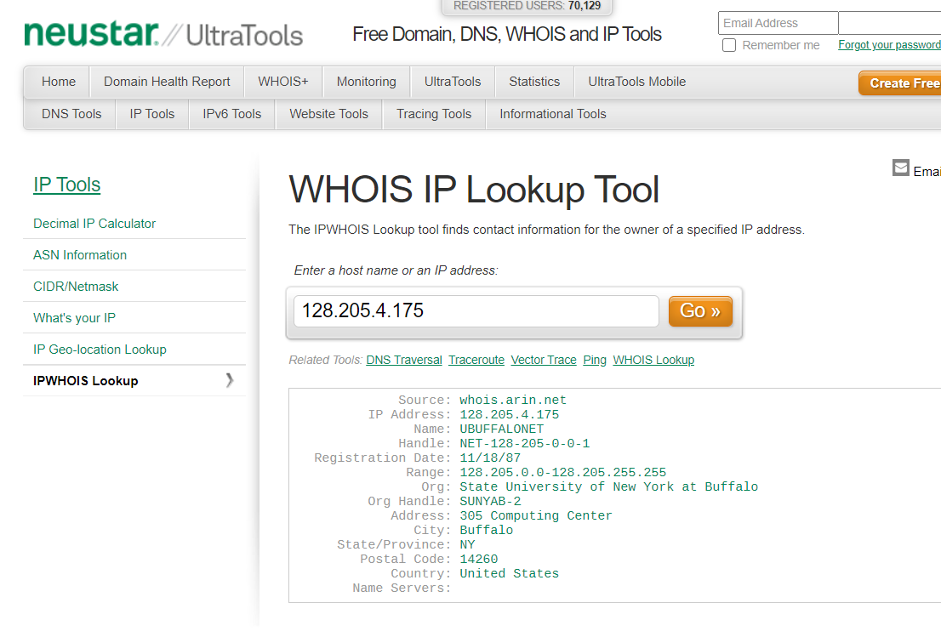 The IP Address belongs to the State University of New York at Buffalo and I found it with UltaTools WHOIS IP Lookup Tool.
2. Aid4Mail Forensics is a email investigation, search by date, header content, message body content. tool that supports various mail formats
3. 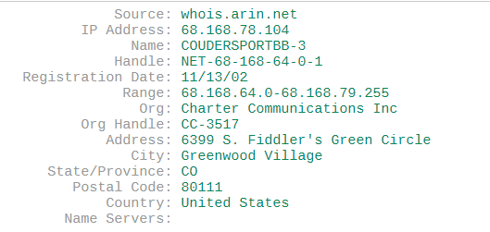 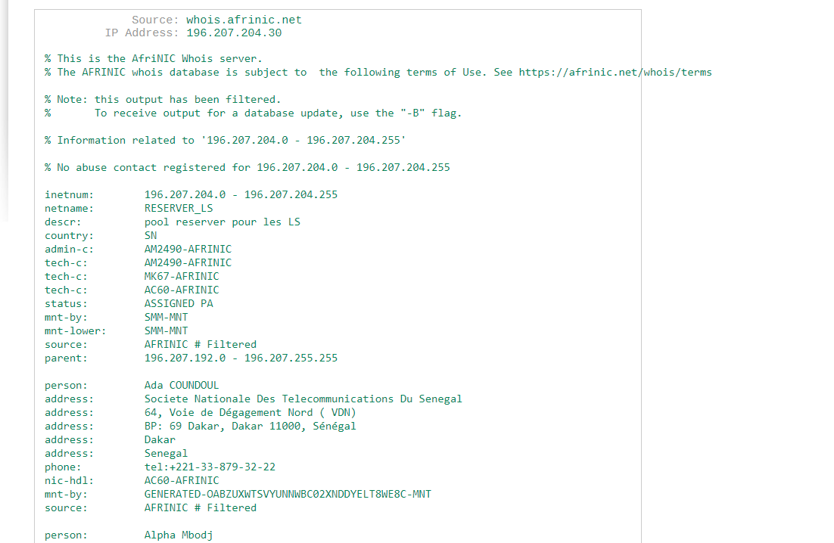 I would probaly contact Charter’s Commincations Inc since I am sure no-one in Senegal will respond especially with them being overseas.