Afeefah Manzoor

ITN 277: Forensics 2

Final Exam Part 2

Part A

A deleted Bitmap

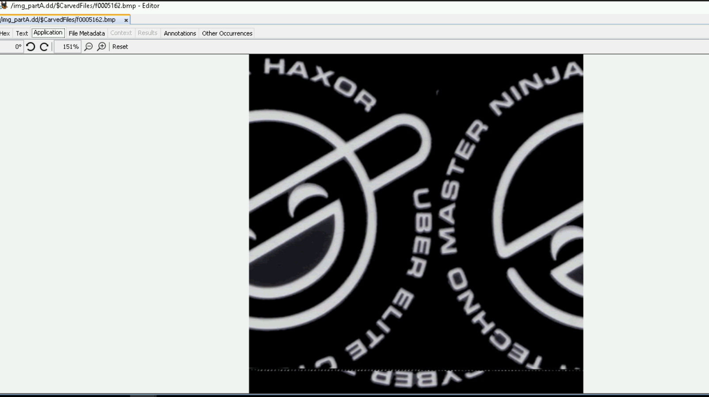



A deleted Doc

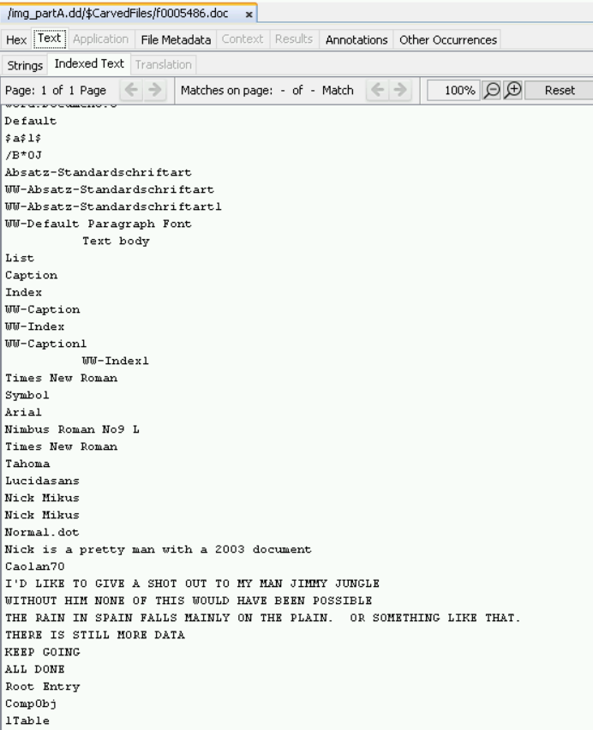



A valid JPG

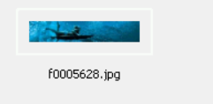

Two PDFs

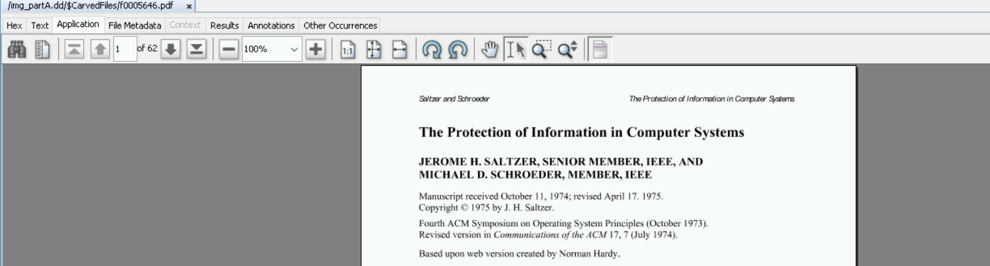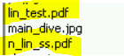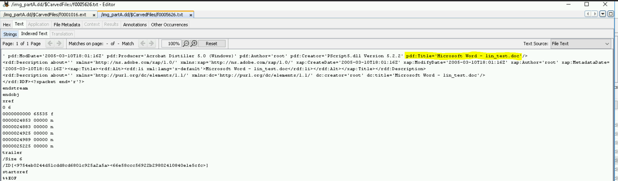

A valid gif

An Excel document

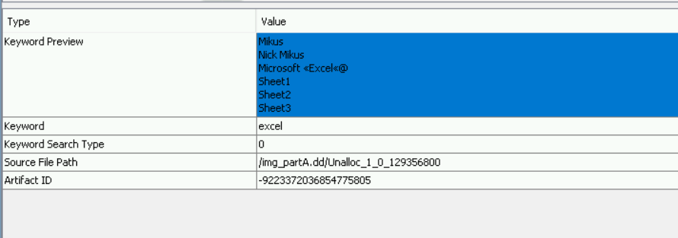and a Powerpoint documen

PART B:

What User Accounts exist?

Administrator

Guest

Mark

Admin

Can you find any associated passwords with the user accounts?

Admin- password guess foren

Password maybe forensics

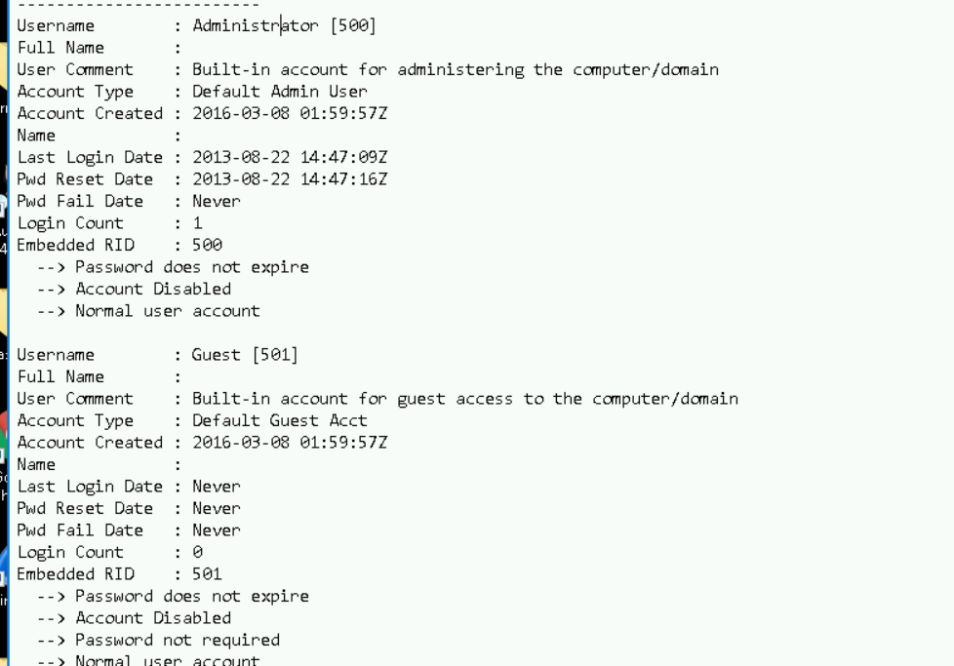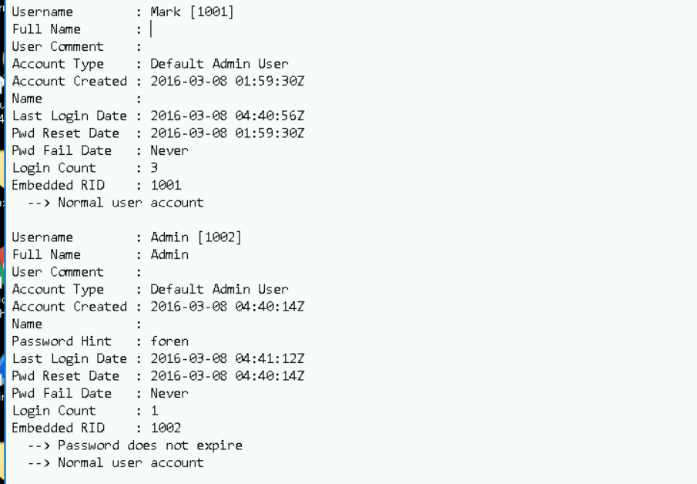

PART C:

1. What are the contents of the Accounts and Passwords file?

2 ) Any evidence of off shore accounts?

3) What are some names of possible third parties involved?

[someguy@somesite.com](mailto:someguy@somesite.com)

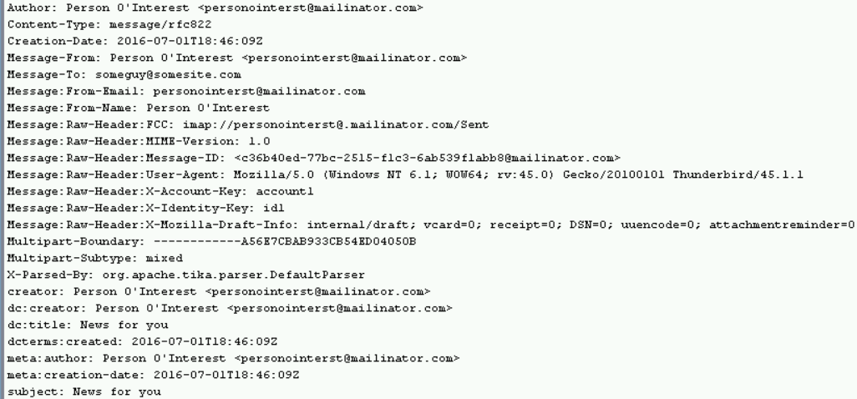

4) Who was the 2015 Chair of the Dietary Guidelines Advisory Committee

There was no one on the chair but the vice chair includes Barbara Millen, and Alice Lichtenstein

