Afeefah Manzoor

ITN277: Forensics 2

Image Carving

Image 1:



Image 2:

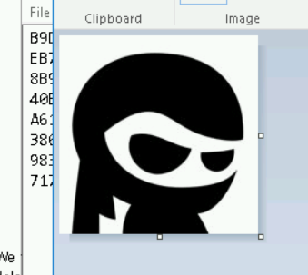

Image 3:

