Afeefah Manzoor

ITN 277: Forensics 2

JBL Lab 6: Recognizing the use of Steganography in Image Files

Section 1:

Part 1:

TavelPhoto.bmp: it looks like a small city that’s between a mountain and a body of water.

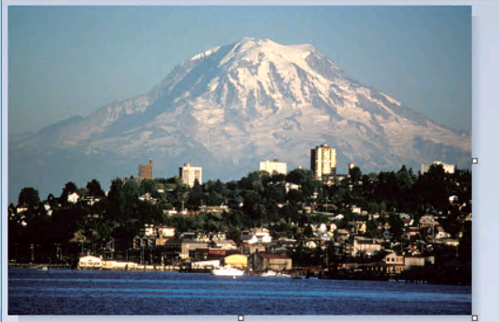

StegoMessage:

Looks like a Ceaser Cypher on a wooden board.

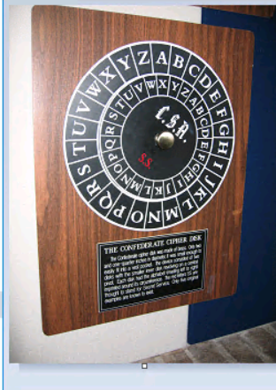

MountRainer:

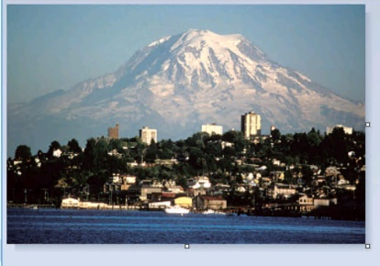It looks nearly identical to the TravelPhoto.

Cyber1:

I looks like a person in a hoodie standing with a laptop in front of a giant monitor.

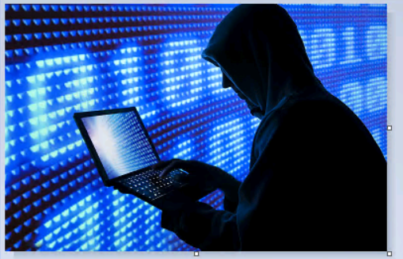

ConferateCipher:

Looks nearly identical to the StegoMessage image.

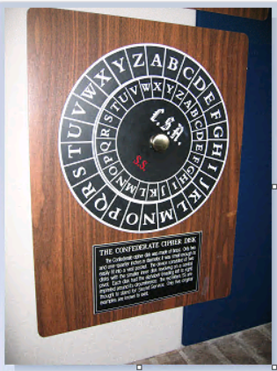

Challenge:

This looks like a red car on grass on a cloudy day.

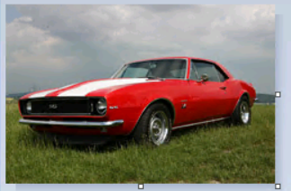

Camaro2011:

It looks like a silver Chevrolet sitting in a driveway.

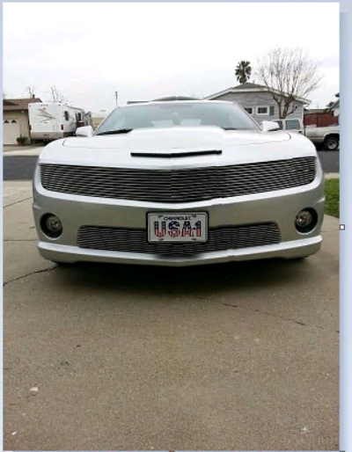

Part 2:

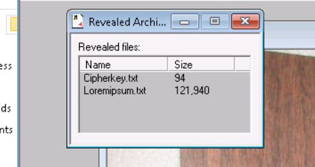cipherkey.txt = 94

loremipsum.txt = 121940

I used the IDEA algorithm to decrypt the message.

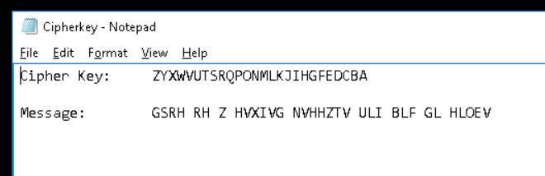

Decrypted: This is a secret message for you to solve

Section 2:

Part 2:

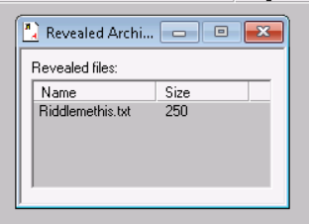 riddlemethis.txt – 250

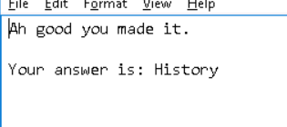

Section 3:

Part 1: DES and 3DES break texts into 64 bits. DES uses 56bit key and run 16 cycles of 48bit subkeys while 3DES runs the algorithm in sussccession with 3 different keys, 48 passses and resulting key with 168 bits. IDEA consists of 8 rounds and operates on 64bit blocks using 128bit key. MDC checks the integrity and helps detect if any message has been tampered with.

Part 2:

