Afeefah Manzoor

ITN 277: Forensics 2

Linux Refresher

A screenshot of the Pony, OldMan, Cave

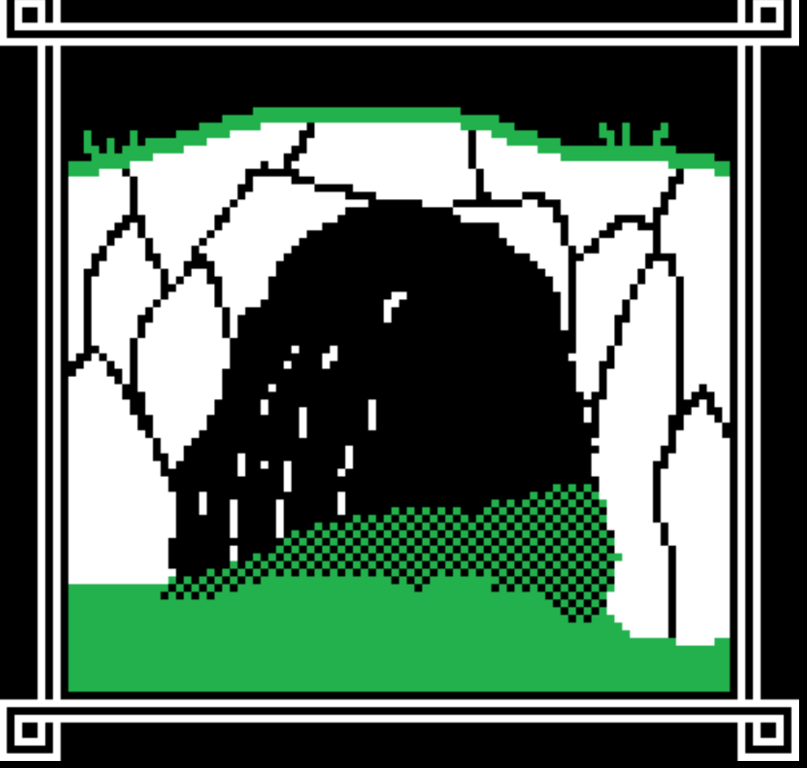

Cave

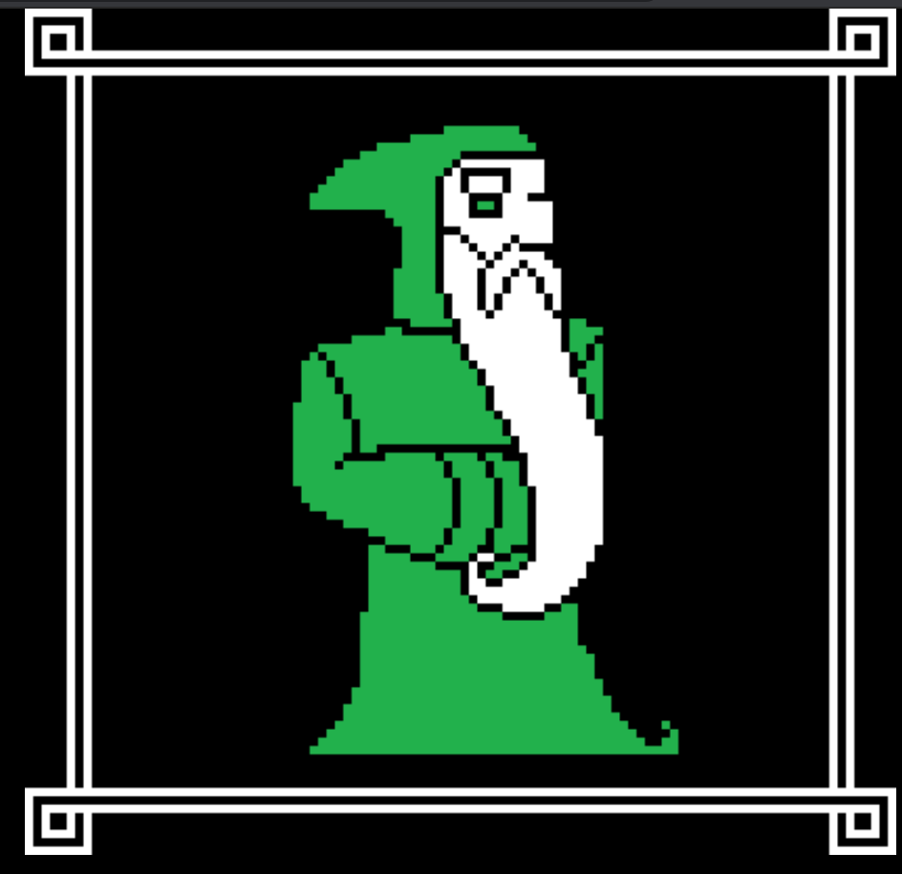

OldMan

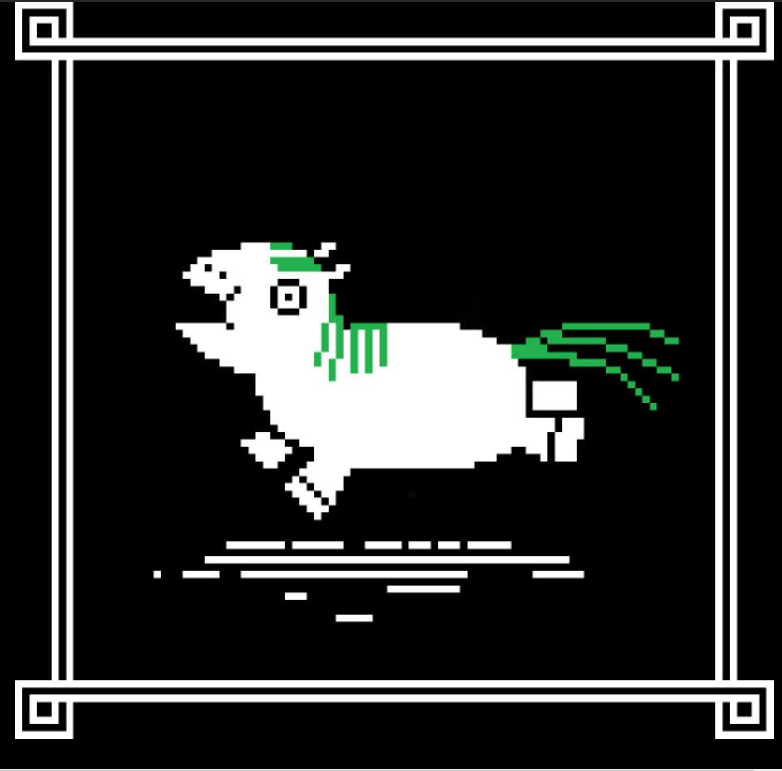

Pony

What does the Old Man tell you?

