Afeefah Manzoor

ITN 277: Forensics 2

Memory Forensics Hands On

Imageinfo

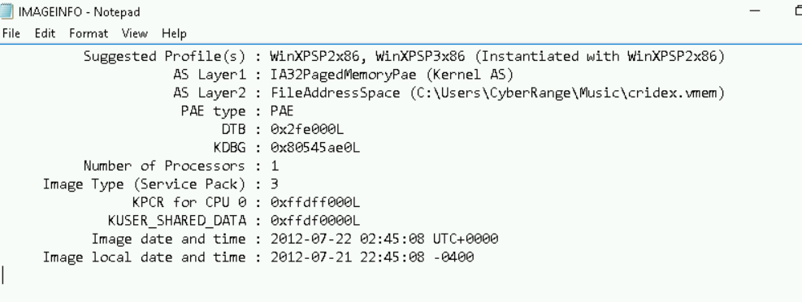

PSLIST

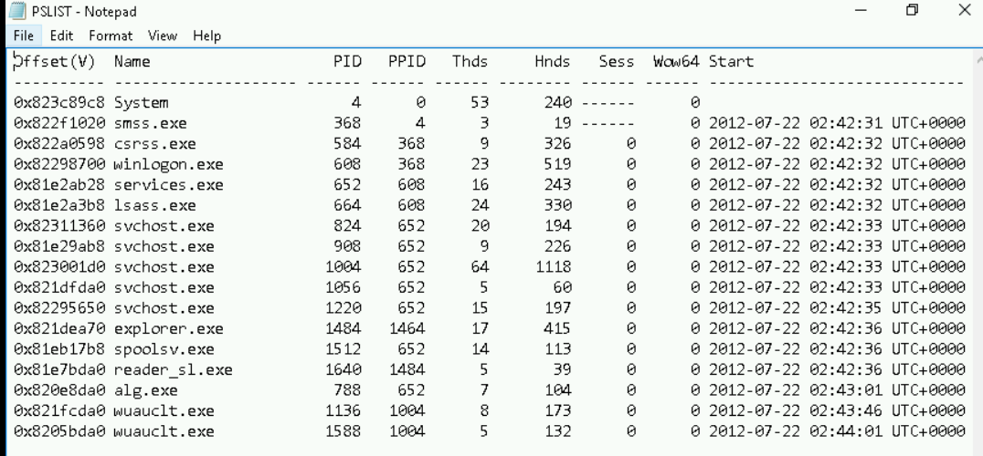

Connscan

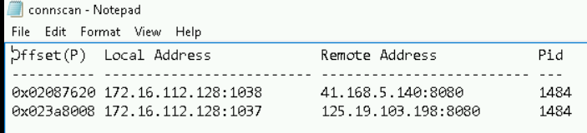

Sockets

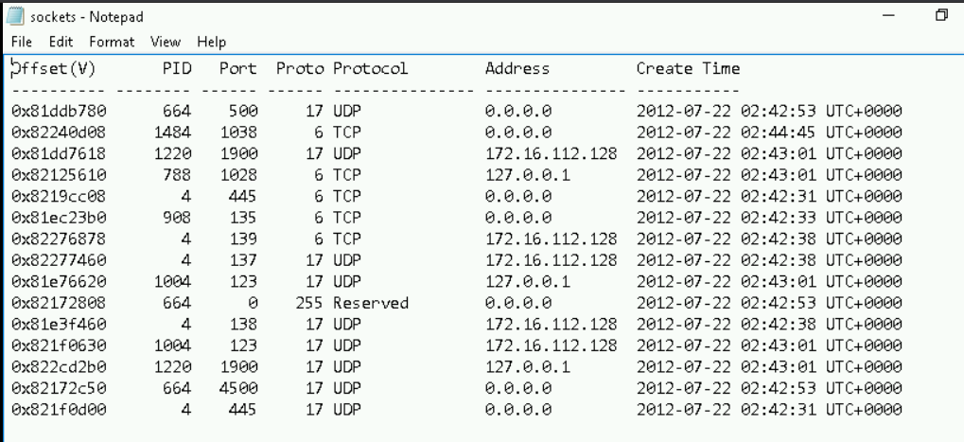

Psscan

