Afeefah Manzoor

ITN 277: Forensics 2

Midterm Practice

Part 1:

Use the evidence file to answer these questions:

1. What kind of camera was used to generate the photos?

 Canon camera

1. Recover as many images that you can.  Just list the file names and make sure you can view the image.  If you cannot see the image, then you may need to do more work before it counts.

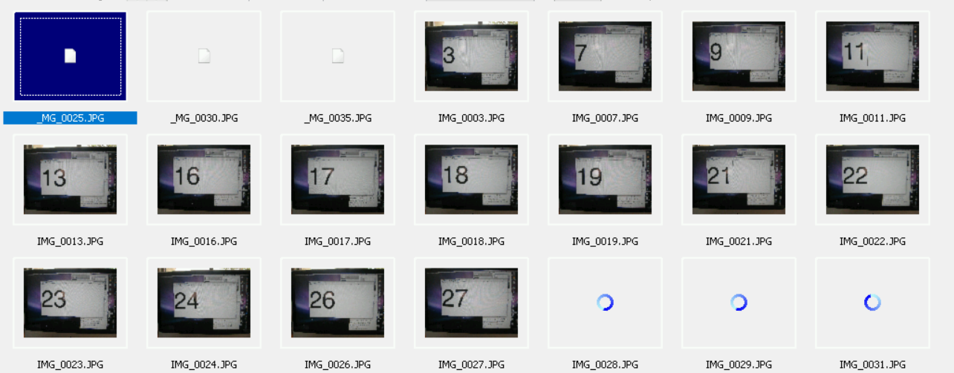

IMG_0003.JPG, IMG_0007.JPG, IMG_0009.JPG, IMG_0011.JPG, IMG_0013.JPG, IMG_0016.JPG, IMG_0017.JPG, IMG_0018.JPG, IMG_0019.JPG, IMG_0021.JPG, IMG_0022.JPG, IMG_0023.JPG, IMG_0024.JPG, IMG_0026.JPG, IMG_0027.JPG, IMG_0028.JPG, IMG_0029.JPG, IMG_0031.JPG, IMG_0032.JPG, IMG_0033.JPG, IMG_0034.JPG, IMG_0036.JPG, IMG_0036.JPG, IMG_0038.JPG, IMG_0042.JPG, IMG_0043.JPG, IMG_0044.JPG, IMG_0045.JPG, IMG_0046.JPG, IMG_0047.JPG, IMG_0048.JPG, IMG_0049.JPG, IMG_0050.JPG, IMG_0051.JPG

1. Several images have issues.  List the files names of which ones and show a screenshot of those images (that's if you can reconstruct them....)

_MG_0025.JPG, _MG_0030.JPG, _MG_0035.JPG

Part 2: Cell Phone

1. Show where (location) the cell phone was used

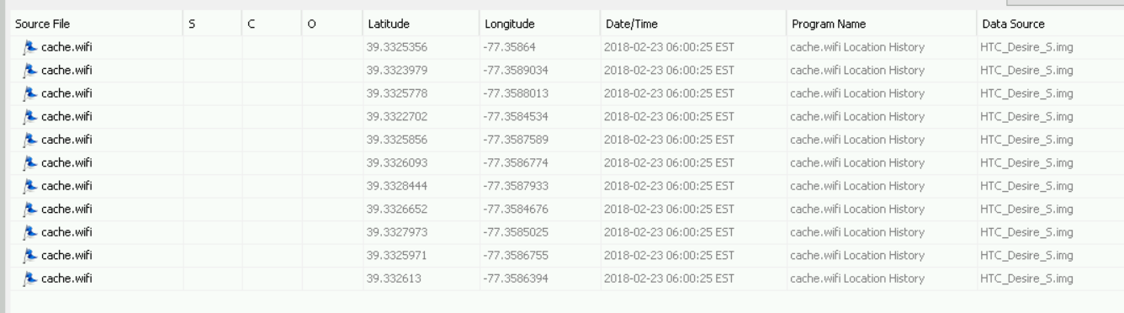

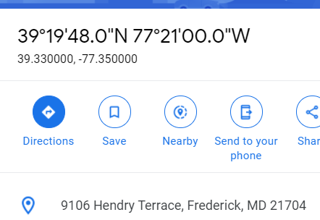39.33, -77.35; Hendry Terrance, Frederick, MD

B. List the Names and Emails of the Contacts from the phone

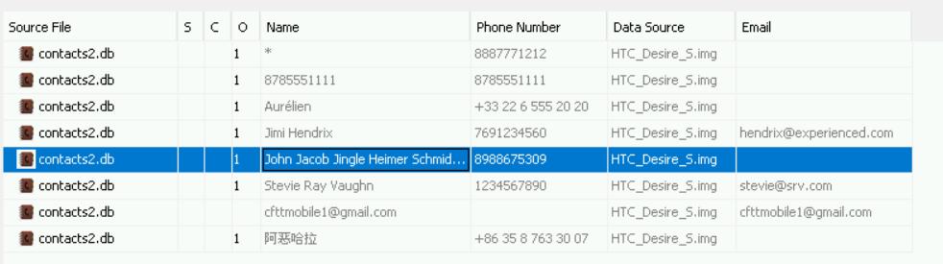

Stevie Ray Vaughn- [stevie@srv.com](mailto:stevie@srv.com)

Jimi Hendrix- [hendrix@experienced.com](mailto:hendrix@experienced.com)

[Cfttmobile1@gmail.com](mailto:Cfttmobile1@gmail.com)

Aurelien

John Jacob Jingle Heimer Schmid

1. Who said to go to the Golden Krone Hotel?



Count Dracula

1. Complete the sentence "Forensics is an emerging technology...."



That is branching off into many different avenues.

E. Show a Timeline of the phone.  Show a screenshot of the files created in 2004.