Afeefah Manzoor

ITN 277:

What Changed?

The differences I have been able to find in the two files are that the entry#% is different in the partion type GUID,Starting LBA, Ending LBa, Unique partition GUID, and the attribute bits. The pool_blk[5], tim[6] are all that I have found.

File2

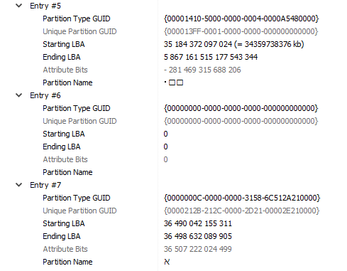

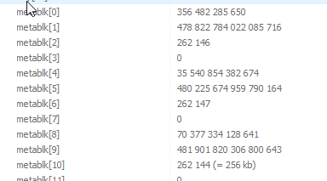

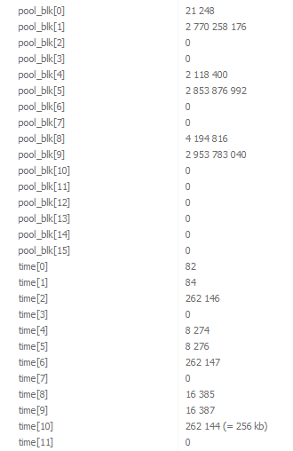

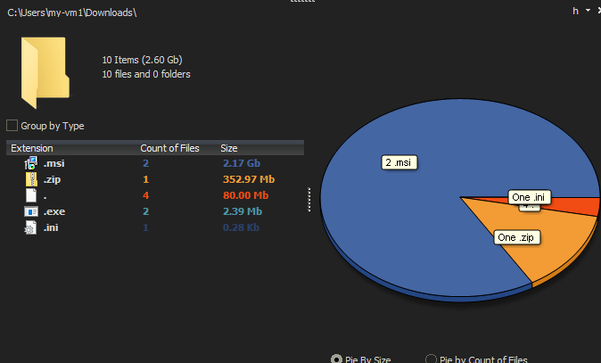

File3

