Afeefah Manzoor

ITN 277: Forensics 2

JBL Lab 7

Section 1

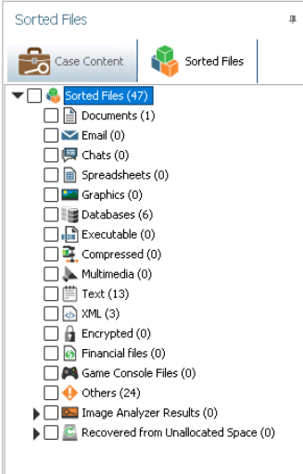

Part 1, Step 19

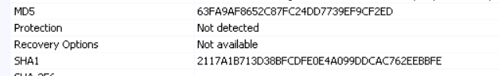

MD5: 63FA9AF8652C87FC24DD7739EF9CF2ED

SHA1:2117A1B713D38BFCDFE0E4A099DDCAC762EEBBFE

Part 2, step 11

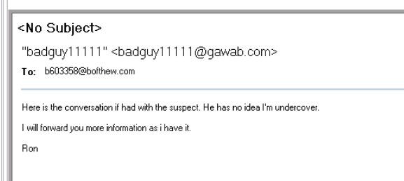

Part 2, step 30

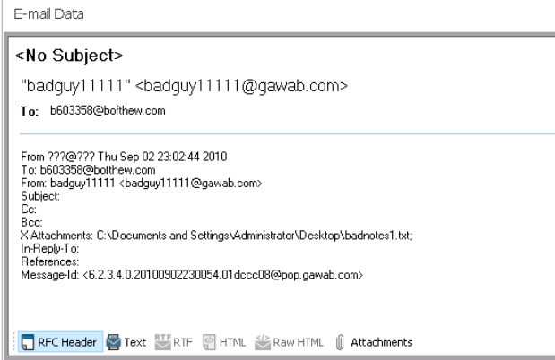part 2, step 32

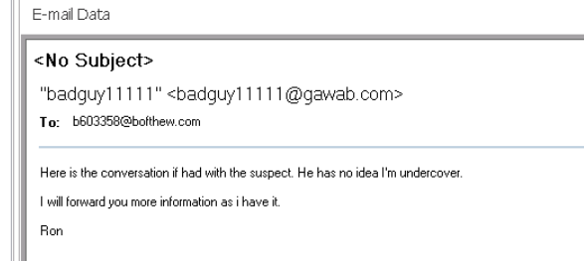

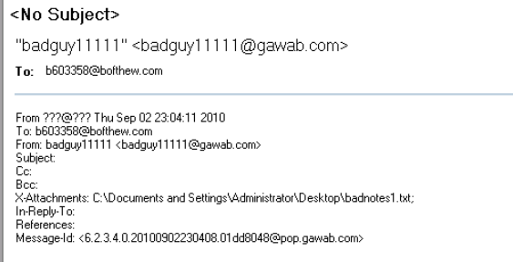

email 2

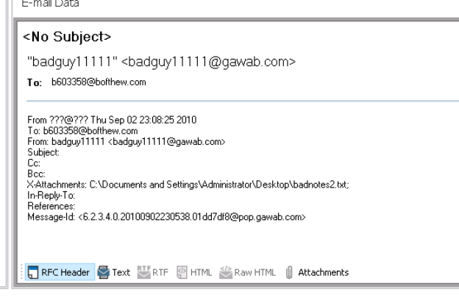

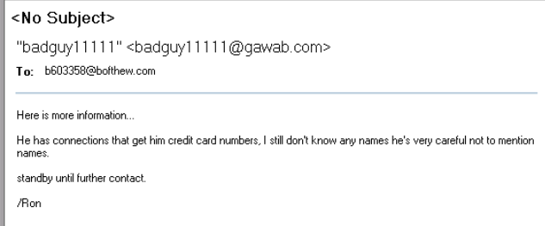

Email 3

Part 2, step 34

Section 2:

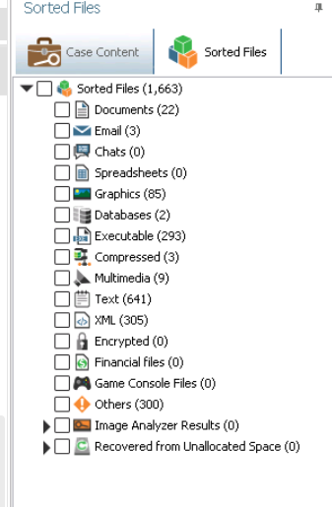part 1, step 8

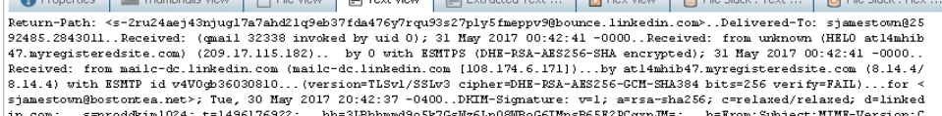

sender- mailc-dc.linkedin.com

recipient: sjamestown@bostontea.net

Part 2, step 6

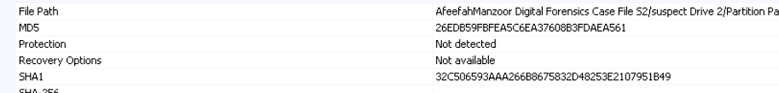

MD5: 26EDB59FBFEA5C6EA37608B3FDAE561

SHA1:32C506593AAA266B8675832D48253E2107951B49

Part 2, step 7



Sender: mail-dc.linkedin.com

Recipient: sjamestown@bostontea.net



MD5:72B7A365D9309587D3F6CEDD49EC3050

SHA1:FBD97781482266E6177FC2DE62605DC0F02ACCF

Part 2, step 10

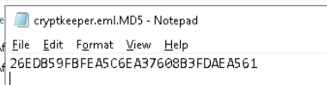

Original: 26EDB59FBFEA5C6EA37608B3FDAE561

Notepad: 26EDB59FBFEA5C6EA37608B3FDAEA561

Both MD5’s are the same.

Part 2 step 15.

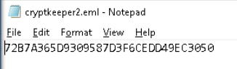

Original: 72B7A365D9309587D3F6CEDD49EC3050

Notepad: 72B7A365D9309587D3F6CEDD49EC3050

Both MD5’s are the same.

Part 2 step 17

Section 3:

Part 1: One of the most secure ways of using email is using an encrypted email, such as proton mail, to protect the emails that you are sending since they are encrypted.

Part 2:

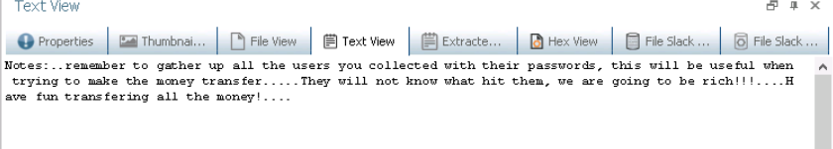

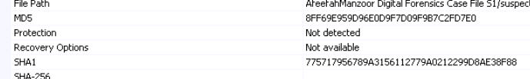

Badnotes1.txt

MD5:8FF69E959D96E0D9F7D09F9B7C2FD7E0

SH1:775717956789A3156112779A0212299D8AE38F88

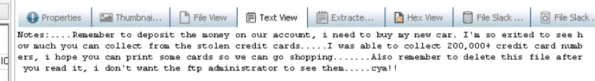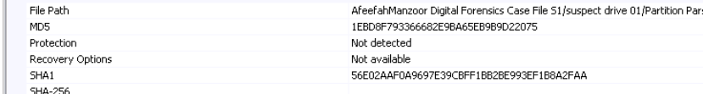

Badnotes2.txt

MD5:1EBD8F793366682E9BA65EB9B9D22075

SHA1:56E02AAF0A9697E39CBFF1BB2BE993EF1B8A2FAA

Part 3:

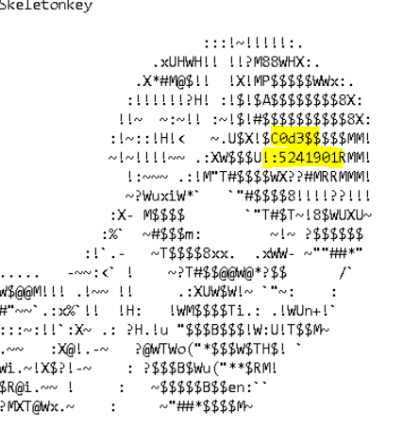5241901

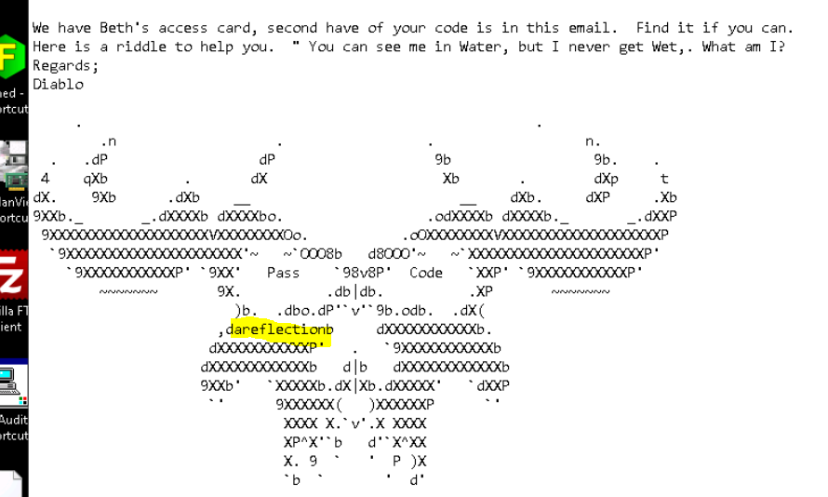a reflection