Afeefah Manzoor

ITN 277: Forensics 2

JBL 9

Section 1:

Part 1:

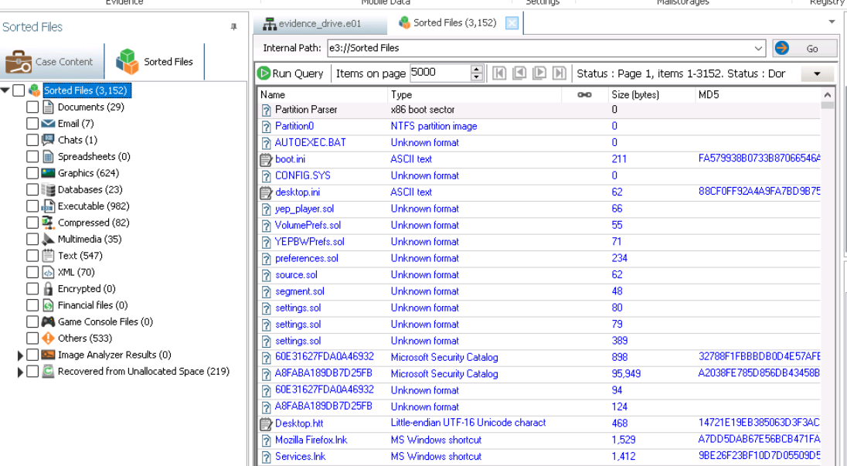Step 21

Part 2:

step 4

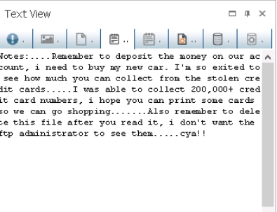

Located on desktop

step 10

step 18: e3://Afeefah Digital Forensics Case File S1/evidence_drive.e01/Partition Parser/Partition63/*binary_file/NTFS/Partition::Free::Spaces/Partition::Free::Spaces::Detected/unallocated_clusters_0_999/Free_Space_158_532584_12

step 37: malware report, it seemed interesting

step 43: 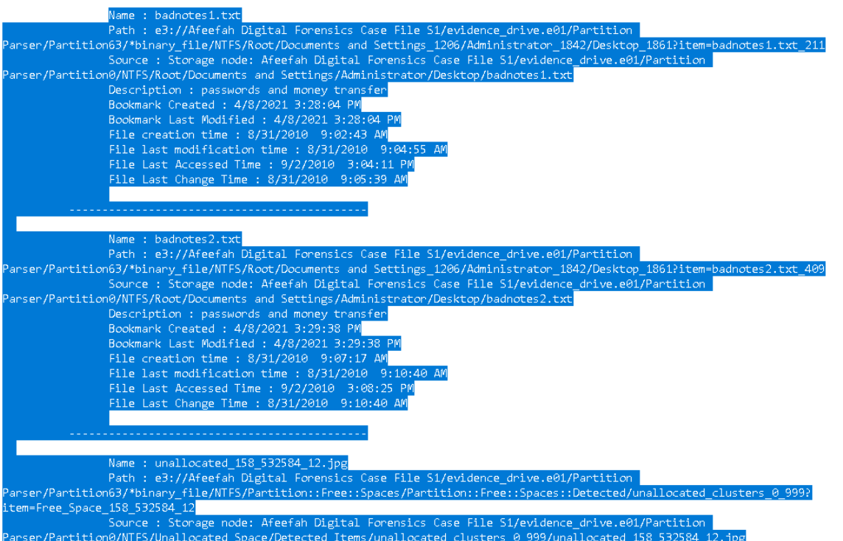

step 46: 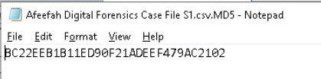

step 49: 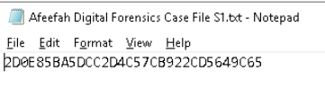

Section 2:

Part 1:

Step 8: 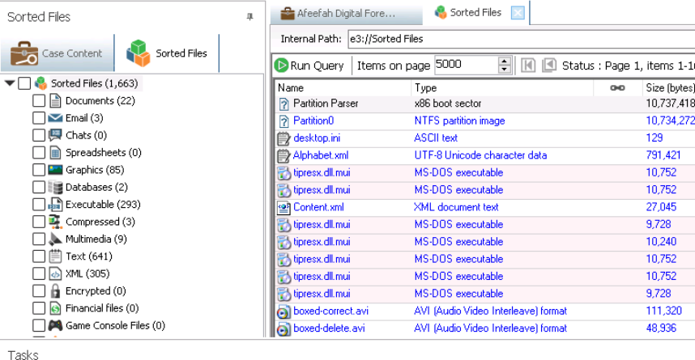

Part 2:

Step 3: 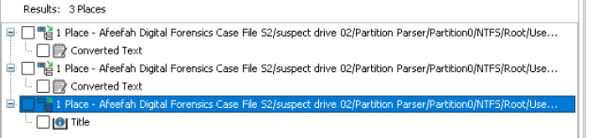

Step 5: 547E54041627B4354260FADE6513C477

Step 7: 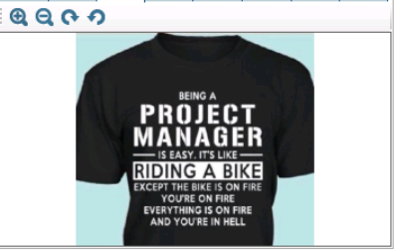

Step 10: e3://Afeefah Digital Forensics Case File S2/suspect drive 02/Partition Parser/Partition2048/*binary_file/NTFS/Root/Users_36/Sam_40/Pictures_2278/projectmanager.crt_2265

Step 15: 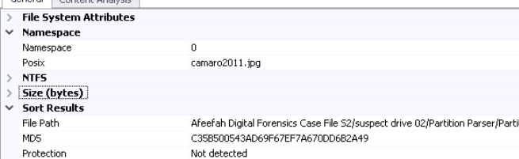

Step 18: 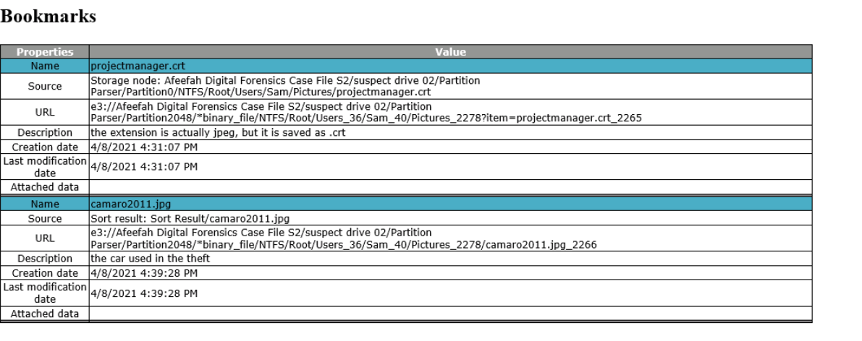

Step 22:

