Afeefah Manzoor

ITN 295- Gateways to the Darkweb

In Class Assignment 3/17/2021

Directions:

Copy/paste 3 URLS & description of the key words.

Financial data

Drugs

Guns

Visit 1 link from each category and screenshot

Financial data:

1. Title: DATA NEEDED – HITMAN FOR HIRE

Description: No Description provided.

*Webpage: thz27bwct37rjv2d.onion*

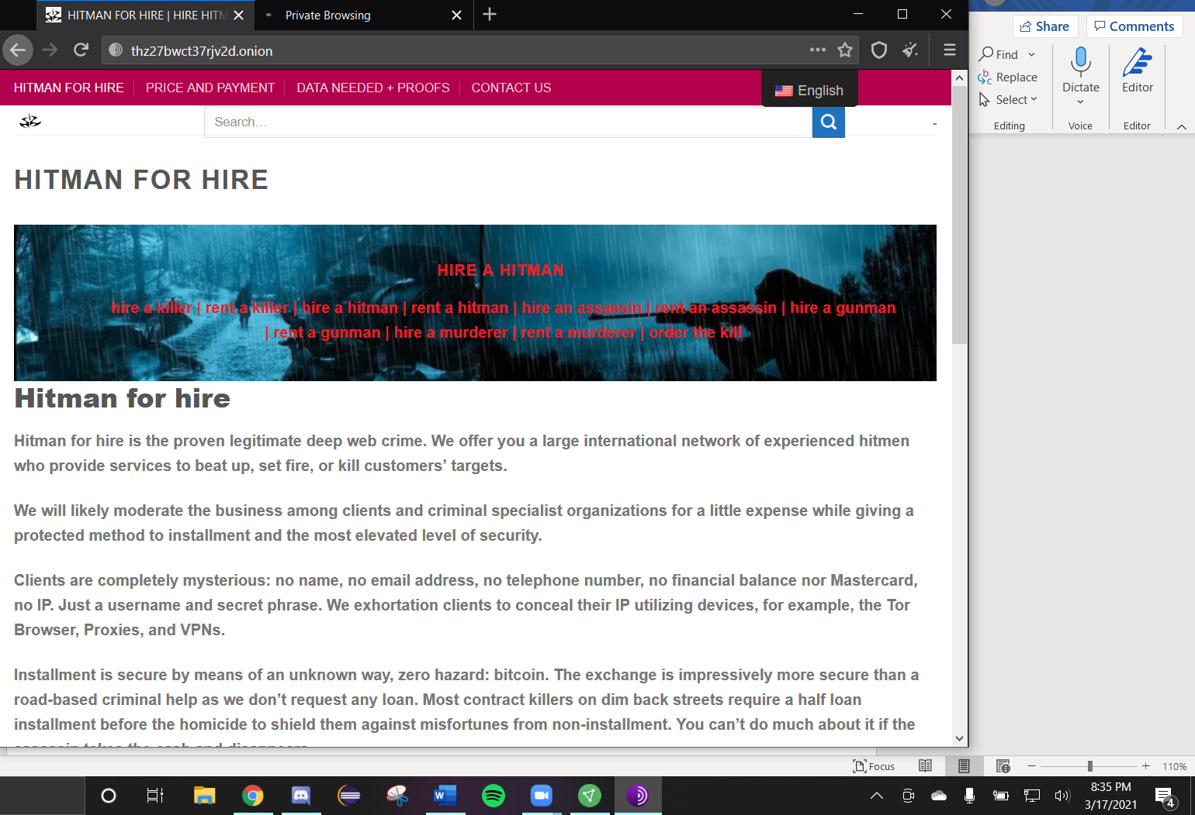

1. Title: imperial market – best financial service

Description: Best financial market – prepaid /cloned / gift cards and money transfers via PayPal or Western Union

*Webpage: 4gffobtccjw34h26meb6zfsleu4bwkowoahzfop7u7bvjj3pipbl67yd.onion*

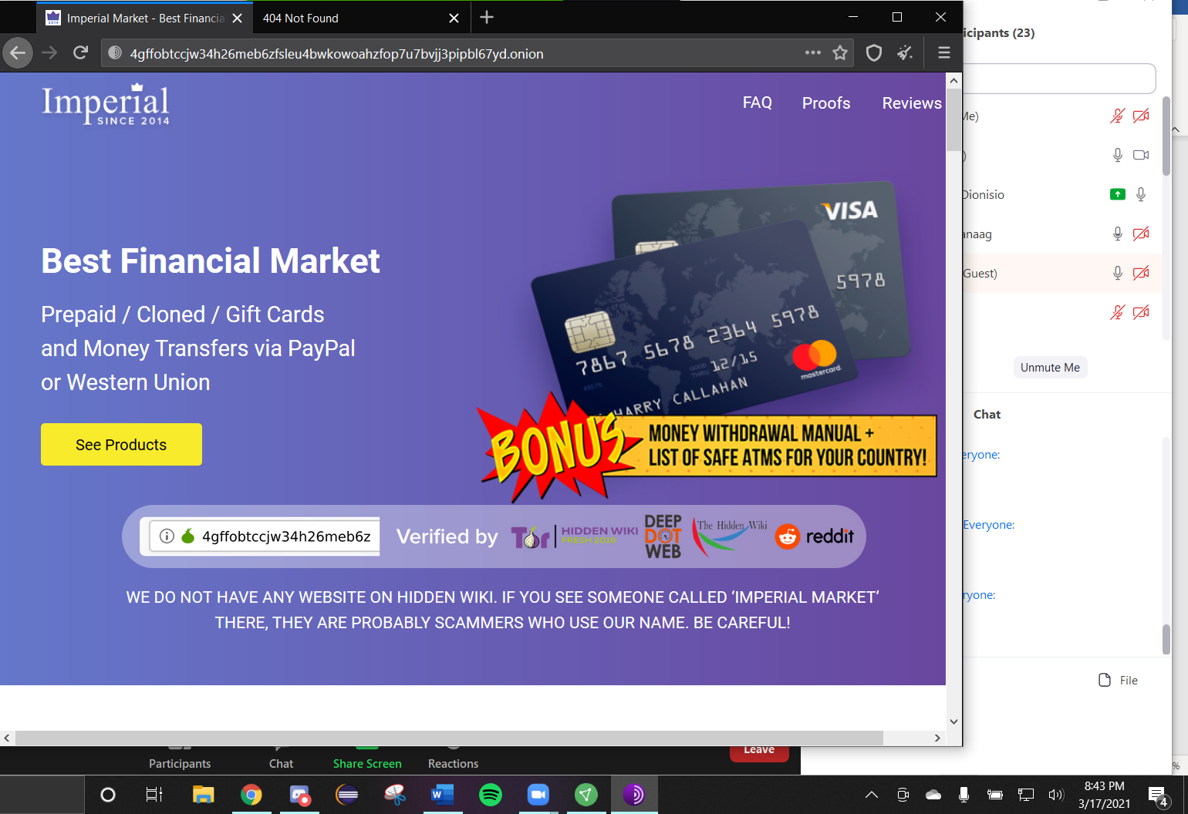

1. Title: about us and our company – investment platform doubler bitcoin

Description: read about us and our company – investment platform XQUBCAKJP2NRIW2W.ONION. our team includes experienced experts, we used modern data centers.

*Webpage: n56xh4ue3i3wfscj.onion*

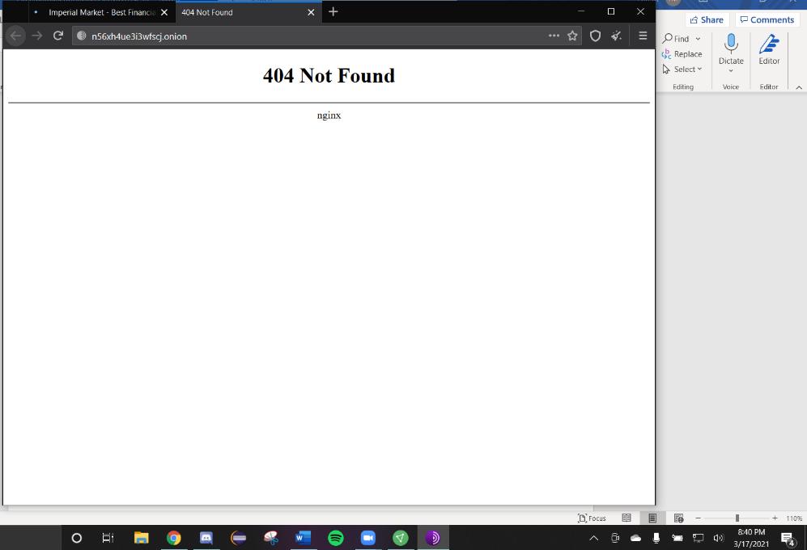

Drugs:

1. Title: 19 drugs

Description: No description provided.

Webpage: zqktlwi4fecvo6ri.onion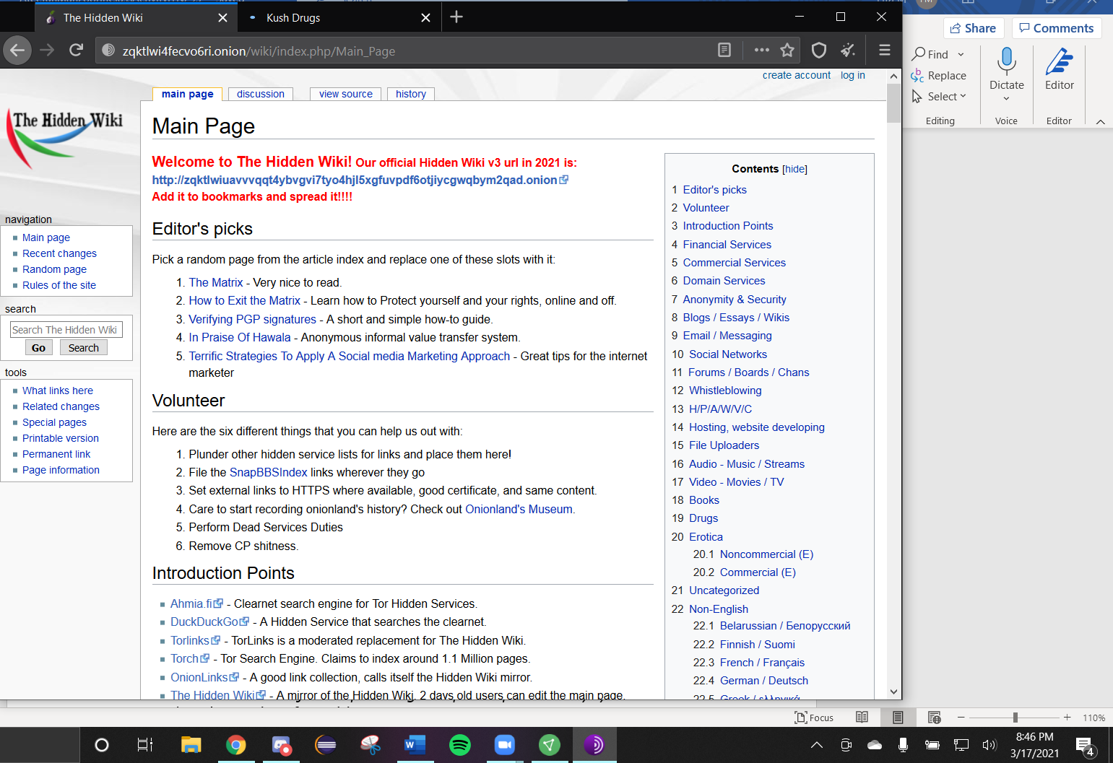

1. Title: DRUGS

Description: Drug store – buy weed, ecstasy, cocaine, lsd, meth

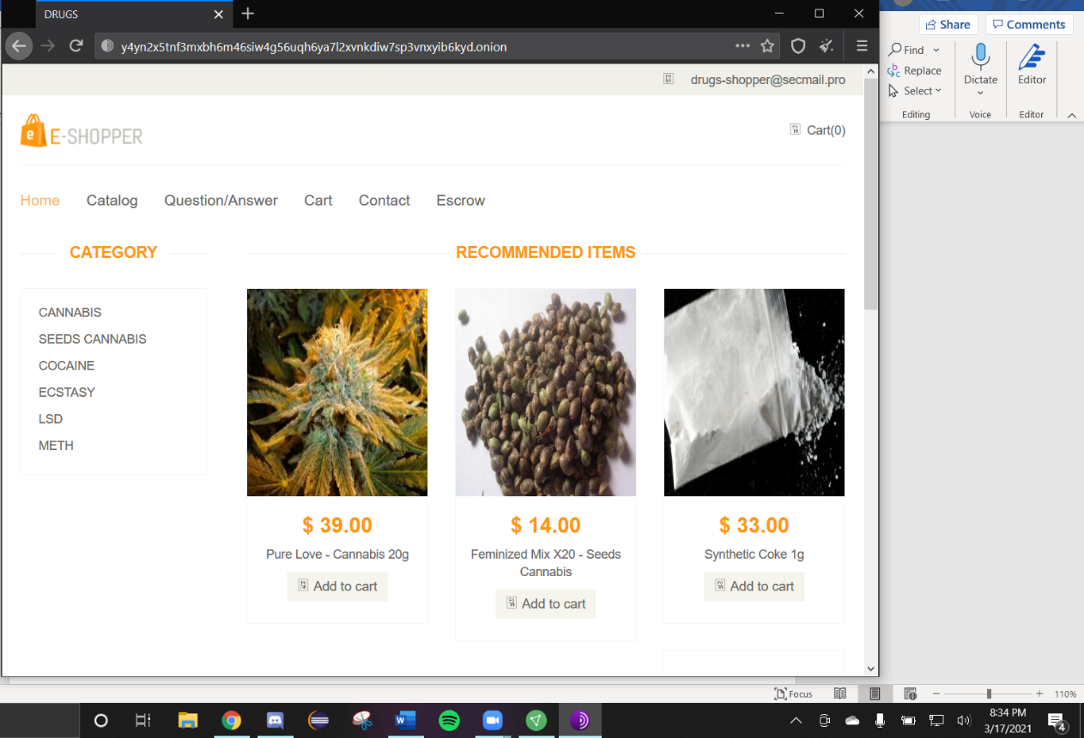Webpage: y4yn2x5tnf3mxbh6m46siw4g56uqh6ya7l2xvnkdiw7sp3vnxyib6kyd.onion

1. Title: Kush drugs

Description: Kush Drugs – buy cannabis best marijuana hemp

Webpage: 2dvnxbhh4dqkmdexrcqj2x6wjvoa2j5yx4n5cqhv4dkhyuzgkuk76lyd.onion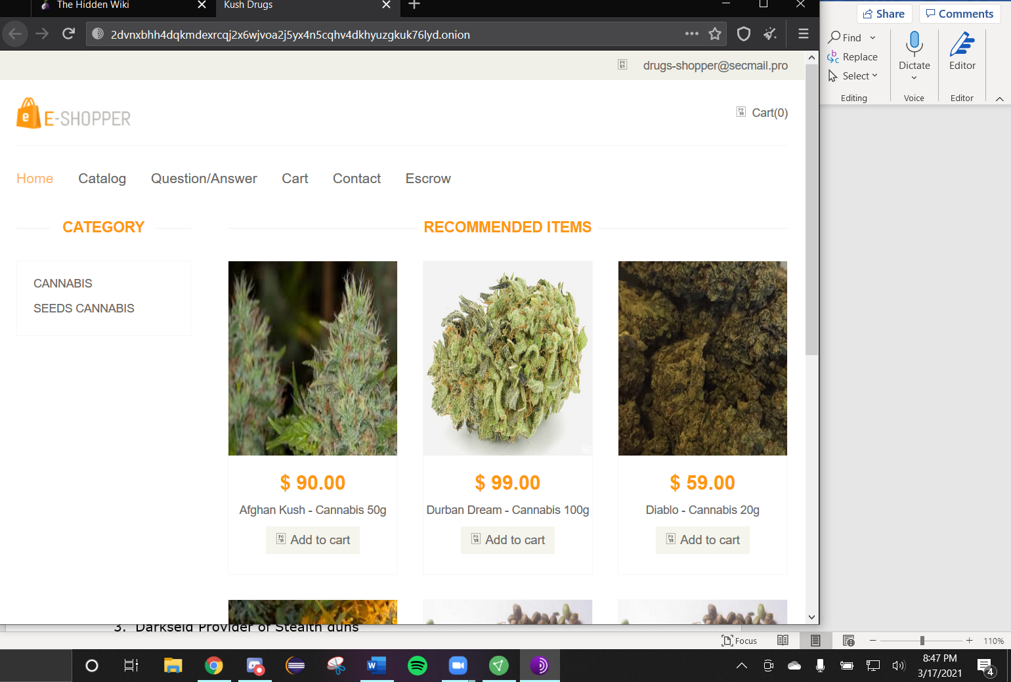

Guns:

1. Title: Euro Guns and A,,o Store – Buy Guns and ammo in the UK for Bitcoing

Description: UK Guns and ammo store, buy guns and ammo on the deep web with bitcoin at our Tor store.

Webpage: tuu66yxvrnn3of7l.onion

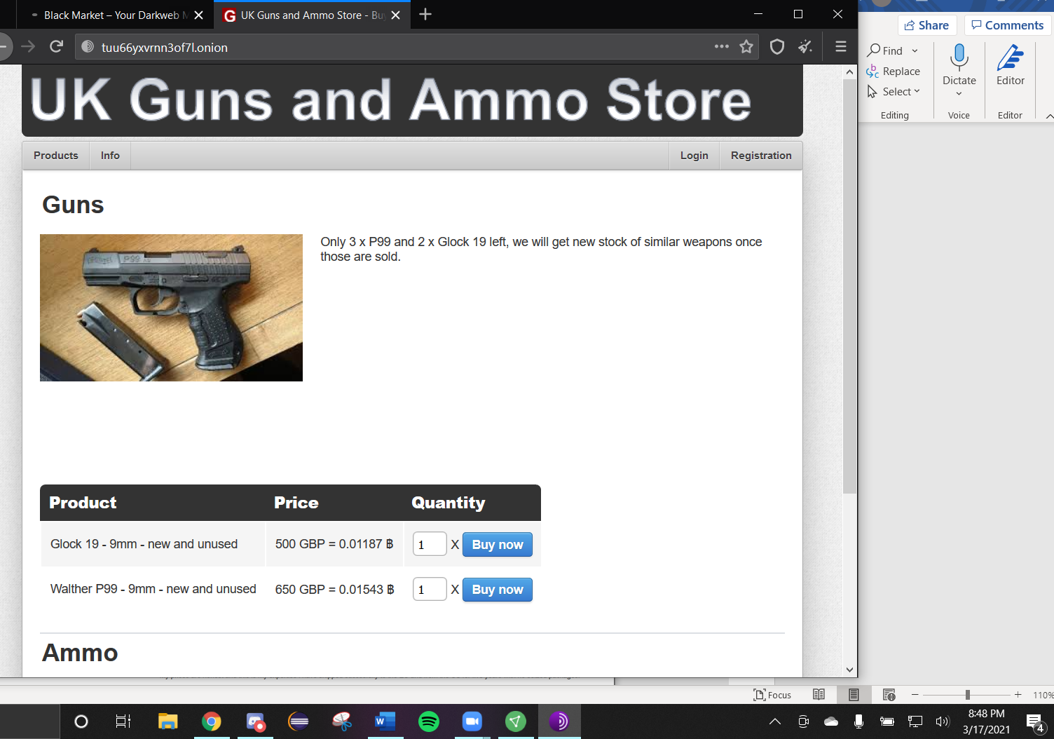

1. Title: Guns for Sale – Black Market

Description: No description provided.

Webpage: lhoktmc7tzo5khl65uj5nnr3qauxozngktt2spa6ovq5dceheludyhyd.onion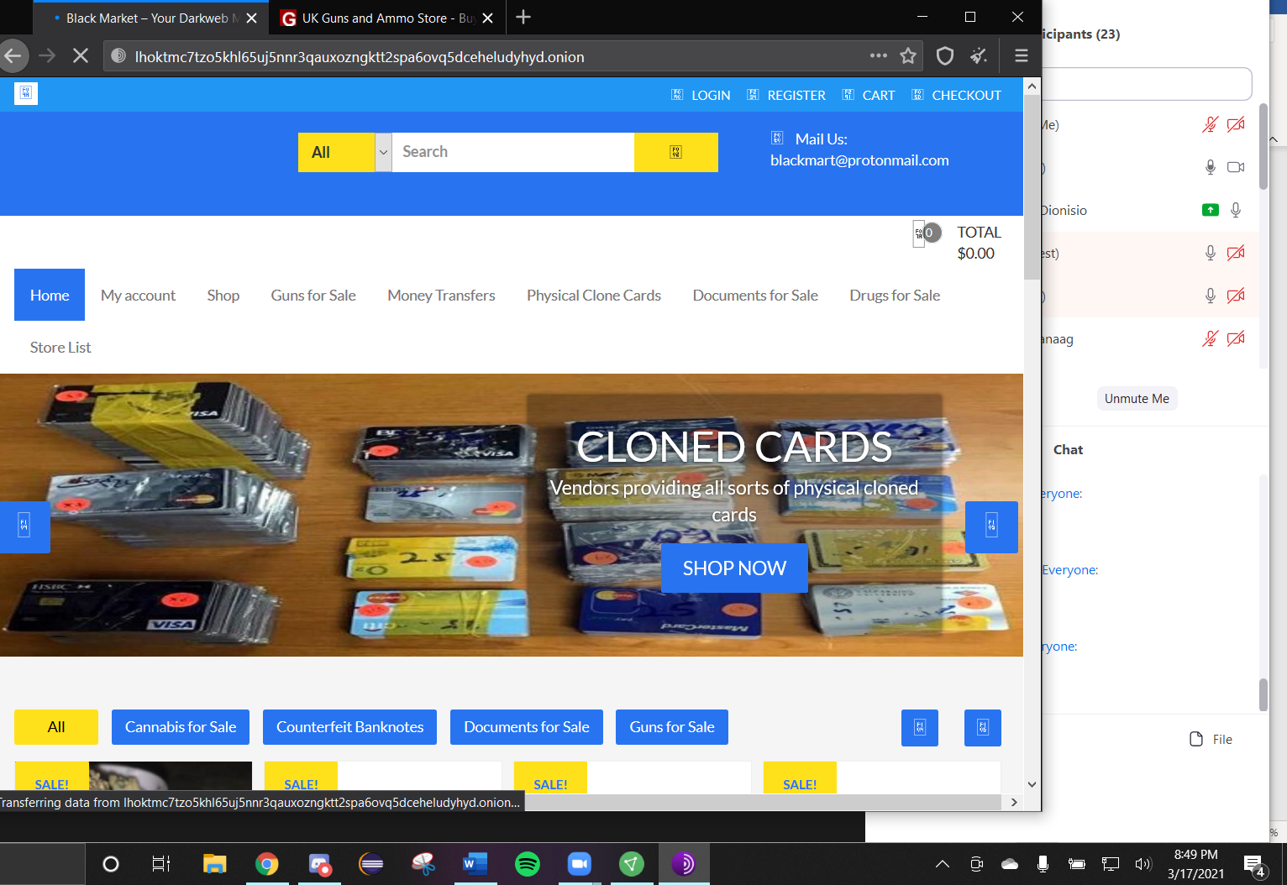

1. Title: Darkseid Provider of Stealth guns

Description: Guns of different calibers and sizes

Webpage: darksei2hj6fojdhqfpyps7xm3h5qeu2wggox3vxsao3drjyuyjg44qd.onion

