**Synopsis**-

Since it is a Mexican restaurant and poncho is symbolic I have designed a game where the prize is the poncho. We are playing the a cartoon character speedy Gonzalez. In an arena where a bull tries to fight with you have three items from the shop burrito hot sauce and taco. Both bull and us have 5 hitpoints. Hot sauce damages the bull. Burrito heals Gonzalez. Taco increases your speed helping us to dodge the bull. With the interactable objects we try to escape from bull hits and win the game.

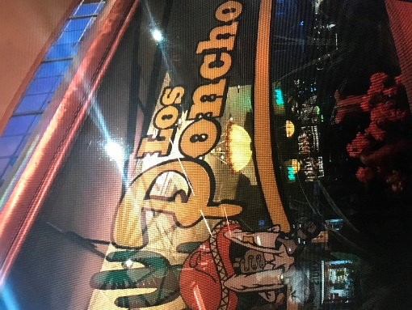

**Usage and Interactions**-

Gonzalez move is happened by arrow keyboards up down left right and spacebar to stop wherever you are.

Both bull and Gonzalez have 100 health in every hit Gonzalez get -25 points.

Hot Sauce -25 point for bull.

Taco increase the speed.

Burrito +25 health for Gonzalez.

Tip: stay away from corners so that more time to dodge we can have.

**Architecture-**

The explanations of the methods are done in the documentation the commentaries on the processing .pde files.

