

English

Instruction and Operation Manual

SensSee
Smart-phone App for Air and Gas Flow Meter

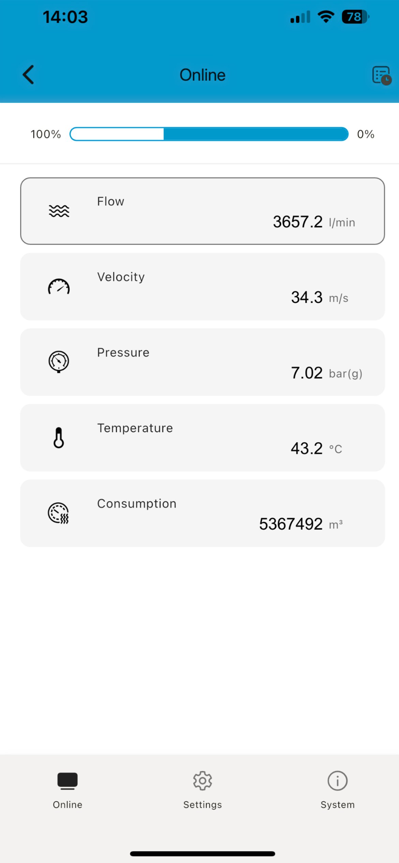 | 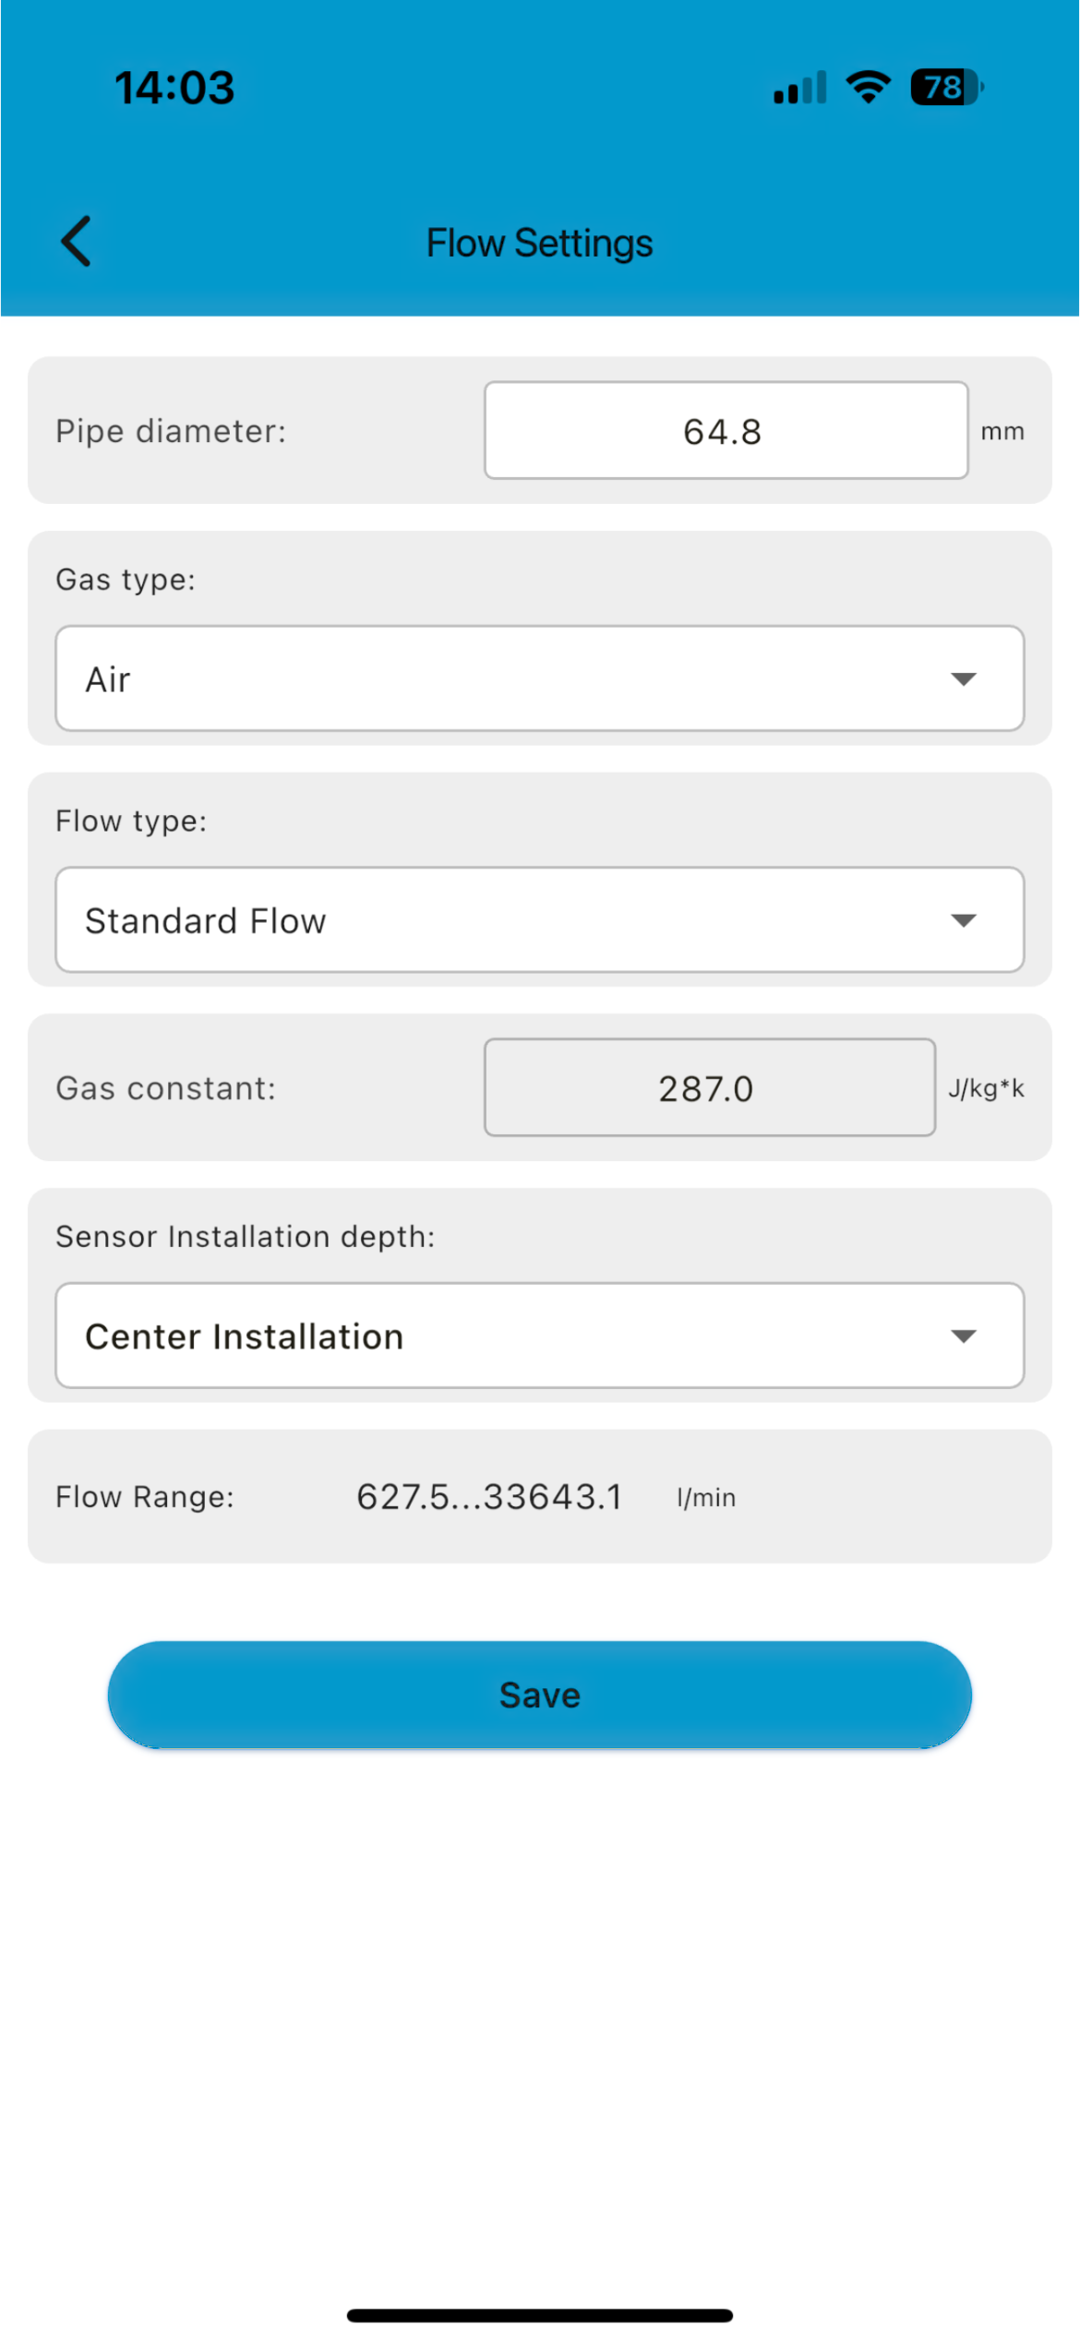

Dear Customer,
Thank you for choosing our product.
Please read the manual in full before you start up the device and carefully observe the instructions stated. The manufacturer cannot be held liable for any damage which occurs because of non-observance or non-compliance with this manual.
Should the device be tampered with in any manner other than a procedure which is described and specified in the manual, the warranty is void and the manufacturer is exempt from liability.
The device is intended exclusively for the applications described in this manual.
Atlas Copco offers no guarantee of suitability for any other purpose. Atlas Copco is also not liable for consequential damage resulting from the delivery, capability or use of this device.

Revision: 2025-3

Last modifications: May, 2026

Table of contents
1 Registered trademarks 4
2 Application 5
2.1 System requirements 5
2.2 Operating requirements 5
3 Features 6
4 Installation and connection 6
4.1 Install the App 6
4.2 Connect to the Flow Meter 6
4.3 Enable the configuration 7
5 Menus 8
5.1 Online 8
5.2 Settings 9
5.3 System 9
6 Settings 10
6.1 Flow 10
6.2 Gas type 11
6.3 Units 11
6.3.1 Flow units 11
6.3.2 Pressure units 11
6.3.3 Temperature units 11
6.3.4 Consumption units 12
6.4 Reference conditions 12
6.5 Factory settings 12
6.6 Consumption counter settings 13
6.7 Output settings 13
6.8 Calibration 15
6.8.1 Calibration type 15
6.8.2 Calibration parameters 15
7 System 15
7.1 Sensor information 15
7.2 Language 16
7.3 App version 16
8 Maintenance 16

Registered trademarks
Trademark | Trademark owner
MODBUS® | Modbus Organization, Hopkinton, USA
HART® | HART Communication Foundation, Austin, USA
Android™,  Google Play | Google LLC

Application
The SensSee App enables you to view measurement readings and change settings for flow meters through Android or iOS devices.
The SensSee App supports the following flow meters:
- FL S93 T, FL S185 T, FL S224 T
- FL S200 P, FL S260 P=
- FLI Dxx C (Dxx = D08, D15, D20, D25, or D32) –
FLI Dxx A (Dxx = D15, D20, D25, D32, D40, D50, D65, or D80)

