CMPSC470

Compiler Construction

Spring 2024

Lab Report – Week 6 - Decimal to Binary Converter (MIPS Assembly)
Aaron Feinberg
CMPSC470-002

Assignment Analysis and Design
In your own words, describe the problem including input and output. Briefly describe how you developed your code. Briefly describe what your code does and how it works – including anything different or unique or special that you did in your software. If the software is long or complicated, describe how it is organized.
Include a copy of any pseudocode or other design documents you used. If you worked with anyone else, asked anyone for help, or looked anything up, then mention it here. Include proper references to the source material.

My program is allocates space for the result value that’s converted into binary and prepares the registers which will be used to store user input ($a0) and the result ($v0). The code in divided into 5 sections named greeting, main, bin_loop, str_loop and print_results. Greeting greets the user and then we immediately move to the main section. Here a syscall is made to read an integer from the input stream and store it in register $a0. The main loop makes the following designations:
- $t0 – holds the position of the current bit we are on in the conversion process (the place value of the binary)
- $a0 – holds the user’s input value
- $t1 – holds the least significant bit (LSB) the value of the bit that will be in position $t0

we use the AND operation over $t0 and $a0 to select a bit to convert to binary. $t0 has 0’s in all positions except the one we are comparing so AND nulls all of them except if the position in $a0 has a 1 where $t0 has a 1.
We then shift all values in $a0 right and $t0 left and loop until $a0 has no more preceding 1’s meaning we’ve read the entire value (up to 31 bits or 2147483647). The print_results section is then jumped to and we print a brief string indicating that the following line will contain the converted value. Since we can only output strings to the buffer, the str_loop once again iterates over the data and stores the ascii representation of each digit. $a0 then points to the address of the string of binary digits. This then printed in the output stream to the user.

Assignment Code
The code is given in the file binary_to_decimal.asm

Assignment Testing
Describe how you tested this program to verify that it runs correctly.

The program was tested with the following values:
[0, 1, 4, 100, 2147483647]
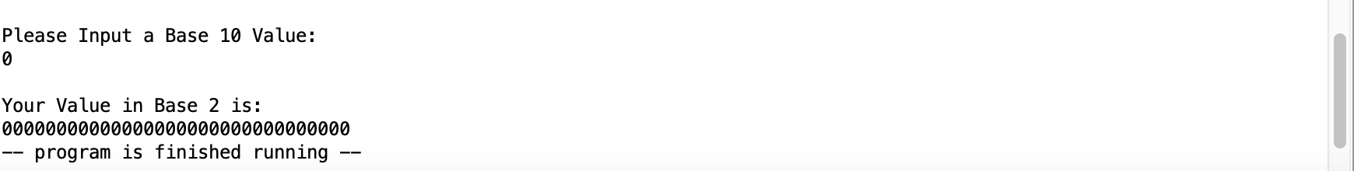
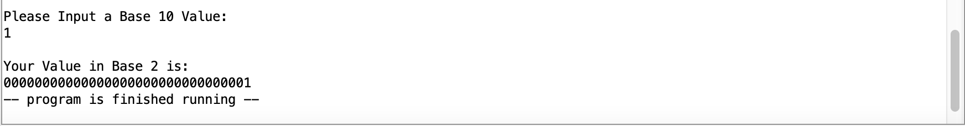
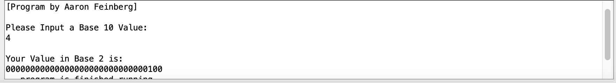
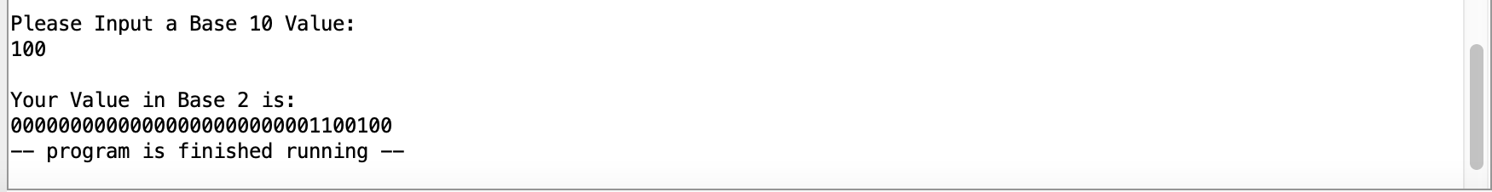
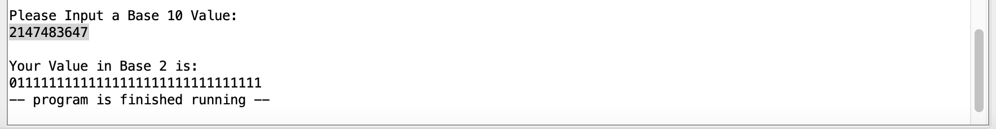
Assignment Evaluation
Briefly describe what you learned from this project. What things did you struggle with? What was easy? Give your opinions of the process, including what you liked about the project and any suggestions you have for improving the project.

I first implemented this program in python and it was fairly easy to do. The learning curve with assignment was in trying to capture the notion of the program in mips. For example, using the AND operator to “read” in 1’s from the users input value required thinking about the operations at a very atomic level. Also, instead of appending to the beginning of an array of values that would represent the value in python, mips requires that we shift the register left or right to adjust the place within the value we are evaluating. It was interesting to write this project since it required a new and very explicit approach to writing the code.

