Employee Success Analytics at NextGen Corp.
Query and Data Outputs

A. Understanding the employee turnover trends and identifying the root causes of high turnover rates.
1. Who are the top 5 highest serving employees?
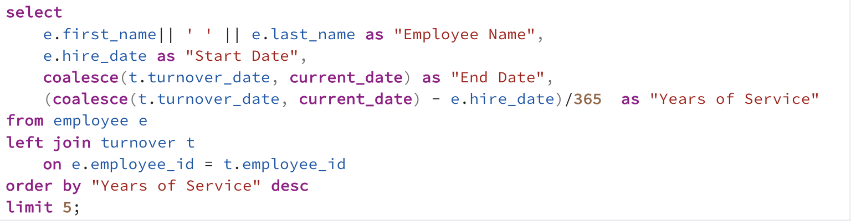
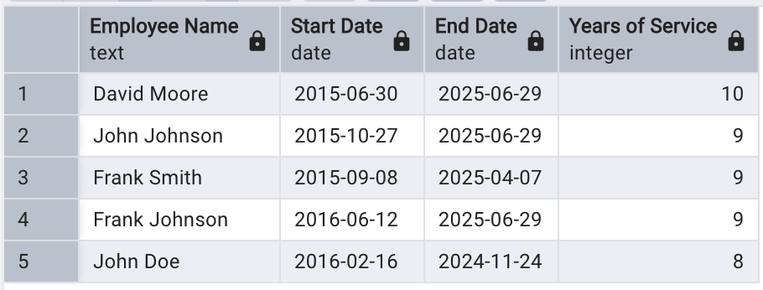

2. What is the turnover rate for each department?
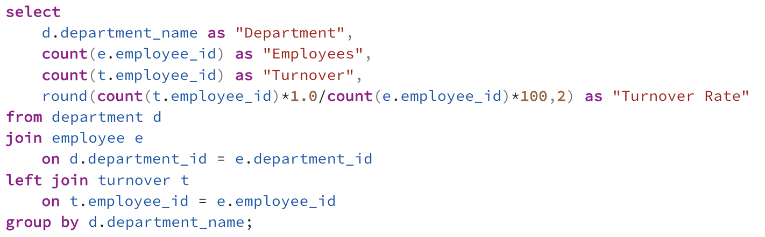
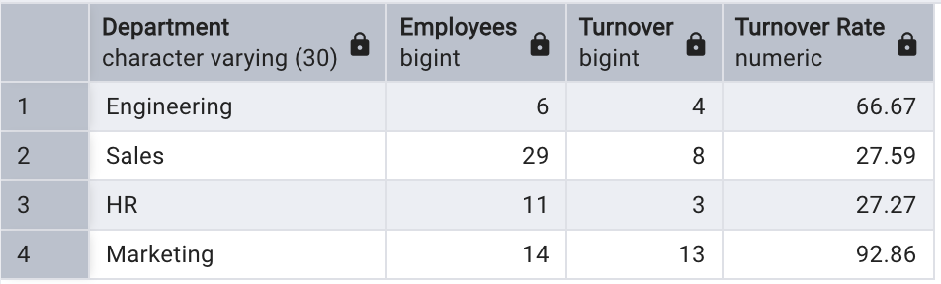

3. Which employees are at risk of leaving based on their performance?
(a) Employees with Lowest 10 Performance Score
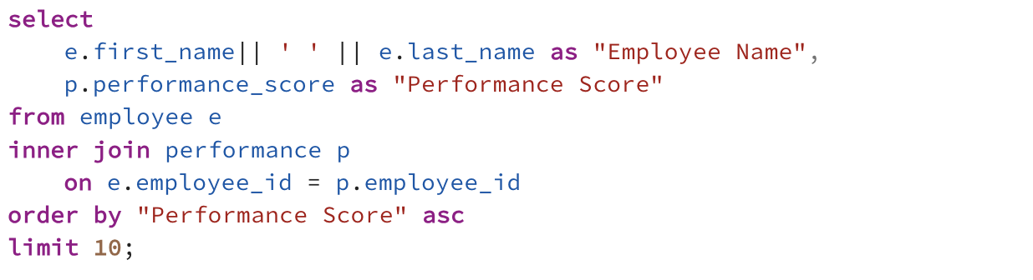
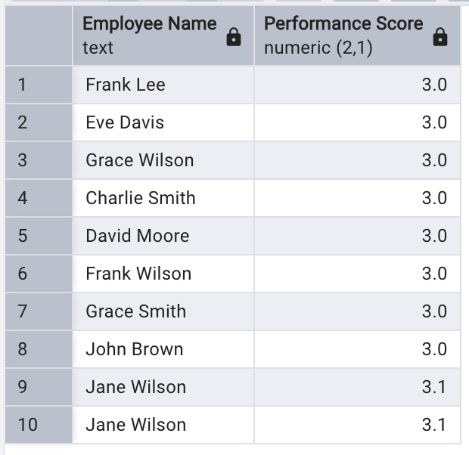
(b) Employees with Lowest 10 Average Performance Score

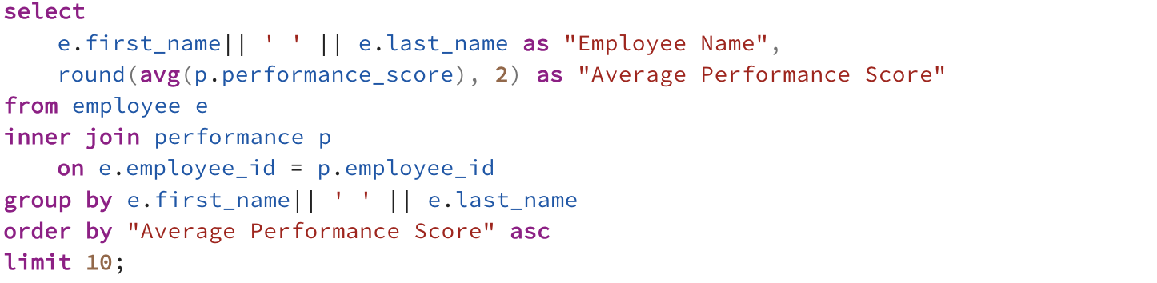
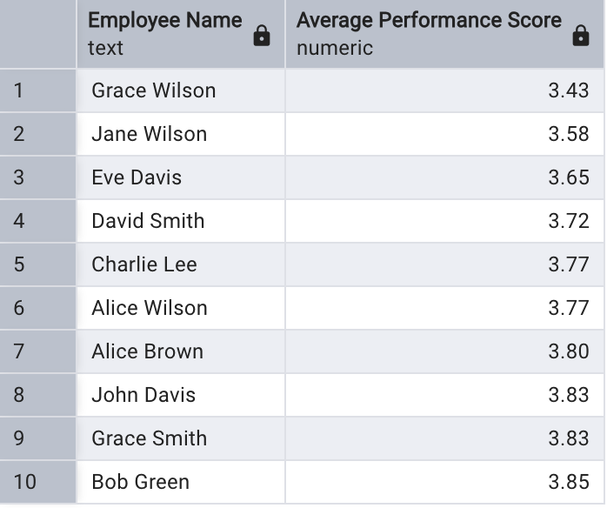

4. What are the main reasons employees are leaving the company?
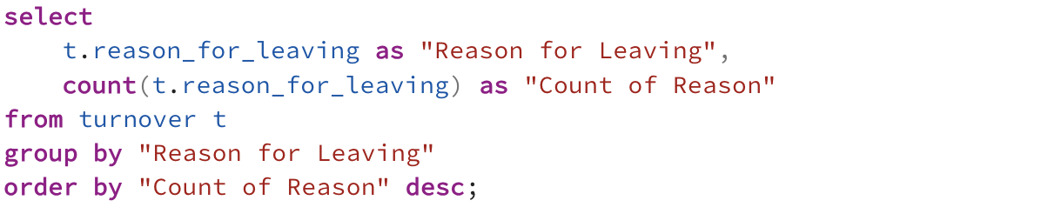
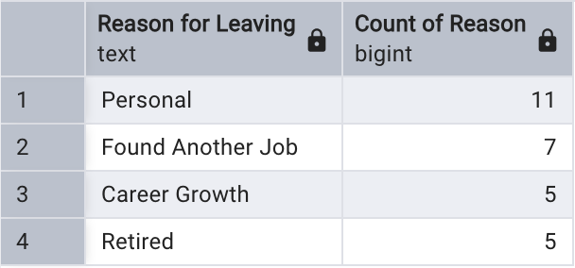

B. Evaluating employee performance across different departments and identifying areas where performance can be improved.

5. How many employees has left the company? (a) Company-wide
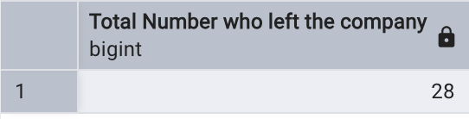
(b) By Department
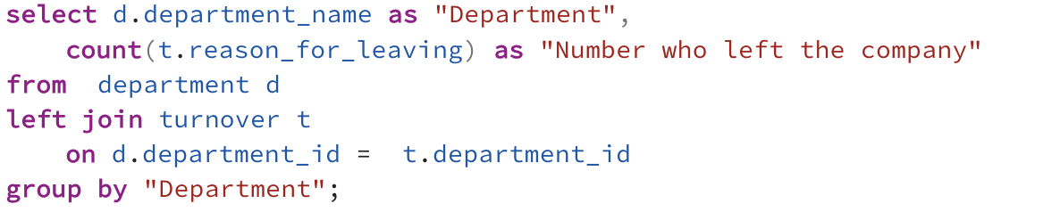
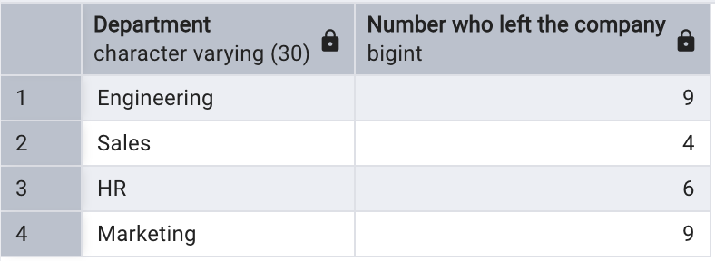
6a. How many employees have a performance score of 5.0?
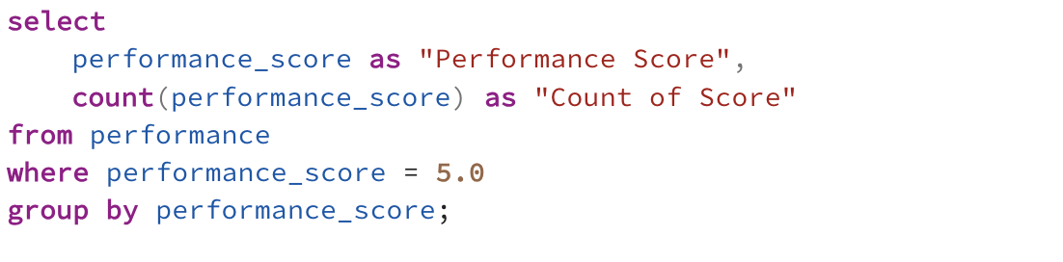
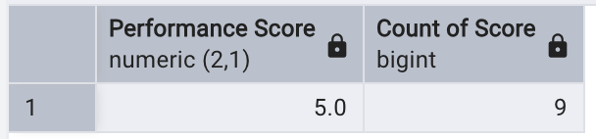
6b. How many employees have a performance score of below 3.5? (i) Company-wide
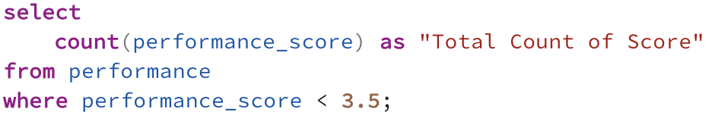
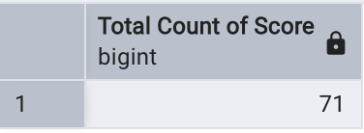
(ii) By Low Performance Score

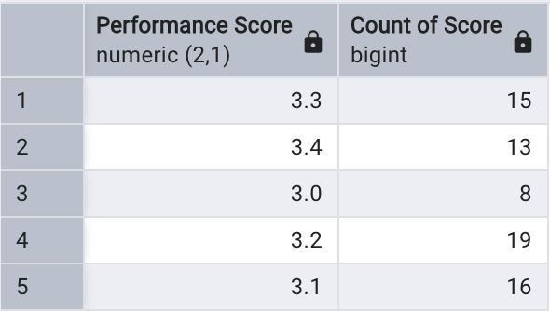

7a. Which department has the most employees with a performance score of 5.0?
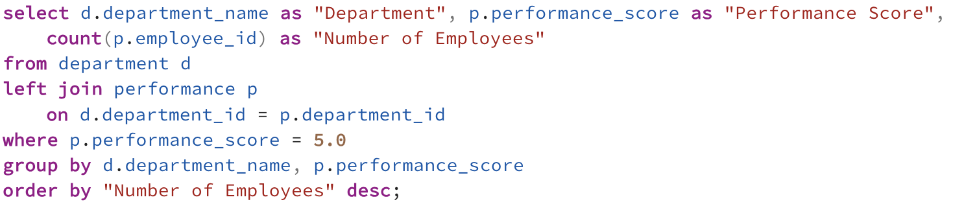
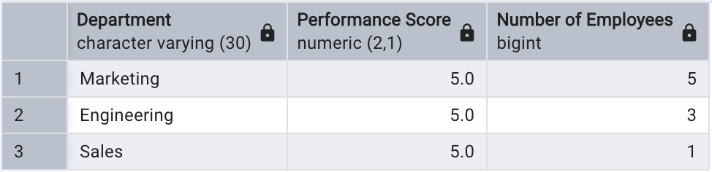
7b. Which department has the most employees with a performance score below 3.5?
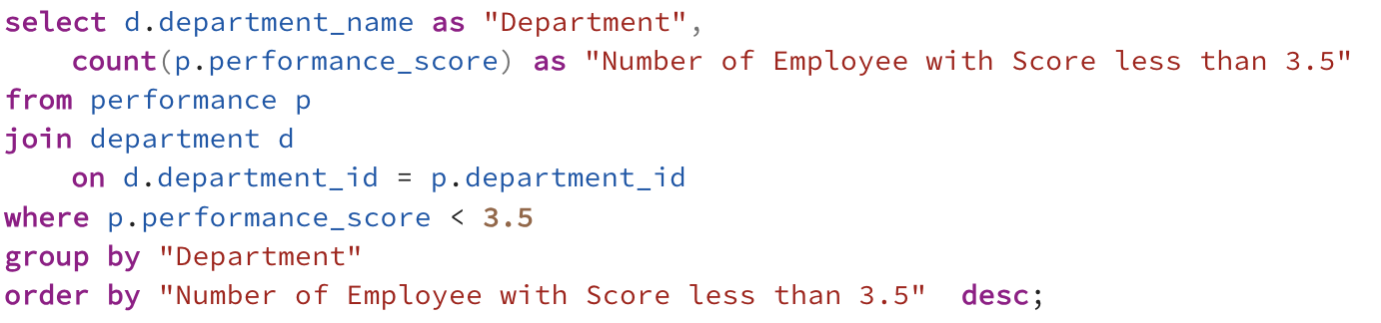
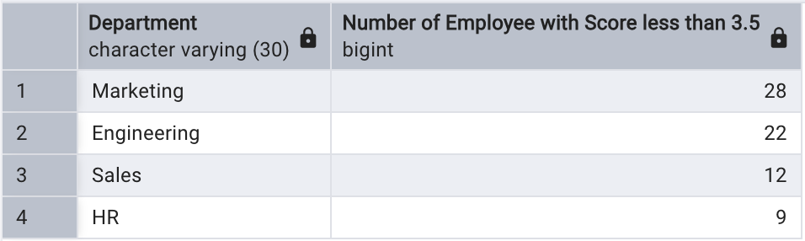

8. What is the average performance score by department?
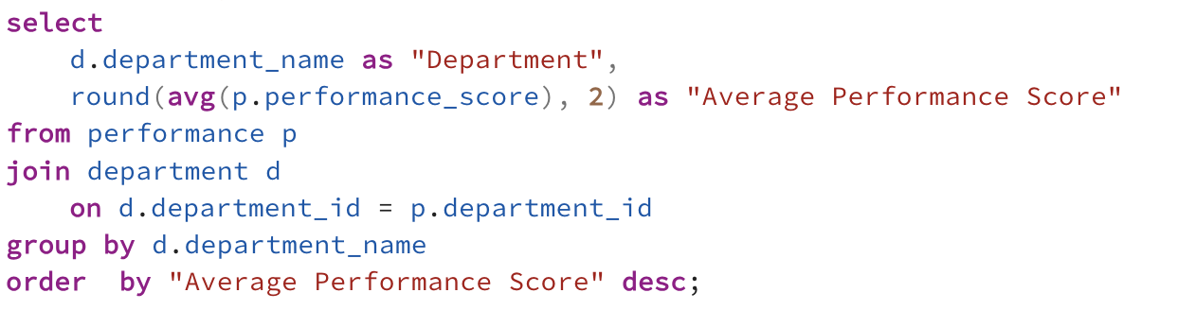
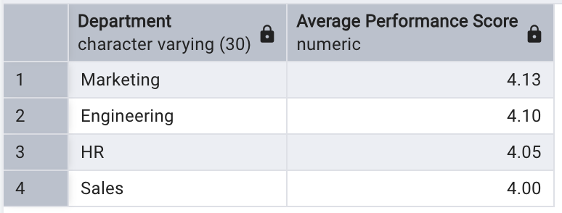

C. Analyze salary distribution and ensure fair compensation based on performance and
departmental benchmarks.
9. What is the total salary expense for the company?

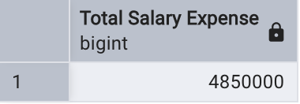

10. What is the average salary by job title?
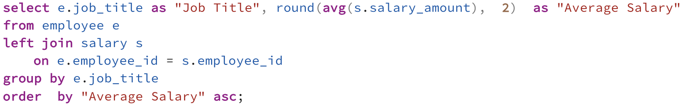
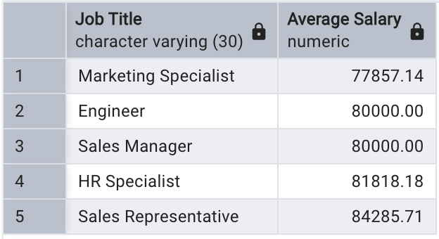

11. How many employees earn above 80,000? (a) Company-wide
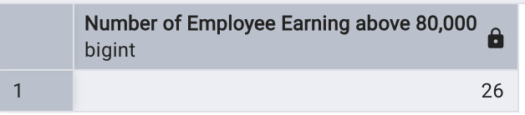

(b) By Department
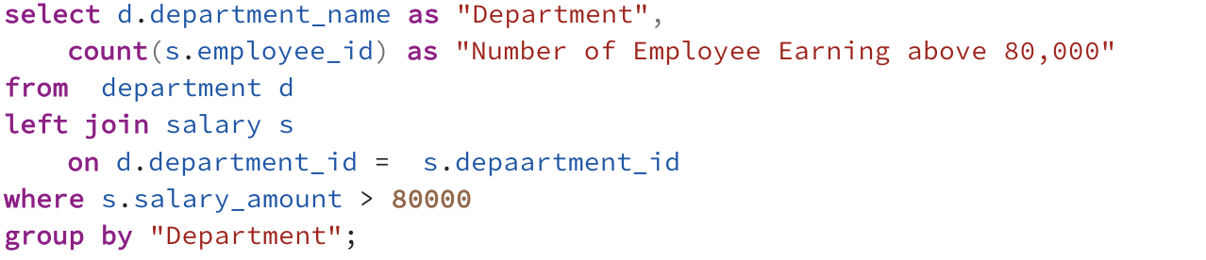
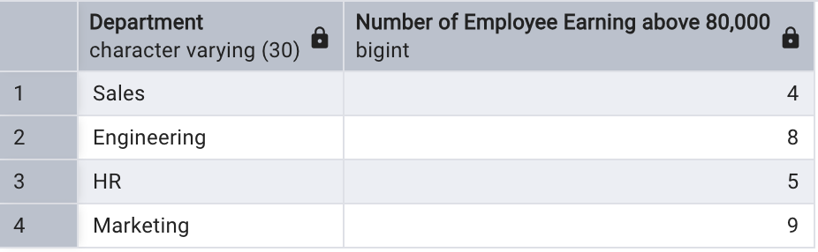
(c) By Job Title
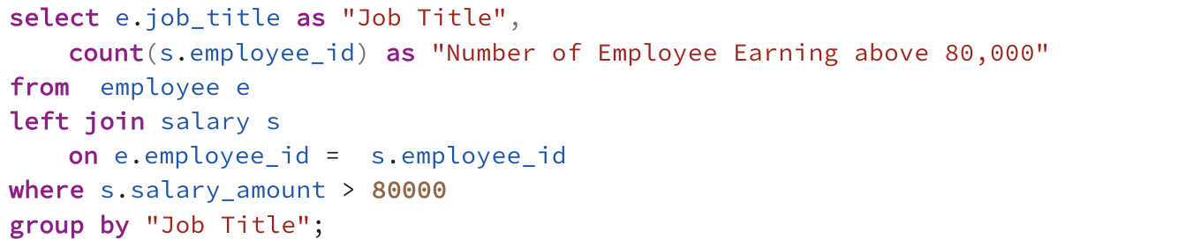
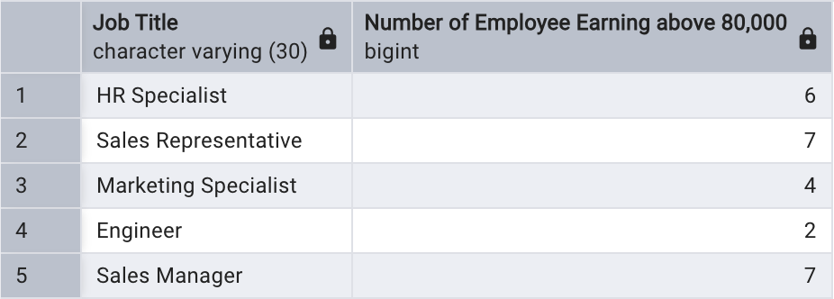

12. How does performance correlate with salary across departments?
(a) For the lowest Salary Amount of 60,000 by Employee Name.
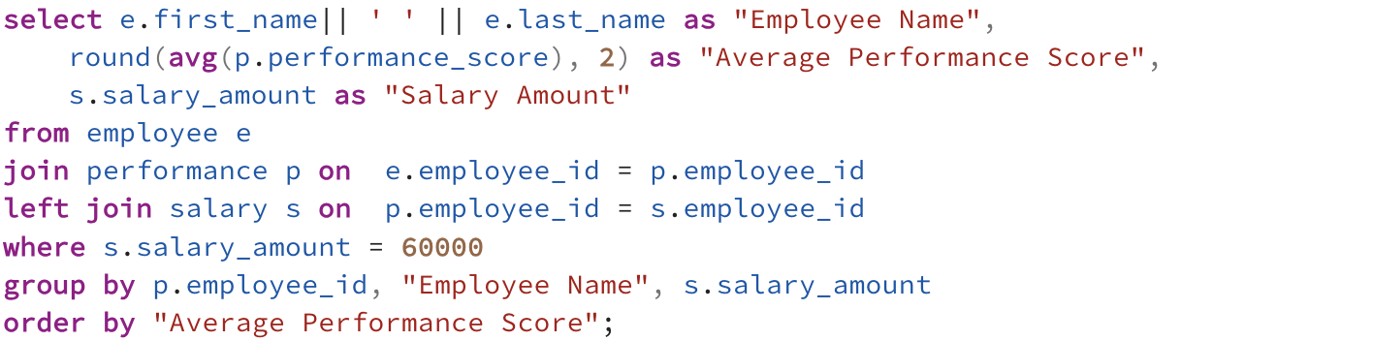
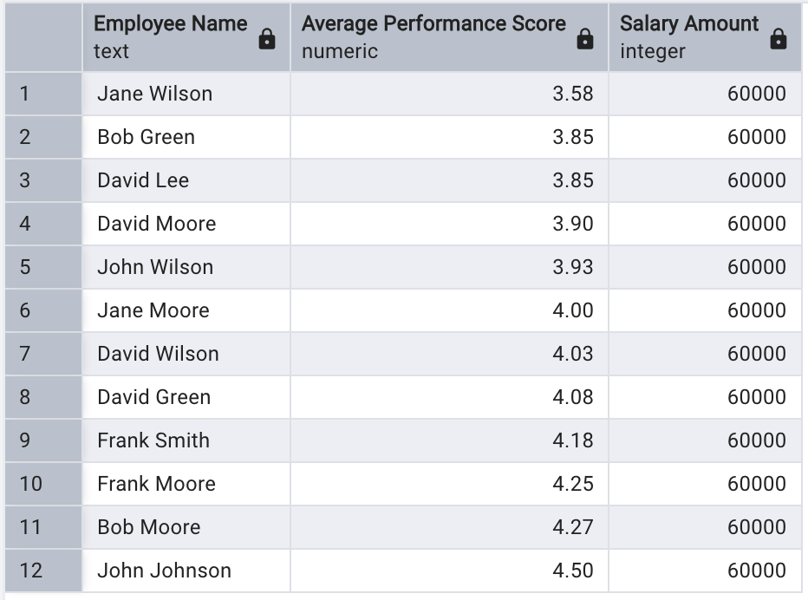
(b) For the highest Salary Amount of 100,000 by Employee Name.
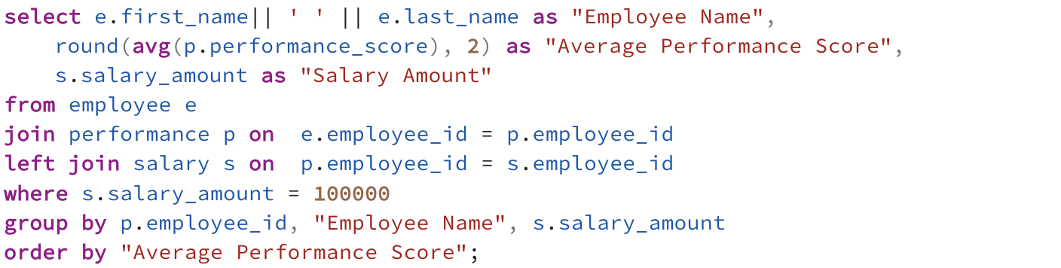
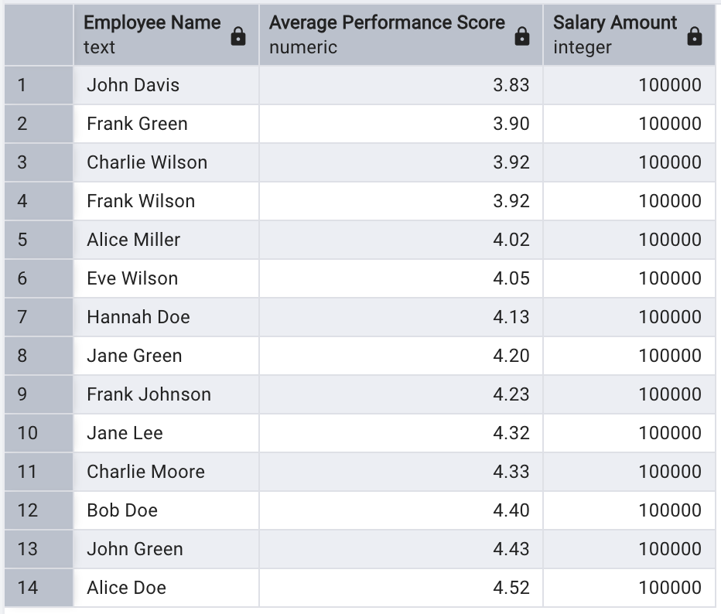
(c) For the lowest Salary Amount of 60,000 by Department.
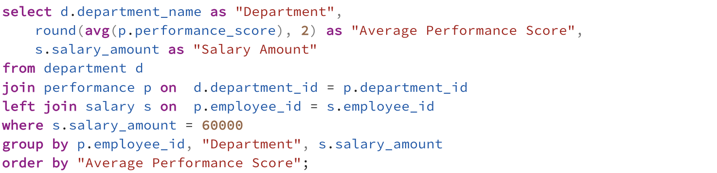
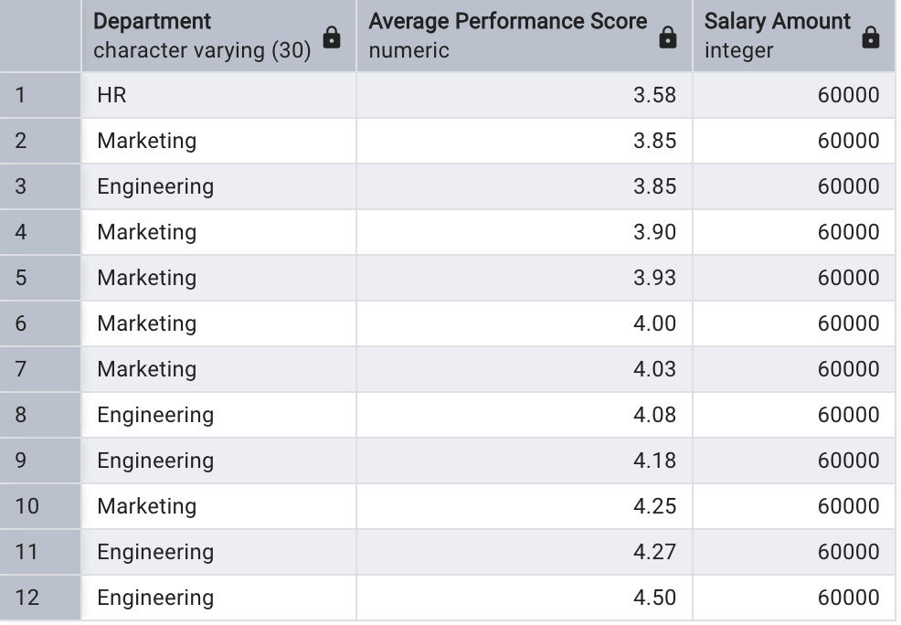
(c) For the highest Salary Amount of 100,000 by Department.
