MINI PROJECT 2

Performance Report
Adaptive Super-Sampling and Multi-Threading Evaluation
Key Performance Result
Rendering time reduced from 250.851 seconds to 23.552 seconds.
Measured Adaptive Super-Sampling speedup: 10.65x.

1. Goal
The goal of this mini-project was to improve the rendering performance of the ray tracer.
The implemented acceleration feature is Adaptive Super-Sampling (ASS).
It is used to optimize the ray beams created for the glossy reflection and diffuse glass effects from Mini-Project 1.
The project also includes multi-threading support, so the scene was rendered in four different modes:
1. No multi-threading, no ASS.
2. With multi-threading, no ASS.
3. No multi-threading, with ASS.
4. With multi-threading, with ASS.

2. Test Scene
The same scene was used for all four measurements.
The scene includes:
- Several dozen geometries.
- At least 5 light sources.
- Shadows.
- Reflection.
- Transparency.
- Glossy reflection and diffuse glass from Mini-Project 1.
- The same camera, resolution, materials, lights, and geometry in all runs.
This ensures that the performance comparison is fair.

3. Adaptive Super-Sampling Explanation
Without ASS, the renderer traces a full grid of rays for every glossy or diffuse beam.
For example, a 7x7 grid requires 49 rays for each beam.
With Adaptive Super-Sampling, the renderer does not always calculate the full grid.
The algorithm works as follows:
1. Sample the four corners of the target area.
2. Compare the colors.
3. If the colors are similar, stop and return their average.
4. If the colors are different, split the area into four smaller areas.
5. Repeat the process recursively.
6. Use a cache so that shared sample points are not calculated more than once.
This reduces the number of rays in smooth areas, while still using more samples where the color changes.

4. Measurements
Image | Multi-threading | ASS | Runtime
A | Off | Off | 250.851 seconds
B | On | Off | 248.804 seconds
C | Off | On | 23.552 seconds
D | On | On | 29.763 seconds
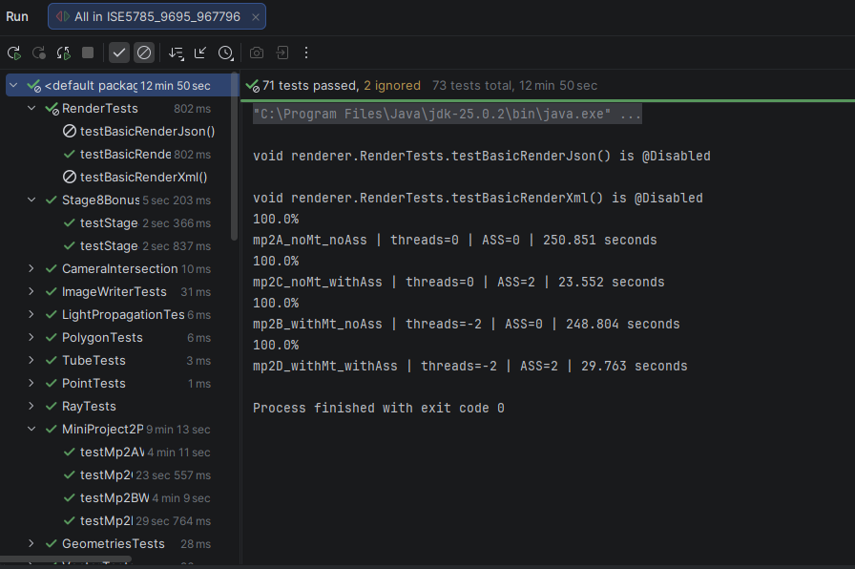
Figure 1. Test execution output showing the four measured rendering modes.

5. Speedup Calculation

Multi-threading Speedup
Calculation
Speedup = A / B
Speedup = 250.851 / 248.804
Speedup = 1.01x

Multi-threading alone gave almost no improvement in this specific run.

ASS Speedup
Calculation
Speedup = A / C
Speedup = 250.851 / 23.552
Speedup = 10.65x

Adaptive Super-Sampling improved the runtime by about 10.65x.

Total Speedup
Calculation
Speedup = A / D
Speedup = 250.851 / 29.763
Speedup = 8.43x

With both multi-threading and ASS enabled, the total speedup was about 8.43x.

6. Results
The most important result is the comparison between image A and image C.
Without ASS | With ASS
250.851 seconds | 23.552 seconds
Measured ASS speedup: 10.65x
This proves that the Adaptive Super-Sampling algorithm significantly reduces render time while keeping the Mini-Project 1 glossy/diffuse effects active.
This matches the expected improvement for Adaptive Super-Sampling.

7. Conclusion
Adaptive Super-Sampling successfully improved the renderer performance.
The algorithm reduced unnecessary ray calculations by adaptively sampling only the areas that required more detail.
The cache also prevented duplicate calculations of shared sample points.
The final result shows that ASS reduced the rendering time from 250.851 seconds to 23.552 seconds, giving a speedup of about 10.65x.
Final Result
Baseline runtime: 250.851 seconds
ASS runtime: 23.552 seconds
Performance improvement: 10.65x

