**INSTALLING R and R Studio your computer**

**INTRODUCTION**

R and R Studio are separate software environments. R is offers a programming platform for scientific computing and graphic, whereas RStudio is an integrated development environment (IDE) or an add-on that allows users to run R in a more user-friendly environment.

RStudio in itself is not very useful without R. On the contrarily, you can use R without RStudio by using any text editor (for example, notepad, Emacs, vi) to write your scripts. As an IDE, RStudio makes it easier to write, run and debug R programs, especially for beginners. For this course it is highly recommend to installation of both R and Rstudio.

**\*\*\* Note**: You will need to install R first before installation RStudio.

The following instructions for installing R and R Studio should work for both **Windows** and **MAC** users.

**INSTALLING R**

* Point your browser to: <http://www.r-project.org/>.
* From the “*Getting Started*” section, click on “[download R](http://cran.r-project.org/mirrors.html)”.
* Scroll down to the end of the page and click on the closest CRAN mirror site.

Recommended CRAN site: <http://iis.stat.wright.edu/CRAN/> Wright State University, Dayton, OH.

* From the “*Download and Install R*” section, click on the link that corresponds to the operating system (OS) of your computer.

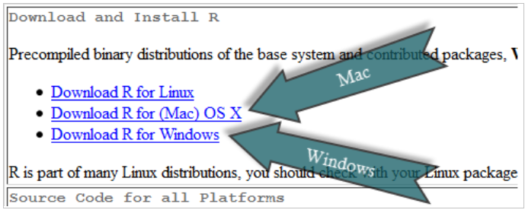That is:

* Click on “[**install R for the first time**](http://iis.stat.wright.edu/CRAN/bin/windows/base/)” (under base)

*You may need to save the file installation file (e.g., “R-3.3.1-win.exe”) and then click on it to start the installation process.*

When the dialog box opens, click “Yes”, “OK”, or “RUN.” The setup wizard should appear. Keep clicking “Next” (or change features **if you understand them**), until it is finished. You should now see the R icon ( ) on your desktop.

This completes the installation of base R on your computer. The next task is to install RStudio.

**INSTALLING R STUDIO PREVIEW**

**\*\*\* Note**: You must install R before you install RStudio Preview version!

A “**preview**” version of RStudio is available for both Windows and Mac users. Similar the Mathematica and other software that makes use of “Notebooks”, the output from an “R Markdown code chunk” is displayed immediately after the code chunk instead of the console. This cool feature is just one of the many features which will be useful to the ECOG-314 class. Curious users can read about the additional features at <http://rmarkdown.rstudio.com/r_notebooks.html>.

**How to download, install and use RStudio Preview**

1 of 6: Point your browser to: <https://www.rstudio.com/products/rstudio/download/preview/>

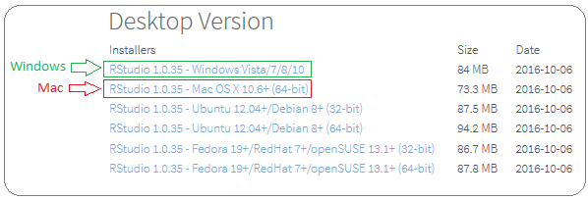2 of 6: Download and install the version that corresponds to the operating system of your computer. For example:

3 of 6: Click on the downloaded installation file to start the installation process. Then click on “Next” when the dialog box opens.

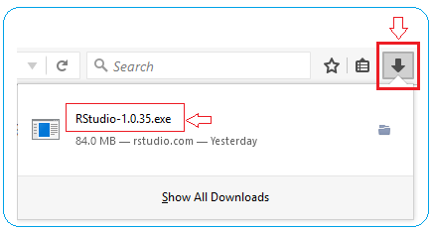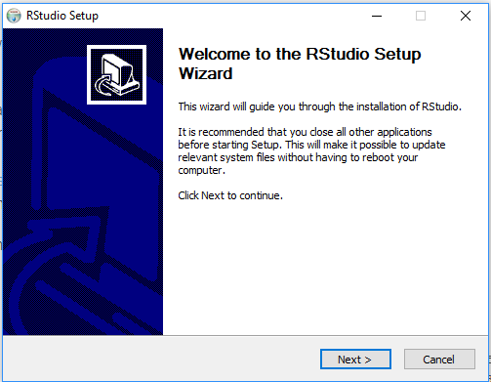

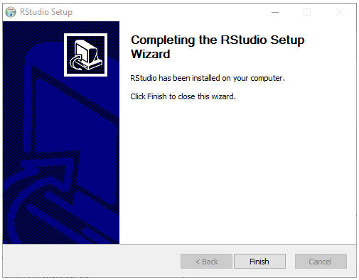4 of 6: Keep clicking on “Next” and finally “Finish” to complete the installation process.

5 of 6: Start RStudio

For Windows users, if you do not see the RStudio shortcut on your screen, click on:

“My Computer”, “C”-drive, “Program Files”, “RStudio”, “bin”, “rstudio.exe”

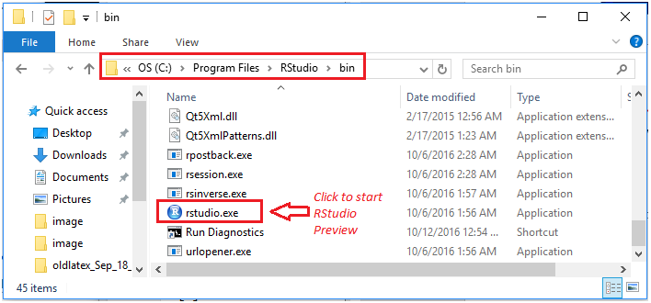 For example:

*** Note: Unlike the installation of R, RStudio installation may not create an icon on your desktop. You can still access you through your search or Windows button.

RStudio’s command icon is

6 of 6: Type the text and numbers shown below in you RStudio console window as shown in figure below:

# Welcome to Ecog314, Spring 2017

# 1: simple calculation

(12 - 6 )/ 2 + sqrt(4)

# 2: Define a vector or numbers 1 through 5 and then find the mean

# and standard deviation

x = 1:5

m_x = mean(x)

sd_x = sqrt(var(x))

Click on line 4 (as shown by the first red right arrow)

Then click on the “**Run**” (red up arrow).

The results will be displayed in the RStudio “Console” window (red down arrow)

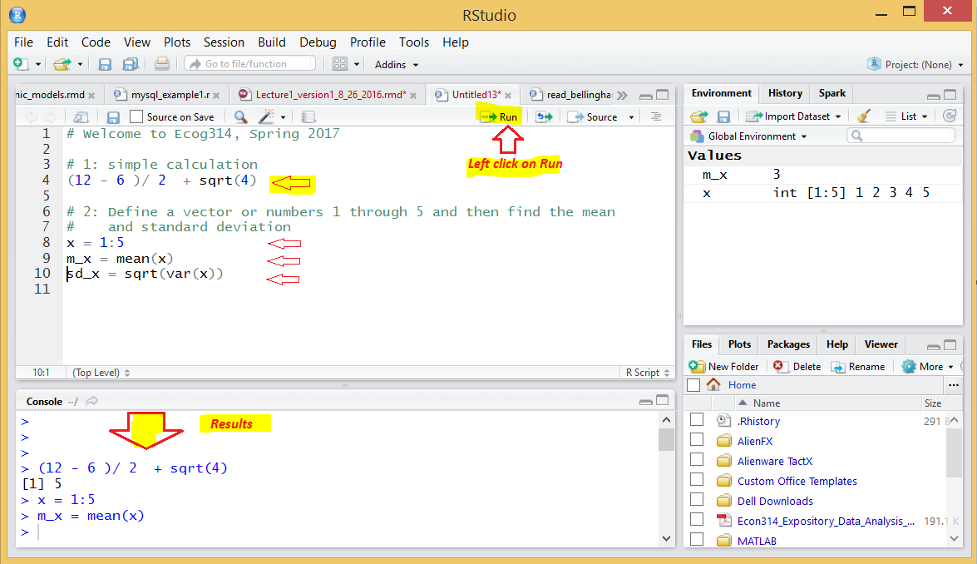

*** Note: If you see the above screen, you’re ready to go!

**HOW TO EXIT R AND RSTUDIO SESSIONS**

You can exit both R and RStudio at the same time using File → Quit R Studio

Or you can type q() at the command prompt.

Note that this is the letter q followed by open and closed parentheses.