PCRA Engineering Process for System and Design FMEA

Professional Commercial Radio & Accessories

Revision History

Version | Date Last Submitted | Authored / Revised By | Document Owner | Description of Changes
0.1 | NA | Joe Sepeczi | Joe Sepeczi | Original draft
0.2 | NA | Joe Sepeczi | Joe Sepeczi | Updates
.04 | NA | Joe Sepeczi | Joe Sepeczi | Updates from the FTR.

Approvals
For major revisions, this document must be reviewed though an FTR by selected representation of HW and SW teams (Accessory, Energy, Radio, Quality, and Management). Representation should include Electrical and Mechanical.
The author can make minor revisions without approval if it does not affect content. Examples of minor revisions include revisions due to grammar, spelling, formatting, or other changes that do not impact the intent of the document.
Reference Documents
Document Number | Document Description
n/a | PCR&A Governance Model http://compass.mot.com/doc/277301406/PCR_DFSS_Governance_Model.xls)
 | PCR&A Critical Parameter Process Doc (TBD

Abbreviations, Acronyms, and Definitions
DOC | Document
EE | Electrical Engineering
HEPG | Hardware Engineering Process Group – A process body, represented by all HW Engineering organizations within PCRA. The purpose of the HEPG is to govern all HW Processes within all PCRA.
HW | Hardware Engineering
ME | Mechanical Engineering
N&E | Networks & Enterprise
PCRA | Professional Commercial Radio and Accessories – This organization is primarily responsible for developing 2-way radio and accessories for Motorola’s indirect market segment. The Energy team, a part of this organization, also provides products for Motorola 2-way radios developed for the direct market segment.
SW | Software Engineering
TOC | Table of Contents
DDW | Drill Deep and Wide
CPI | Continuous Process Improvement
SR | Submission Record
CR | Change Record
SEPG | Software Engineering Process Group
PMPG | Program Management Process Group
PG | Process Group

Table of Contents
Table of Contents 3
1. Document Information 5
1.1. Document Purpose 5
1.1.1. Description 5
1.1.2. Records 5
1.2. Process Overview 6
1.2.1. Planning (M13-M11) 6
1.2.2. Scope (M13-M11) the following is what should be considered when deciding what to perform FMEA’s on. 6
1.2.3. Execution (M11-M5) 7
1.2.4. Tracking and Reviews (M11-M5) 7
1.2.5. Effectiveness Measures 8
1.2.6. Implementation 8
2. Appendix 9
2.1.1. RPN Guidelines 9

Document Information

Document Purpose
This document defines the PCR and Accessories process for system and design FMEA. From here on out, the term FMEA will be used and it will cover both types. The governance portion of the document focuses on new product development. The FMEA tool can also be used outside of the new product development phase to identify and mitigate hidden risks in any type of product or service. In this case, all the sections such as forming the right team, figuring out the right scope, following the 12step process, etc. are still applicable but might need to be slightly modified to fit the particular situation (consult your local black belt).

Description
Failure modes and effects analysis (FMEA) is a step-by-step approach for identifying possible failures in a design, a manufacturing or assembly process, or a product or service. The purpose of the FMEA is to take actions to eliminate or reduce failures, starting with the highest-priority ones. The purpose of this document is to describe the FMEA process and governance of this process in PCR&A including the four design centers of Schaumburg, Penang, Chengdu, and Lawrenceville.

Records
All records to be generated in the accomplishment of the tasks defined in the document should be listed in this section. If there are no records generated from the process “None” can be entered in the table.
Where appropriate the procedure should address how records are identified, collected, indexed, accessed, filed, stored and maintained after the retention period.

Record | Location | Retained For | Maintained By
Reference Material | HEPG PAL | As long as the item is needed for continuing business use (review annually to verify continuing value) | HEPG

Process Overview

Planning (M13-M11)

Team Formation

A cross Functional Team of People with diverse knowledge about the development process, product being designed, and customer needs. This team should have representatives from Mechanical, Electrical, System, Software and MOL in the areas of architecture, design and test.

The CP owner worksheet of the PCR&A governance model should be used as a guide to building a cross functional team. This lists the owners of the specific FMEA’s for the project. The General R&R Definitions worksheet of the PCR&A governance model outlines the roles and responsibilities.

Resource Planning

The DFSS Alignment to project worksheet in the PCR&A Governance Model should be used as a guideline for the timing of the FMEA activities in reference to the MGates of the project.

The DFMEA work should be treated just as any other program deliverable with committed staff to work on the DFMEA from start to completion.

Milestone Creation

The DFMEA work should be treated just as any other program deliverable with milestones in the overall PPM schedule. The following link provides an overview of what is expected: http://compass.mot.com/doc/285849058/PCRAPMOTraining.ppt#321,22,Part 2. FMEA owners should work with their Black Belts and Program managers to get the FMEA milestones and dates into their PPM schedule. For specifics, please see the details in the PPM schedule template.

Scope (M13-M11) the following is what should be considered when deciding what to perform FMEA’s on.

General Guidelines

A product with new functionality is being designed or redesigned

A product is being developed on a new platform (or major components/IC being changed).

An existing product is being applied in a new way.

Improvement goals are planned for an existing product (including cost reductions).

Guidelines for identifying the specific FMEA focus areas

SME/SLT knowledge on current risk areas in the design. This includes an analysis of all the new and/or changed components of this design.

Review Historical issues repository (CQCM, FRB, lessons learned, DDW, Customer Survey, Warranty, Field Return data, FMEA data) of similar products already developed.

Output of the critical parameter identification process for the program.

Execution (M11-M5)

The following 12 Step process outlined in the Motorola University CIC 3151 training is the core process that PCR&A will use for executing DFMEA’s (page 106 of http://compass.mot.com/doc/318986531/CIC3251ENIG_Instructor_Guide_Design_FMEA.pdf).

List function

List Potential Failure Modes

List Potential Effects

Assign Severity rating

List Potential Causes

Assign Occurrence

List Current Controls (The detection control should be determined by the test team).

Assign detection rating

Calculate RPN (risk priority number)

Use RPN’s to help decide on high priority failure modes

Take action to reduce or eliminate the risk associated with high priority failure modes. The action should have a definitive owner, action, date, and a validation that the action had the desired effect.

Re-compute RPN to reflect impact of action taken on failure mode. The results of the action should be reviewed by the team and a decision should be made whether further action is required.

Tracking and Reviews (M11-M5)

The FMEA milestones will be reviewed along with all other program milestones at the MOC monthly meetings, core team meetings and/or the quality reviews (http://compass.mot.com/doc/230958251/Standard_MOC_presentation_slides.ppt#301,12,Matrix 1.5 DFSS Milestones). The FMEA owner is responsible for reporting status unless there is an agreement that another person will report the status.

FMEA reports are what should be used for tracking the status. The Status should be reviewed at design reviews and internal quality reviews with managers and quality representatives. The goal is for the entire team to understand the DFMEA risks, mitigation plans, and risks not being mitigated (an example of this can be found at http://compass.mot.com/go/318753882).

An alternative method of tracking high risk items is with the creation of an SR. This is recommended if the program doesn’t have a forum such as quality reviews to review the FMEA data.

The following information should be reviewed by the team during review meetings: high risk failure modes, root cause, effect on the customer, recommended actions and goals, owner, and dates for completion. It is recommended that the “all FM’s with actions” Relex report be used for summarizing the FMEA status.. This report allows the report generator to list an RPN threshold to report a summary on (PCR&A recommended guideline is to report and review either the top 20% risks or any risk with RPN above 80).

Relex is the common repository for storing all of the PCR&A FMEA work. Having a common repository facilitates sharing and reuse in an organization. Guidelines for DFMEA’s data entry into Relex, reusing data from past products, and reporting are found at http://compass.mot.com/doc/293657567/Relex_hands_on_training.ppt.

The product FMEA is a living document throughout the product lifecycle until M2 but active work (tracking and reviews) continue until the team, management, and quality agree that the risks have been mitigated down to an acceptable level. A decision should be made and documented on any risks that weren’t mitigated to an appropriate level by the entire team.

Effectiveness Measures

It is recommended to review the following list of items at M3 to assess the effectiveness of the FMEA. This may be at the lessons learned meeting or a special final FMEA review. Information such as this can help us understand whether there are opportunities for FMEA process improvement based on the issues that manifested themselves. The Black Belt should facilitate this process.

Failure Modes identified but resulted in defects found during test (mitigation ineffectiveness metric)

Failure Modes identified and resulted in no defects found during test (mitigation effectiveness metric)

Failure Modes missed but defects found during test (identification ineffectiveness metric).

Implementation

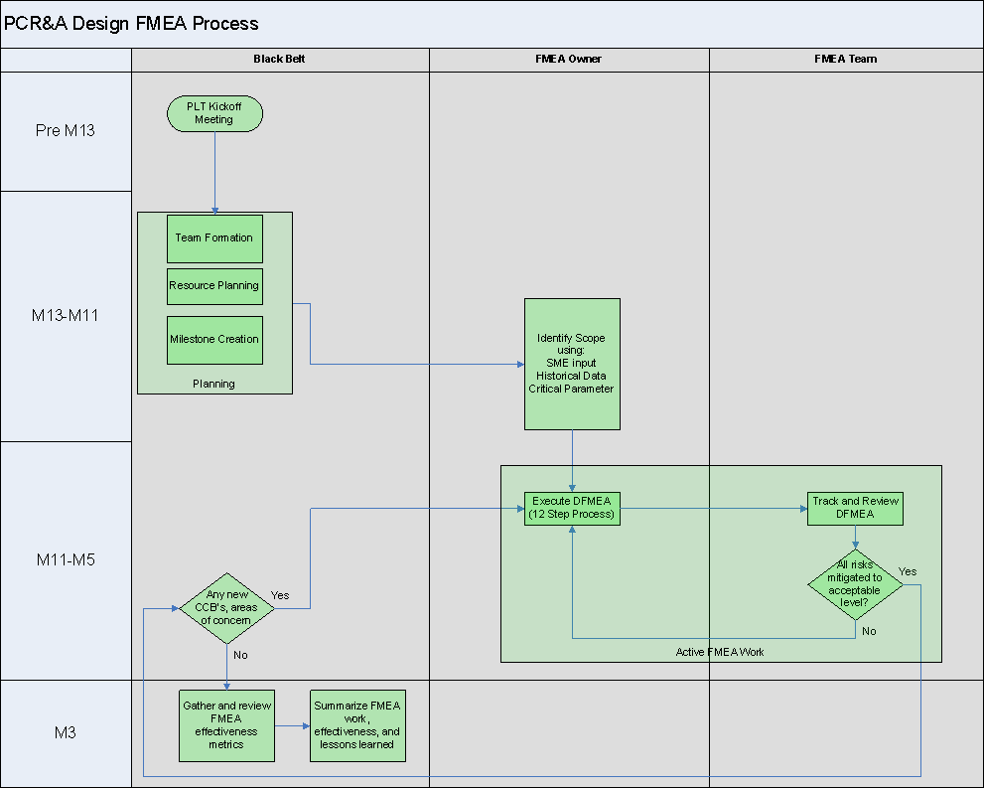

Appendix

RPN Guidelines

Table 1 Design FMEA - Occurrence (O)

Probability of Failure | Possible Failure Rates | Ranking
Very High: Failure is almost inevitable | = 1 in 2 | 10
 | 1 in 3 | 9
High: Repeated failure | 1 in 8 | 8
 | 1 in 20 | 7
Moderate: Occasional failures | 1 in 80 | 6
 | 1 in 400 | 5
 | 1 in 2,000 | 4
Low: Relatively few failure | 1 in 15,000 | 3
 | 1 in 150,000 | 2
Remote: Failure is unlikely | = 1 in 1,500,000 | 1

Table 2 Design FMEA - Severity (S)

Effect | Criteria: Severity of Effect | Ranking
Hazardous- without warning | Very high severity ranking when a potential failure mode affects product operation and/or involves noncompliance with government regulation without warning. | 10
Hazardous with warning | Very high severity ranking when a potential failure mode affects safe product operation and/or involves noncompliance with government regulation with warning | 9
Very High | Product/item inoperable, with loss of primary function. | 8
High | Product/item operable, but at reduced level of performance. Customer dissatisfied. | 7
Moderate | Product/item operable, but Comfort/Convenience item(s) inoperable. Customer experiences discomfort. | 6
Low | Product/item operable, but Comfort/Convenience item(s) operable at reduced level of performance. Customer experiences some dissatisfaction. | 5
Very Low | Fit & Finish/squeak & Rattle item does not conform. Defect noticed by most customers. | 4
Minor | Fit & Finish/squeak & Rattle item does not conform. Defect noticed by average customers. | 3
Very Minor | Fit & Finish/squeak & Rattle item does not conform. Defect noticed by discriminating customers. | 2
None | No Effects | 1

Table 3 Design FMEA – Prevention/Detection (D)

Detection | Criteria: Likelihood of Prevention/Detection by Design Control | Ranking
Absolute Uncertainty | Design Control will not and/or can not prevent/detect a potential cause and subsequent failure mode until catastrophic occurred in the field; or there is no Design Control. | 10
Very Remote | Design Control will only prevent/detect a potential cause and subsequent failure mode in the field but before catastrophic occurring. | 9
Remote | Design Control will only prevent/detect a potential cause and subsequent failure mode after shipping out but before end customer/user receiving it | 8
Very Low | Low chance the Design Control will prevent/detect a potential cause and subsequent failure mode prior to shipping out the finished product. | 7
Low | High chance the Design Control will prevent/detect a potential cause and subsequent failure mode prior to shipping out the finished product. | 6
Moderate | Low chance the Design Control will prevent/detect a potential cause and subsequent failure mode prior to mass production. | 5
Moderately High | High chance the Design Control will prevent/detect a potential cause and subsequent failure mode prior to mass production. | 4
High | Low chance the Design Control will prevent/detect a potential cause and subsequent failure mode prior to design releasing. | 3
Very High | High chance the Design Control will prevent/detect a potential cause and subsequent failure mode prior to design releasing. | 2
Almost Certain | Design Control will almost certainly prevent/detect a potential cause and subsequent failure mode prior to engineering proto type. | 1

Table 4 Process FMEA - Occurrence (O)

Probability of Failure | Possible Failure Rates | Cpk | Ranking
Very High: Failure is almost inevitable | = 1 in 2 | < 0.33 | 10
 | 1 in 3 | = 0.33 | 9
High: Repeated failure | 1 in 8 | = 0.51 | 8
 | 1 in 20 | = 0.67 | 7
Moderate: Occasional failures | 1 in 80 | = 0.83 | 6
 | 1 in 400 | = 1.00 | 5
 | 1 in 2,000 | = 1.17 | 4
Low: Relatively few failure | 1 in 15,000 | = 1.33 | 3
 | 1 in 150,000 | = 1.50 | 2
Remote: Failure is unlikely | = 1 in 1,500,000 | = 1.67 | 1

Table 5 Process FMEA - Severity (S)

Effect | Criteria: Severity of Effect | Ranking
Hazardous- without warning | May endanger machine or assembly operator. Very high severity ranking when a potential failure mode affects safe product operation and/or involves noncompliance with government regulation. Failure will occur without warning. | 10
Hazardous with warning | May endanger machine or assembly operator. Very high severity ranking when a potential failure mode affects safe product operation and/or involves noncompliance with government regulation. Failure will occur with warning. | 9
Very High | Major disruption to production line. 100% of product may have to be scrapped. Product/item inoperable, loss of primary function. Customer very dissatisfied. | 8
High | Minor disruption to production line. Product may have to be sorted and a portion (less than 100%) scrapped. Product/item operable, but at a reduced level of performance. Customer dissatisfied. | 7
Moderate | Minor disruption to production line. A portion (less than 100%) of the product may have to be scrapped (no sorting). Product/item operable, but some Comfort/Convenience item(s) inoperable. Customer experiences some discomfort. | 6
Low | Minor disruption to production line. 100% of the product may have to be reworked. Product/item operable, but some Comfort/Convenience item(s) operable at reduced level of performance. Customer experiences some dissatisfaction. | 5
Very Low | Minor disruption to production line. The product may have to be sorted and a portion (less than 100%) reworked. Fit & Finish/Squeak & Rattle item does not conform. Defect noticed by most customers. | 4
Minor | Minor disruption to production line. A portion (less than 100%) of the product may have to be reworked on-line but out-of-station. Fit & Finish/Squeak & Rattle item does not conform. Defect noticed by average customers. | 3
Very Minor | Minor disruption to production line. A portion (less than 100%) of the product may have to be reworked on-line but in-station. Fit & Finish/Squeak & Rattle item does not conform. Defect noticed by discriminating customers. | 2
None | No Effects | 1

Table 6 Process FMEA - Detection (D)

Detection | Criteria: Likelihood of Detection by Process Control | Detection Reliability | Probability of Defect being shipped out | Ranking
Almost Impossible | No known control(s) available to detect failure mode | - | > 1/10 | 10
Very Remote | Very remote likelihood current control(s) will detect failure mode | at least 80% | 1/20 | 9
Remote | Remote likelihood current control(s) will detect failure mode | at least 85% | 1/50 | 8
Very Low | Very low likelihood current control(s) will detect failure mode | at least 90% | 1/100 | 7
Low | Low likelihood current control(s) will detect failure mode | at least 95% | 1/200 | 6
Moderate | Moderate likelihood current control(s) will detect failure mode | at least 98% | 1/500 | 5
Moderately High | Moderately high likelihood current control(s) will detect failure mode | at least 99% | 1/1,000 | 4
High | High likelihood current control(s) will detect failure mode | at least 99.5% | 1/2,000 | 3
Very High | Very high likelihood current control(s) will detect failure mode | at least 99.8% | 1/5,000 | 2
Almost Certain | Current control(s) almost certain to detect the failure mode. | at least 99.99% | 1/10,000 | 1

