

SOFTWARE DFMEA PROCESS DOCUMENT

Open Issues in this Version of the document

Element | Status* | Detail
 | Missing | The process to update the DFMEA in the subsequent MOL & SR releases is not identified at this point in time. The Process Champion will have to address this issue in long run.
 | Incomplete | There is a list of artifacts that will need to be updated to incorporate DFMEA. ECP ID 1221.
* “Missing”, “Incomplete”, “Complete” or “May Change”
Change History

Version | Date | Author | Description
01.00-D01 | 03-Aug-09 | Koutropoulos Nancy / Pang WooKong / Saw ChaiLing | Initial creation of SW DFMEA Process document. FTR ID 5421249609
 | 03-Aug-09 | Koutropoulos Nancy / Pang WooKong / Saw ChaiLing | Updates from the FTR.

Approvals

Name | Responsibilities | Department Name | Date | WebForm ID
Ooi Soo Min | SEPG lead
Aiyaroo Shalini | SQA Manager
Khow Teong Chin | TS PA Champion
Dr. Khoh Soo Beng | DFSS Champion

Table of Contents
1 Introduction 7
1.1 Purpose 7
1.2 Scope 7
1.3 Definitions, Acronyms and Abbreviations 7
1.4 References 8
2 Software DFMEA Process 9
2.1 Planning(M13-M11) 10
2.1.1 Team Formation 10
2.1.1.1 Roles and Responsibilities 10
2.1.1.2 Entry Criteria 10
2.1.1.3 Activities 10
2.1.1.4 Exit Criteria 10
2.1.1.5 Deliverables 10
2.1.2 Resource Planning 10
2.1.2.1 Roles and Responsibilities 10
2.1.2.2 Entry Criteria 10
2.1.2.3 Activities 10
2.1.2.4 Exit Criteria 10
2.1.2.5 Deliverables 10
2.2 Identify Potential Failure Modes to Input to DFMEA 12 Step Process (M13-M11) 11
2.2.1 Identify Potential Failure Modes from Failure Mode Worksheet 12
2.2.1.1 Roles and Responsibilities 12
2.2.1.2 Entry Criteria 12
2.2.1.3 Activities 12
2.2.1.4 Exit Criteria 12
2.2.1.5 Deliverables 12
2.2.2 Identify Potential Failure Modes from P-Diagram 12
2.2.2.1 Roles and Responsibilities 12
2.2.2.2 Entry Criteria 12
2.2.2.3 Activities 12
2.2.2.4 Exit Criteria 12
2.2.2.5 Deliverables 13
2.2.3 Identify Potential Risk Areas from Hierarchical Breakdown 13
2.2.3.1 Roles and Responsibilities 13
2.2.3.2 Entry Criteria 13
2.2.3.3 Activities 13
2.2.3.4 Exit Criteria 13
2.2.3.5 Deliverables 13
2.2.4 Gather historical data/input 13
2.2.4.1 Roles and Responsibilities 13
2.2.4.2 Entry Criteria 13
2.2.4.3 Activities 13
2.2.4.4 Exit Criteria 13
2.2.4.5 Deliverables 13
2.3 DFMEA 12 Step Process (M11-M7) 14
2.3.1 Roles and Responsibilities 14
2.3.2 Entry Criteria 14
2.3.2.1 Activities 14
2.3.2.2 Exit Criteria 15
2.3.2.3 Deliverables 15
2.4 Tracking/Verification (M11-M5) 15
2.4.1 Roles and Responsibilities 15
2.4.2 Entry Criteria 15
2.4.3 Activities 15
2.4.4 Exit Criteria 15
2.4.5 Deliverables 16
2.5 Measurement Metrics (M3) 16
2.5.1 Roles and Responsibilities 16
2.5.2 Entry Criteria 16
2.5.3 Activities 16
2.5.4 Exit Criteria 16
2.5.5 Deliverables 16
2.6 Lesson Learned (After SA) 16
2.6.1 Roles and Responsibilities 16
2.6.2 Entry Criteria 16
2.6.3 Activities 16
2.6.4 Exit Criteria 16
2.6.5 Deliverables 16
2.6.6 Fill Out Interaction Matrix 22
2.6.6.1 Roles and Responsibilities 22
2.6.6.2 Entry Criteria 22
2.6.6.3 Activities 22

2.6.6.3.1 Identify use case level scenarios 22

2.6.6.3.2 Identify desired functionality 23
2.6.6.4 Exit Criteria 23
2.6.6.5 Deliverables 23
2.6.7 Fill Out Interaction Matrix 24
2.6.7.1 Roles and Responsibilities 24
2.6.7.2 Entry Criteria 24
2.6.7.3 Activities 25

2.6.7.3.1 Identify component level changes and associated noise factors that might potentially impact the functionality of these components. 25

2.6.7.3.2 Identify desired functionality 25
2.6.7.4 Exit Criteria 25
2.6.7.5 Deliverables 25

Appendices
Appendix A Roles and Responsibilities 17
Appendix B Hierarchical Breakdown 18
Appendix C P-Diagram 20
Appendix D Interaction Matrix for System Level FMEA 22
Appendix E Interaction Matrix for Design Level FMEA 24
Appendix F Specification Worksheet 27
Appendix G Populate Failure Mode Worksheet 28
Appendix H Timing Diagram Examples 29
1. Scenario Planning Example: 29
2. Timing Diagram Example: 29
3. Issues Log Example: 29
Appendix I State Machine Example 31
Appendix J Tools to Discover Root Cause 32
Appendix K Measurement Charts and Tables 33

To insert Table of Figure, go to “Insert” → “Index and Tables” →select “Table of Figure” option → Click on “Options” → under the Style drop down list select “STD Appendix”→Click ok. There will be message pop up on “Do you want to replace Table of Figures” →Select ‘No”

Figures
Figure 2.1 : Software DFMEA Process Flow 9
Figure 2.2 : Potential Failure Modes Identification Process Flow 11

To insert Table of Figure, go to “Insert” → “Index and Tables” →select “Table of Figure” option → Click on “Options” → under the Style drop down list select “STD Figure”→Click ok. There will be message pop up on “Do you want to replace Table of Figures” →Select ‘No”

Tables
Table 1

To insert Table of Figure, go to “Insert” →”Reference”→ “Index and Tables” →select “Table of Figure” option → Click on “Options” → under the Style drop down list select “STD Table”→Click ok. There will be message pop up on “Do you want to replace Table of Figures” →Select ‘No”

Please highlight each of the table of content and right click, select “Update field” → “Update entire table” in order to update the table of content.
- Introduction
  - Purpose
The purpose of the document is to address the process to be followed for Software DFMEA activity. DFMEA should be considered to identify and mitigate risks on any New, Unique or difficult parts of our design. An analysis of issues in previous similar products should be considered to help determine what might be difficult in this product.

  - Scope
The scope of this document covers planning, execution/implementation, tracking, verification, measurement and post mortem of DFMEA activity. It describes process input, output, activities involved, roles and responsibilities for DFMEA executed in the Software organization.
*Assumption : Engineers have attended CIC 3151 DFMEA training.

  - Definitions, Acronyms and Abbreviations

CCB | Change Control Board. In this document, it refers to build CCB team. The members are build manager, architects and team representatives if needed.
CCM | Common Change Management
SCM | Software Configuration Management
SQA | Software Quality Assurance
IR | Integration Request
FTR | Formal Technical Review
SR | Submission Record
CR | Change Record
PPM | Primavera Project Management
BB | Black Belt

Interaction Matrix | Scenarios that are used to define desired functionality that is then input into the specification worksheet.
Specification Worksheet | Risk assessment for design error and impact for each functionality identified in the interaction matrix. The highest risk items are then transferred to the Failure Mode Worksheet.

  - References

- Documentation Standard, ZMY01-STD-2003A230, Version R01.01, http://compass.mot.com/go/124991070
- PCR&A Governance DFSS document template, Version R02.00
http://compass.mot.com/doc/277301406/PCR_DFSS_Governance_Model.xls
- ASTRO SASD DFMEA Practices http://compass.mot.com/doc/248577213/ASTRO_SASD_DFMEA_Practices.ppt
- Relex hands on training, http://compass.mot.com/doc/293657567/Relex_hands_on_training.ppt
- Motorola University CIC 3151 Design Failures Modes and Effects Analysis training
http://compass.mot.com/doc/318986531/CIC3251ENIG_Instructor_Guide_Design_FMEA.pdf
- Software Design Control
http://compass.mot.com/doc/272771704/Software_Design_Control.doc
- Product and Process Quality Assurance (PPQA) Audit Checklist
http://zmy12bd1.pen.comm.mot.com/sw_web/vobs/cmmi/document/PPQA/st_ppqa_audit_checklist.xls
- Post Mortem Template
http://zmy12bd1.pen.comm.mot.com/sw_web/vobs/cmmi/document/CAR/st_post_mortem.ppt
- Metrics Definition and Analysis
http://zmy12bd1.pen.comm.mot.com/sw_web/vobs/cmmi/document/MA/sg_measure_analysis.doc
- Software Project Management Plan Template
http://zmy12bd1.pen.comm.mot.com/sw_web/vobs/cmmi/document/PP/st_spmp.doc
- Relex Tool
http://il27web408/RelexiArchitect2008/

- Software DFMEA Process

Figure 2.1 : Software DFMEA Process Flow
Responsibility  Stages | PMO, Project Lead/DE Managers  Start | BB,Feature Lead, Feature Owner ,Architect, team members | Feature Lead, Feature Owner | Action Owner | Quality
M13-M11  Planning | Team Formation  Resource/  Schedule Planning
M13-M11  Preparation for SW DFMEA 12 Step Process |  | Identify potential failure modes to input into DFMEA 12 Step Process
M11-M5  DFMEA 12 Step Process | Yes | Req/Design changes?  No  DFMEA 12 Step Process
M11-M5  Tracking |  |  | Log issues in tracking tool & Capture tracking ID in DFMEA worksheet/standard repository |  | Track no. of action items. E.g. RPN >=100
M7-M5  Verification | RPN high | Is RPN high? E.g. > =100  Re-compute RPN. |  | Verify fixed issues
M3  Measurement Metrics |  | RPN low |  |  | Gather Measurement Data
After SA  Lesson Learned |  | End  Post Mortem
  - Planning(M13-M11)
    - Team Formation
      - Roles and Responsibilities
Please refer to Appendix A
      - Entry Criteria
- Feature owners and architects of the key features identified
      - Activities
- Assemble a cross-functional team of people with diverse knowledge about the process, product or service and customer needs. Key people often included are: BB, feature lead, feature owner, architects, box test lead, SIT test lead.
- Document in the governance template.
- Obtain and analyze the lesson learned input or historical data from previous projects that might be good input for implementing DFMEA.
      - Exit Criteria
- DFMEA team members names identified
- Governance doc updated
      - Deliverables
- DFMEA team members names documented in the governance document. Template is located at: http://compass.mot.com/go/pcrastandardtemplates.
    - Resource Planning
      - Roles and Responsibilities
- Please refer to Appendix A
      - Entry Criteria
- DFMEA team members involved
- PPM Schedule
      - Activities
- Estimate effort needed to work on DFMEA for feature lead, feature owner and feature architect. Need to determine the amount of time it will take to perform the following activities:
    - FMEA Analysis Complete
    - FMEA Action Plan Identified
    - FMEA Action Plan Complete
      - Exit Criteria
- Program schedule updated with DFMEA activities & effort. Black Belt needs to work with the Project Manager to ensure that the PPM schedule is updated appropriately
      - Deliverables
- M11 Resource Plan including FMEA activities.
  - Identify Potential Failure Modes to Input to DFMEA 12 Step Process (M13-M11)
Figure 2.2 : Potential Failure Modes Identification Process Flow
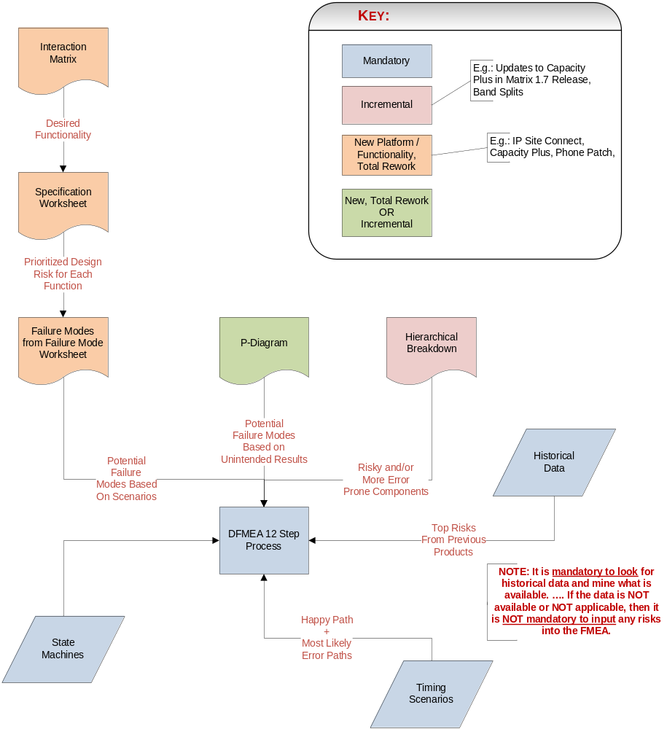
    - Identify Potential Failure Modes from Failure Mode Worksheet
      - Roles and Responsibilities
- Please refer to Appendix A
      - Entry Criteria
- Interaction Matrix
- Specification Worksheet
      - Activities
- Fill out Interaction Matrix. See Appendix D (system level) OR Appendix E (design level) for details on how to fill out an interaction matrix.
- Fill out Specification Worksheet. See Appendix F for details on how to fill out a specification worksheet.
- Fill out Failure Mode Worksheet. See Appendix G for details on how to fill out a failure mode worksheet.
      - Exit Criteria
- Interaction Matrix table, Specification Worksheet and Failure Mode Worksheet are updated.
      - Deliverables
- Potential failure modes.

    - Identify Potential Failure Modes from P-Diagram
      - Roles and Responsibilities
- Please refer to Appendix A
      - Entry Criteria
- Features / functionality that is new for this release.
      - Activities
- Generate P-diagram. Refer to Appendix C for sample of P-diagram.
- Ask the following key questions as you are populating P-diagram :
    - Unintended Results - > What are the potential failures. E.g. Radio does not key-up.
    - Noise Factors -> what is the root cause for each of the unintended results. E.g. what causes the Radio not to key-up?
    - Control Factors -> What are the current design prevention and detection methods that can contain/neutralize the root cause? E.g. what are the current design activities (prevention and detection) that can prevent and contain the root cause that causes the radio not to key-up?
      - Exit Criteria
- Noise factors identified.
- Unintended results identified.
- Control factors identified.
      - Deliverables
- P-Diagram

    - Identify Potential Risk Areas from Hierarchical Breakdown
      - Roles and Responsibilities
- Please refer to Appendix A
      - Entry Criteria
- Feature / functionality that is new for the release.
      - Activities
- Create a hierarchical breakdown of the modules that are changing. Refer to Appendix B for sample of hierarchical breakdown.
- Highlight the modules that are the most error prone.
      - Exit Criteria
- Hierarchical breakdown created.
      - Deliverables
- A list of the most error prone modules
- Hierarchical breakdown with highlighted modules of interest.
    - Gather historical data/input
      - Roles and Responsibilities
- Please refer to Appendix A
      - Entry Criteria
- Features/Areas/Scopes for DFMEA identified.
      - Activities
- Determine what historical product data could be useful.
- Determine the potential sources for this product data (FRB, CQCM, DDW, FMEA, lessons learned)
- Analyze the historical information that might be good input for DFMEA. .
*
      - Exit Criteria
- Historical data reviewed
- Input from relevant people obtained.
      - Deliverables
- Pareto chart of issues from previous products
- Top risks from previous products (Failure Modes, causes, actions)

  - DFMEA 12 Step Process (M11-M7)
    - Roles and Responsibilities
- Please refer to Appendix A.
    - Entry Criteria
- Failure modes identified from failure mode worksheet.
- Failure modes identified from p-diagram.
- Risky / error prone components.
- Top risks from previous programs.
- State Machines. See Appendix I for an example of Box Level State Machine. For component DFMEA, component state machine will be considered as input to DFMEA.
- Timing scenarios (happy path as well as most likely potential error paths). See Appendix H for examples.
      - Activities
- List Function
- Transfer the function from the failure mode worksheet, p-diagram or the list of risky / error prone components.
- List potential failure modes
- Transfer failure modes from inputs to the FMEA worksheet.
- Walk through the state machine and identify any potential failure modes. See Appendix I for examples.
- Brainstorm on any concerns that any participant has.
- Look at any failure modes associated with timing scenarios. See Appendix H for examples.
- List potential effects
- Ask, “What does the customer experience because of this failure? What happens when this failure occurs?”
- Assign severity rating
- List potential cause
- fishbone’s, 5 why’s etc. See Appendix J for examples.
- Assign occurrence rating
- List current controls
- Assign detection rating-
- Calculate Risk Priority Number (RPN)
- Use RPN’s to help decide on high-priority failure modes
- Take action to reduce or eliminate the risk associated with high-priority failure modes. (PCR&A recommended guideline is to report and review either the top 20% risks and/or any risk with RPN 100 or greater)
- Recommended guidelines on identifying action plan :
- Consider changing design, if not possible
- Consider doing code optimization, if not possible
- Consider developing new test cases to detect potential failure modes
- Re-compute RPN to reflect impact of action taken on failure mode. If the recommended actions are not good enough, repeat steps 11 and 12.
Note: Whenever there are design or requirement changes, the team needs to re-analyze the potential failure modes identified earlier and add new potential failure modes due to new design/requirement changes

      - Exit Criteria
- DFMEA 12 Step Process completed
      - Deliverables
- List of potential failure modes with high RPN (E.g. PCR&A recommended guideline is RPN > =100).
- Top 20% of potential failure modes in pareto chart.
- RPN identified
- Action items identified
- Action items assigned to owner
- Target completion date identified
  - Tracking/Verification (M11-M5)
    - Roles and Responsibilities
- Please refer to Appendix A.
    - Entry Criteria
- Action items are identified and available
- Action owners are identified and available.
- Target Completion Date is available.
    - Activities
- A standard tool that is allowing easy access to track and log issues that are related to design/software changes should be available. CQCM is such a tool where issues that involve design/software changes can be logged as SR in CQCM. When using CQCM, select ‘Issue’ as the SR type and use the SPCF(System,Product,Component,Functional area) that is used for fault logging. When submitting SR, please follow the format below for the header :
- [DFMEA] [Title]
- Update status and capture tracking ID of the issue(e.g SR#) in DFMEA worksheet. A standard repository that contains all the FMEA’s allowing easy access to review, share, and leverage this knowledge should be available. Relex is such a repository and is currently the one that PCR&A uses for all FMEA work. Relex tool is found at http://il27web408/RelexiArchitect2008/.

- Track number of action items/risks and the status in dashboard.(E.g. # Risks identified/Pending Validation/Closed). Metrics will be reviewed/monitored periodically during monthly quality review. Quality indicator/dashboard template is found at http://compass.mot.com/doc/291300538/Quality_Indicator_M11-M3_template(working).xls

- All issues need to be closed and verified by M5
    - Exit Criteria
- All action items that require changes to design are recommended to log in a tracking tool. An example of a tracking tool is CQCM.
- Status of the action items/risks are updated in a standard repository, e.g Relex.
- Total number of action items/risks and the status tracked in dashboard.
- SR(s) verified and closed.
    - Deliverables
- Action items with design changes in tracking tool.
- Status in Quality dashboard.
  - Measurement Metrics (M3)
    - Roles and Responsibilities
- Please refer to Appendix A.
    - Entry Criteria
- All action items or SR(s) are closed.
- All defects raised are available.
    - Activities
- Gather data for the list of metrics below for Post Mortem.
1) Failure Modes not identified & happen
2) Failure Modes identified & happen
3) Failure Modes identified & Not happen.
4) Percentage of RPN reduction.
- Please refer to Appendix K for samples.
    - Exit Criteria
- Charts and tables are updated for the metrics needed.
    - Deliverables
- Charts and tables
  - Lesson Learned (After SA)
    - Roles and Responsibilities
- Please refer to Appendix A
    - Entry Criteria
- Product is shipped.
    - Activities
- Conduct Post Mortem after shipping the product. DFMEA Post Mortem is integrated with Project Post Mortem.
- All team members need to be involved in the post mortem meeting
    - Exit Criteria
- All issues and suggestions to improve the process/design are identified and captured in Project Post Mortem slides. Post Mortem template is found at http://zmy12bd1.pen.comm.mot.com/sw_web/vobs/cmmi/document/CAR/st_post_mortem.ppt
    - Deliverables
- Lesson Learned.

- Roles and Responsibilities

Stages | Main Activity | Roles --> | System Level Black Belt | BB/  SDFSS Champion | Black Belt Mentor | Feature owner/ Feature Lead | Tech Arch/Dev | Action Owner | DE Mngr | PMO/  RM | Quality
 |  | Responsibilities
 |  | |
 |  | v
Planning | Team Formation | Assemble a cross-functional team of people to form DFMEA team |  |  |  |  |  |  | X | X
Planning | Resource Planning | Estimate effort needed for DFMEA and include the effort/resource in the planning schedule | X | X | X | X | X |  | X | X
Preparation for SW DFMEA 12 Step Process | Identify Potential Failure Modes to Input to DFMEA 12 Steps Process | Identify potential failure modes from Failure Mode worksheet/P-Diagram/Hierarchical Breakdown | X | X | X | X | X
Preparation for SW DFMEA 12 Step Process | Gather Historical Data | Review historical information that might be good input for DFMEA | X | X | X | X | X
DFMEA 12 Step Process | DFMEA 12 Step Process & Re-visit DFMEA | Perform DFMEA 12 Step Process and re-visit DFMEA when there are design/requirement changes | X | X | X | X | X
Tracking | Log issues as SR in CQCM | Ensure all action items that require design change are logged in CQCM | X | X |  | X |  | X
Tracking | Capture tracking ID(E.g. SR#) and input DFMEA updates in DFMEA worksheet/standard repository | Enter tracking ID (E.g.SR#) and updates in DFMEA worksheet./standard repository | X | X | X | X |  | X
Tracking | Track no. of action items and status | Update dashboard with no. of action items and the status. | X | X |  |  |  |  |  |  | X
Verification | Verify fixed issues | Ensure all fixed issues are verified. | X | X |  | X |  | X
Measurement Metrics | Gather measurement data | Obtain data and update charts to reflect the metrics tracked. | X | X |  |  |  |  |  |  | X
Lesson Learned | Post Mortem | To gather lesson leaned from all DFMEA team members | X | X | X | X | X | X | X | X | X
MISC | Status Reports to all stakeholders (internal / external) | Provide status to all stakeholders | X | X
MISC | Mentoring is provided per agreed plan | Mentor new BB/DFSS Champion | X | X | X
MISC | Keeps Compass up to date | Ensure the documents in compass are up-to-date. | X | X

This is a reference with more specific information on what activities and deliverables each given role has a level of ownership with. This is a general guideline that can be tailored per the specific project.

Bold X (Highlighted in grey) - overall owner. It’s the responsibility of the overall owner to ensure that the respective main activities are executed for closure.
X - engagement required in a partial ownership capacity
- Hierarchical Breakdown

System
Functionality
Sub-function
Sub-function
Sub-function
Sub-function
Sub-function
Sub-function
Sub-function
Sub-function
Sub-function
Sub-function
Sub-function
Sub-function
DFMEA
Scope
Interactions
Active
Noun-Verb
Pairs


System
Functionality
Sub-function
Sub-function
Sub-function
Sub-function
Sub-function
Sub-function
Sub-function
Sub-function
Few or no
dropped calls
Sub-function
Sub-function
Sub-function
Sub-function
DFMEA
Scope
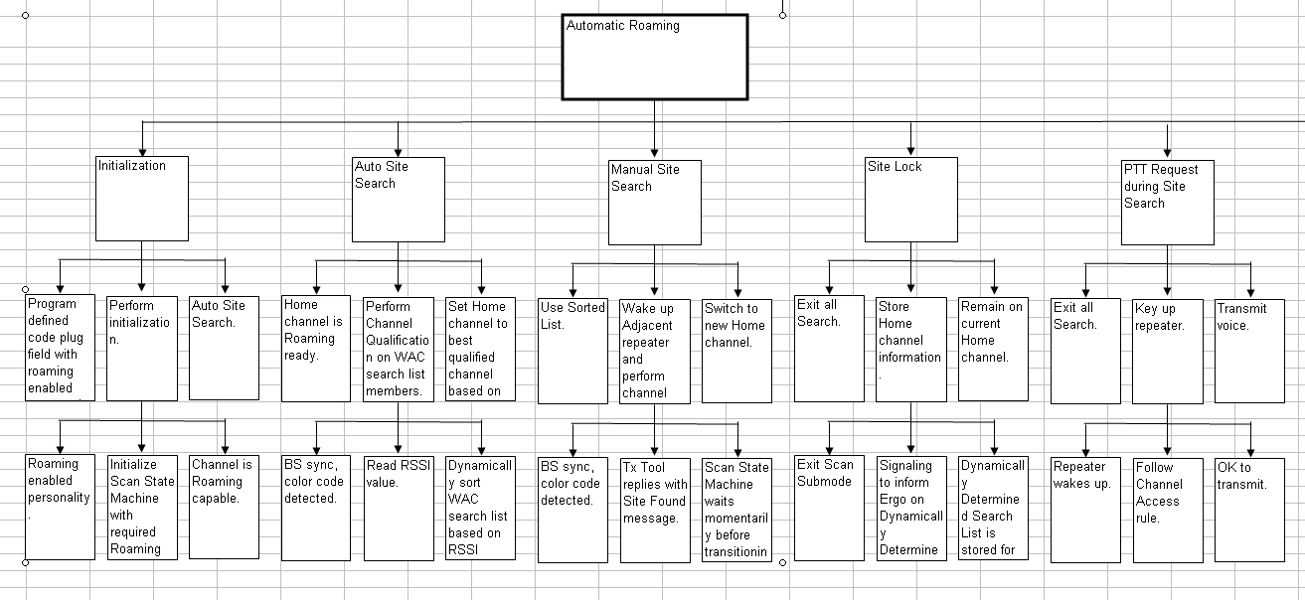

- P-Diagram
P-Diagram: Overview

Ideal Function
(Intended function)
Noise Factors
(Unexpected Variation due to external environment, internal, piece-to-piece, customer usage, wear out)
Control Factors
Signal
Causes the system
to deliver the user
intent
(System output that
determines the
perceived result)
(Design parameters whose nominal values can be adjusted by the user or
programming modes in the software)
Unintended Results
(Failure Modes)
Functionality/
System/sub-system/
Or Component
(Transforms user intent into perceived results)
SYSTEM
INTENDED RESULT
CUSTOMER
INTEND
(SIGNAL)
(Energy Transformation)
1
2
5
4
3
UNINTENDED RESULTS
(FAILURE MODES)
NOISE FACTORS

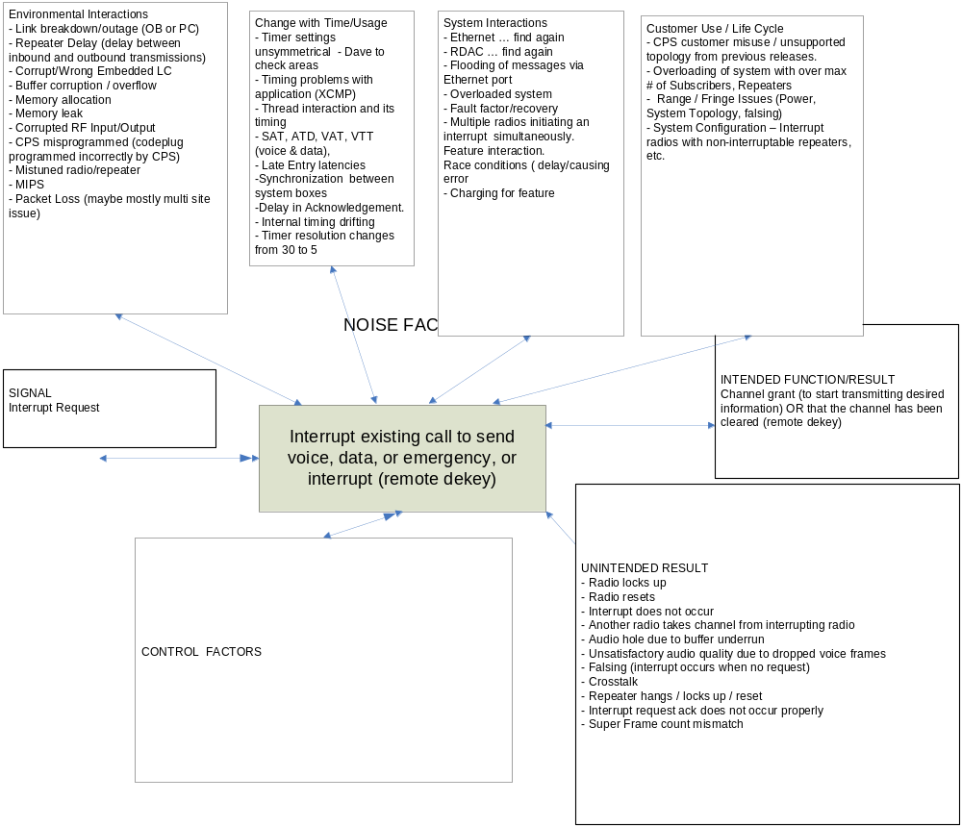

- Interaction Matrix for System Level FMEA
    - Fill Out Interaction Matrix
      - Roles and Responsibilities
- Please refer to Appendix A.
      - Entry Criteria
  - New items / functionality in release.
  - Big Picture; 1000 foot view of what the release will bring to the customer (e.g. Matrix 1.4 was extended coverage area via IP Site Connect; Matrix 1.5 was additional capacity). Insure you identify product evolution in terms of technology (i.e. repeater from RF repeating to router type functionality in IP Site Connect).
  - Voice of SLT.
  - Voice of Business (MRD, IBP, TRS, Tech Scope Slides).
- Voice of Customer (VOC), if available.

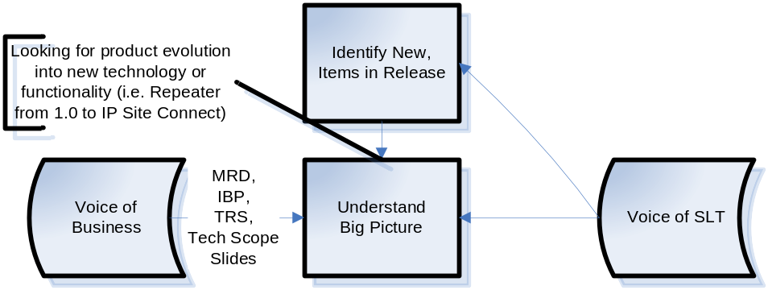
      - Activities
        - Identify use case level scenarios
- Ask the following question: What is new in this release? What are the boundaries? What is new in this release? What is included and what is not? What are the high risk areas? The goal is to identify what this release is providing that the previous release(s) did not. Also, try to identify if we have provided the functionality in past products.
- Collect and read the integrated business plan (IBP), the marketing requirements document (MRD), the technical requirements specifications (TRS) and technology scope slides. These will provide the inputs for helping identify the potential customers and how they are envisioned to use the product, critical success factors, any products that this product will be replacing, etc.
- Look for product evolution into new technology or functionality. The goal is to identify how this release fits into the marketplace, how our customers will be using the release and what products (if any) it is replacing
- Get inputs from SLT, System Architects and System Design about what they want to learn from the FMEA. The goal is to determine what scenarios the team is interested in focusing upon. These are typically at the use case level and encompass the information that is learned from the previous bullets.
- Go through Feature List in Feature Impact Analysis document (FIA). The goal is to identify impacted features and derive scenarios.
        - Identify desired functionality
- Go through each scenario combination and ask the following question: What types of information is transferred / needed during the interaction.
- Try to specify as an action verb / noun combination.
      - Exit Criteria
- Interaction matrix scenarios have been identified.
- Desired functionality for each scenario interaction has been identified
      - Deliverables
- Interaction matrix populated with appropriate scenarios and the desired functionality for each scenario interaction.

Interaction Matrix Worksheet (System Level)

Impacted Existing Feature’s Scenario
listed in 1st column

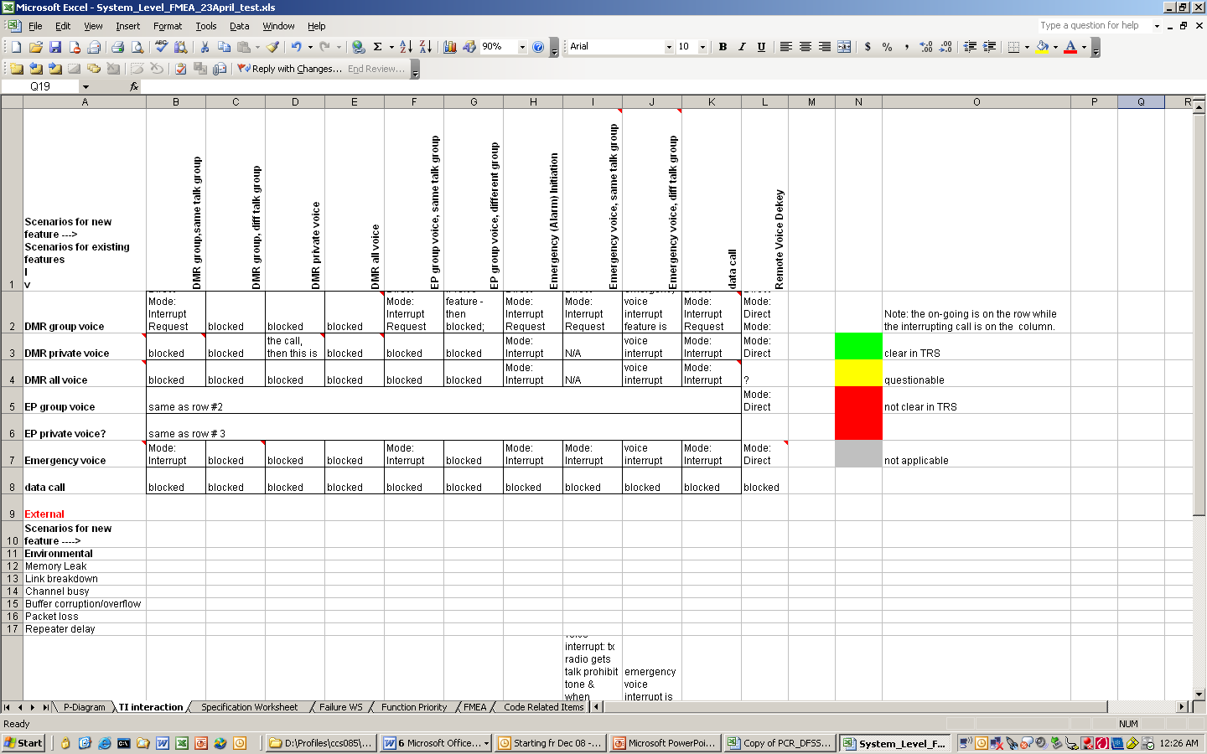
New feature actions/
Scenarios listed in 1st row.

Define the function you want the system design to provide for the interaction identified by the scenarios for new feature/new feature action(1st row) and scenarios for existing features (1st column)

- Interaction Matrix for Design Level FMEA
    - Fill Out Interaction Matrix
      - Roles and Responsibilities
- Please refer to Appendix A
      - Entry Criteria
  - TRS
    - Noise List
    - Scenario List
  - Feature Impact Analysis Document
  - Box Level SRS

MRD
TRS
Noise List
Scenario List
Architecture Doc
Feature Impact Analysis (Component List)
Box SRS
Noise List
Scenario List
Existing List
New List
Box Level DFMEA shall focus on component interaction and component noise factors.
Make reference
Derive
Box Level DFMEA
State Machine

      - Activities
        - Identify component level changes and associated noise factors that might potentially impact the functionality of these components.
- Go through Feature Impact Analysis document to identify impacted components, derive scenarios & populate interaction worksheet.
- Go through the Noise Factors List and/or Noise factors from P-Diagram to identify applicable noise factors.
        - Identify desired functionality
- Go through each scenario combination and ask the following question: What types of information is transferred / needed during the interaction.
- Try to specify as an action verb / noun combination.
      - Exit Criteria
- Interaction matrix scenarios have been identified.
- Desired functionality for each scenario interaction has been identified
      - Deliverables
- Interaction matrix populated with appropriate scenarios and the desired functionality for each scenario interaction.

Interaction Matrix Worksheet (Design) Level)

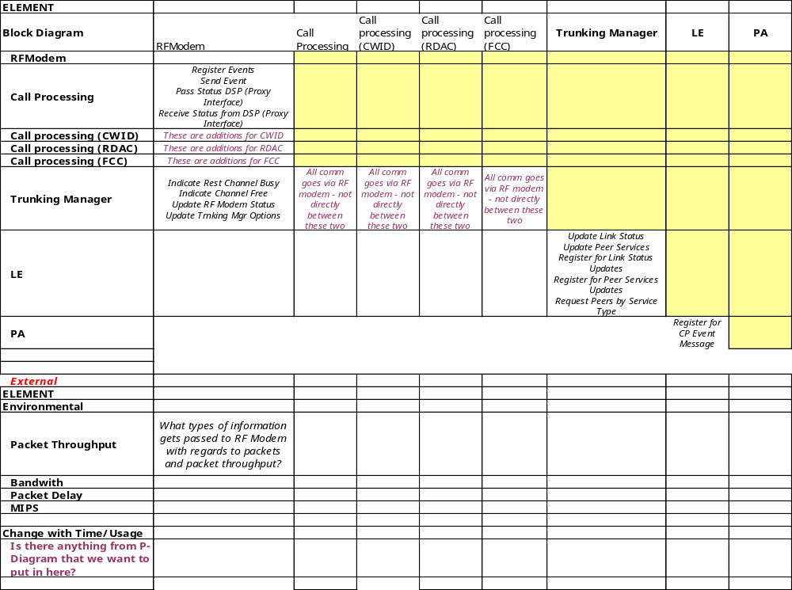
Each Impacted cComponentntified by the cs listed in 1st e updated to incorporate DFMEA. s
listed in 1st row
as column
heading
Define the function you want the system design to provide for the interaction identified by the Ccomponents (1st columnrow) and Components/Noise Factor (1st rowcolumn)
Impacted Components/ Noise factors listed in 1st columnImpacted Existing Feature’s Scenario
listed in 1st column

Define the function you want the system design to provide for the interaction identified by the scenarios for new feature/new feature action(1st row) and scenarios for existing features (1st column)
Define the function you want the system design to provide for the interaction identified by the Components (1st row) and Components/Noise Factor (1st column)

- Specification Worksheet

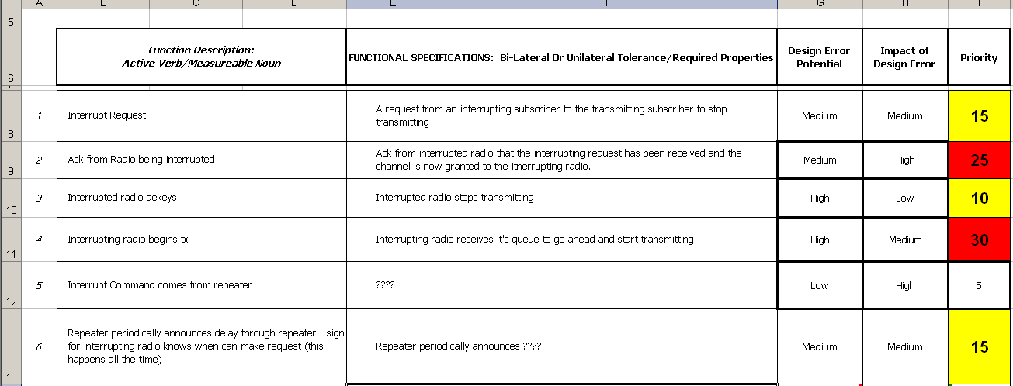

Step #3:
Assign a functional priority rating to identify the highest priority functions for FMEA
Step #1:
Copy defined functionality from the Interaction Matrix to the Specification Worksheet 1st column.
Step #2:
Define a functional specification for each item listed in column #1.

- Populate Failure Mode Worksheet

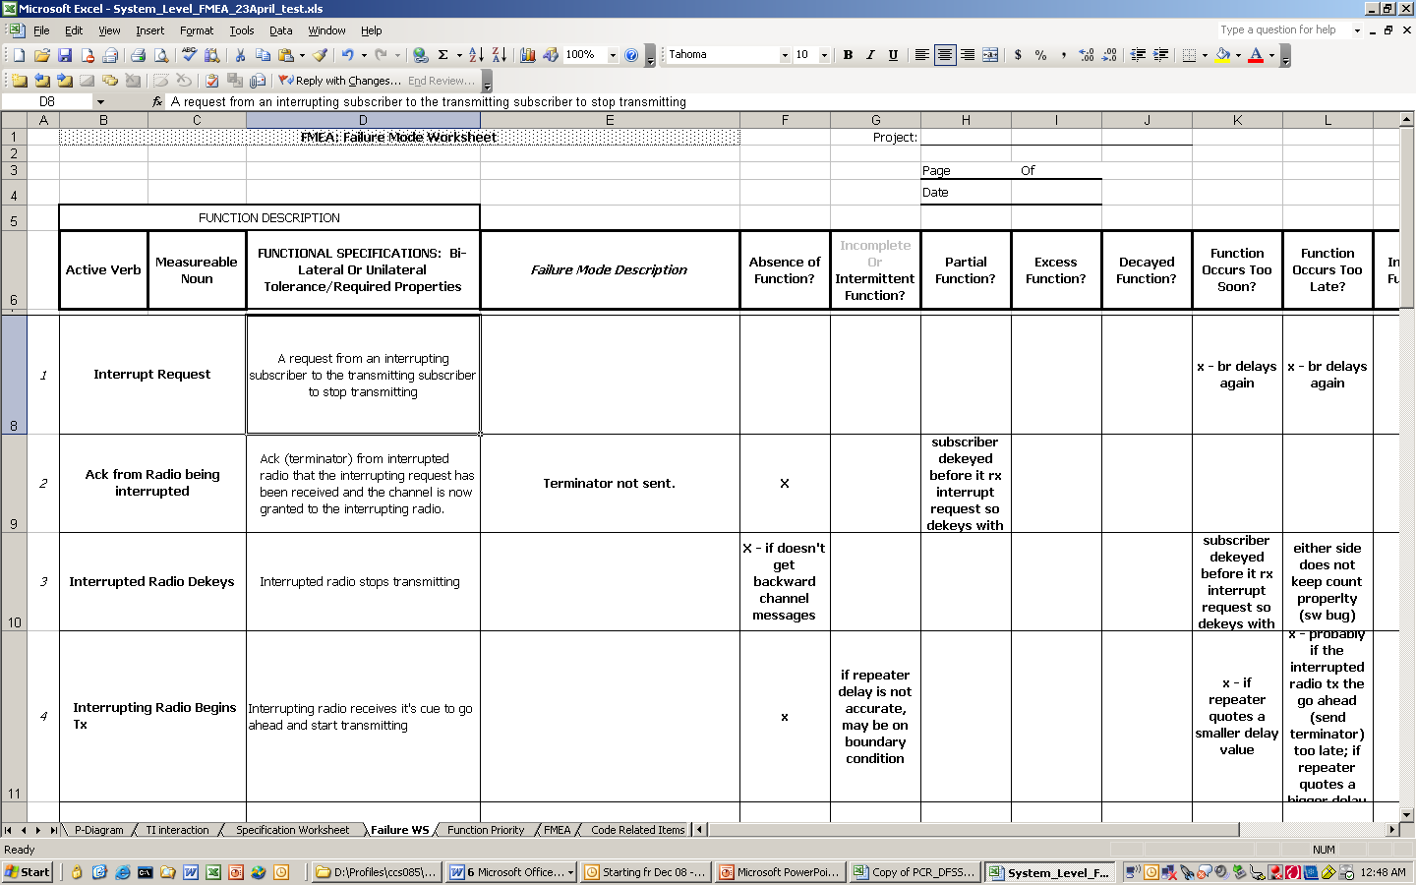
Step #2:
Consider each of 8 Failure Modes for each function. Ask the question, what happens if ….

Step #1:
Transfer each high priority function from the specification worksheet.

- Timing Diagram Examples

- Scenario Planning Example:
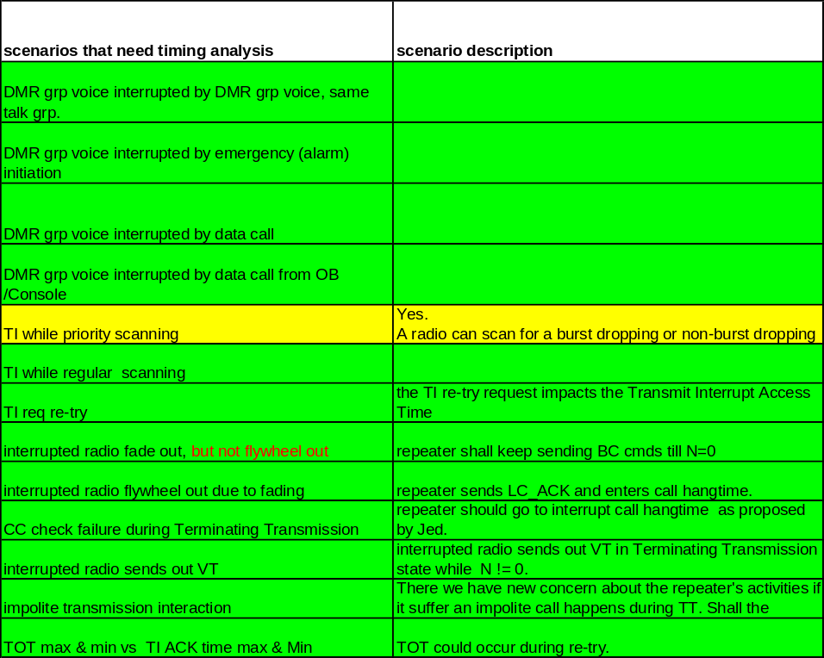

- Timing Diagram Example:

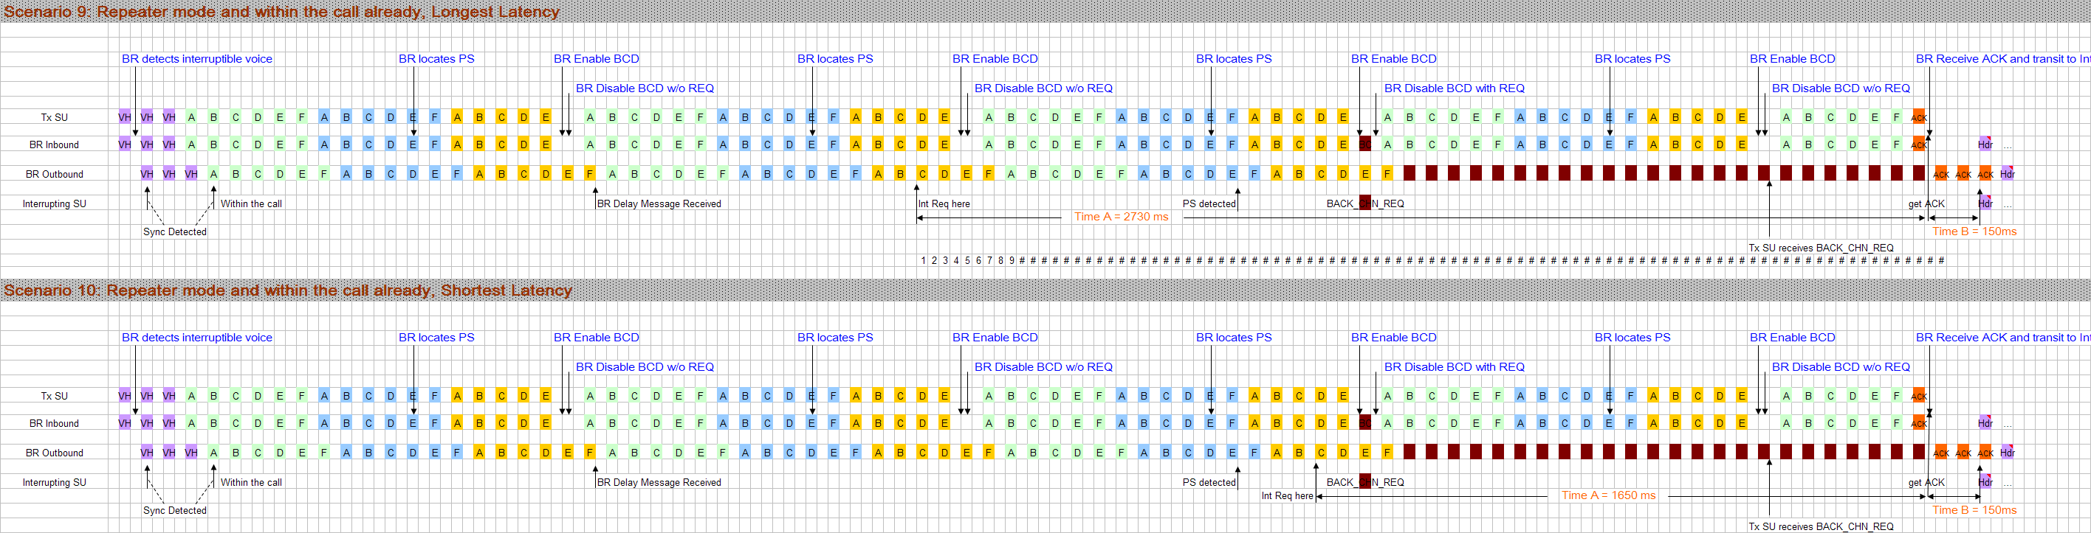

- Issues Log Example:

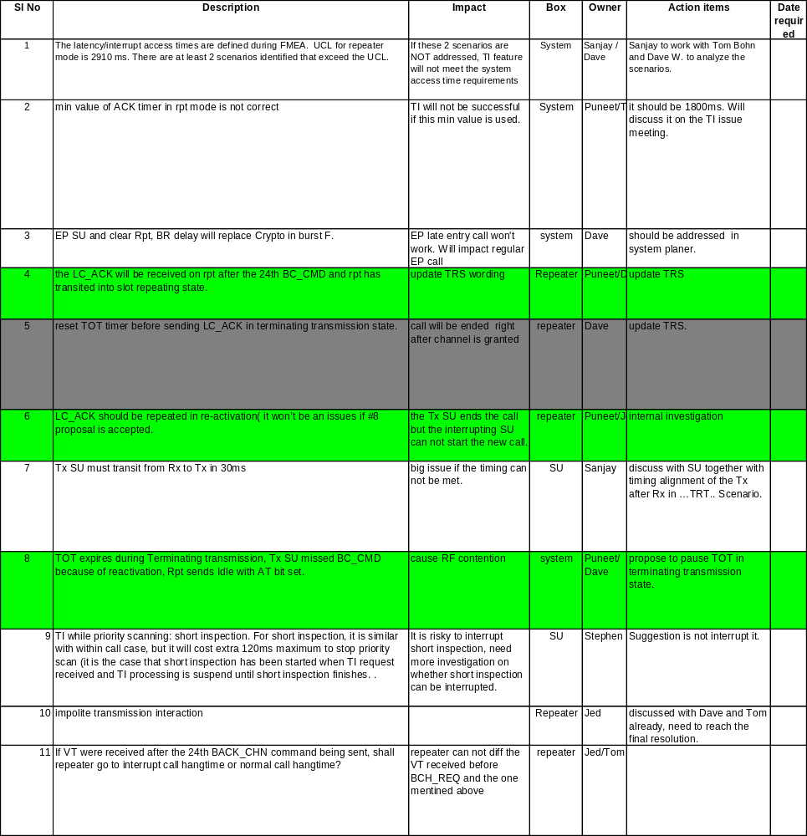

- State Machine Example

This is a state machine from the Transmitter Interrupt feature from the TRS Volume II document:

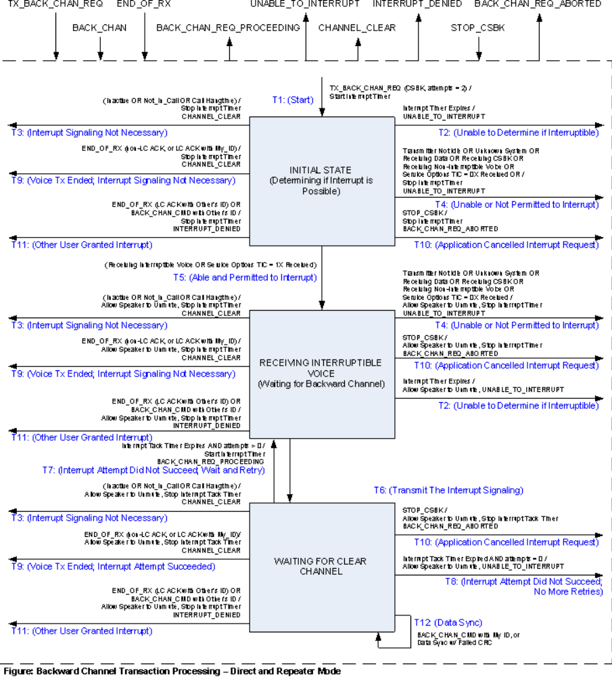

- Tools to Discover Root Cause

5 WHY | Cause and Effect
A questioning technique to help connect the cause to the failure mode or effect  How to Construct a 5 Why  - Start with the failure mode and ask why it would fail  - Look at the inputs and the noise factors on the P-Diagram and ask how it could contribute to failure  - Continue until you get to the root cause  - You know you are done when turning the cause on and off turns the problem on and off  5 Why Example • Stalled Car  - Why did the car stop?  - The engine died  - Why did the engine die?  - No fuel to the engine  - Why did the engine not get fuel?  - No fuel in the tank  - Why was there no fuel in the tank?  - Did not fill up in the morning  - Why didn’t the tank get filled in the morning? | A method for the team to organize potential causes using the “5 M’s and a P” to make sure all causes have been thoroughly investigated  Also known as Ishikawa or Fishbone  The cause and effect diagram develops a picture composed of words and lines designed to show the relationship between the effect and its causes.  It helps reach a common understanding of the problem and exposes the potential drivers of the problem  Failure  Mode  Category 4  Category 3  Category 2  Category 1  Potential Cause  How to Construct a Cause and Effect Diagram  - Write the failure mode or effect in the head of the “fish.”  - Determine the major categories of the effect. The 5M’s and an E are good place to start.  (Method, Man, Material, Machine, Measurement, Environment)  - List potential causes under each category. Use the inputs from the process map.  - If new inputs are discovered, add them back to the process map  Finance  Policy  Documentation  Why are invoices paid late?  Computer  System  Excess  Demand  Access Limitations  Low Priority  Older System  Downtime  New  Maintenance  Contractor  Excess  Demand  Manual  Sort  Process  Internal Mail  System  Cost-Reduction Program  One Pick-Up Daily  Workspace  Equipment  Lost/Misplaced Mail  Turnover  Inexperienced Staff  Manual  Files  Crowded  Space  Resigned  No Limit Manager  Missing Documentation  Branch Offices  Forward Payments Weekly  Centralized  Payment  Authorization  Audit Recommendation  for Tighter Control  Reorganization  of Purchase Org.  Missing  Purchase Orders  Maximize Cash  Payment  Delays  Increased  Workload  Staff  Turnover  Hiring  Freeze  Access Limitations  Low Priority  Morale  Paycuts  Overtime  Reduced  Productivity Deadlines

- Measurement Charts and Tables

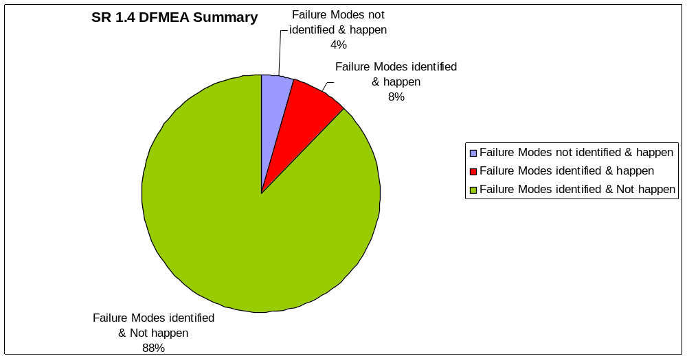

Matrix R1.4 Software DFMEA | Failure Modes not identified & happen | Failure Modes identified & happen | Failure Modes identified & Not happen
Matrix R1.4 Software DFMEA | 4 | 7 | 80
Matrix R1.4 Software DFMEA | 4.76% | 8.33% | 95.24%

Risk Reduction | Initial RPN | Revised RPN  (after recommended actions were taken) | RPN Reduced | % RPN Reduction
1000-Channels FMEA | 813 | 95 | 718 | 88.31%
Auto-Roaming | 2372 | 347 | 2025 | 85.37%
Enhanced Privacy | 8516 | 3198 | 5318 | 62.45%
SCAN | 1376 | 340 | 1036 | 75.29%
VOX | 2268 | 1053 | 1215 | 53.57%
Total | 15345 | 5033 | 10312 | 67.20%

