Quick workflow on HDBSCAN prediction for new observations
After parameter optimization (with the supervised methodology previously developed), we found the best parameters, and apply them to the data:
Note: for this algorithm, to be able to predict new data the “prediction_data=True” options must be setted.
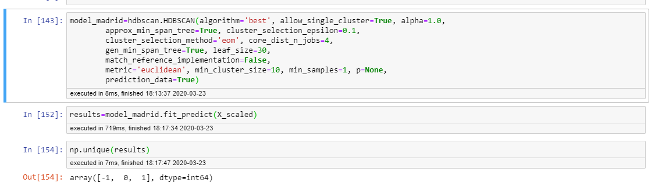
Plotting the results give rise to typical graphs previously observed:
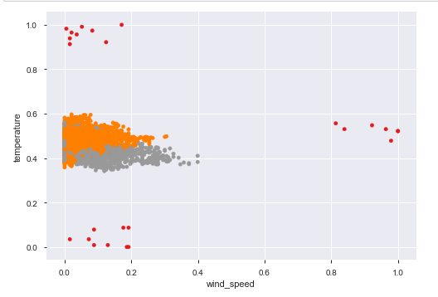
Unseen dataframe is actually some random observations from the original dataframe. The prediction is made with the methodology stated in the HDBSCAN documentation. However, its output predict much more clusters that the ones we had previously. Furthermore, it predicts outliers in point where they should not be.
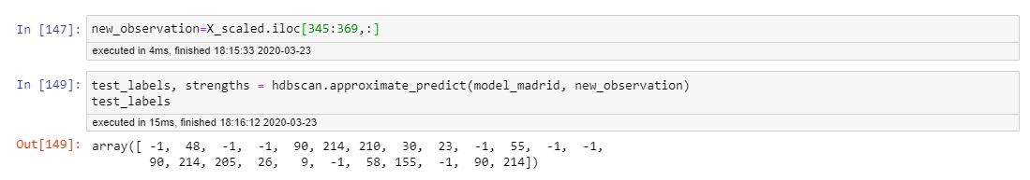

Plotting the results can be observed:
