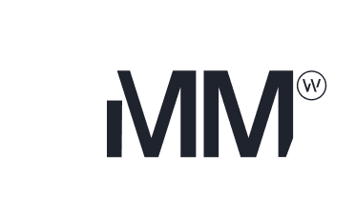

Formal Approval

01/01/2025
We have the pleasure in forwarding you Formal Approval for finance.
The details of the loan are as follows:
Applicant Overview
Borrower(s):
Mortgagor(s):
Guarantor(s):

Product Details
Lender | Mortgage Mart of Australia | Product Name | Ultra
Loan Account Number(s) | #### | Loan Amount | $####
Loan Term | Years | Interest Rate | ##%
Revert Rate | ##% | Monthly Repayment | $####
Rate Type | Variable | Repayment Type | P&I
Annual Facility Fee | $395.00 | Monthly Fees | $0.00
Offset Account | Yes | Redraw Facility | ####
Note that the interest rate is generally 2% higher if you are in default.
The actual increased interest rate will be described in your loan agreement terms and conditions.
Security Property: | ####
Our Panel Solicitor: | Green Mortgage Lawyers
Special Conditions: | - ####  - ####
This approval may be withdrawn at any time if anything occurs which in the opinion of its Funders and/or Insurers that adversely affects the loan proposal as they understand it. This document is not an offer of finance.
Your loan offer documents will be issued in the near future, these contain the terms and conditions that make up the offer. You will need to review, sign, and return the loan documents, and satisfy any pre-settlement conditions, prior to any funds being made available.
If you request or make any changes to the application details and its Funders and/or Insurers agree, additional costs and processing time should be allowed for your loan to be re-approved.

Yours Sincerely, The Mortgage Mart Team

