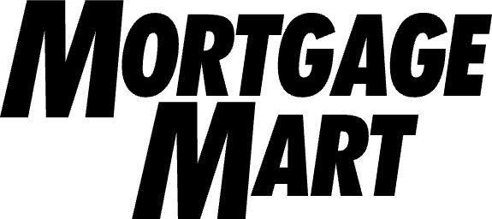
United Homes Qld Pty Ltd

8 Honeysuckle Crescent,
Bridgeman Downs
ABN: 75634805208

15th October 2025

Dear United Homes Qld Pty Ltd,

We are ready to start making progress payments.
We want to let you know that we can start releasing progress payments for our mutual customers. This means you can now commence the construction or renovations.
What you need to know?

Customer Name(s): | Tristan & Penelope Waller
Application Number: | 400178868
Disbursement Total:
Construction Address: | 60 Ryder Street, Wynnum, Queensland, 4178

What you need to do?
When you have completed a stage of construction:
- Firstly, prepare an invoice outlining the stage of work completed and request the respective payment amount as outlined in the Progress Payment Schedule.
- Ask your client to review and sign the invoice (this includes the client/s writing their name, date, and the words “I authorise payment of this invoice” on the invoice), which confirms they have provided authorisation that the construction stage has been successfully completed and the progress payment is ready to be made.
- Finally, email all signed invoices to construction@wlth.com so we can initiate the payment process.
Please be advised that every invoice received will require a progress inspection report to be completed prior to your invoice being processed. This may extend the time required prior to the invoice being paid.
This can take up to 10 - 15 business days and the progress payment will be processed once the inspection has been completed. Please consider this when determining your payment terms from our customers.

Yours Sincerely,
The Mortgage Mart Team

WLTH-V1.2 | Commencement Letter | Australian Credit Licence 525752 13WLTH | hello@wlth.com
P1 / 1

