**EIKON Hints & Tips**

Thank you for your time recently. Below is a guide to help you navigate through various applications and features relevant to your workflow. We covered many of these points during our recent session.

**Eikon Answers**

You can type in phrases e.g. "Google vs Samsung revenue 2012-2014 USD". If you are looking for anything, the search box is always the best place to begin. You can also type in phrases such as “top 20 pharma companies uk by revenue” to find what you are looking for.



**Keyboard Shortcuts**

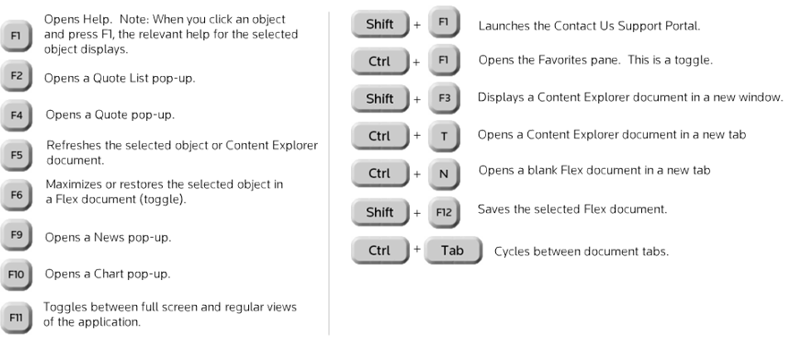

The Shortcuts above will save you time and effort. The F6 screen is a commonly used to maximise the screen you are working on.

**App Library**

By clicking the Orange Helios shown in the snapshot above you can access the App Library. Thomson Reuters apps are pulled from an online storage facility which is efficient because it only pulls information when you need it. Apps are categorised by their function and they are also classified by asset class.

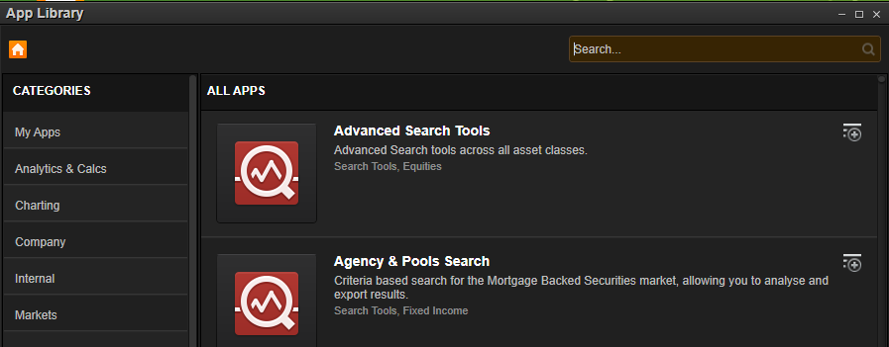

Add your favourite apps to your App Library buy clicking on the plus sign.

**News Monitoring**

News is searchable in many views within Eikon. You can start searching by typing into the **Eikon Answers** bar at the top-left of your screen. To display all results for a query please hold down Shift + Enter.

For advanced searches use the **News Monitor** app. You can search through Reuters News Wires or Global Press. Reuters News Wires incorporates Thomson Reuters sources as well as thousands of market sources such as Dow Jones News. The news is very factual and you will see asset specific news as well as top news for different industries from a range of topics e.g. from Fixed Income to mining news in Africa.

Global Press gives you access to more than 9000 additional sources. You will have access to local newspapers and sources all within the one app e.g. City A.M., The Independent, Dow Jones News. You can browse our sources by clicking on the “create” button.

Since we are the world’s leading news and business intelligence provider, we often break the news before others in the market. Our **Reuters Best** website shows you where we were first to the market. **Breaking Views** will provide commentary on the Financial Markets from our dedicated market specialists and **Reuters Insider** will break news to you through short and concise videos.

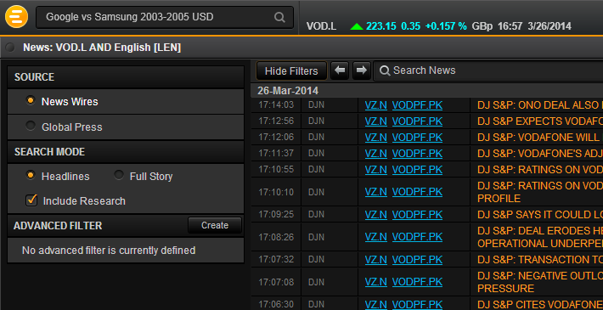

Please make sure you select “Show Filters” to see the filters on the left if your screen does not appear to show them,

**Broker Research**

You can search for research using the **News Monitor** app or through **company profile** pages.  To access company specific research:

1. Type a company into the top-left Eikon Answers box
2. Click on the "Research" tab
3. Select "Company Research" and proceed to view any documents you wish. Alternatively you can select News and Research within a company overview or open the **Company Research** app from the app library.

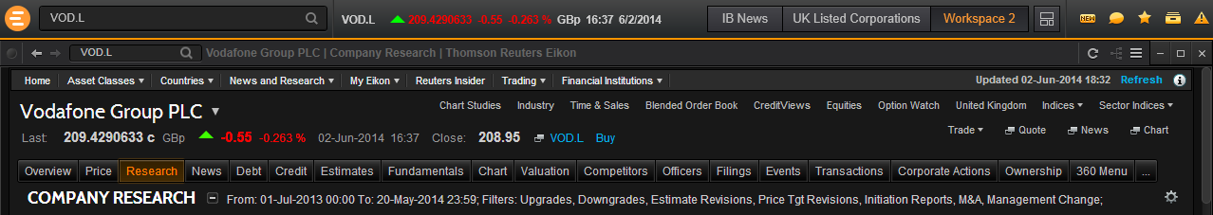

I have highlighted where to find Advance Research Searching (top arrow). Click the settings tab to the bottom-right of the screenshot to view brokers you can request real-time research from.

You can batch download documents if you are looking to download multiple reports into the one view. You can also export the broker reports to PDF format or Excel if you plan to print them. You can also forward interesting articles and reports to colleagues using **Reuters Messaging**. The Industry App is also another tool which will help you visualise Broker Research, news and events within a particular market sector. I will explain this in more detail shortly.

There are two types of research: **real-time** and **embargoed**/aftermarket. Real-time research is free of charge but you need entitlements from the broker in order to access their reports. Corporations often find it challenging to obtain real-time access to broker reports which can limit your research capabilities. To overcome this, after-market research (an add-on package) allows you to access the largest collection of broker research globally from exclusive contributors such as UBS, Credit Suisse and Barclays. In the Corporate Finance world, embargoed research provides you vital market intelligence.

**Estimates**

Accessing the most credible global estimates database through Eikon is very easy. IBES estimates, seen as the gold standard in Estimates content, can be viewed in company pages by clicking on the **Estimates tab**. You can then view **Top Analysts** by company and find out which analysts are performing the best. You also have the ability to view an analyst's performance scorecard to evaluate their performance across all of the stocks they cover. Furthermore, you will have contact details for some of the analysts should you need to get in touch.

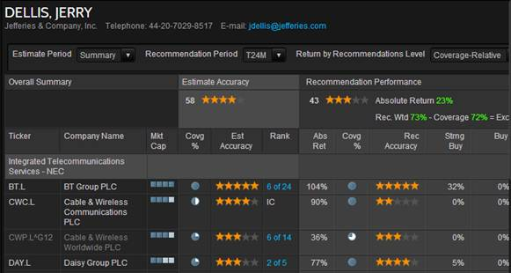

Within the **Detailed Estimates** tab illustrated above you have the ability to view estimates using 17 different measures e.g. EPS, EBITDA. Not only do we provide the mean estimate across different analysts, we also provide a **SmartEstimate\***.

*\*SmartEstimate is calculated using a weighted average of analyst estimates, excluding all estimates older than the most recent RevisionCluster, older than 120 days, or more than 5 standard deviations from the mean. 2/3 of an analyst's overall weight is determined by the contributor's Summary Single-Stock Estimate Score(SES) on the stock. The final 1/3 of the analyst's weight is determined according to the Estimate Age of the estimate, with more recent estimates getting proportionally higher weights by the contributor's Sin.*

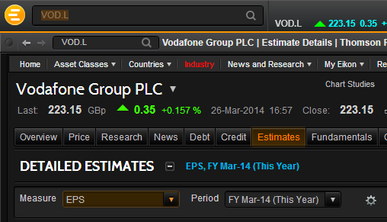

Predicted Surprise is the difference between the Mean Estimate and the SmartEstimate for a particular stock in a particular fiscal period. It can be expressed either in terms of the local currency or as a percentage of the mean estimate. A Predicted Surprise is deemed to be significant if its magnitude exceeds a minimum percentage and a nominal amount that vary by currency. For US securities, a Predicted Surprise must exceed 1.5% and $.01 to be considered significant.

Within this Estimates section, you also have the ability to look at an interactive income statement which takes into consideration analysts’ predictions giving you a better idea of how the stock is forecasted to perform.

**Transactions: Deals/M&A**

Eikon provides access to the "**Mergers and Acquisitions Advanced Search**" app which allows you to screen for M&A transactions from the world's **largest** deals database. You can screen using 40 different filters displayed in an intuitive and user-friendly interface. The popular "Target Public Status" filter allows you to limit your screening to private companies only. You will also be able to screen M&A using Eikon for Excel.

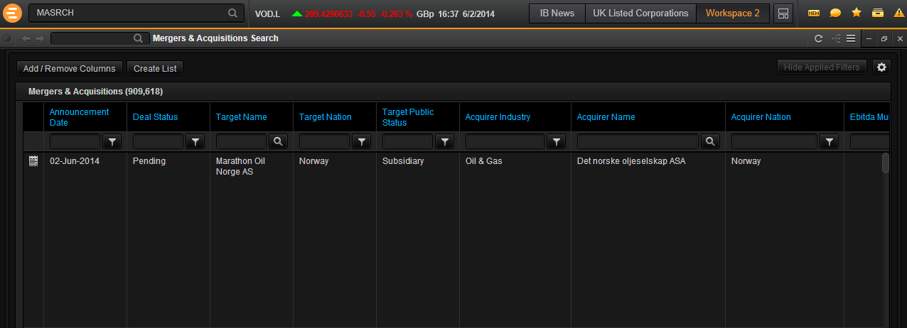

**Virtual Briefcase**

You will see a briefcase logo on the top-right of your screen and a blue “**Add to briefcase**” hyperlink throughout the product. This briefcase is your personal online storage cloud facility at Thomson Reuters. You can save research reports or any lists of stocks on to this cloud in order to make it accessible through mobile apps or through another PC

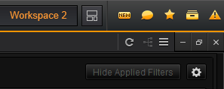

**StreetEvents**

Events can be accessed in company pages and industry views. You can simply add events to your Outlook Calender keeping you up to date with the latest conference calls or earnings releases within your sector. Furthermore, if you miss an important event we provide transcripts for major calls usually around 6 hours after the meeting has taken place. If you do not have time to look through the full event transcript then you can use the "Guidance" feature within the events tab, summarising any textual or numerical data mentioned during the call that could impact the Income Statement and other financials.

Events are also available to monitor within Flex documents (customised workspaces) and through the Industry app. E.g. if you are looking at the Automotive Industry in Europe within the Industry App, it is very easy to view all events and research within the sector by clicking on the relevant tabs

**Alerts**

Create price alerts:

1. Click on the warning triangle on the top-right of your screen to access the alert manager.
2. Open the alert manager
3. Select Market Monitoring/Data
4. Add symbol/RIC/equity
5. Choose equities
6. Select “bid” and this will load the current share price for stock
7. Add limits
8. Choose delivery of alert.

To set up an alert for Regulatory News Service (RNS) for the same stock:

1. Click on the news section to the left of your screen
2. Type RNS under the sources section
3. Choose delivery method.

You can add and remove as many apps as you like. Alerts can be delivered through different methods e.g. a daily/weekly/live email, a pop-up etc.



**Flex Documents: Create Your Own View and Workspace**

An app called "**Flex Monitor**" gives you the power to create your own customised workstations. These documents allow you to manage a portfolio of stocks with related news and charts to help you monitor the market. To make life easier, we have created an app called "**Flex Samples**" which you can use as templates to create your own workspaces. You can then edit the content and features to make the workspace relevant to you. Once you complete the template you can save it into your briefcase to access the quote lists from a mobile device.

.

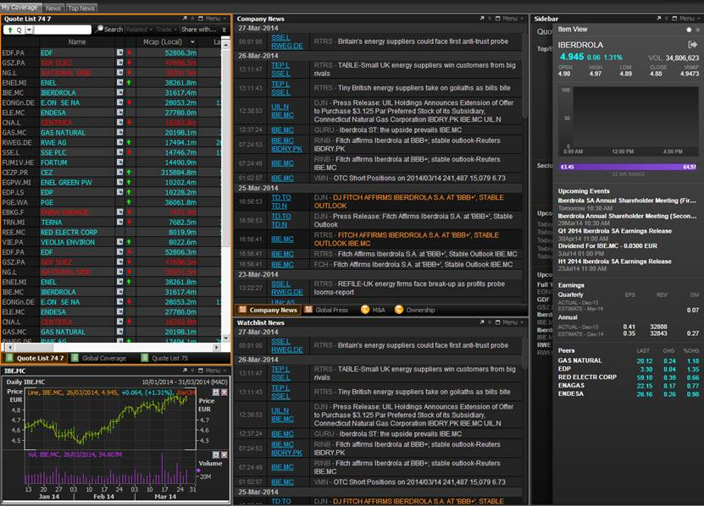

Above is a Flex monitor for energy companies. This allows you to conduct competitor analysis within the one screen.



Your files are saved on to your Thomson Reuters Drive and you can access this drive by clicking on the button highlighted in the screenshot above. When you reopen Eikon your workspace will appear the way in which you left it. To build a Flex document from scratch, you can simply open the **Flex Monitor** app.**DataStream within Eikon and Microsoft Excel**

DataStream is accessible via the "**Chart Studios**" app and through Eikon Excel. This will give you access to the **largest** collection of time series globally. Key sources such as Oxford Economics are included within the app. The content is unique and unrivalled and the charting tools allow you to seamlessly compare trends and create forecasts.

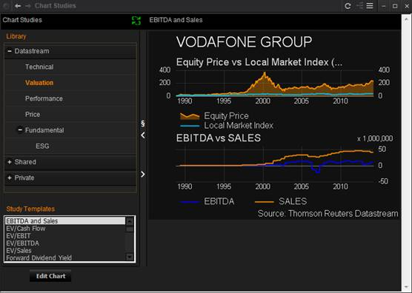

**Thomson Reuters Messaging**

Our Messaging tool at the top-right of your screen allows you to communicate with others. You can share interesting articles and and send files using this intuitive messaging system. You can also add any external contacts who use Eikon outside of your work environment to stay connected with your wider community. Messaging allows collaboration across different departments and organisations.



**Thomson Reuters Eikon - Microsoft Excel**

We have developed an **Excel** tool which incorporates Eikon's auto-suggest features making model-building a simpler task. Company screening will be available very soon and will allow you to insert formulas directly into Excel. Furthermore, advanced deals screening for ECM and DCM are also coming shortly. We have a **PowerPoint** add-in which allows you to use Excel and  Powerpoint to create reports and presentations which can be updated and refreshed simultaneously. This feature is useful when creating pitch-books and saves Junior Analysts a lot of time.

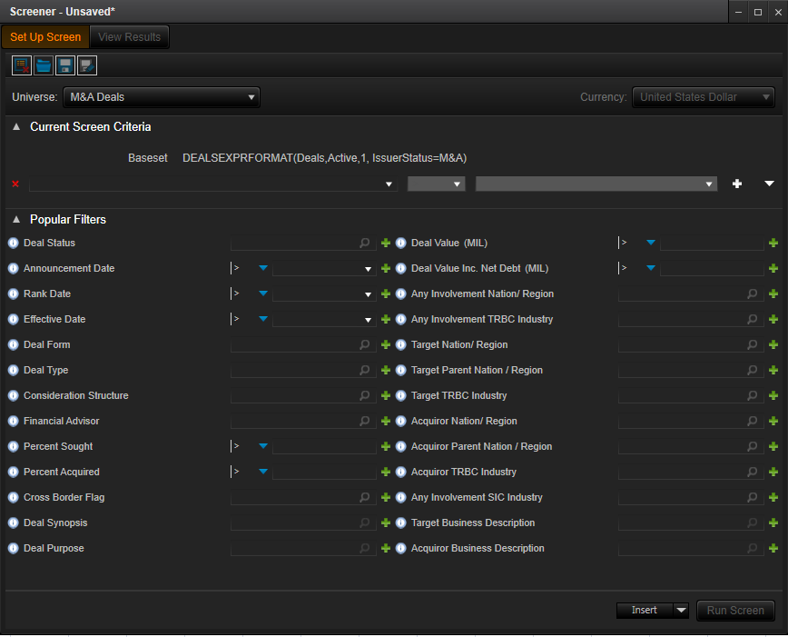

**The possibilities are endless. The Eikon Excel M&A screener allows you to choose from 194 filters to allow you to get the information you need.**

To access Eikon Excel, simply click the Start Button > All Programs > Thomson Reuters > Thomson Reuters Eikon - Microsoft Excel

Once you have opened up Eikon Excel you will see two new tabs at the top of the screen:

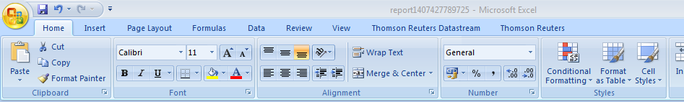

Please click on the Thomson Reuters tab and select “Log in”:

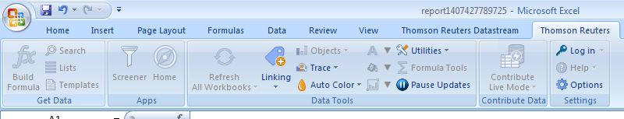

Once logged in, please select the options tab below the arrow in the picture above and select Apps to show the following:

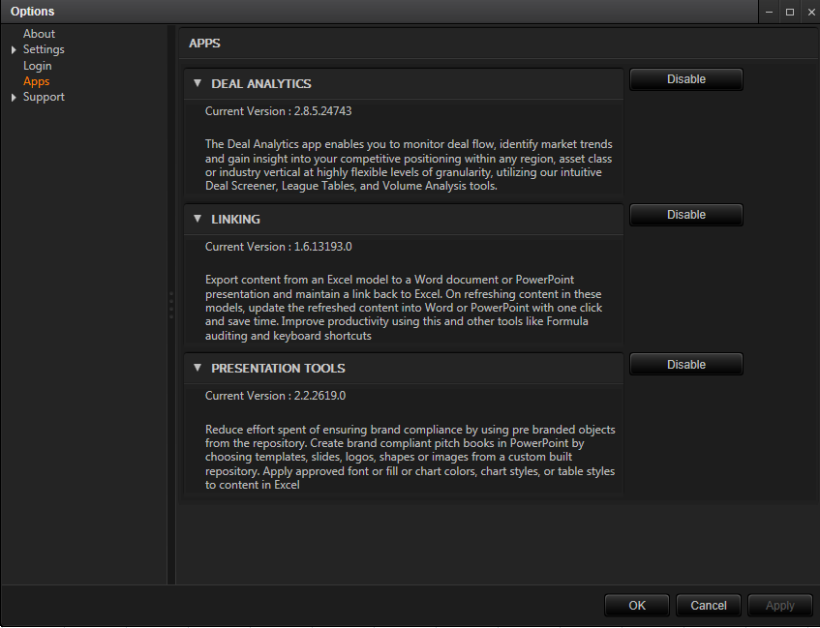

Please make sure you download all programs to benefit from Eikon Excel. You will then see the Deals Screener appear within Excel as well as Presentation Linking tools for Pitchbook creation:

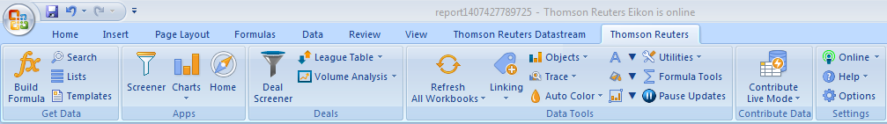

You can then use the screener to begin your M&A analysis. Within Eikon’s front-end desktop software the M&A screener uses 40 different filters. Within Excel, you have 194 filters to choose from making it an ideal solution for advanced screening.

**Additional Apps**

* **The Economic Monitor:** offers comprehensive real-time economic coverage and lets you see what’s affecting the markets and impacting your trading. Combined with market holidays, central bank and political events and government debt auctions

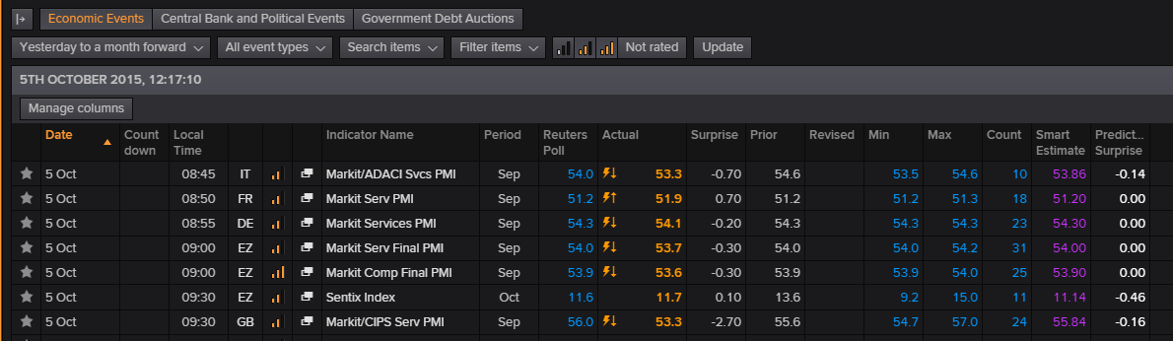

* **Macro Explorer:** this app pulls in macro data from DataStream allowing you to quickly analyze different markets by selecting countries using the world map and by choosing filters e.g. Inflation, GDP, Unemployment
* **Industry App:** allows you to find sector specific news, research and events within certain geographies making market monitoring an easier task
* **Interactive Map:** allows analysts focusing on Commodities to locate a vessel or plant to view production numbers or to track the physical movements of a vessel in transit
* **Monitor:** Allows you to view different stocks in a simplified yet intuitive manner
* **Social Media Monitor:** Twitter sentiment analysis filters company-specific tweets and CashTags into the one screen allowing you to understand what social media world is saying about a stock or industry
* **Eikon Web:** a Google Chrome Extension for Eikon will be available soon providing you access to a web-based version of Eikon through Google Chrome browser. There will be a function that allows you to find related Eikon content from external websites using the right-click button on your mouse. Within the Mobile app you can take a screenshot and Eikon will find the related news for you automatically after analyzing the image in milliseconds

**Online Training & Program Certification**

Our aim is to help you find the data you need whenever you need it. Here is a link to our online product training portal: [**http://training.thomsonreuters.com/**](http://training.thomsonreuters.com/)

**Product Certification Program**

Our OnDemand training allows you to learn at your desktop at your own pace. A final assessment will prove your knowledge to peers and future employers. Please click the link below:

[**http://training.thomsonreuters.com/cert/**](http://training.thomsonreuters.com/cert/)



**Quick Reference Card Thomson Reuters Eikon for Microsoft Office Frequently Used Formulas**

|  |  |
| --- | --- |
| **Consensus Estimates** | |
| Average Broker Rec | TR.RecMean, TR.RecLabel |
| Price Target | TR.PriceTargetMeanEst |
| CAPEX | TR.CAPEXMean |
| Operating Income | TR.OPRMeanEstimate |
| Revenue Estimate | TR.RevenueMeanEstimate |
| EBITDA Estimate | TR.EBITDAMean |
| EBIT Estimate | TR.EBITMean |
| Net Income Estimate | TR.NetIncomeMeanEstimate |
| CFPS Estimate | TR.CFPSMean |
| EPS | TR.EPSMeanEstimate |
| DPS | TR.DPSMean |
| ROE | TR.ROEMean |
| ROA | TR.ROAMean |

|  |  |  |  |  |  |  |
| --- | --- | --- | --- | --- | --- | --- |
| **Financial Information** | |  |  | | | |
| Revenue | TR.Revenue | EV | | TR.EV |
| COGS | TR.CostofRevenueTotal | Market Cap | | TR.CompanyMarketCap |
| Depreciation | TR.Depreciation | Shares Out | | TR.SharesOutstanding |
| Gross Income | TR.GrossProfit | EPS | | TR.BasicNormalizedEps |
| SG & A | TR.SGandAExp | Fully Diluted EPS | | TR.DilutedNormalizedEps |
| Total operating exp | TR.TotalOperatingExpense | BVPS | | TR.BookValuePerShare |
| Operating Income | TR.OperatingIncome | CFPS | | TR.CFPSActValue |
| Interest Income | TR.NetInterestIncome | FCF Per Share | | TR.FCFPSActValue |
| EBIT | TR.EBIT | DPS | | TR.DpsCommonStock |
| EBITDA | TR.EBITDA | R&D | | TR.ResearchAndDevelopment |
| Pretax Income | TR.NetIncomeBeforeTaxes | Income Tax % | | TR.IncomeTaxRatePct |
| Net Income | TR.NetIncome | Dep & Amortization | | TR.DepreciationAmort |
|  |  |  | |  |
| Total Assets | TR.TotalAssets | Cash | | TR.Cash |
| Accounts Payable | TR.AccountsPayable | Receivables Total net | | TR.TotalReceivablesNet |
| Current Liabilities | TR.CurrentLiabilities | Inventories | | TR.Inventories |
| Minority Interest | TR.MinorityInterestBSStmt | Current Assets | | TR.CurrentAssets |
| Preferred Stock Net | TR.PreferredStockNet | Total Debt | | TR.TotalDebt |
| Total Liab & Equity | TR.TtlLiabShareholderEqty | Net Debt | | TR.NetDebt | |
|  |  |  | | | |

|  |  |  |  |
| --- | --- | --- | --- |
| **Valuation (historical)** | | | |
| EV/Total Revenue | | TR.EVToSales |
| EV/EBITDA | | TR.EVToEBITDA |
| EV/EBIT | | TR.EVToEBIT |
| P/BVPS | | TR.PriceToBVPerShare |
| P/TangBVPS | | TR.PriceToTangBVPerShare |
| P/E | | TR.PE |
| **Valuation (forecast)** | |  |
| EV/Fwd Total Rev | | TR.EV/TR.RevenueMeanEstimate |
| Fwd EV/EBITDA | | TR.EV/TR.EBITDAMean |
| Fwd EV EBIT | | TR.EV/TR.EBITMean |
| Foward P/EPS | | TR.PtoEPSMeanEst |
| PEG Ratio | | TR.PEG |
| P/Foward CFPS | | TR.PtoCPSMeanEst |
|  | |  | |
| **Valuation SmartEstimates** | | | |
| Fwd EV/Revenue | TR.FwdEVtoREVSmartEst | | |
| Fwd EV/EBIT | TR.FwdEVtoEBISmartEst | | |
| Fwd EV/EBITDA | TR.FwdEVtoEBTSmartEst | | |
| Fwd P/EPS | TR.FwdPtoEPSSmartEst | | |

|  |  |
| --- | --- |
| **Fixed Income** | |
| Issue Name | DSPLY_NAME |
| Maturity Date | TR.FiMaturityDate |
| Current Yield | TR.FiCurrentYield |
| Current Price | TRDPRC_1 |
| Principal Amount | TR.FiFaceIssuedTotal |
| **Credit Rating** |  |
| Rating | TR.GR.Rating |
| Moodys Rating | TR.FiMoodysRating |
| S&P Rating | TR.FiSPRating |
| Fitch Rating | TR.FiFitchsRating |

|  |  |  |
| --- | --- | --- |
| **Market Information** | | |
| RIC | TR.RIC |
| Closing Price | TR.PriceClose |
| Opening Price | TR.PriceOpen |
| Intra Day High | TR.PriceHigh |
| Intra Day Low | TR.PriceLow |
| Trading Volume | TR.Volume |
| Dividend Yield | TR.DividendYield |
| BETA 5 Year | TR.BetaFiveYear |
| Shares Outstanding | TR.SharesOutstanding |
| Headquarters | TR.HeadquartersRegion |
| Industry | TR.TRBCIndustry |
| Business Description | TR.BusinessSummary |



**Quick Reference Card Thomson Reuters Eikon for Microsoft Office Frequently Used Parameters**

|  |
| --- |
| **Date and Time functions** |
| =DfAddWD | Adds the number of working days to a date | Syntax: =DFAddMonths (Calendars, CalcDate, NbMonths, DfMode)  e.g. =DfAddWD("USA","30JUN05",2,"")  Function Output: July 5th 2005 (July 4th 2005 is a non-working day in the US, hence the next working day is retrieved) |
| =DfAddMonths | Adds the number of months to a date |
| =DfAddYears | Adds a number of years to a date. |
| =RTNow | Retrieves the current system time |
| =RTToday | Retrieves the current system date |  |

|  |  |
| --- | --- |
| **NULL: Populating empty cells** | |
| NULL:ZERO | displays 0 |
| NULL:NA | displays #NA |
| NULL:NAND | displays #N/A ND |
| NULL:SKIP | skips line if no data for at least one instrument |
| NULL:PREVIOUS | duplicates value of the previous data point |
| NULL:NEXT | duplicates value of the following data point |

|  |  |  |  |
| --- | --- | --- | --- |
| **Financial Period Syntax** | |  | |
| *Relative Periods* | (Replace n with 0 for last reported period,  -1 for previous period and 1 for next period) |  |  |
| FY[n] Fiscal Year |  |  |
| FQ[n] Fiscal Quarter |  |  |
| FI[n] Fiscal Interim |  |  |
| FS[n] Fiscal Semi-Annual |  |  |
| CY[n] Calendar Year |  |  |
|  |  |  |
| *Absolute Periods* | |  |  |
| FY[YYYY] e.g. FY2014, FY2012 | |  |  |
| CY[YYYY] e.g. CY2013 | |  | |
| [q]FQ[YYYY] Fiscal Year/quarter e.g. 3FQ2013 | |  | |
| [s]FS[YYYY] Fiscal Semi-Annual e.g. 2FS2013 | |  | |

|  |  |
| --- | --- |
| **Period Argument Codes** | |
| FY0 | Last Fiscal Year |
| FY1 | Next Fiscal Year |
| FY-1 | Previous Fiscal Year |
| FQ0 | Last Fiscal Quarter |
| FI | Fiscal Interim |
| FS | Fiscal Semi-Annual |
| CY | Calendar Year |
| LTM | Last Twelve Months |
| NTM | Next Twelve Months |

|  |  |
| --- | --- |
| **Scale Parameter** | |
| 0 | No Scaling |
| 3 | Scale the value into thousands |
| 6 | Scale the value into millions |
| 9 | Scale the value into billions |

**Chain Instruments**e.g. 0#.DJA, 0#.FTSE, 0#.STOXX, 0#.NDX, 0#.N225   
(.FTSE is the RIC of FTSE100 index, while 0#.FTSE gives all the RICs for the index constituents)

**Global Business Consulting**

Americas: +1 877 877 5435

EMEA: +44 870 787 6846

Japan: 0120 555 358

Singapore: 001 800 2535 9108

Hong Kong: +852 2535 9108

Australia: 0011 800 2535 9108

**trconsulting@thomsonreuters.com**

**Basic Eikon Formula**  
TR(Instrument(s), Data Item(s), Parameters(s))  
=TR("MSFT.O","TR.TotalRevenue","Period=FY0")   
*displays Microsoft’s most recent fiscal year total revenue.*

**Advanced Eikon Formula**  
TR(Instrument(s), Data Item(s), Parameters(s),Destination cell,Cell references)  
=TR("MSFT.O","TR.Revenue","Period=#1 Scale=#2 Curn=#3 CH=Fd",$A$1,B1,C1,D1)  
*displays : Microsoft’s Revenue for the period in cell B1, scaled to the number in C1 converted to currency in D1, with column header. The output is shown in cell $A$1*

|  |  |  |  |  |  |  |  |  |  |  |  |  |  |  |  |  |  |  |  |  |  |  |  |  |
| --- | --- | --- | --- | --- | --- | --- | --- | --- | --- | --- | --- | --- | --- | --- | --- | --- | --- | --- | --- | --- | --- | --- | --- | --- |
| |  |  | | --- | --- | | **Useful ISO Codes** | | | Australian Dollar | AUD | | British Pound | GBP | | Canadian Dollar | CAD | | Chinese Yuan | CNY | | Danish Kroner | DKK | | Euro | EUR | | Mexican Peso | MXN | | Japanese Yen | JPY | | Swedish Kronor | SEK | | Swiss Franc | CHF | | US Dollar | USD | |
|  |  |
|  |  |
|  |  |
|  |  |
|  |  |
|  |  |
|  |  |
|  |  |
|  |  |
|  |  |

|  |  |
| --- | --- |
| **Eikon Formulae Shortcuts** | |
| =RIC | Identifier lookup | CTRL - Selects top hit |
| =DI | Data Item lookup | TAB - Moves to next argument |
| =ANS | Answers your question | Enter - Commits function |
| =TR | Formula builder | Esc - Exits out of assistant |

