ASSIGNMENT-4 :

**Creating a Database Using MongoDB and Mongosh**

Name : A.S. AFFAAN SAFI

Email : 20at1a0503@gpceet.ac.in

Phone no: 7013104852

Roll NO : 20AT1A0503(CSE )

College Name : G . Pullaiah College of Engineering & Technology

Mongo DB COMPASS --

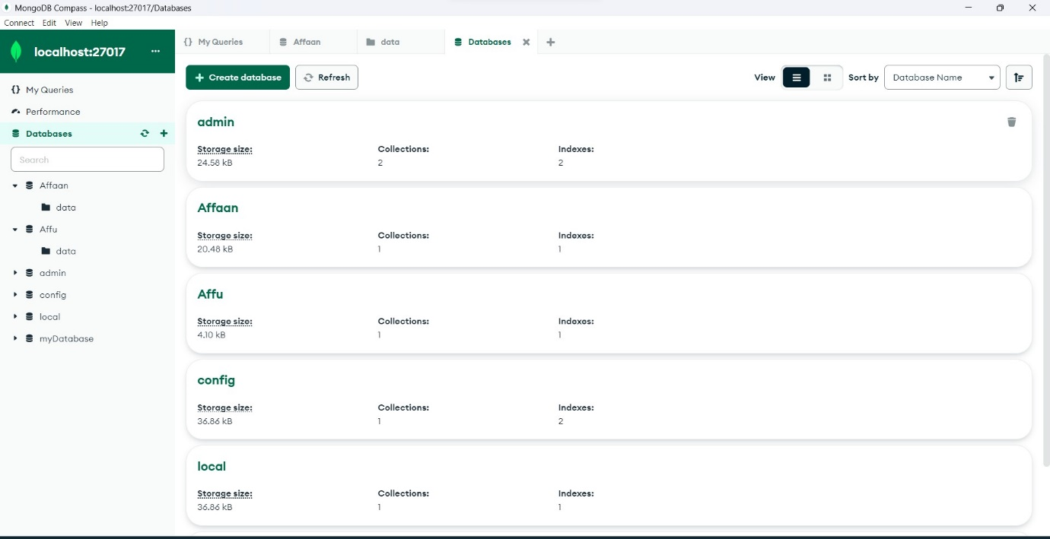

** CREATING A NEW DATABASE

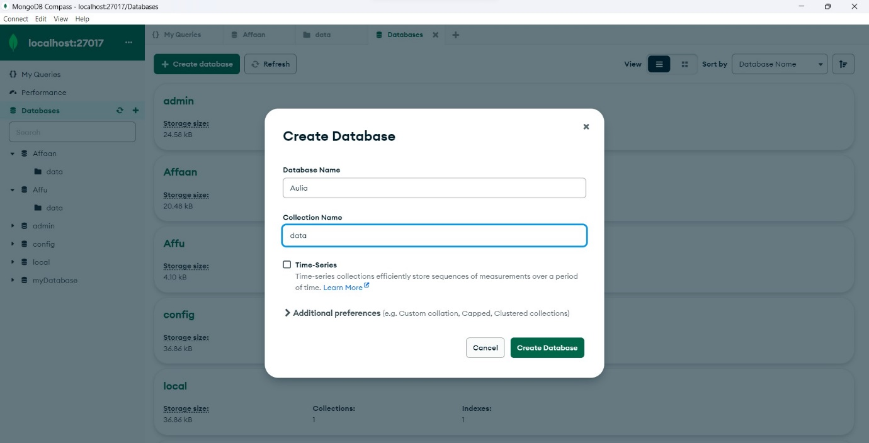

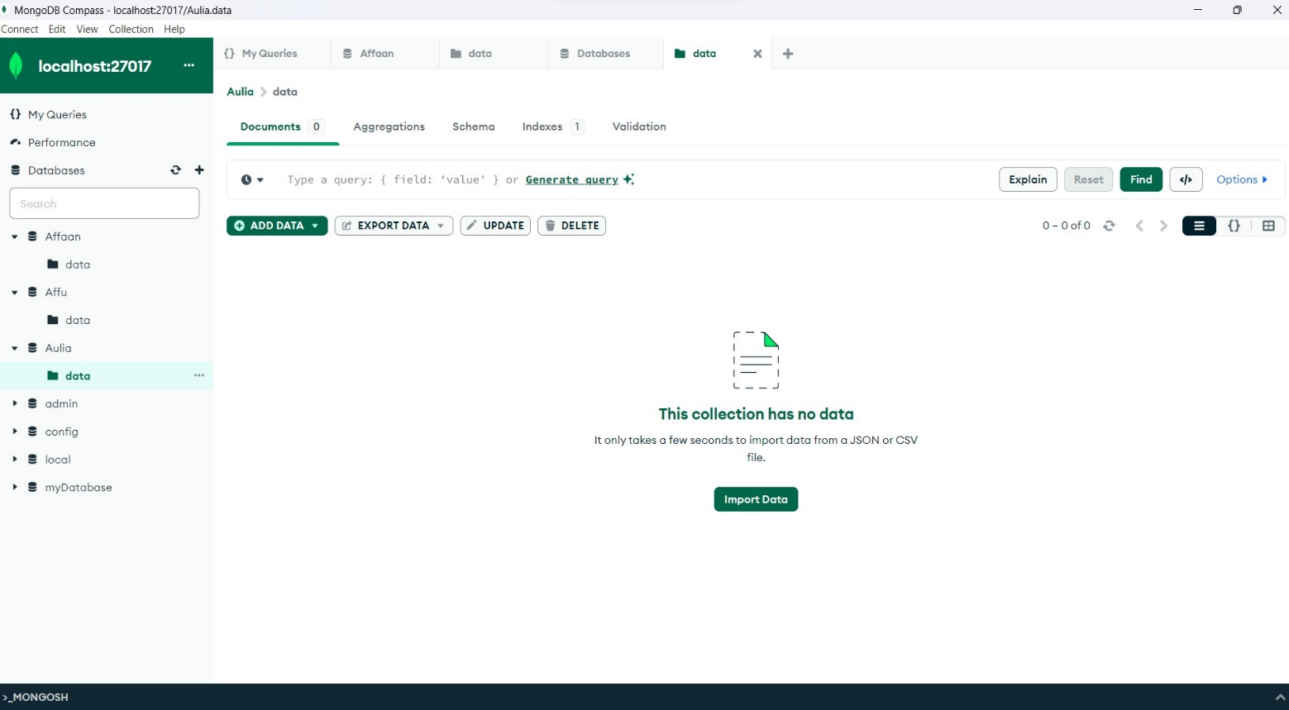

MONGOSH COMMAND LINE INTERFACE : --

