React.js Component Creation

name : A.S. AFFAAN SAFI

email : 20at1a0503@gpceet.ac.in

phone no **:**  7013104852

Roll NO : 20AT1A0503(CSE )

College Name : G . Pullaiah **College of Engineering & Technology**

source code :

CARD COMPONENT :

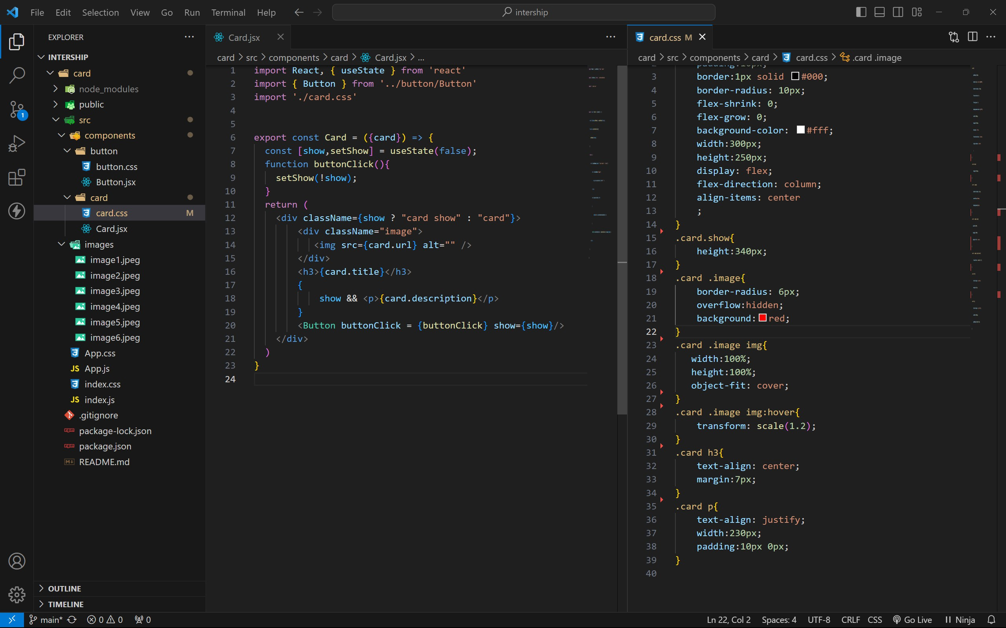

BUTTON COMPONENT :

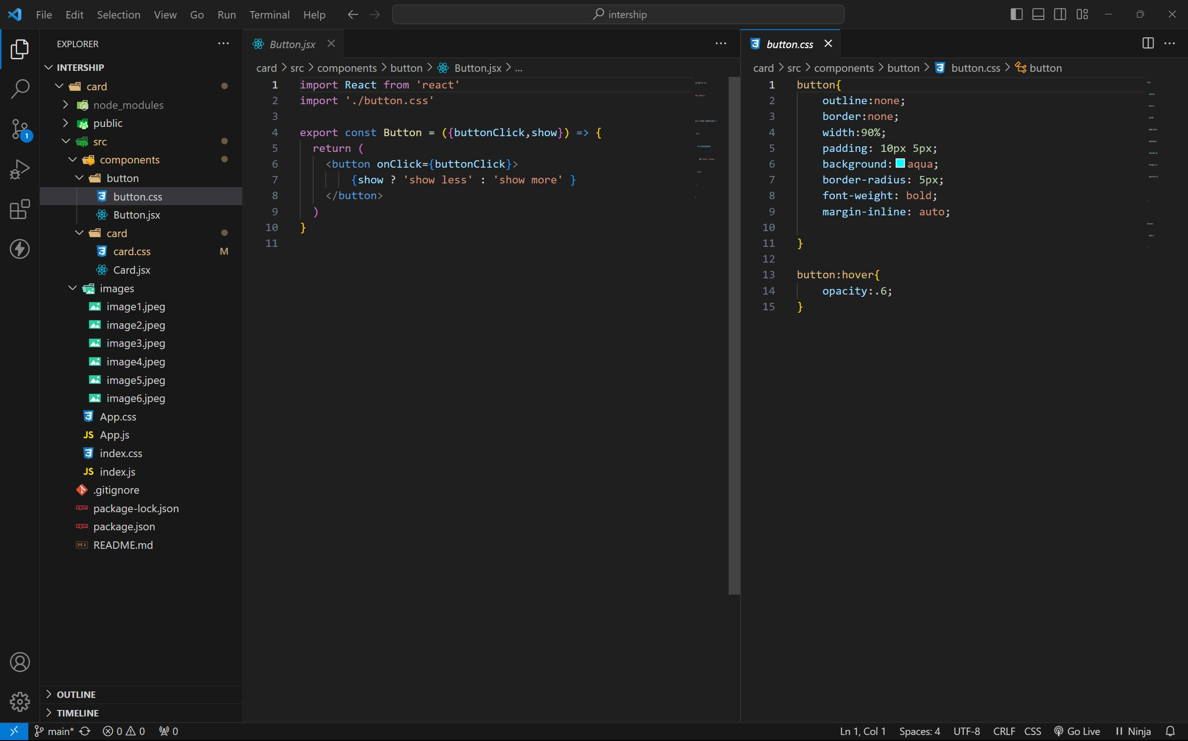

APP COMPONENT :

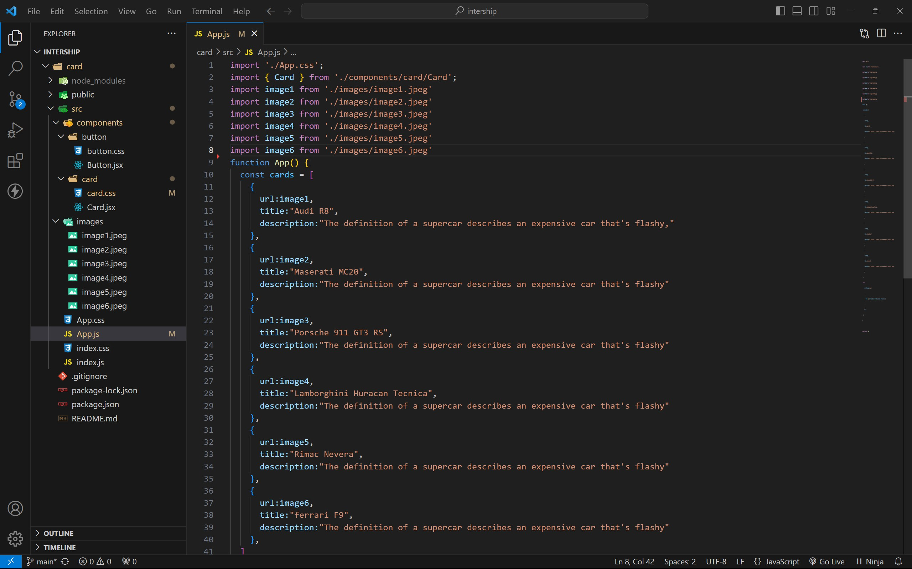

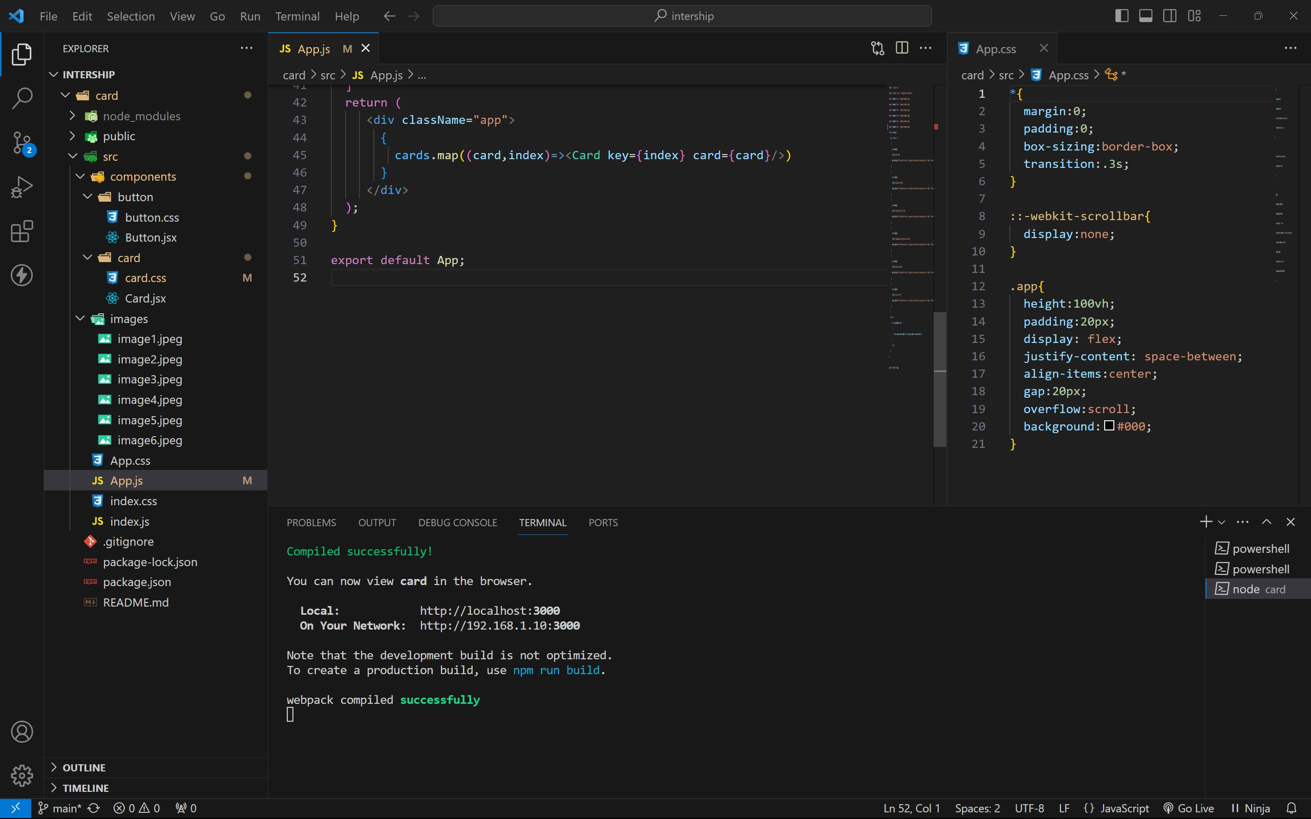

approach :

1. initially taking an array of objects like below

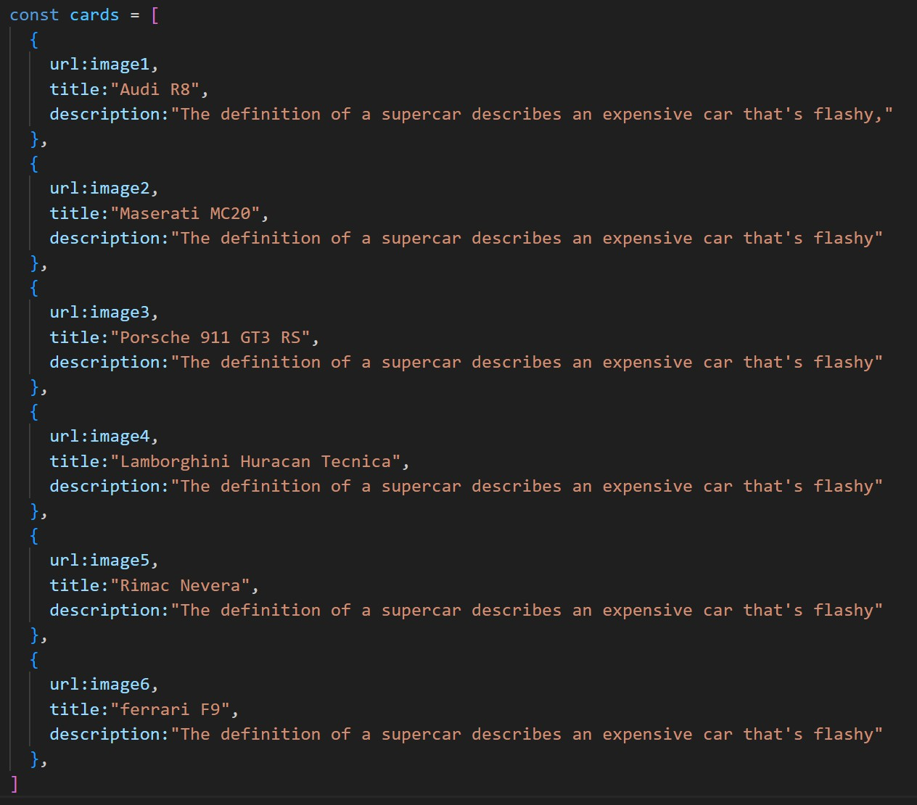

1. Passing this card array to child (card component) of App component by using props;
2. getting data as argument like {card} in card component.
3. in card component i use one state [show, setShow] to get extra info as description.
4. When we click the button then show becomes true by assigning setShow (!show) .

OUTPUT :

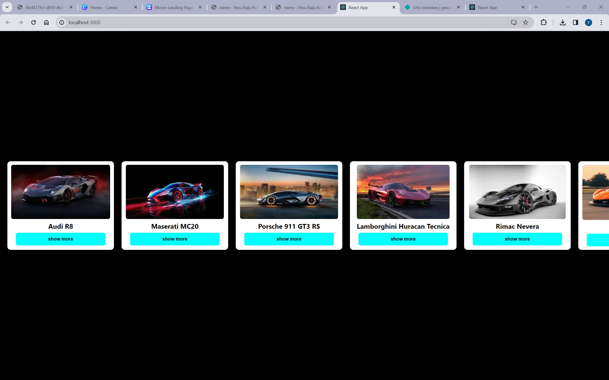

AFTER BUTTON CLICKS :

