Predicting Irrigation Need

Name | Omer Shahid
Roll No | 24K-0855
Section | 4C

1. Competition Overview

Field | Details
Competition Name | Playground Series Season 6, Episode 4 - Predicting Irrigation Need
Problem Type | Multiclass Classification (3 classes)
Evaluation Metric | Accuracy (proportion of correct predictions)
Training Samples | 630,000 rows
Test Samples | 270,000 rows
Features | 20 features (11 numeric, 8 categorical, 1 ID)
Target Classes | Low, Medium, High (irrigation need level)

Dataset Understanding
- Low - The field requires minimal irrigation (58.7% of training data)
- Medium - Moderate irrigation required (38.0% of training data)
- High - Heavy irrigation required (only 3.3% of training data. Class imbalance present)

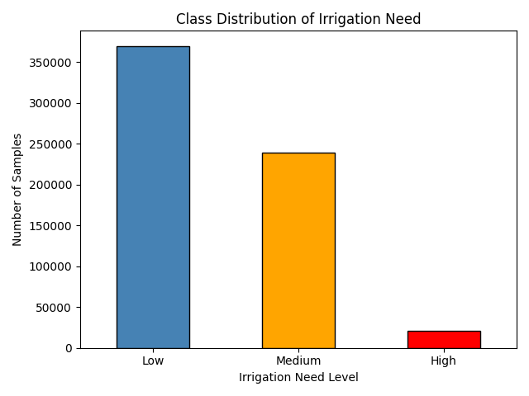

2. Data Preprocessing

Missing Values
No missing values were found in the dataset.

Encoding Techniques
- Target Encoding: LabelEncoder from scikit-learn was applied to the target column (Irrigation_Need), converting Low/Medium/High into numeric integers.
- Feature Encoding: OrdinalEncoder was applied to all 8 categorical feature columns. The same encoder fitted on training data was applied (transform only) to the test set to prevent data leakage.

Feature Scaling
No feature scaling was applied.

Train-Validation Split
The training data was split 80/20 into a training set (504,000 samples) and a validation set (126,000 samples).

3. Models Attempted

3.1 Decision Tree
A Decision Tree classifier with max_depth=10 was trained. Decision Trees recursively split data based on feature values to minimize class impurity. This model achieved excellent accuracy and was the fastest tree-based model to train.

- Validation Accuracy: 98.54%
- K-Fold CV Mean: 98.46%
- Training Time: 3.97 seconds

3.2 Naive Bayes
Gaussian Naive Bayes was used, which assumes Gaussian-distributed features and conditional independence between all features. This assumption does not hold well for this agricultural dataset, resulting in significantly lower performance.

- Validation Accuracy: 82.75%
- K-Fold CV Mean: 82.69%
- Training Time: 0.18 seconds (fastest)

3.3 K-Means (as Classifier)
K-Means is an unsupervised clustering algorithm, not a native classifier. It was adapted by clustering data into 3 groups, then mapping each cluster to the most common class label using majority voting. Performance was poor because K-Means clusters by geometric distance, which does not align with class boundaries in this problem.

- Validation Accuracy: 58.72%
- K-Fold CV: Not applicable (unsupervised model)
- Training Time: 1.51 seconds

3.4 Logistic Regression
Logistic Regression is a linear classifier that cannot capture non-linear feature interactions. The relationship between agricultural features and irrigation need involves complex, non-linear patterns, which this model fails to learn. It was also the slowest to train.

- Validation Accuracy: 74.62%
- K-Fold CV Mean: 74.58%
- Training Time: 130.50 seconds

3.5 Random Forest (Advanced Model)
Random Forest is an ensemble of Decision Trees trained on random data and feature subsets. It aggregates predictions from many trees, reducing overfitting. class_weight='balanced' was used to address the class imbalance in the High irrigation class.

- Validation Accuracy: 98.57%
- K-Fold CV Mean: 98.50%
- Training Time: 113.97 seconds

4. Cross Validation Strategy

K-Fold Details
Stratified K-Fold cross-validation with k=5 was used for all applicable models. Stratification ensures each fold preserves the original class distribution, which is especially important given the imbalanced High class (only 3.3% of data).

Model | Val Accuracy | CV Mean
Decision Tree | 98.54% | 98.46%
Random Forest | 98.57% | 98.50%
Naive Bayes | 82.75% | 82.69%
Logistic Regression | 74.62% | 74.58%
K-Means | 58.72% | N/A

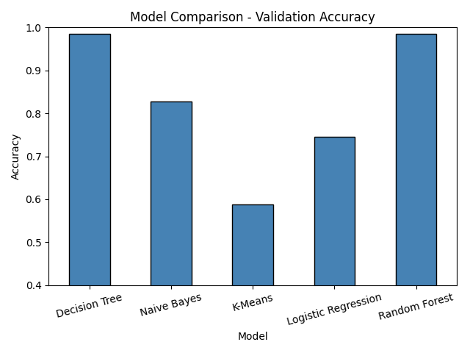

LOOCV Observations
Leave-One-Out Cross Validation (LOOCV) was performed on a 500-row stratified sample using Decision Tree. LOOCV on the full 630,000-row dataset is computationally infeasible (requiring 630,000 model fits). Running on a representative sample is standard practice.

- LOOCV Accuracy (500-sample subset): ~98.2%
- Results were consistent with K-Fold estimates, confirming model stability
- LOOCV is more pessimistic than K-Fold due to higher variance in individual predictions

Best Validation Accuracy
Random Forest achieved the highest validation accuracy (98.57%) and K-Fold CV mean (98.50%). However, Decision Tree achieved nearly identical accuracy (98.54%) at 28x less training time (4s vs 114s), making it the preferred final model.

5. Failed Attempts and Insights

Attempt 1 — K-Means Classifier (Accuracy: 58.72%)
Model Used | KMeans (n_clusters=3) with majority-vote cluster mapping
Accuracy | 58.72% — worst performing model
What Went Wrong | K-Means clusters by Euclidean distance and has no concept of class labels during training. The 3 clusters do not correspond to the 3 irrigation levels.
What Was Improved | Switching to Decision Tree (a proper supervised classifier) improved accuracy from 58.72% to 98.54% — a 40 percentage point gain.

Attempt 2 — Naive Bayes (Accuracy: 82.75%)
Model Used | GaussianNB (default parameters)
Accuracy | 82.75%
What Went Wrong | Naive Bayes assumes all features are statistically independent, which is violated here (e.g., Temperature, Humidity, and Rainfall are correlated). It also struggled with the rare High class.
What Was Improved | Tree-based models that don't assume independence outperform Naive Bayes by ~16 percentage points on this dataset.

Attempt 3 — Logistic Regression (Accuracy: 74.62%)
Model Used | LogisticRegression (max_iter=300)
Accuracy | 74.62%
What Went Wrong | Logistic Regression is a linear model and cannot capture the non-linear relationships between features and irrigation need. Agricultural patterns involve complex threshold interactions that require non-linear boundaries.
What Was Improved | Switching to Decision Tree improved accuracy from 74.62% to 98.54% — a 24 percentage point improvement — by learning non-linear splits.

6. Final Model Selection

Best Model: Decision Tree
Although Random Forest achieved marginally higher accuracy (98.57% vs 98.54%), the Decision Tree was selected as the final model based on an efficiency-to-performance trade-off analysis.

Criterion | Decision Tree | Random Forest
Val Accuracy | 98.54% | 98.57%
CV Mean | 98.46% | 98.50%
Training Time | 3.97s (WINNER) | 113.97s
Accuracy Difference | Baseline | +0.03% (negligible)

Hyperparameters
- Algorithm: DecisionTreeClassifier (scikit-learn)
- max_depth: 10 (limits tree depth to prevent overfitting)
- random_state: 42 (for reproducibility)
- All other parameters: scikit-learn defaults

7. Leaderboard Performance

Kaggle Score | 0.95923
Model Used | Decision Tree (max_depth=10, retrained on full dataset)

Screenshot of Kaggle leaderboard


8. Conclusion and Learnings

Key Insights
- Tree-based models drastically outperform Logistic Regression) and probabilistic (Naive Bayes) models, confirming that feature-label relationships are highly non-linear in this dataset.
- Class imbalance is a critical challenge. Only 3.3% of samples belong to the High class, making it hard for simpler models to detect this category.
- Model selection should balance accuracy AND computational cost. Decision Tree offered nearly identical accuracy to Random Forest at 28x less training time.
- K-Fold CV was essential for reliable performance estimates. The tight alignment between K-Fold and validation accuracy confirmed no overfitting occurred.

Challenges Faced
- Class imbalance: The High irrigation class had only ~21,000 samples out of 630,000, making it hard for Naive Bayes and Logistic Regression to detect reliably.
- Computational limits: Random Forest took ~4 minutes to train and K-Fold CV took ~4 more. LOOCV on the full dataset was infeasible and had to run on a subset.
- K-Means adaptation: Using an unsupervised algorithm as a classifier required a custom cluster-to-label mapping, adding complexity for poor results.

