AI Assignment 3 - Kaggle Report

Student Information
Name: Muhammad Affan Rasheed
Roll No: 24K-0579
Section: BCS-4C
Submission Date: 26 April ,2026

1. Competition Overview
- Competition Name: Predicting Irrigation Need Playground Series - Season 6 Episode 4
- Problem Type: multi class classification
- Evaluation Metric: balanced accuracy between the predicted class and observed target.
- Brief understanding of the dataset: Irrigation need with 3 classes Low,Medium,high

2. Data Preprocessing
- Missing values handling : No missing values were found in either the training or test dataset.
- Encoding techniques:
- OrdinalEncoder was used for all categorical features with handle_unknown='use_encoded_value' to handle any unseen categories gracefully
- LabelEncoder was applied to the target variable (Irrigation_Need) to convert Low/Medium/High to numeric labels
- Both encoder fits were done on training data only and then applied to validation and test sets

- Feature scaling:
- StandardScaler was applied after encoding to normalize all features to zero mean and unit variance
- Scaler was fit only on training data to prevent data leakage

- Train-validation split:
- 80/20 split: 504,000 training samples, 126,000 validation samples
- random_state=42 for reproducibility

3. Models Attempted
-All models attempted belonged to sklearn library
Model | Key Parameters
Decision Tree | max_depth=10, random_state=42
Naive Bayes | GaussianNB (default)
K-Means as Classifier | n_clusters=3, n_init=10, majority vote mapping
Logistic Regression | max_iter=1000, random_state=42
Random Forest | n_estimators=100, max_depth=15, n_jobs=-1

Decision Tree
- Used max_depth=10 to prevent overfitting on the large dataset
- Fast to train and provides good baseline accuracy

Naive Bayes
- GaussianNB used assuming continuous features follow normal distribution
- Simplest probabilistic model; expected lower accuracy due to feature independence assumption

K-Means as Classifier
- Fitted K-Means with 3 clusters (matching 3 target classes)
- Each cluster was mapped to the majority class label from training labels
- Unsupervised method adapted for classification — performance expectedly lower

Logistic Regression
- Multi-class logistic regression with increased max_iter=1000 for convergence
- Linear decision boundaries; good for understanding feature importance

Random Forest (Final Model)
- Ensemble of 100 decision trees with max_depth=15
- n_jobs=-1 used to parallelize training across all CPU cores
- Best performing model due to reduced variance through bagging

4. Cross Validation Strategy

K-Fold Cross Validation
- K-Fold CV was performed on the Decision Tree model due to computational constraints of running 5-fold CV on Random Forest with 630,000 rows."KFold with shuffle=True and random_state=42 for consistent splits
- Each fold: ~504,000 training, ~126,000 validation samples
K-Fold Mean Accuracy: 0.9847
K-Fold Std Dev: 0.0003357

LOOCV Observations
- LOOCV is computationally infeasible on 630,000 rows
- Applied LOOCV on a random sample of 200 rows from the training data
- Each sample used as test once while remaining 199 used for training

LOOCV Accuracy (200 samples): 0.795
LOOCV confirmed that the model generalizes well even on very small subsets, though it is expensive to run.
Best Validation Accuracy: 0.985151

5. Failed Attempts and Insights
Model | Accuracy | Issue | What Was Improved
Naive Bayes  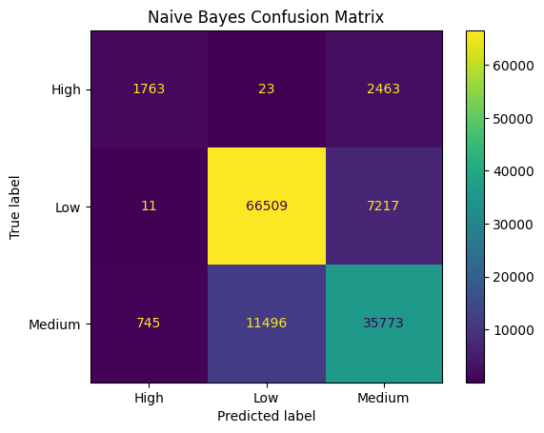 | 0. 825754 | Feature independence assumption violated; poor on correlated features | Switched to tree-based models
K-Means  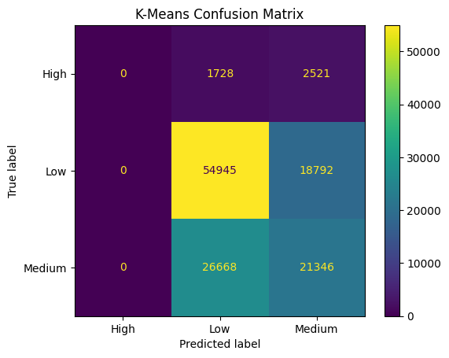 | 0.605484 | Unsupervised; cluster-to-class mapping was unstable and inaccurate | Used supervised classifiers instead
Logistic Regression  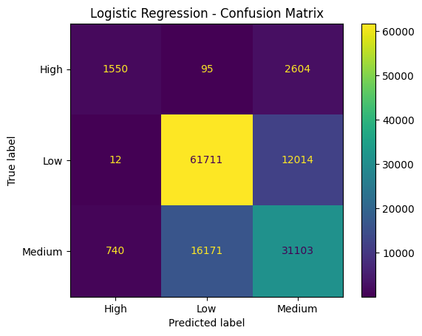 | 0.748921 | Linear boundaries insufficient for complex interactions in agricultural data | Used non-linear ensemble model

6. Final Model Selection
Best Model: Random Forest Classifier
Hyperparameters
Parameter | Value | Reason
n_estimators | 100 | Enough trees for stable predictions without excessive training time
max_depth | 15 | Prevents overfitting while capturing complex patterns
random_state | 42 | Reproducibility
n_jobs | -1 | Uses all CPU cores for faster training

Why Random Forest Was Selected
- Highest validation accuracy among all models tested
- Handles both categorical (after encoding) and numerical features well
- Robust to overfitting due to ensemble averaging
- No strong assumptions about data distribution unlike Naive Bayes
- Handles class imbalance better than single trees (Low: 58.7%, High: 3.3%)

Final Validation Accuracy: Random Forest - 98.985% (0.985151)

7. Leaderboard Performance
Kaggle Score: 0.95543
Rank: 2837



8. Conclusion and Learnings

Key Insights
- Random Forest significantly outperformed simpler models like Naive Bayes and K-Means on this dataset
- The dataset had a class imbalance with 'High' irrigation need being very rare (3.3%) which affected recall for that class
- Feature encoding and scaling were critical preprocessing steps for all models to function correctly
- K-Means when used as a classifier is unreliable since it has no concept of class labels during training
- 5-Fold CV gave consistent results suggesting the model is not overfitting

Challenges Faced
- Large dataset size (630,000 rows) made LOOCV and some model training very slow
- Class imbalance meant accuracy alone was not always the best indicator of model quality
- K-Means cluster-to-label mapping was non-trivial and gave poor results
- Logistic Regression required many iterations to converge on scaled data

Future Improvements
- Try XGBoost or LightGBM which are faster and often more accurate than Random Forest
- Apply SMOTE or class weighting to better handle the imbalanced 'High' irrigation class
- Perform feature importance analysis to remove irrelevant features
- Tune Random Forest hyperparameters using GridSearchCV for better accuracy
- Explore feature engineering such as combining soil and weather features

