Operating Systems Theory Assignment 1 : Linux Kernel Development and System Call Implementation
Student Name: Muhammad Affan Rasheed
Student ID: k240579
Kernel Version: 6.17.0-14-generic to 6.19.5-k240579
Date: March 4, 2026

Steps:
- Check Current Kernel: Before starting, verify the base system kernel using uname -r.
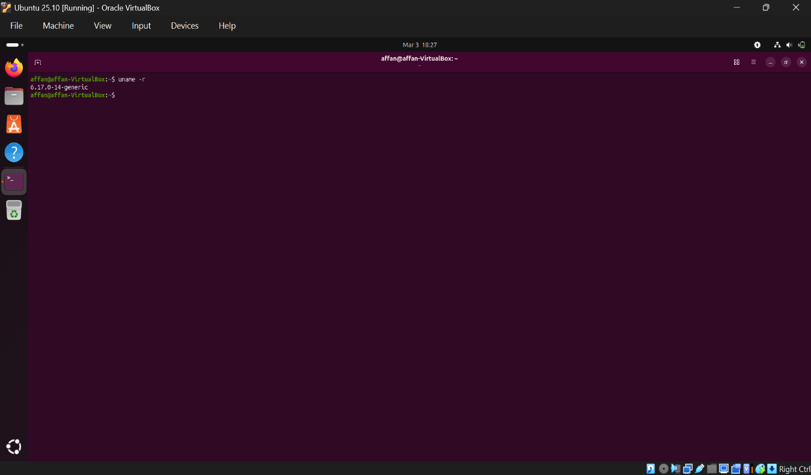

- Install Essential Dependencies: Prepared the environment by updating the package list and installing necessary development libraries:
- sudo apt update
- sudo apt install libdw-dev libelf-dev -y
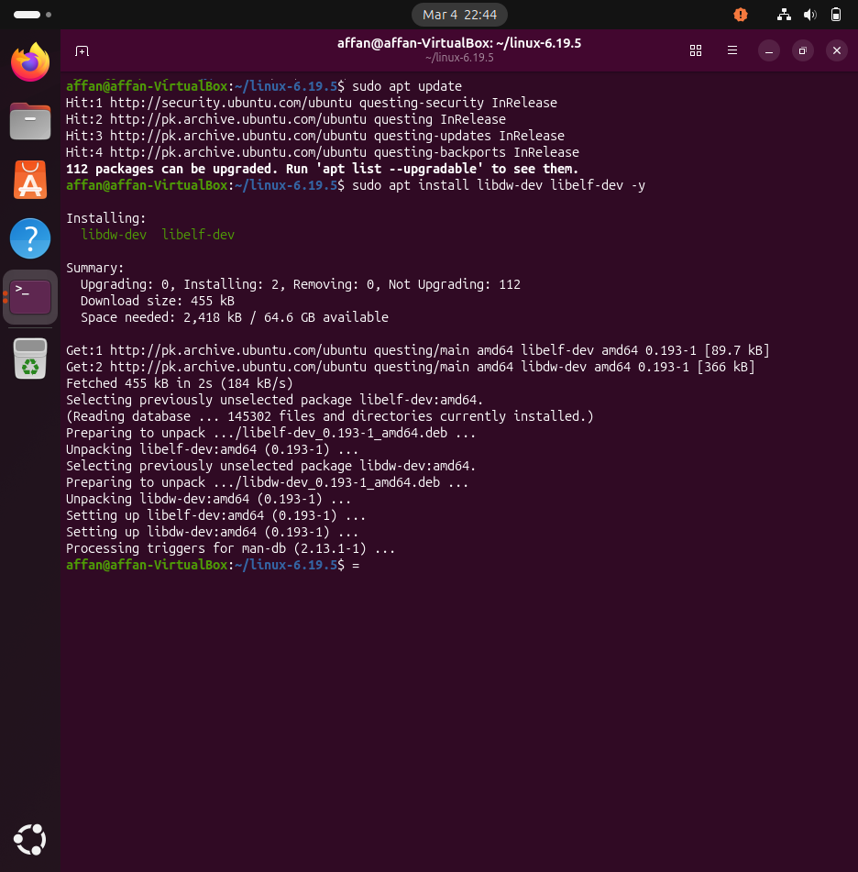
- Downloaded the Linux Kernel 6.19.5 source code to the home directory.
- Kernel Configuration & Key Fixes:
- Generated the initial configuration by copying the current system config: cp /boot/config-$(uname -r) .config.
- Applied Critical Security/Build Fixes: To prevent build failures related to Ubuntu's trusted keys and debugging info, the following scripts were used:
  - scripts/config --set-str SYSTEM_TRUSTED_KEYS ""
  - scripts/config --set-str SYSTEM_REVOCATION_KEYS ""
  - scripts/config --disable DEBUG_INFO_BTF
- Verification: Verified these changes using grep -E "CONFIG_SYSTEM_TRUSTED_KEYS|CONFIG_SYSTEM_REVOCATION_KEYS|CONFIG_DEBUG_INFO_BTF" .config.
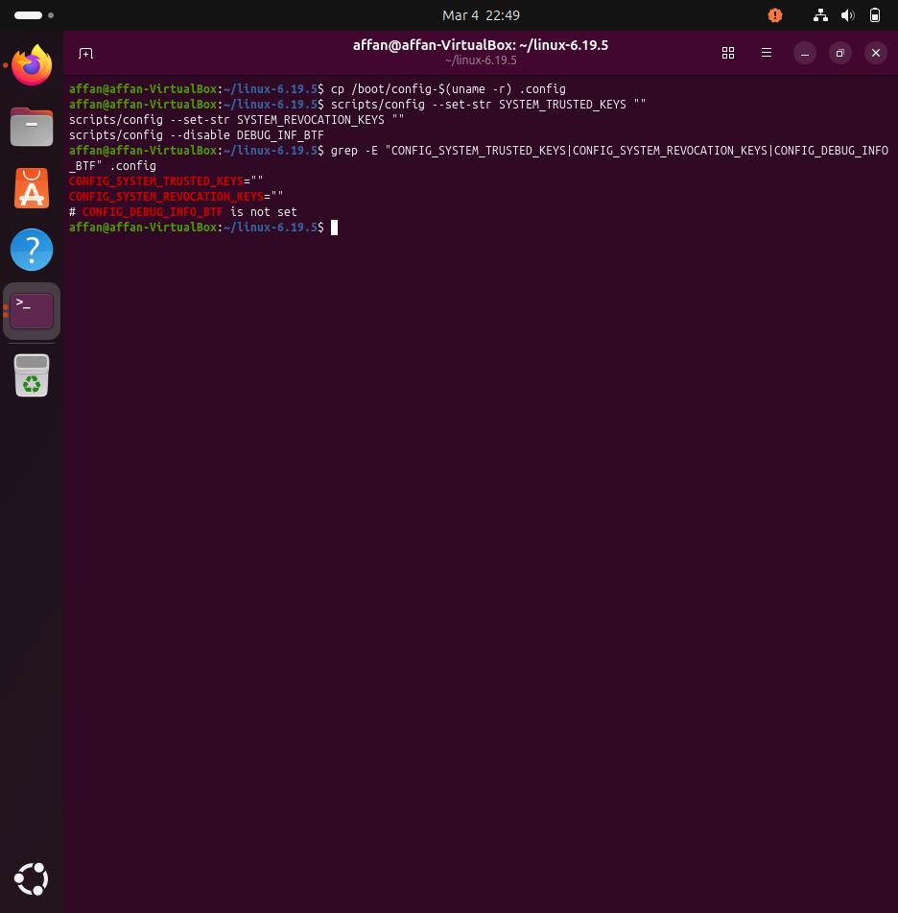
(without clearing these values got debian/canonical-certs.pem missing target error in compilation)

- Create Syscall Directory: Inside the source folder, created a directory named hello.
- Implement Syscall: * Created hello.c inside that folder containing the printk function to display "Hello World from k240579! (Muhammad Affan Rasheed)".
  - Created a Makefile in the same folder to ensure hello.o is compiled into the kernel.
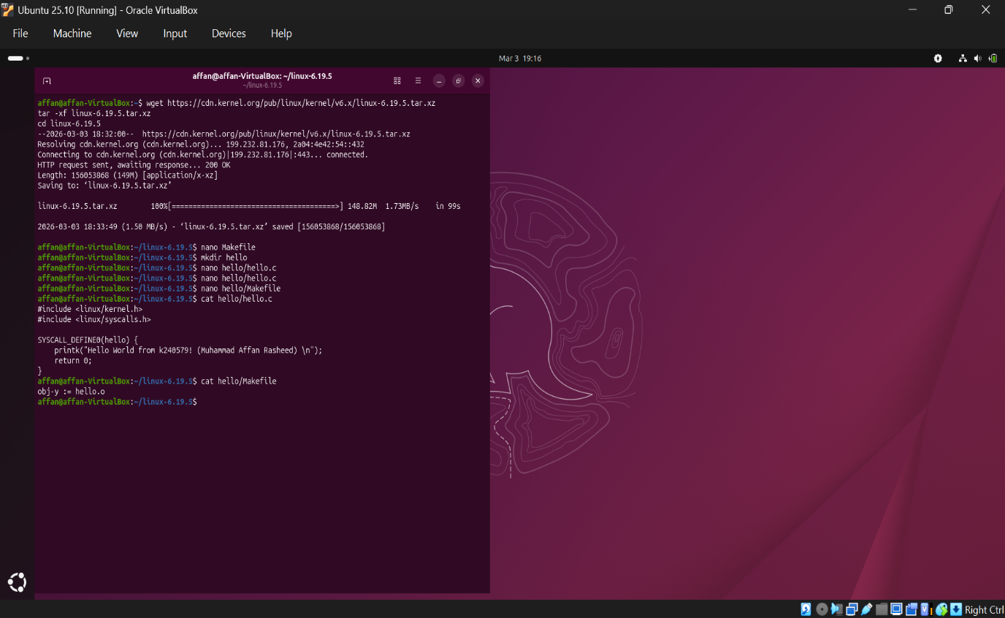

- Personalize Kernel Version (Roll No): Configured the kernel's Local Version to include the roll number -k240579. This was done via make menuconfig under General Setup (setting CONFIG_LOCALVERSION="-k240579"), ensuring the final kernel identity is unique to this submission.
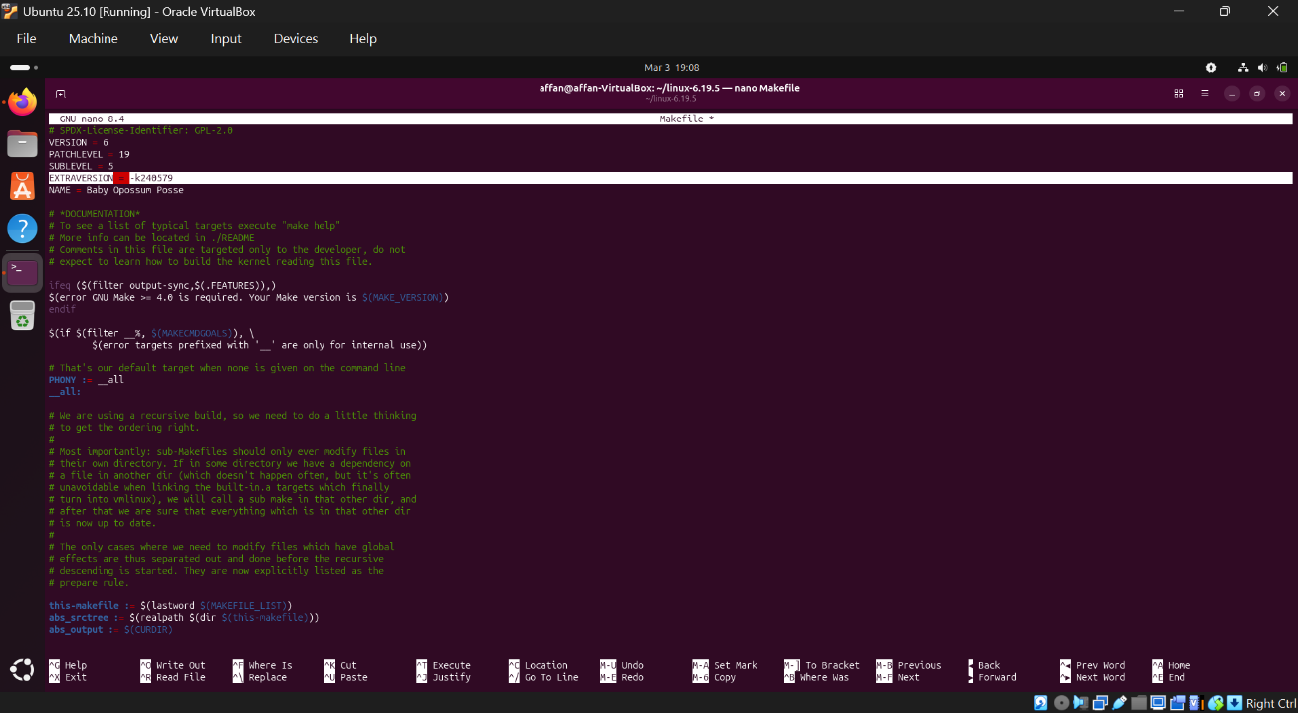

- Register Syscall: Added the syscall to the table:
  - Path: arch/x86/entry/syscalls/syscall_64.tbl
  - Entry: Added ID 471 as common hello sys_hello.
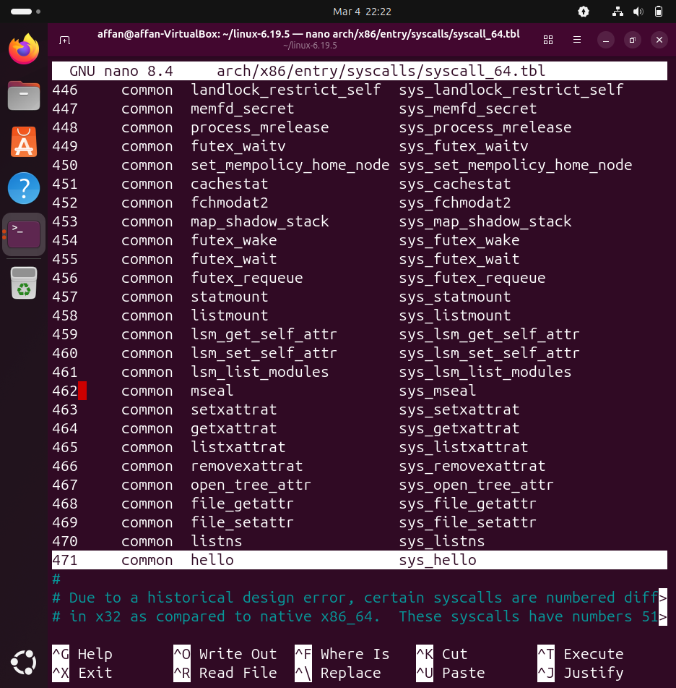

- Compilation
  - Dependency Resolution: During the initial phase, the build failed due to a missing utility. Resolved this by installing gawk.
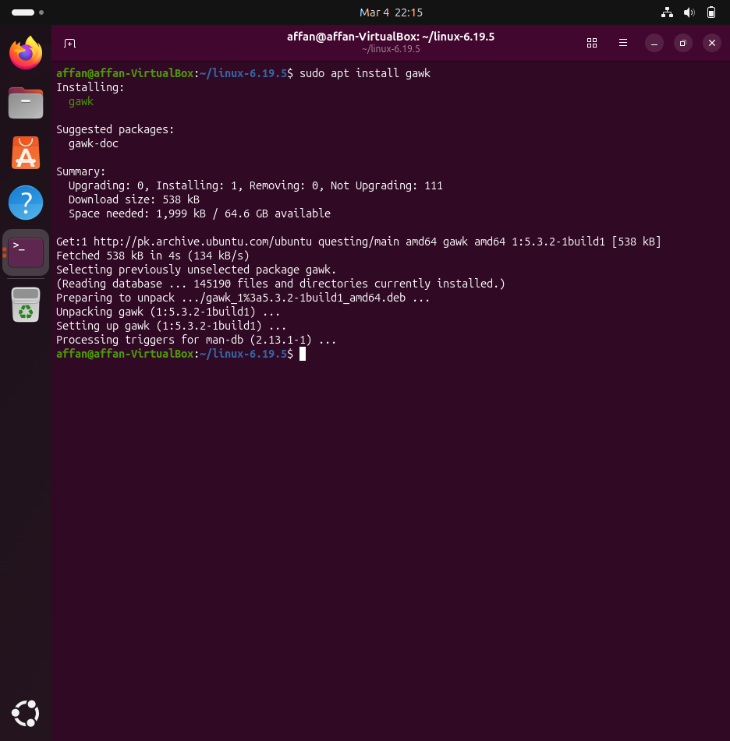
  - Multi-Core Build: Executed the compilation using all available processor cores to optimize speed: make -j$(nproc). The process completed in approximately 10 hours. (dunno why it took this long but the main reason could be because there were about 29 GB of files that needed to be compiled and linked)

- Verify Build Success: Confirmed the successful generation of the kernel images:
  - Ran ls -l vmlinux arch/x86/boot/bzImage.
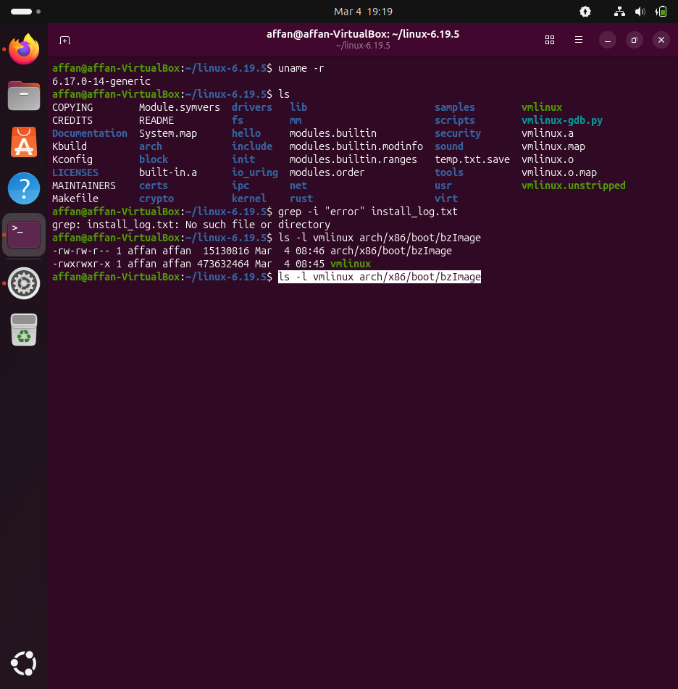

- Install Modules: Executed sudo make modules_install 2>&1 | tee install_log.txt to install drivers to /lib/modules/6.19.5-k240579/.
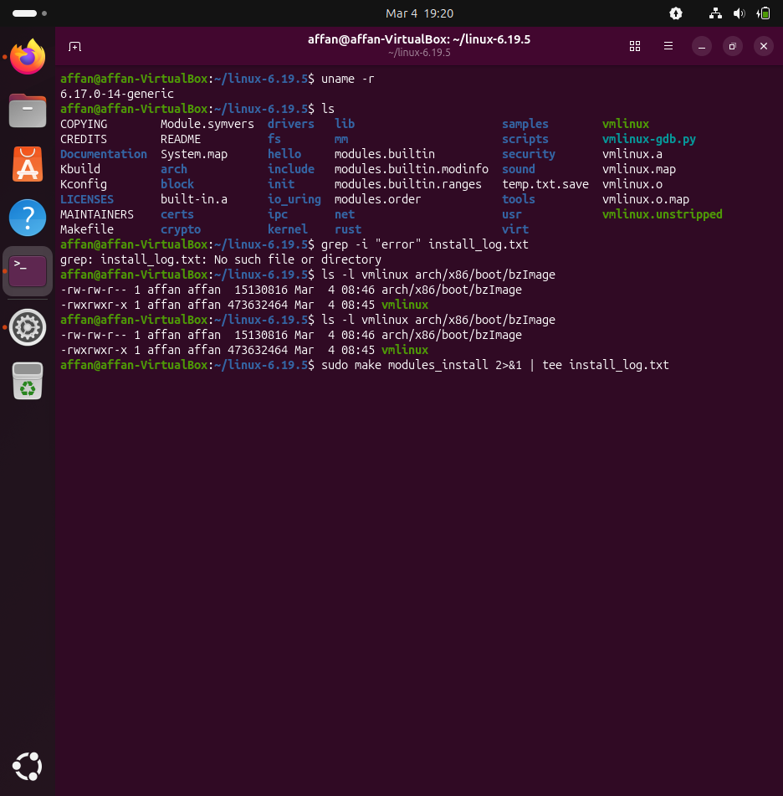

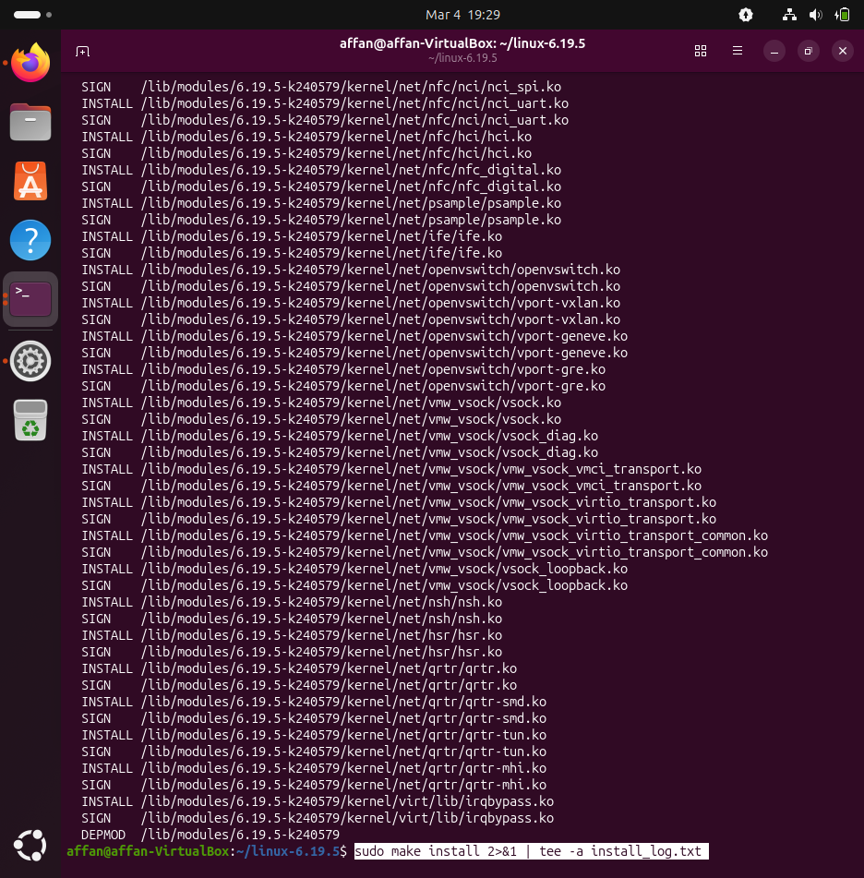

- Install Kernel to Bootloader: Executed sudo make install 2>&1 | tee -a install_log.txt.
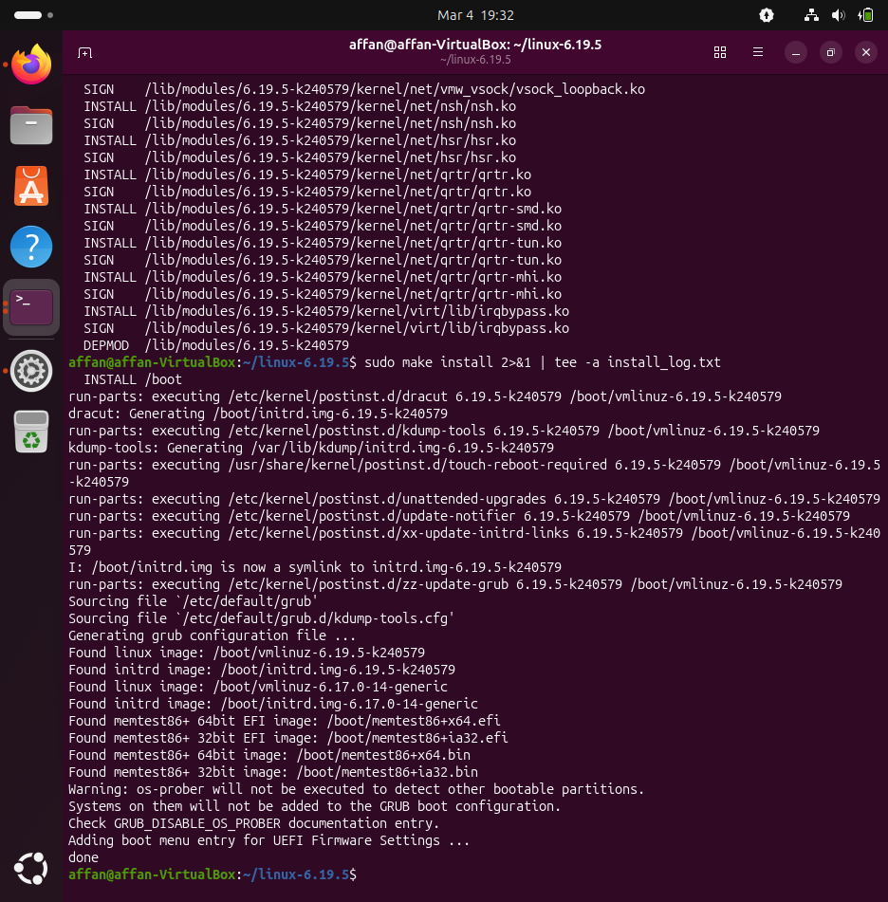

- Verify Boot Files: Confirmed the installation by running ls -lh /boot/vmlinuz-6.19.5*, verifying the 15MB bootable image.
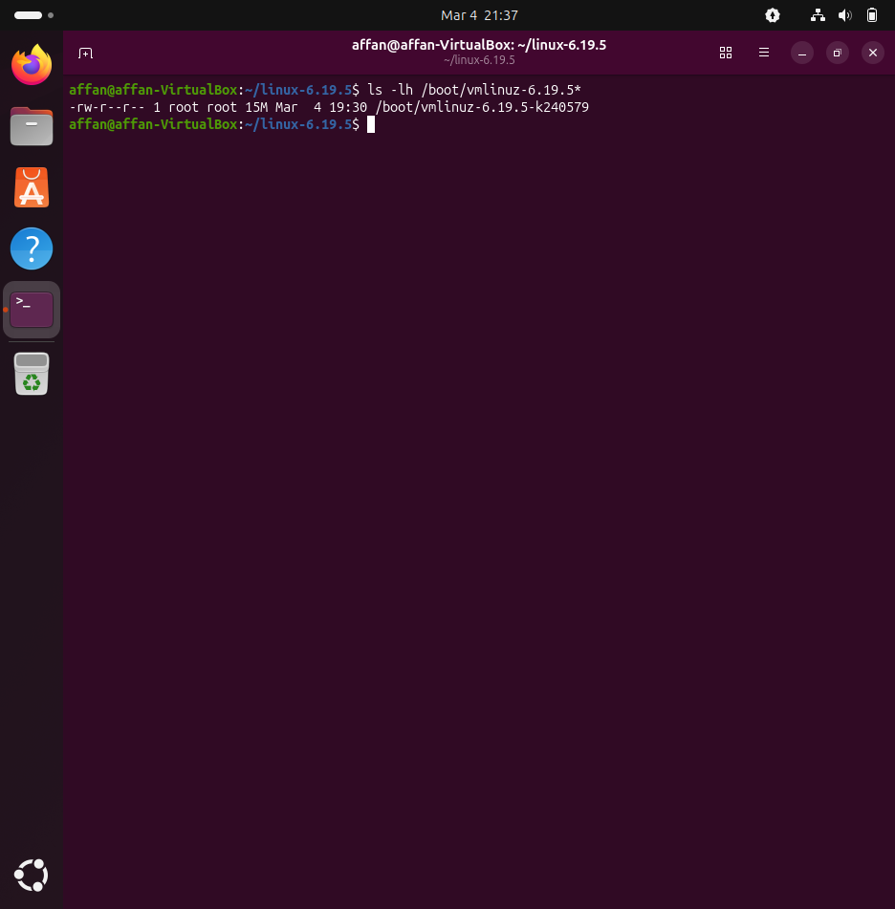

- Reboot into New Kernel: Restarted the VM

- Verify Active Version: Ran uname -r.
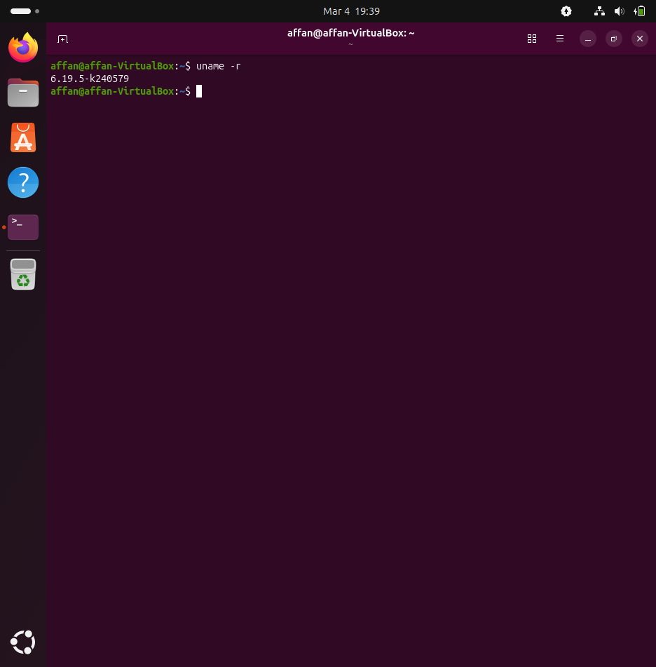

- User-Space Test:
  - Created test_hello.c using the syscall(471) wrapper.
  - Compiled and executed: ./test_hello. Result: "System call returned 0".
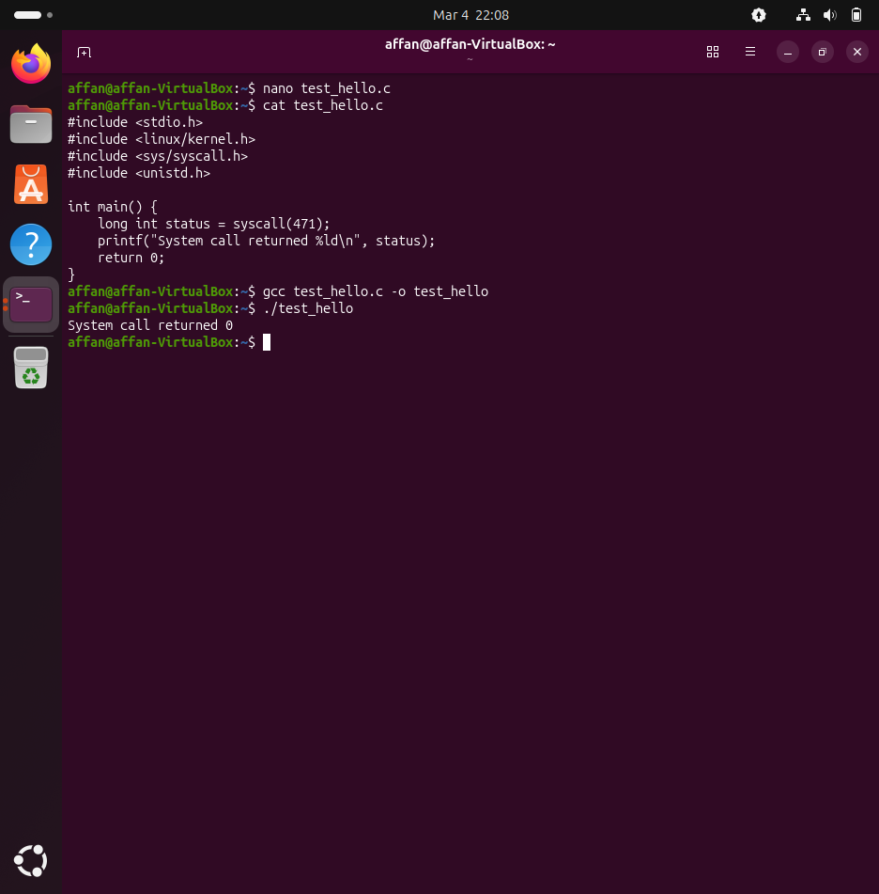

- Kernel Log Check: Ran sudo dmesg | tail.
