K240579 – OS ASSIGNMENT 2 – QUESTIONS 2,3,4

Q2:
//used alternate smaller values for N, TILE, AND M as output was taking too long
#include <stdio.h>
#include <stdlib.h>
#include <pthread.h>
#include <math.h>
#include <float.h>
#include <string.h>

#define N 4 //used 4 instead of 1000
#define TILE 2 //used 2 instead of 100
#define TILES (N / TILE)
#define M 2 //used 2 instead of 4
#define HOT 35.0
#define COLD -10.0
#define NAN_VAL -9999.0
#define THREADS 100

double sat[M][N][N], global[N][N], overlap[N][N], norm[N][N], risk[N][N];
double gmax, gmin, gmean, gvar;
int anomalies, hcount = 0, ccount = 0;

typedef struct {
int r;
int c;
} Cell;

Cell hot[N*N], cold[N*N];

typedef struct {
double max;
double min;
double avg;
double var;
double std;
int anom;
} Tile;
Tile tiles[TILES][TILES];
pthread_mutex_t m_merge = PTHREAD_MUTEX_INITIALIZER;
pthread_mutex_t m_stat = PTHREAD_MUTEX_INITIALIZER;
pthread_mutex_t m_hot = PTHREAD_MUTEX_INITIALIZER;
pthread_mutex_t m_cold = PTHREAD_MUTEX_INITIALIZER;
pthread_mutex_t m_q = PTHREAD_MUTEX_INITIALIZER;

pthread_barrier_t b1, b2;
pthread_cond_t cond = PTHREAD_COND_INITIALIZER;

int q[TILES*TILES][2], qh = 0, qt = 0, done = 0;

int isnanv(double v) {
if (v == NAN_VAL) {
return 1;
} else {
return 0;
}
}
void *sat_thread(void *arg) {
int s = *(int*)arg;
free(arg);

for (int r = 0; r < N; r++) {
for (int c = 0; c < N; c++) {
if (isnanv(sat[s][r][c])) {
double sum = 0;
int cnt = 0;
int dr[4] = {-1, 1, 0, 0};
int dc[4] = {0, 0, -1, 1};

for (int d = 0; d < 4; d++) {
int nr = r + dr[d];
int nc = c + dc[d];

if (nr >= 0 && nr < N && nc >= 0 && nc < N && !isnanv(sat[s][nr][nc])) {
sum += sat[s][nr][nc];
cnt++;
}
}
if (cnt != 0) {
sat[s][r][c] = sum / cnt;
} else {
sat[s][r][c] = 0;
}
}
}
}
for (int r = 0; r < N; r++) {
for (int c = 0; c < N; c++) {
pthread_mutex_lock(&m_merge);
global[r][c] += sat[s][r][c];
overlap[r][c] += 1;
pthread_mutex_unlock(&m_merge);
}
}

pthread_barrier_wait(&b1);
return NULL;
}
void *tile_thread(void *arg) {
while (1) {
pthread_mutex_lock(&m_q);

while (qh == qt && !done) {
pthread_cond_wait(&cond, &m_q);
}

if (qh == qt && done) {
pthread_mutex_unlock(&m_q);
break;
}
int tr = q[qh][0];
int tc = q[qh][1];
qh++;

pthread_mutex_unlock(&m_q);
int r0 = tr * TILE;
int c0 = tc * TILE;
double mx = -DBL_MAX;
double mn = DBL_MAX;
double sum = 0;

for (int r = r0; r < r0 + TILE; r++) {
for (int c = c0; c < c0 + TILE; c++) {
double v = global[r][c];
if (v > mx) {
mx = v;
}
if (v < mn) {
mn = v;
}
sum += v;
}
}
double avg = sum / (TILE * TILE);
double var = 0;
double std;
double an = 0;

for (int r = r0; r < r0 + TILE; r++) {
for (int c = c0; c < c0 + TILE; c++) {
double d = global[r][c] - avg;
var += d * d;
}
}
var /= TILE * TILE;
std = sqrt(var);

for (int r = r0; r < r0 + TILE; r++) {
for (int c = c0; c < c0 + TILE; c++) {
if (fabs(global[r][c] - avg) > 2 * std) {
an++;
}
}
}
tiles[tr][tc] = (Tile){mx, mn, avg, var, std, an};

pthread_mutex_lock(&m_stat);
if (mx > gmax) {
gmax = mx;
}
if (mn < gmin) {
gmin = mn;
}
gmean += avg * TILE * TILE;
gvar += var;
anomalies += an;
pthread_mutex_unlock(&m_stat);
}
return NULL;
}

void *hot_thread(void *arg) {
for (int r = 0; r < N; r++) {
for (int c = 0; c < N; c++) {
if (global[r][c] > HOT) {
pthread_mutex_lock(&m_hot);
hot[hcount].r = r;
hot[hcount].c = c;
hcount++;
pthread_mutex_unlock(&m_hot);
}
}
}
pthread_barrier_wait(&b2);
return NULL;
}

void *cold_thread(void *arg) {
for (int r = 0; r < N; r++) {
for (int c = 0; c < N; c++) {
if (global[r][c] < COLD) {
pthread_mutex_lock(&m_cold);
cold[ccount].r = r;
cold[ccount].c = c;
ccount++;
pthread_mutex_unlock(&m_cold);
}
}
}
pthread_barrier_wait(&b2);
return NULL;
}

void *norm_thread(void *arg) {
double range = gmax - gmin;
if (!range) {
range = 1;
}

for (int r = 0; r < N; r++) {
for (int c = 0; c < N; c++) {
norm[r][c] = (global[r][c] - gmin) / range;
}
}
pthread_barrier_wait(&b2);
return NULL;
}

int dist(int r1, int c1, int r2, int c2) {
return abs(r1 - r2) + abs(c1 - c2);
}

void *risk_thread(void *arg) {
pthread_barrier_wait(&b2);

for (int r = 0; r < N; r++) {
for (int c = 0; c < N; c++) {
double ph = 0;
double pc = 0;

for (int i = 0; i < hcount; i++) {
ph += 1.0 / (dist(r, c, hot[i].r, hot[i].c) + 1);
}

for (int i = 0; i < ccount; i++) {
pc += 1.0 / (dist(r, c, cold[i].r, cold[i].c) + 1);
}

risk[r][c] = norm[r][c] * ph / (pc + 1);
}
}
return NULL;
}

int main() {
srand(42);

for (int s = 0; s < M; s++) {
for (int r = 0; r < N; r++) {
for (int c = 0; c < N; c++) {
if (rand() % 10 == 0) {
sat[s][r][c] = NAN_VAL;
} else {
sat[s][r][c] = -20 + ((double)rand() / RAND_MAX) * 70;
}
}
}
}

memset(global, 0, sizeof(global));
memset(overlap, 0, sizeof(overlap));

gmax = -DBL_MAX;
gmin = DBL_MAX;

pthread_barrier_init(&b1, NULL, M + 1);

pthread_t st[M];
for (int i = 0; i < M; i++) {
int *x = malloc(sizeof(int));
*x = i;
pthread_create(&st[i], NULL, sat_thread, x);
}

pthread_barrier_wait(&b1);

for (int i = 0; i < M; i++) {
pthread_join(st[i], NULL);
}

for (int r = 0; r < N; r++) {
for (int c = 0; c < N; c++) {
if (overlap[r][c]) {
global[r][c] /= overlap[r][c];
}
}
}

for (int i = 0; i < TILES; i++) {
for (int j = 0; j < TILES; j++) {
q[qt][0] = i;
q[qt][1] = j;
qt++;
}
}

pthread_t rt[THREADS];
for (int i = 0; i < THREADS; i++) {
pthread_create(&rt[i], NULL, tile_thread, NULL);
}

pthread_mutex_lock(&m_q);
done = 1;
pthread_cond_broadcast(&cond);
pthread_mutex_unlock(&m_q);

for (int i = 0; i < THREADS; i++) {
pthread_join(rt[i], NULL);
}

gmean /= N * N;
gvar /= TILES * TILES;

pthread_barrier_init(&b2, NULL, 4);

pthread_t A, B, C, R;
pthread_create(&A, NULL, hot_thread, NULL);
pthread_create(&B, NULL, cold_thread, NULL);
pthread_create(&C, NULL, norm_thread, NULL);
pthread_create(&R, NULL, risk_thread, NULL);

pthread_join(A, NULL);
pthread_join(B, NULL);
pthread_join(C, NULL);
pthread_join(R, NULL);

printf("Max %.2f Min %.2f Mean %.2f Var %.4f\n", gmax, gmin, gmean, gvar);
printf("Hot %d Cold %d Anom %d\n", hcount, ccount, anomalies);

double top[10] = {0};
int tr[10] = {0};
int tc[10] = {0};

for (int r = 0; r < N; r++) {
for (int c = 0; c < N; c++) {
double v = risk[r][c];
for (int k = 0; k < 10; k++) {
if (v > top[k]) {
for (int j = 9; j > k; j--) {
top[j] = top[j - 1];
tr[j] = tr[j - 1];
tc[j] = tc[j - 1];
}
top[k] = v;
tr[k] = r;
tc[k] = c;
break;
}
}
}
}
for (int i = 0; i < 10; i++) {
printf("[%d,%d]=%.4f\n", tr[i], tc[i], top[i]);
}
return 0;
}
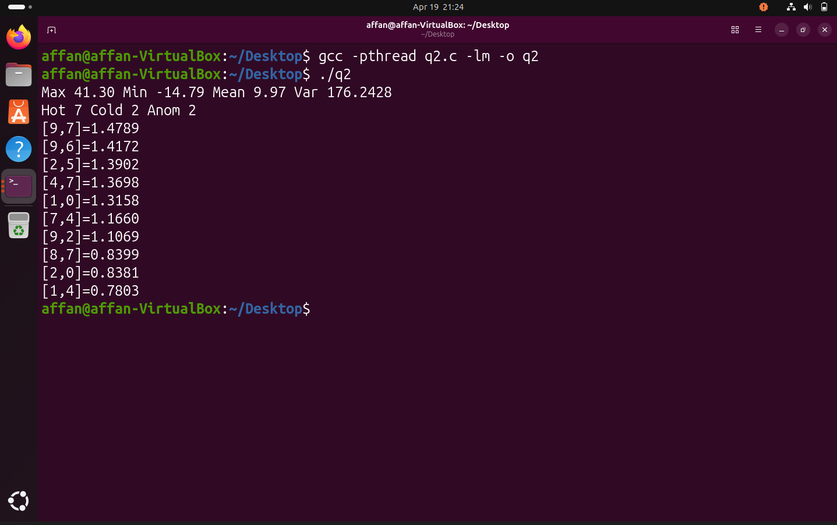

Q3:
//used abbreviations CRIT = Critical, NORM=Normal, SER=Serious

#include <stdio.h>
#include <stdlib.h>
#include <pthread.h>
#include <unistd.h>
#include <time.h>

#define SENIOR 2
#define JUNIOR 3
#define TOTAL (SENIOR+JUNIOR)
#define MAX_WAIT 30
#define PROMOTE 5

typedef enum { CRIT, SER, NORM } Type;
const char *T[]={"CRIT","SER","NORM"};

typedef struct P{
int id; Type t; time_t arr;
struct P *n;
}P;

typedef struct{ P *h,*t; int c; }Q;
typedef struct{ int id,type,cn; pthread_t tid; }D;

Q qc={0}, qs={0}, qn={0};
D doc[TOTAL];
int pid=1;

pthread_mutex_t m=PTHREAD_MUTEX_INITIALIZER;
pthread_cond_t c_any=PTHREAD_COND_INITIALIZER,
c_crit=PTHREAD_COND_INITIALIZER;

void en(Q*q,P*p){ p->n=0; if(!q->t) q->h=q->t=p; else q->t=q->t->n=p; q->c++; }
P* de(Q*q){ if(!q->h) return 0; P*p=q->h; q->h=p->n; if(!q->h) q->t=0; q->c--; return p; }

void treat(D*d,P*p){
printf("[D%d %s] P%d %s\n",d->id,d->type?"J":"S",p->id,T[p->t]);
sleep(1); free(p);
}

void *patient(void *a){
Type t=*(Type*)a; free(a);
P*p=malloc(sizeof(P));

pthread_mutex_lock(&m);
p->id=pid++; p->t=t; p->arr=time(0);

printf("[P%d] %s\n",p->id,T[t]);

if(t==CRIT) en(&qc,p);
else if(t==SER) en(&qs,p);
else en(&qn,p);

pthread_cond_signal(t==CRIT?&c_crit:&c_any);
pthread_mutex_unlock(&m);
return 0;
}

void *doctor(void *a){
D*d=&doc[*(int*)a]; free(a);

while(1){
P*p=0;
pthread_mutex_lock(&m);

if(d->cn>=3 && qs.c){
p=de(&qs); d->cn=0;
}
else if(!d->type && qc.c){
p=de(&qc); d->cn=0;
}
else if(qs.c){
p=de(&qs); d->cn=0;
}
else if(qn.c){
p=de(&qn); d->cn++;
}
else{
pthread_cond_wait(d->type?&c_any:&c_crit,&m);
pthread_mutex_unlock(&m);
continue;
}

pthread_mutex_unlock(&m);
if(p) treat(d,p);
}
}

void *promoter(void *a){
while(1){
sleep(1);
pthread_mutex_lock(&m);
if(qs.c>=PROMOTE){
P*p=de(&qs); p->t=CRIT;
en(&qc,p);
printf("[PROMOTE] P%d\n",p->id);
pthread_cond_signal(&c_crit);
}
pthread_mutex_unlock(&m);
}
}

void check(Q*q){
time_t now=time(0);
for(P*p=q->h;p;p=p->n)
if(difftime(now,p->arr)>MAX_WAIT){
printf("[TIMEOUT] P%d\n",p->id);
p->t=CRIT;
}
}

void *timeout(void *a){
while(1){
sleep(5);
pthread_mutex_lock(&m);
check(&qs); check(&qn);
pthread_mutex_unlock(&m);
}
}

int main(){
for(int i=0;i<TOTAL;i++){
doc[i]=(D){i,i>=SENIOR,0};
int *x=malloc(sizeof(int)); *x=i;
pthread_create(&doc[i].tid,0,doctor,x);
}

pthread_t p1,p2;
pthread_create(&p1,0,promoter,0);
pthread_create(&p2,0,timeout,0);

Type seq[]={CRIT,NORM,NORM,SER,SER,SER,SER,SER,NORM,CRIT};
int n=sizeof(seq)/sizeof(Type);

for(int i=0;i<n;i++){
Type *x=malloc(sizeof(Type)); *x=seq[i];
pthread_t t;
pthread_create(&t,0,patient,x);
pthread_detach(t);
usleep(300000);
}

sleep(15);
printf("\nDone\n");
return 0;
}
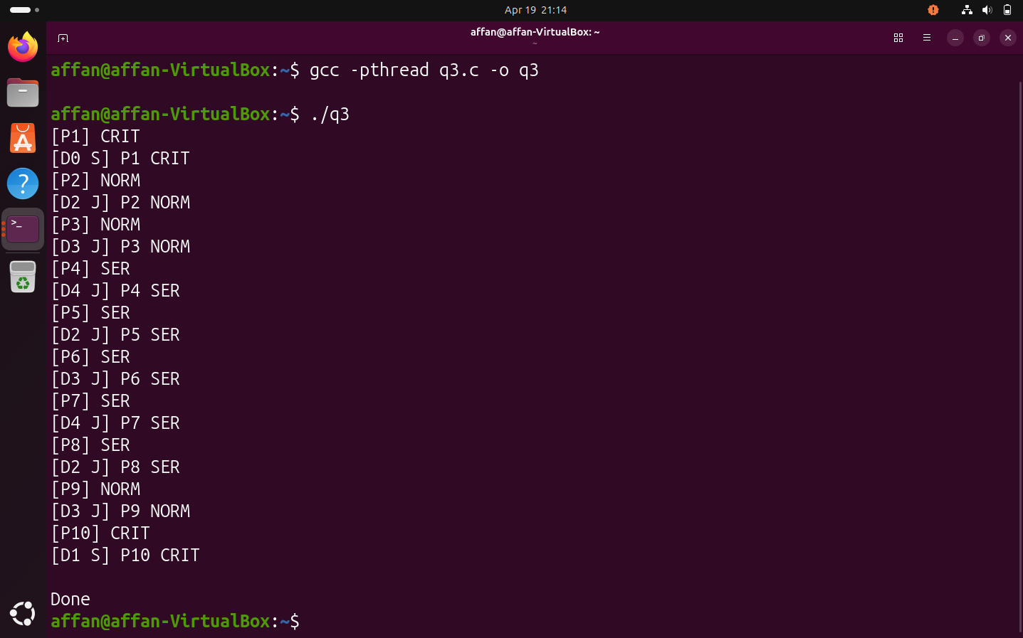
Q4:

#include <stdio.h>
#include <stdlib.h>
#include <pthread.h>
#include <unistd.h>
#include <time.h>

#define NUM_RUNWAYS 3
#define MAX_FLIGHTS 200
#define WAIT_THRESHOLD 5

typedef enum {
EMERGENCY_LAND = 0,
LOW_FUEL_LAND,
LANDING,
CARGO_TAKEOFF,
TAKEOFF
} FlightType;

const char *flightTypeStr[] = {
"EMERGENCY", "LOW_FUEL", "LANDING", "CARGO", "TAKEOFF"
};

typedef struct {
int id;
int priority;
int preempted;
FlightType type;
time_t arrivalTime;
} Flight;

typedef struct {
Flight *data[MAX_FLIGHTS];
int size;
} PriorityQueue;

typedef struct {
int id;
int busy;
int underMaintenance;
Flight *currentFlight;
} Runway;

PriorityQueue queue = {0};
Runway runways[NUM_RUNWAYS];

pthread_mutex_t queueMutex = PTHREAD_MUTEX_INITIALIZER;
pthread_mutex_t runwayMutex = PTHREAD_MUTEX_INITIALIZER;

pthread_cond_t flightAvailable = PTHREAD_COND_INITIALIZER;
pthread_cond_t runwayFree = PTHREAD_COND_INITIALIZER;

int systemRunning = 1;
int nextFlightId = 1;

void swap(int i, int j) {
Flight *t = queue.data[i];
queue.data[i] = queue.data[j];
queue.data[j] = t;
}

void push(Flight *f) {
int i = queue.size;
queue.size++;
queue.data[i] = f;

while (i > 0) {
int parent = (i - 1) / 2;
if (queue.data[parent]->priority <= queue.data[i]->priority) {
break;
}
swap(i, parent);
i = parent;
}
}

Flight* pop() {
if (queue.size == 0) {
return NULL;
}

Flight *top = queue.data[0];
queue.size--;
queue.data[0] = queue.data[queue.size];

for (int i = 0; ; ) {
int left = 2 * i + 1;
int right = 2 * i + 2;
int smallest = i;

if (left < queue.size && queue.data[left]->priority < queue.data[smallest]->priority) {
smallest = left;
}

if (right < queue.size && queue.data[right]->priority < queue.data[smallest]->priority) {
smallest = right;
}

if (smallest == i) {
break;
}

swap(i, smallest);
i = smallest;
}
return top;
}

void adjustPriorities() {
time_t now = time(NULL);

for (int i = 0; i < queue.size; i++) {
if (difftime(now, queue.data[i]->arrivalTime) > WAIT_THRESHOLD && queue.data[i]->priority > 0) {
queue.data[i]->priority--;
}
}
}

void* flightGenerator(void *arg) {
while (systemRunning) {
sleep(1);

Flight *f = malloc(sizeof(Flight));
f->id = nextFlightId;
nextFlightId++;
f->type = rand() % 5;
f->priority = f->type;
f->arrivalTime = time(NULL);
f->preempted = 0;

pthread_mutex_lock(&queueMutex);
push(f);
printf("[Generator] Flight %d (%s, p=%d)\n", f->id, flightTypeStr[f->type], f->priority);
pthread_cond_signal(&flightAvailable);
pthread_mutex_unlock(&queueMutex);
}
return NULL;
}

void* runwayController(void *arg) {
int id = *(int*)arg;
free(arg);

while (systemRunning) {
pthread_mutex_lock(&queueMutex);

while (queue.size == 0 && systemRunning) {
pthread_cond_wait(&flightAvailable, &queueMutex);
}

if (!systemRunning) {
pthread_mutex_unlock(&queueMutex);
break;
}

adjustPriorities();
Flight *f = pop();
pthread_mutex_unlock(&queueMutex);

pthread_mutex_lock(&runwayMutex);
while (runways[id].busy || runways[id].underMaintenance) {
pthread_cond_wait(&runwayFree, &runwayMutex);
}

if (runways[id].underMaintenance) {
pthread_mutex_unlock(&runwayMutex);

pthread_mutex_lock(&queueMutex);
push(f);
pthread_mutex_unlock(&queueMutex);
continue;
}

runways[id].busy = 1;
runways[id].currentFlight = f;
pthread_mutex_unlock(&runwayMutex);

printf("[Runway %d] Flight %d (%s)\n", id, f->id, flightTypeStr[f->type]);

sleep(2);
free(f);

pthread_mutex_lock(&runwayMutex);
runways[id].busy = 0;
runways[id].currentFlight = NULL;
pthread_cond_broadcast(&runwayFree);
pthread_mutex_unlock(&runwayMutex);
}
return NULL;
}

void rebuildHeap() {
for (int i = queue.size / 2 - 1; i >= 0; i--) {
for (int j = i; ; ) {
int l = 2 * j + 1;
int r = 2 * j + 2;
int s = j;

if (l < queue.size && queue.data[l]->priority < queue.data[s]->priority) {
s = l;
}
if (r < queue.size && queue.data[r]->priority < queue.data[s]->priority) {
s = r;
}

if (s == j) {
break;
}

swap(j, s);
j = s;
}
}
}

void* emergencyMonitor(void *arg) {
while (systemRunning) {
sleep(2);

pthread_mutex_lock(&queueMutex);

for (int i = 0; i < queue.size; i++) {
if (queue.data[i]->type == EMERGENCY_LAND) {
queue.data[i]->priority = -1;
printf("[Emergency] Flight %d prioritized\n", queue.data[i]->id);
rebuildHeap();

pthread_mutex_lock(&runwayMutex);
for (int r = 0; r < NUM_RUNWAYS; r++) {
if (runways[r].busy && runways[r].currentFlight && runways[r].currentFlight->type != EMERGENCY_LAND) {
printf("[Preempt] Runway %d\n", r);
push(runways[r].currentFlight);

runways[r].busy = 0;
runways[r].currentFlight = NULL;
pthread_cond_broadcast(&runwayFree);
break;
}
}
pthread_mutex_unlock(&runwayMutex);
break;
}
}

if (rand() % 8 == 0) {
int r = rand() % NUM_RUNWAYS;

pthread_mutex_lock(&runwayMutex);
if (!runways[r].busy) {
runways[r].underMaintenance = 1;
printf("[Maintenance] Runway %d\n", r);

sleep(3);

runways[r].underMaintenance = 0;
pthread_cond_broadcast(&runwayFree);
}
pthread_mutex_unlock(&runwayMutex);
}

pthread_mutex_unlock(&queueMutex);
}
return NULL;
}

int main() {
srand(time(NULL));

for (int i = 0; i < NUM_RUNWAYS; i++) {
runways[i] = (Runway){i, 0, 0, NULL};
}

pthread_t generatorThread;
pthread_t emergencyThread;
pthread_t controllers[NUM_RUNWAYS];

pthread_create(&generatorThread, NULL, flightGenerator, NULL);
pthread_create(&emergencyThread, NULL, emergencyMonitor, NULL);

for (int i = 0; i < NUM_RUNWAYS; i++) {
int *id = malloc(sizeof(int));
*id = i;
pthread_create(&controllers[i], NULL, runwayController, id);
}

sleep(20);
systemRunning = 0;

pthread_cond_broadcast(&flightAvailable);
pthread_cond_broadcast(&runwayFree);

pthread_join(generatorThread, NULL);
pthread_join(emergencyThread, NULL);

for (int i = 0; i < NUM_RUNWAYS; i++) {
pthread_join(controllers[i], NULL);
}

printf("\nSimulation Complete\n");
return 0;
}
