Probability Histogram

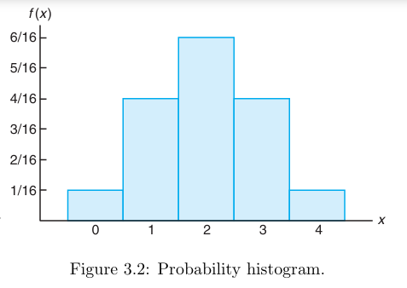

Probability Mass Function

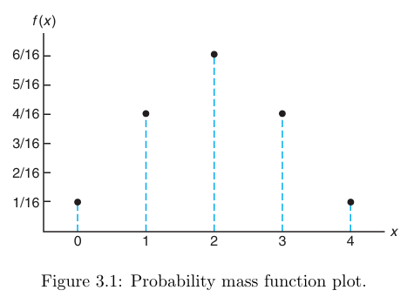

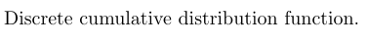
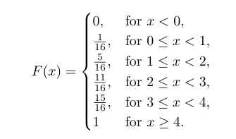

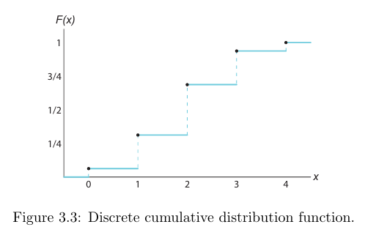

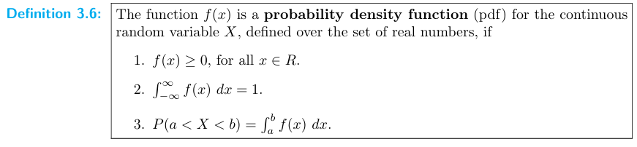

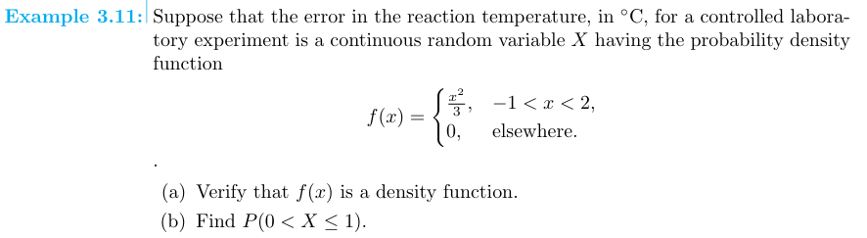
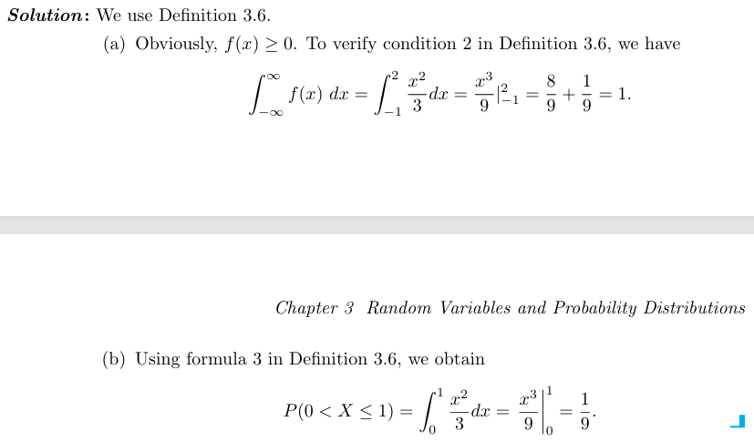
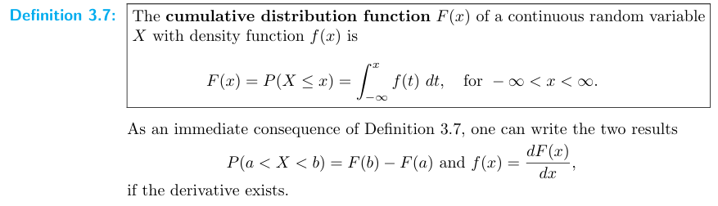
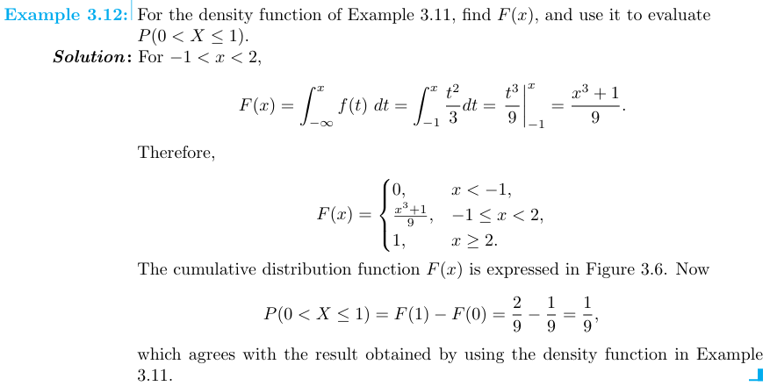

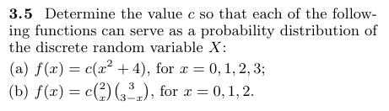
Solution: (a)
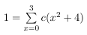
$$1=c \{\left(0+4\right)+\left(1+4\right)+\left(4+4\right)+\left(9+4\right)\}$$
1 = c {4+5+8+13}
1 = c {30}
C = 1/30

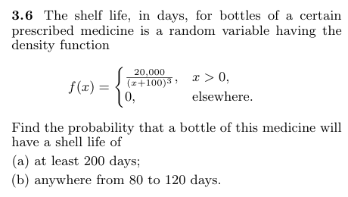
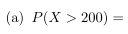
$$=20000 \int_{200}^{∞}{{(x+100)}^{-3}}dx$$

$$=20000\frac{{\left(x+100\right)}^{-3+1}}{-3+1}$$

$$=20000\frac{{\left(x+100\right)}^{-2}}{-2}$$

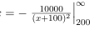
$$= -10000 \left\{\frac{1}{∞}- \frac{1}{{\left(200+100\right)}^{2}}\right\}$$
$$= -10000 \left\{0- \frac{1}{{\left(300\right)}^{2}}\right\}$$
$$= -10000 \left\{-\frac{1}{90000}\right\}$$
$$= 1/9$$

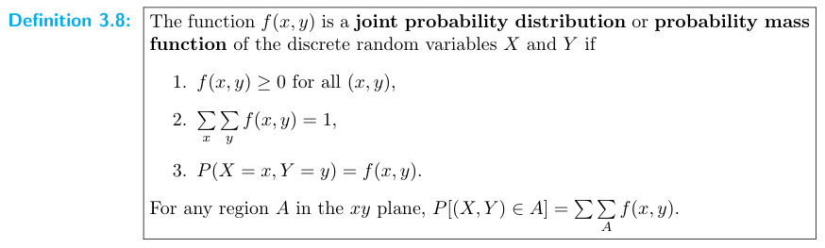
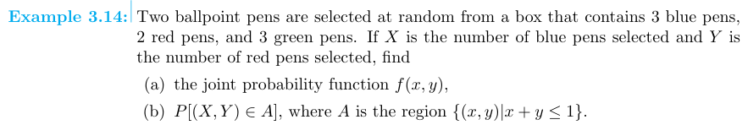

Solution:
Two ballpoint pens are selected at random from a box that contains 3 blue pens, 2 red pens, and 3 green pens. Total 8 pens

The possible pairs of values (x, y) are (0,0), (0,1), (1,0), (1,1), (0,2), and (2,0).

O (S) = ⁸ C ₂ = 28

If X is the number of blue pens selected and Y is the number of red pens selected,

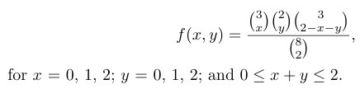
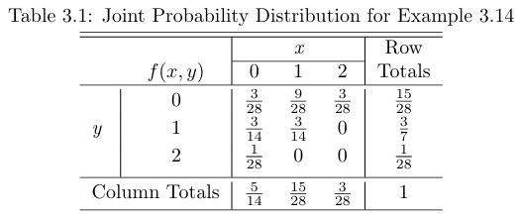
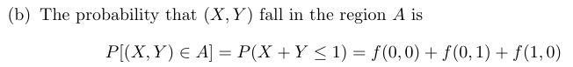

f (x, y) = f (0, 0) = ³ C ₀ ² C ₀ ³ C ₂ / ⁸ C ₂ = 3 / 28
f (x, y) = f (0, 1) = ³ C ₀ ² C ₁ ³ C ₁ / ⁸ C ₂ = 6 / 28
f (x, y) = f (1, 0) = ³ C ₁ ² C ₀ ³ C ₁ / ⁸ C ₂ = 9 / 28

