SOFTWARE DESIGN SPECIFICATION
IntelliFly: Advanced Flight Scheduler System

Course / Context:
Data Structures & Algorithms / Software Engineering
Authors:
[Author Name(s) — Placeholder]
Institution:
[University / Department — Placeholder]
Date:
April 25, 2026
Version: 1.0

Table of Contents
Chapter 1: Introduction ...................................................................................... 3
1.1 System Overview ....................................................................................... 3
1.2 Problem Statement ..................................................................................... 3
1.3 Scope ................................................................................................ 3
1.4 Objectives ........................................................................................... 4
1.5 Users and Stakeholders ................................................................................ 4
1.6 System Requirements Summary ............................................................................ 5
1.7 Software Process Model ................................................................................. 5
Chapter 2: System Analysis and Modeling ......................................................................... 6
2.1 Use Case Diagram ....................................................................................... 6
2.2 Class Diagram ......................................................................................... 7
2.3 Activity Diagrams ..................................................................................... 10
2.4 Sequence Diagrams ..................................................................................... 11
2.5 Component Diagram ..................................................................................... 12
2.6 Deployment Diagram .................................................................................... 13
Chapter 3: Architectural View (4+1 Model) ....................................................................... 14
3.1 Logical View ......................................................................................... 14
3.2 Process View ......................................................................................... 14
3.3 Development View ..................................................................................... 15
3.4 Physical View ........................................................................................ 16
3.5 +1 Use Case View ..................................................................................... 16
References .................................................................................................... 17

Chapter 1: Introduction

1.1 System Overview
IntelliFly is a command-line, single-file C++ application (compiled under C++17) that provides an interactive flight scheduling and management system. It integrates a rich suite of classic and advanced data structures — including AVL trees, B-trees, indexed min-heaps, chained hash tables, open-addressing hash tables, and a Trie — together with graph algorithms (Dijkstra's shortest path, Kruskal's and Prim's Minimum Spanning Tree, BFS, DFS, topological sort), multiple sort algorithms (merge sort, quick sort with median-of-three), and four string-search algorithms (Brute-Force, KMP, Rabin-Karp, Boyer-Moore).
The system is structured around three principal runtime components:
- Flight — a data record representing a single flight with attributes such as flight number, origin, destination, departure/arrival times, priority class, and validity status.
- FlightManager — the central business-logic layer that maintains all flights, runways, the airport route graph, the scheduling heap, and the undo stack.
- CLI — the interactive menu-driven interface that translates user commands into FlightManager operations and presents formatted results to the console.

1.2 Problem Statement
Airport operations involve managing hundreds of concurrent flights with varying urgency levels — from emergency medical flights to VIP charters to regular commercial services. Scheduling errors, runway conflicts, and inefficient route assignment cause safety risks, financial losses, and operational delays. Airlines and airport authorities require a reliable automated system that:
- Assigns and tracks flights with priority-aware scheduling (Emergency > VIP > Normal).
- Allocates and deallocates physical runway resources without conflicts.
- Computes optimal routes and network structures across multiple airports.
- Supports fast lookup, cancellation, and pattern-based search across flight logs.
- Provides autocomplete assistance to operators entering airport codes.
- Maintains an undo history for accidental actions.
IntelliFly addresses this problem domain in an educational context, demonstrating how each algorithmic component contributes to a coherent, functional scheduling system.

1.3 Scope

1.3.1 In Scope
- Flight registration: add, cancel, and retrieve flights by flight number.
- Priority scheduling: Emergency (1), VIP (2), Normal (3) — managed via an indexed min-heap and a lazy priority queue.
- Runway management: viewing status, allocating a free runway to a flight, and releasing a runway.
- Route graph: bidirectional weighted edges between airports; Dijkstra shortest-path and Kruskal/Prim MST.
- Sorting: flights listed by departure time (merge sort) or by priority (quick sort).
- String search across concatenated flight logs using KMP, Rabin-Karp, Boyer-Moore, or Brute-Force.
- Airport autocomplete powered by a Trie prefix tree.
- Undo stack: reversal of the most recent ADD or ALLOC operations.
- Demo scenario and sample data loader for testing purposes.

1.3.2 Out of Scope
- Graphical User Interface (GUI) or web/mobile front-end.
- Persistent storage: no file I/O, database, or network layer — all data resides in memory.
- Multi-user or concurrent access: the system is single-threaded with no network exposure.
- Real-time flight tracking or integration with external aviation APIs.
- Authentication, authorization, or role-based access control.
- Passenger management, ticketing, or baggage handling.

1.4 Objectives
The following objectives define the measurable goals of IntelliFly:
- Provide O(log n) flight lookup, insertion, and cancellation by leveraging AVL trees and B-trees for indexed access.
- Schedule the highest-priority flight in O(log n) time using an indexed min-heap with lazy deletion.
- Compute shortest inter-airport distances in O((V + E) log V) via Dijkstra's algorithm.
- Produce a Minimum Spanning Tree of the airport network in O(E log E) via Kruskal's algorithm.
- Return all flights sorted by departure in O(n log n) using stable merge sort.
- Search flight description logs with sub-linear average complexity using KMP or Rabin-Karp.
- Offer prefix-based airport autocomplete in O(|prefix| + k) using a Trie, where k is the number of suggestions.
- Support a consistent undo mechanism for at least the last ADD and ALLOC operations.
- Present all results through a formatted, menu-driven CLI requiring no external dependencies at runtime.

1.5 Users and Stakeholders
Role | Type | Interaction | Primary Concern
Airport Operations Officer | Primary User | Adds, cancels, views, and schedules flights via CLI. | Accuracy and speed of flight management.
Airline Dispatch Staff | Primary User | Checks priority scheduling and route distances. | Correct priority ordering; shortest path routing.
Runway Controller | Primary User | Allocates and frees runways through the Runway menu. | No double-allocation; real-time status visibility.
System Administrator | Primary User | Loads sample data, runs demos, and undoes actions. | System correctness and undoability.
Computer Science Educator | Stakeholder | Reviews DS/algorithm implementations for teaching. | Code clarity, correctness, and educational value.
CS Students | Stakeholder | Study the codebase as a reference implementation. | Readability and demonstration of algorithms.
University / Institution | Stakeholder | Evaluates the project as coursework submission. | Compliance with requirements; quality of design.

1.6 System Requirements Summary

1.6.1 Functional Requirements
- FR-01: The system shall allow the user to add a new flight by providing flight number, origin, destination, departure time, arrival time, priority level, and optional description.
- FR-02: The system shall reject duplicate flight numbers at insertion time.
- FR-03: The system shall allow the user to cancel (soft-delete) a flight by flight number.
- FR-04: The system shall display full details of any valid flight identified by its flight number.
- FR-05: The system shall list all active flights in tabular form.
- FR-06: The system shall list flights sorted by departure time using merge sort.
- FR-07: The system shall list flights sorted by priority (then by departure) using quick sort.
- FR-08: The system shall display the status of all runways and support runway allocation and deallocation.
- FR-09: The system shall compute and display shortest-path distances from a source airport to all reachable airports using Dijkstra's algorithm.
- FR-10: The system shall compute and display a Minimum Spanning Tree of the airport route graph using Kruskal's algorithm.
- FR-11: The system shall search concatenated flight descriptions using KMP (default), Rabin-Karp, Boyer-Moore, or Brute-Force string matching.
- FR-12: The system shall provide prefix-based airport code autocomplete via a Trie, returning up to 10 suggestions.
- FR-13: The system shall schedule the next flight (highest priority, earliest departure) on demand.
- FR-14: The system shall maintain an undo stack and reverse the most recent ADD or ALLOC action.
- FR-15: The system shall pre-load sample flights and routes on startup.

1.6.2 Non-Functional Requirements
ID | Category | Requirement
NFR-01 | Performance | Flight lookup shall complete in O(log n) time. Sort operations shall complete in O(n log n). String search via KMP shall complete in O(n + m).
NFR-02 | Reliability | The system shall not crash on invalid user input; all inputs shall be validated before processing.
NFR-03 | Usability | The CLI menu shall be navigable with single integer selection. All error messages shall be clearly prefixed with [ERROR] and successes with [SUCCESS].
NFR-04 | Maintainability | All data structure implementations shall be generic (C++ templates) to permit substitution of key/value types without code duplication.
NFR-05 | Portability | The system shall compile with g++ -std=c++17 on Linux, macOS, and Windows (MinGW) without modification.
NFR-06 | Memory Safety | All heap-allocated data structure nodes (AVL, BTree, Trie) shall be explicitly freed in destructors to prevent memory leaks.
NFR-07 | Scalability | The system shall handle up to 10,000 flights without degradation, given O(log n) index operations.
NFR-08 | Correctness | Sort, search, and graph algorithm outputs shall be verifiable against theoretical complexity expectations.

1.7 Software Process Model

1.7.1 Selected Model: Iterative and Incremental Development
IntelliFly is best developed using the Iterative and Incremental (I&I) Software Development Life Cycle model. The project was built in clearly identifiable layers: (1) core data models (Flight, Runway, Edge), (2) standalone data structure modules (AVL, BTree, Hash Tables, Trie, Heap), (3) graph and algorithm modules, (4) the FlightManager orchestration layer, and finally (5) the CLI interface.

1.7.2 Justification
- Decomposable functionality: each data structure and algorithm module is independently testable before integration into FlightManager, matching the I&I iteration concept.
- Risk mitigation: complex components (e.g., AVL rebalancing, Kruskal's Union-Find) can be developed and verified in isolation, reducing integration risks.
- Educational alignment: an iterative model allows students and reviewers to trace the evolution from basic flight storage to advanced graph-based route planning.
- Incremental correctness: merge sort, quick sort, and string-search algorithms can be validated against known outputs before being wired into the scheduler.
- No external stakeholder feedback loops are required, making heavyweight models such as Scrum or XP unnecessary for this single-developer educational project.

Chapter 2: System Analysis and Modeling

2.1 Use Case Diagram

2.1.1 Actors
- Airport Operator — the primary human user who interacts with all CLI menus.
- Airline Staff — a secondary user primarily interested in priority scheduling and route information.
- System (Internal) — the software itself, which performs demo loading, undo operations, and sample data initialization.

2.1.2 Use Case Overview (Structured Text Representation)
The following depicts the system boundary and actor-use case relationships:

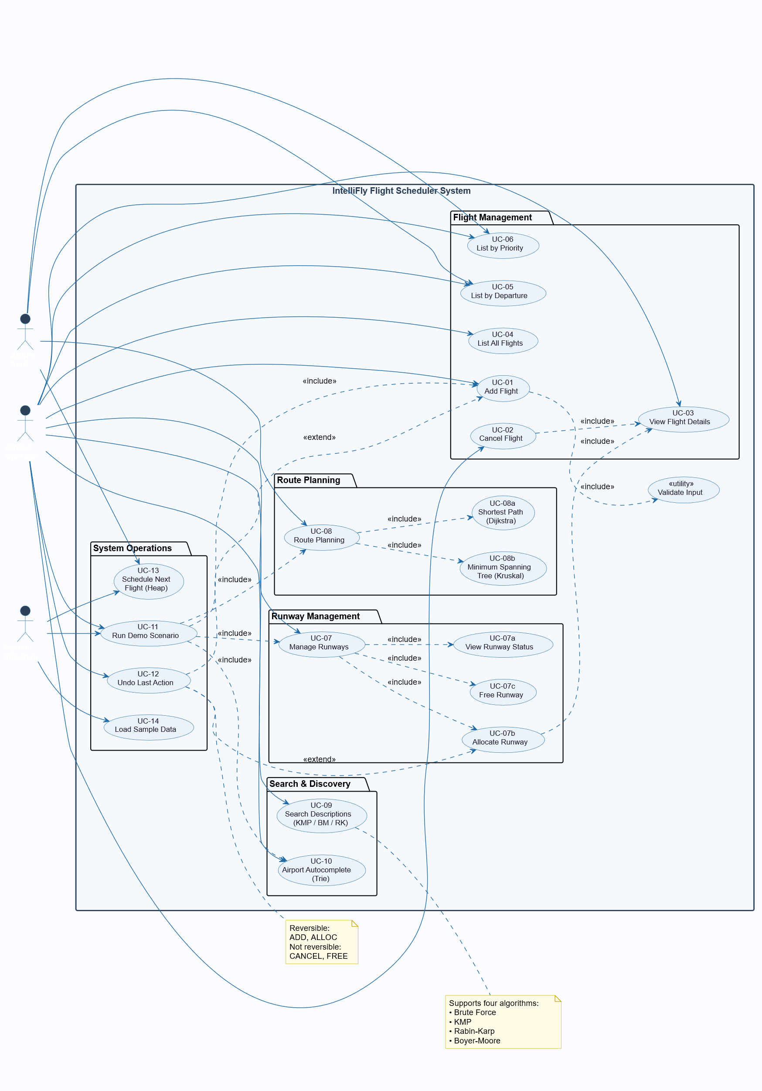

2.1.3 Use Case Relationships
Use Case | Relationship | Related Use Case | Type
UC-01 Add Flight | includes | Validate Input (implicit) | <<include>>
UC-02 Cancel Flight | includes | UC-03 View Flight (lookup) | <<include>>
UC-07 Manage Runways — Allocate | includes | UC-03 View Flight (validity check) | <<include>>
UC-08 Route Planning — Shortest Path | extends | UC-08 View MST | <<extend>>
UC-11 Run Demo | includes | UC-01, UC-05, UC-08, UC-07, UC-10 | <<include>>
UC-12 Undo | extends | UC-01 / UC-07 Allocate | <<extend>>

2.1.4 Use Case Description Table
Key use cases are described below in full detail.

UC-01: Add Flight
Use Case Name | UC-01: Add Flight
Actor | Airport Operator
Description | The operator enters flight details. The system validates the input and registers the flight across all internal indices.
Preconditions | The system is running. The flight number does not already exist.
Postconditions | Flight is stored in the flights vector, ChainedHashTable, OpenAddressingHash, AVL schedule tree, BTree, IndexedMinHeap, lazy PQ, and undo stack.
Main Flow | 1. User selects option 1 from main menu. 2. User provides: flight number, origin, destination, departure time (HH:MM), arrival time (HH:MM), priority (1/2/3), optional description. 3. System validates all fields (non-empty, correct format, valid priority). 4. System checks for duplicate flight number via ChainedHashTable. 5. System inserts the flight and records an ADD action on the undo stack. 6. System outputs [SUCCESS] confirmation.
Alternate Flow | If the flight number already exists, system outputs [ERROR] Flight already exists and returns to menu.
Exception Flow | If time format is invalid (non-HH:MM), system outputs Invalid time format! and returns to menu.

UC-02: Cancel Flight
Use Case Name | UC-02: Cancel Flight
Actor | Airport Operator
Description | Operator provides a flight number to mark it as cancelled (soft delete).
Preconditions | Flight exists and is currently valid.
Postconditions | Flight's valid flag is set to false. It is removed from ChainedHashTable, OpenAddressingHash, and AVL schedule tree. A CANCEL action is recorded on undo stack.
Main Flow | 1. User selects option 2. 2. User enters flight number. 3. System locates flight via hash table. 4. System sets valid=false and removes from indices. 5. System outputs [SUCCESS].
Alternate Flow | Flight not found: system outputs [ERROR] Flight not found!

UC-07: Manage Runways
Use Case Name | UC-07: Manage Runways
Actor | Airport Operator / Runway Controller
Description | Operator views runway status, allocates the next free runway to a specified flight, or releases a runway by ID.
Preconditions | Runways (1, 2, 3) are initialized at system startup. For allocation: the target flight must exist and be valid.
Postconditions | Allocated: selected runway's free flag set to false. ALLOC action pushed to undo stack. Freed: runway's free flag restored to true. FREE action pushed to undo stack.
Main Flow | 1. User selects option 7. 2. Sub-menu shows: (1) View Status, (2) Allocate, (3) Free. 3. For Allocate: user provides flight number; system finds first free runway, marks it occupied, returns runway ID. 4. For Free: user provides runway ID; system restores it to free state.
Alternate Flow | Allocate — no free runway available: system outputs No runway available! Allocate — flight not found: system outputs error.

UC-08: Route Planning
Use Case Name | UC-08: Route Planning
Actor | Airport Operator / Airline Staff
Description | Provides two graph-based views: (1) shortest-distance from a source airport using Dijkstra's algorithm; (2) Minimum Spanning Tree of all airport connections via Kruskal's algorithm.
Preconditions | At least one route (edge) must exist in the route graph.
Postconditions | No state mutation. Results displayed as a formatted table.
Main Flow | Option 1 — Shortest Distances: User enters airport code. System runs Dijkstra from that node. System displays table of reachable airports and distances in minutes. Option 2 — MST: System runs Kruskal's algorithm on all edges. System displays MST edges with weights and total weight.
Alternate Flow | Source airport not in graph: No routes found! message displayed.

2.2 Class Diagram

2.2.1 BCE Classification
Category | Class / Module | Responsibility
Boundary | CLI | Renders menus, reads user input, formats and displays output. All interaction with std::cout and std::cin is confined here.
Control | FlightManager | Orchestrates all business logic: coordinates data structures, enforces rules (no duplicates, valid runway allocation), manages undo stack.
Entity | Flight (struct) | Holds flight data: flightNo, origin, dest, departure, arrival, priority, valid, description.
Entity | Runway (struct) | Holds runway state: id, free flag.
Entity | Edge (struct) | Represents a directed weighted graph edge: u, v, w.
Entity | Graph | Manages the airport adjacency list and edge list. Provides BFS, DFS, Dijkstra, Prim, Kruskal, TopoSort.
Entity | AVL<Key, Val> | Self-balancing BST; used to index flights by departure time for ordered schedule retrieval.
Entity | BTree<Key, Val> | B-tree of order 2; secondary index mapping flightNo -> vector index.
Entity | IndexedMinHeap<T, Key> | Heap supporting O(log n) decrease-key; used for priority + departure-time scheduling.
Entity | ChainedHashTable<K, V> | Hash table with separate chaining; primary O(1) average lookup index for flight numbers.
Entity | OpenAddressingHash<K, V> | Hash table with linear probing; secondary index for flight number -> vector index.
Entity | Trie | Prefix tree; supports airport code autocomplete in O(|prefix|).
Entity (Utility) | sorting namespace | Provides mergeSort and quickSort with custom comparators.
Entity (Utility) | strsearch namespace | Provides brute, kmp, rabinKarp, and boyerMoore pattern matching.

2.2.2 Class Diagram
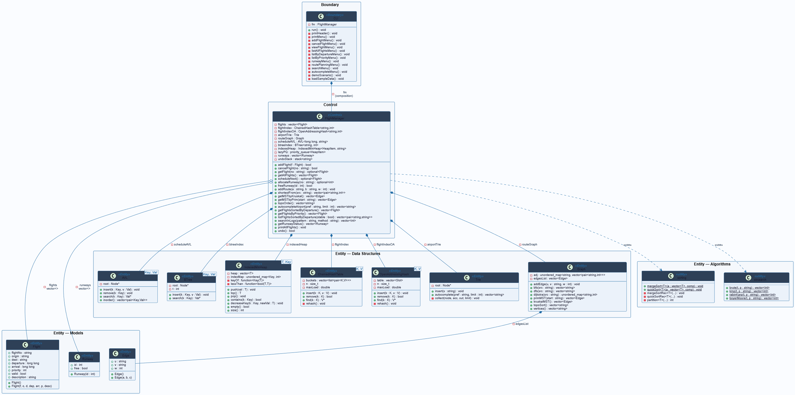

2.2.3 Key Relationships
- CLI has-a FlightManager (composition — CLI owns the FlightManager instance).
- FlightManager has-a Graph, AVL, BTree, two hash tables, IndexedMinHeap, Trie, vector<Runway>, stack<string> (all composition — FlightManager owns these as member variables).
- FlightManager has-a* Flight (aggregation — Flight objects are stored in a vector owned by FlightManager).
- AVL<Key,Val>, BTree<Key,Val>, IndexedMinHeap<T,Key>, ChainedHashTable<K,V>, OpenAddressingHash<K,V> are all generic (templated) entity classes — no inheritance hierarchy; they are parameterized at compile time.
- Graph uses Edge internally (composition — edgesList is owned by Graph).

2.3 Activity Diagrams

2.3.1 Add Flight Workflow
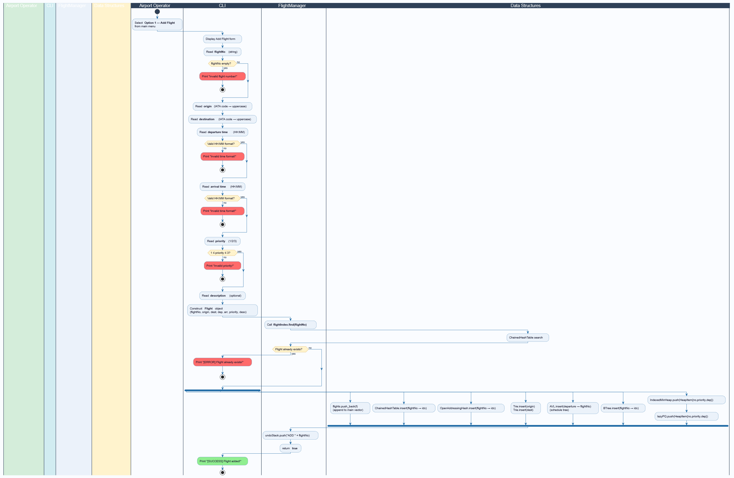

2.3.2 Route Planning — Dijkstra Workflow
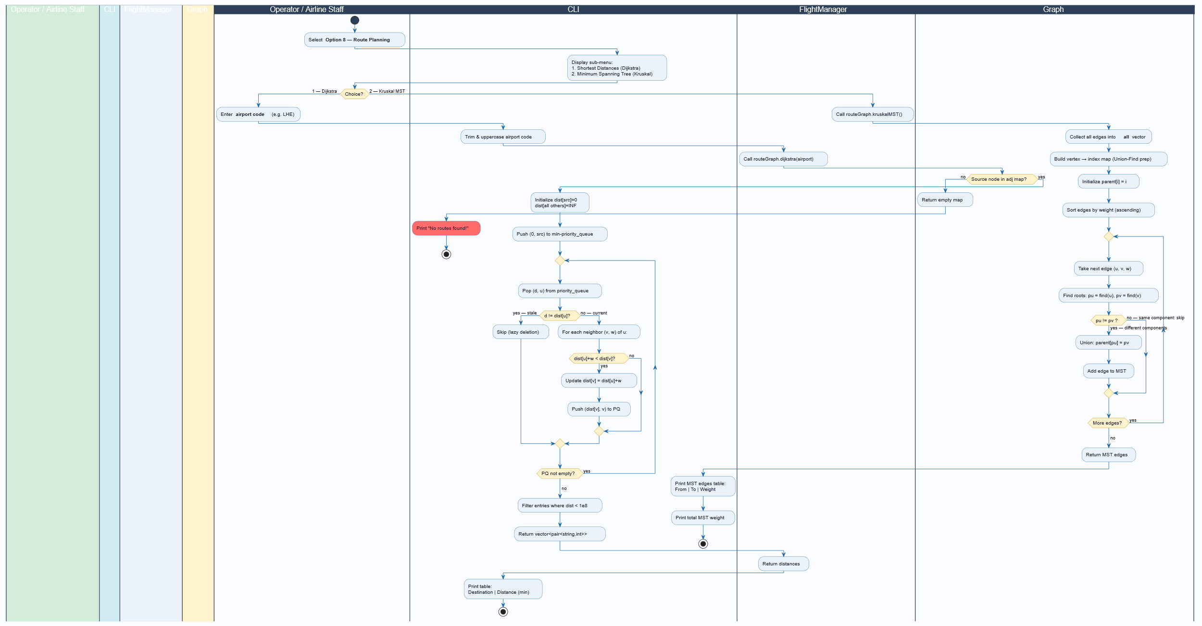

2.3.3 Runway Allocation Workflow (Swimlanes)
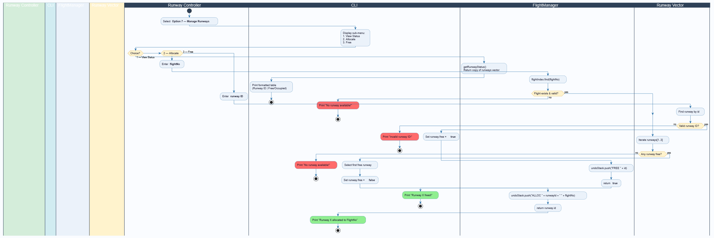

2.4 Sequence Diagrams

2.4.1 Add Flight — Object Interaction Sequence
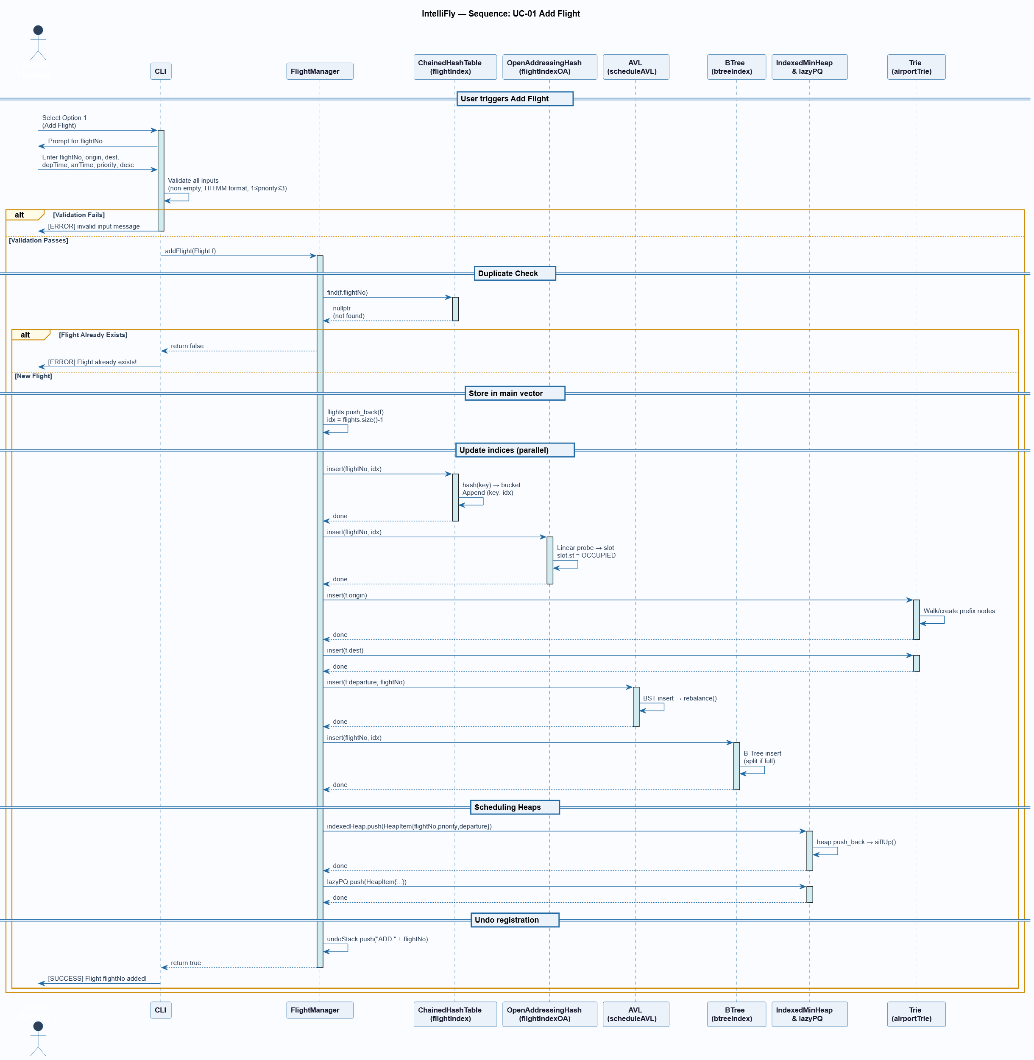

2.4.2 Schedule Next Flight — Object Interaction Sequence
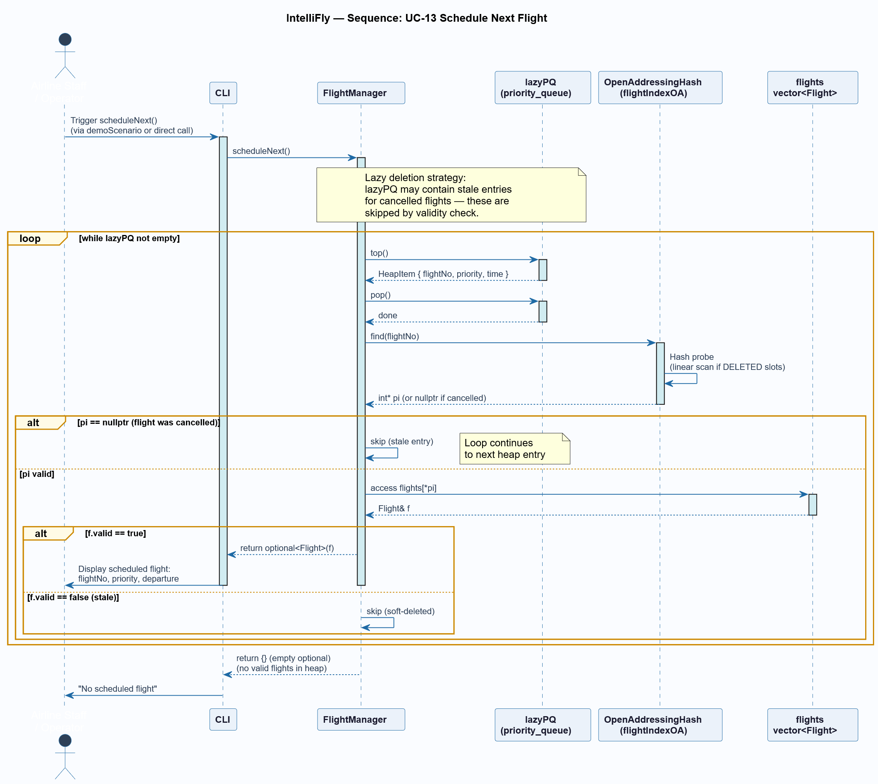

2.5 Component Diagram
The system is composed of the following logical components and their dependencies:
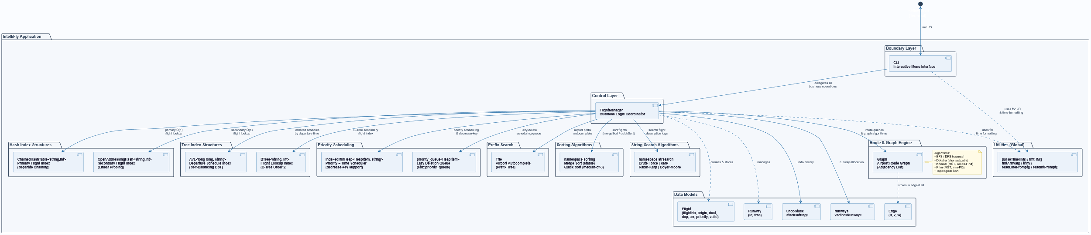

2.6 Deployment Diagram
IntelliFly is a standalone, single-binary CLI application. Its deployment environment is minimal:
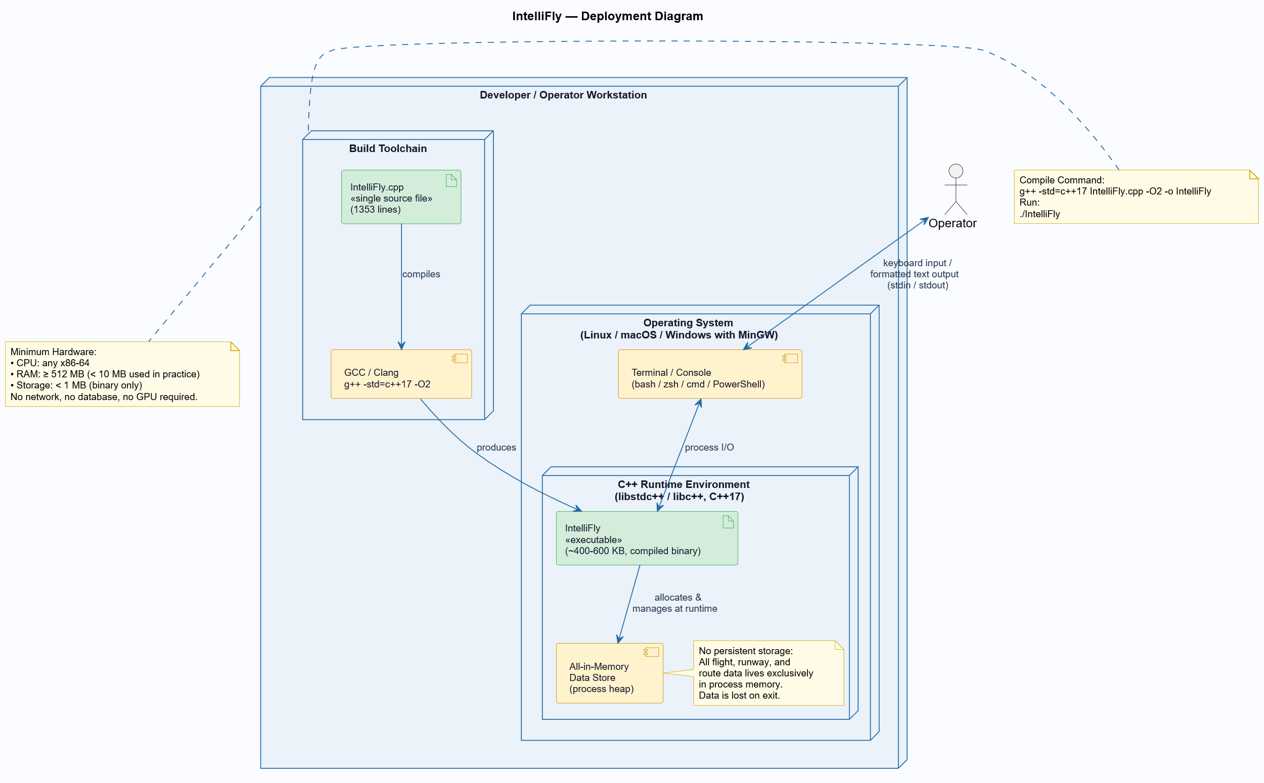
No network, no database server, no additional runtime libraries are required.

Chapter 3: Architectural View (4+1 Model)

3.1 Logical View
The Logical View describes the core abstractions of the system and their relationships as visible to the design team.

3.1.1 Primary Packages
Package / Namespace | Contents | Role
Models | Flight, Runway, Edge | Passive data-holding structures with no business logic.
DataStructures | AVL, BTree, IndexedMinHeap, ChainedHashTable, OpenAddressingHash, Trie | Generic, reusable indexed-access and ordered-traversal containers.
Graph | Graph class (BFS, DFS, Dijkstra, Prim, Kruskal, TopoSort) | Airport network representation and traversal/optimization algorithms.
Algorithms::Sort | sorting::mergeSort, sorting::quickSort | In-place and stable sorting with custom comparators.
Algorithms::Search | strsearch::brute, kmp, rabinKarp, boyerMoore | Pattern-matching over concatenated flight log strings.
Control | FlightManager | Central coordinator; owns all data structures and enforces business rules.
Boundary | CLI | All user I/O; translates raw input into FlightManager method calls.
Utilities | parseTimeHM, fmtHM, fmtArrival, trim, readLinePrompt, readIntPrompt | Stateless helper functions shared across modules.

3.1.2 Key Logical Constraints
- All mutation of flight data must go through FlightManager — never directly through CLI or external code.
- The dual hash-table strategy (ChainedHashTable + OpenAddressingHash) provides two independent O(1) average-case lookup paths for redundancy and educational comparison.
- Soft deletion (valid = false) is used to preserve vector indices and avoid AVL/BTree rebalancing complexity on every cancellation.

3.2 Process View
IntelliFly is a single-threaded, synchronous application. There is no concurrency, no multi-threading, and no inter-process communication.

3.2.1 Main Execution Thread
- main() instantiates CLI and calls cli.run().
- cli.run() enters a blocking read-eval-print loop (REPL) that reads an integer menu option, dispatches to the appropriate handler, and waits for the next input.
- All data structure operations (insert, search, delete, sort, graph traversal) execute synchronously within the REPL cycle.

3.2.2 Significant Computational Workflows
Operation | Algorithm / Structure | Time Complexity
Add Flight | ChainedHashTable.insert + AVL.insert + BTree.insert + Heap.push | O(log n) dominated by tree operations
Cancel Flight | ChainedHashTable.remove + AVL.remove | O(log n)
Get Flight | ChainedHashTable.find | O(1) average
Schedule Next | lazyPQ.top/pop + OA Hash.find | O(log n)
Sort by Departure | sorting::mergeSort | O(n log n), stable
Sort by Priority | sorting::quickSort | O(n log n) average
Shortest Path | Dijkstra on Graph adjacency list | O((V+E) log V)
MST (Kruskal) | Union-Find + sort edges | O(E log E)
String Search | KMP / Rabin-Karp / BM | O(n + m) / O(n) avg / O(nm) worst
Autocomplete | Trie DFS from prefix node | O(|prefix| + k)

3.3 Development View
Because IntelliFly is a single-file project, the development view is organized by logical sections within main.cpp rather than by file hierarchy.

3.3.1 Logical File Structure
IntelliFly.cpp
├── [Lines 1–36] Preprocessor includes and type aliases
├── [Lines 37–97] Utility functions (parseTimeHM, fmtHM, trim, I/O helpers)
├── [Lines 99–116] Data models: Flight struct
├── [Lines 118–125] Data models: Runway struct
├── [Lines 127–198] namespace sorting (mergeSort, quickSort)
├── [Lines 200–297] class AVL<Key, Val>
├── [Lines 299–377] class BTree<Key, Val>
├── [Lines 379–450] class IndexedMinHeap<T, Key>
├── [Lines 452–542] class ChainedHashTable<K, V>
├── [Lines 492–542] class OpenAddressingHash<K, V>
├── [Lines 544–587] class Trie
├── [Lines 589–663] namespace strsearch (brute, kmp, rabinKarp, boyerMoore)
├── [Lines 665–775] struct Edge + class Graph
├── [Lines 777–993] class FlightManager
├── [Lines 996–1342]class CLI
└── [Lines 1344–1352] int main()

3.3.2 Compilation
g++ -std=c++17 IntelliFly.cpp -O2 -o IntelliFly
- Requires: GCC 8+ or Clang 7+ with full C++17 support (structured bindings, std::optional, std::string_view).
- No Makefile or build system required; single compilation unit.

3.4 Physical View
The physical deployment of IntelliFly is a single-host scenario:
Component | Specification
Hardware | Any general-purpose x86-64 workstation or server with at least 512 MB RAM.
Operating System | Linux (Ubuntu 20.04+), macOS 11+, or Windows 10+ with MinGW/MSYS2.
Runtime | C++ Standard Library only (libstdc++ or libc++). No third-party runtime dependencies.
Storage | Single binary file (~400–600 KB compiled). No database files or configuration files.
Networking | None. System is fully local and offline.
Terminal | Any ANSI-compatible terminal for CLI output rendering.

3.5 +1 Use Case View
The Use Case view ties the architectural elements back to the user scenarios identified in Chapter 2. The table below maps key use cases to the architectural components they activate:
Use Case | CLI Method | FlightManager Method(s) | Data Structures Activated
UC-01 Add Flight | addFlightMenu() | addFlight() | ChainedHashTable, OA Hash, AVL, BTree, IndexedMinHeap, Trie, Stack
UC-02 Cancel Flight | cancelFlightMenu() | cancelFlight() | ChainedHashTable, OA Hash, AVL, Stack
UC-03 View Flight | viewFlightMenu() | getFlight() | ChainedHashTable
UC-04 List All | listAllFlightsMenu() | getAllFlights() | flights vector
UC-05 List by Departure | listByDepartureMenu() | getFlightsSortedByDeparture() | mergeSort, flights vector
UC-06 List by Priority | listByPriorityMenu() | getFlightsByPriority() | quickSort, flights vector
UC-07 Manage Runways | runwayMenu() | allocateRunway(), freeRunway() | Runway vector, ChainedHashTable, Stack
UC-08 Route Planning | routePlanningMenu() | shortestFrom(), getMSTbyKruskal() | Graph (Dijkstra, Kruskal, Union-Find)
UC-09 Search | searchMenu() | searchInLogs() | strsearch (KMP/RK/BM/Brute)
UC-10 Autocomplete | autocompleteMenu() | autocompleteAirport() | Trie
UC-12 Undo | (implicit via stack) | undo() | undoStack, ChainedHashTable, OA Hash, AVL
UC-13 Schedule Next | demoScenario() | scheduleNext() | lazyPQ, OA Hash, flights vector

References
[1] Grady Booch, James Rumbaugh, and Ivar Jacobson. The Unified Modeling Language User Guide, 2nd ed. Addison-Wesley Professional, 2005.

[2] Object Management Group (OMG). Unified Modeling Language (UML) Specification, Version 2.5.1. OMG Document formal/2017-12-05. https://www.omg.org/spec/UML/

[3] Thomas H. Cormen, Charles E. Leiserson, Ronald L. Rivest, and Clifford Stein. Introduction to Algorithms, 4th ed. MIT Press, 2022.

[4] Ian Sommerville. Software Engineering, 10th ed. Pearson Education, 2015.

[5] Roger S. Pressman and Bruce R. Maxim. Software Engineering: A Practitioner's Approach, 9th ed. McGraw-Hill Education, 2019.

[6] Bjarne Stroustrup. The C++ Programming Language, 4th ed. Addison-Wesley Professional, 2013.

[7] Philippe Kruchten. Architectural Blueprints — The '4+1' View Model of Software Architecture. IEEE Software, 12(6):42–50, November 1995.

[8] Robert Sedgewick and Kevin Wayne. Algorithms, 4th ed. Addison-Wesley Professional, 2011.

[9] Erich Gamma, Richard Helm, Ralph Johnson, and John Vlissides. Design Patterns: Elements of Reusable Object-Oriented Software. Addison-Wesley Professional, 1994.

[10] Donald E. Knuth. The Art of Computer Programming, Vol. 3: Sorting and Searching, 2nd ed. Addison-Wesley Professional, 1998.

