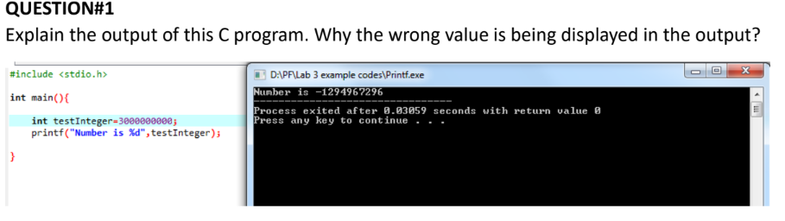

In the above the problem the value initialized to testInteger i.e 3000000000 is too large for the datatype Integer which can only store values upto 2147483647.