



Celebrate Hub

Student Name & ID:
Hassan Ali Salim Al-Siyabi -- 12S19150
Affan Obaid Said Al-Taei -- 16S20130
Abstract:
CelebrateHub is a full-stack web application designed to streamline event planning in Oman by creating a centralized online marketplace that connects users with trusted event and hospitality service providers. The platform addresses the inefficiencies and frustrations of traditional planning methods, such as relying on numerous phone calls or disparate social media pages, which often lead to wasted time and unmet expectations. The primary objective of CelebrateHub is to simplify the process for users to explore, compare, and book a wide range of services including catering, decoration, and photography for events like weddings, birthdays, and corporate functions all within a single, transparent interface. Key features of the system include advanced search and filtering by price, location, and service type, as well as an emphasis on clear, upfront pricing, real-time availability updates, and customer reviews to build user confidence in their booking decisions. The system facilitates secure online payments with multiple options, removing common customer pain points related to hidden costs and uncertain availability. Developed using the Agile Methodology and a technology stack including HTML, CSS, and JavaScript, the platform supports Oman Vision 2040 by promoting digital transformation and empowering local small and medium enterprises (SMEs) in the hospitality sector. By consolidating the fragmented market, CelebrateHub aims to provide a more efficient, reliable, and stress-free event planning experience for the Omani market and its local vendors.

Overall Project description:
Project Scope and Overview | This project proposes the development of a web-based marketplace platform that connects users with hospitality companies and event organizers. The platform will allow users to easily search, filter, and book services for different occasions such as birthdays, weddings, graduations, and corporate events. Key criteria such as price per hour, timing, and location will be available to help users make informed choices.  The system aims to simplify the event planning process by bringing multiple service providers into a single platform, enabling comparison, reviews, and secure booking. In addition to core event services, the platform will also provide options for value-added services such as birthday entertainers, wedding decoration, catering, and photography.
Problem Statement | Organizing events such as birthdays, weddings, or corporate functions often presents significant challenges for individuals. Most customers struggle to find suitable event organizers or hospitality companies that match their needs in terms of budget, timing, and location. The current process usually involves making numerous phone calls, searching across different social media platforms, or relying on personal recommendations, which is both inefficient and unreliable.
Project Objectives | - Provide a centralized platform: users can search, filter, and choose event services by price, location, time, and type.  - Clear and trustworthy: customers see full details, prices, availability, and real reviews before booking.  - Easy planning: ready-made packages for birthdays, weddings, graduations, and corporate events.  - Safe payments: book and pay online securely, with multiple payment options.
Project description (The project alignment with Oman Vision 2040, Significance of the project into the Oman Market) | CelebrateHub is a web-based platform for event management and hospitality services in Oman, designed to help people easily find and book services such as catering, decoration, photography, and venues for birthdays, weddings, and conferences. Instead of relying on social media or contacting many companies, users can compare prices, locations, and reviews all in one place. The project supports Oman Vision 2040 by promoting digital transformation, helping small businesses grow, and creating opportunities for youth entrepreneurship. It is significant for the Omani market because it makes event planning easier, builds trust between customers and service providers, and contributes to the growth of the tourism and service economy.
Project Methodology | The development of CelebrateHub will use Agile Methodology, which focuses on flexibility, step-by-step progress, and regular feedback. Agile is chosen because it helps the team quickly adapt to changes, involves users in the process, and delivers working features in small stages.
Project Technology and Tools  (Hardware and Software Specifications) | Hardware minimum requirements:  Device name: DESKTOP-4JQPM4F  Processor: Intel(R) Core (TM) i3-10100 CPU  Installed RAM: 8 GB  Decice ID: 3CCDDE62-6613-4C18-8E2B-994161089287  Product ID: 00325-96386-05481-AAOEM  System type: 64-bit operating system, x64-based processor  Pen and touch: No pen or touch input is available for this display  Software:  Software: Editing Platform: Notepad++, Visual Studio Code (version: 1.94.0), Microsoft World, Google AI Studio, Firebasse Studio.  FrontEnd Language: HTML, CSS, BootStrap, JavaScript, PhP.  BackEnd Language: Java, PhP, MySQL.  Hosting and Deployment: GitHub pages, Firebase, MongoDB  Web browsers: Google Chrome, Firefox, Microsoft Edge
Functional Requirements (Tracing Sheet)

Module Id | Module Name and Short Description | Priority (LOW, HIGH) | Reference in  analysis (DFD #, UC#...etc. ) | Reference in design  Document  (screen No ,  Table…etc.) | Reference in test cases  TC# | Comments  by reviewers
CAT A |  | H
Module 1 | Access | H
MIF1 | Registration (customer/service provider) | H
MIF2 | Login (Customer/Admin/Provider) | H
MIF3 | Help | H
MIF4 | About as | H
MIF5 | Forget password | H
MIF6 | Reset password | H
M1F7 | Logout | H
Module 2 | Customer Dashboard | H
M2F1 | Edit profile | H
M2F2 | Booking History | H
M2F3 | Booking | H
Module 3 | Authentication | H
M3F1 | OTP/email | H
M3F2 | Encryption | H
Module 4 | Search | H
M4F1 | Filter by price | H
M4F2 | Select event packages | H
M4F3 | Select Individual Services | H
M4F4 | Find by nearby location | H
M4F5 | Select Add-On Services | H
Module 5 | Payment | H
M5F1 | A dummy payment table will be created and to make the payment.  users need to place card number, CVV, date and name on card | H
Module 6 | Admin Dashboard | H
M6F1 | Edit/Delete services | H
M6F2 | View report/feedback | H
M6F3 | View customer/provider profile | H
M6F4 | Reset user’s password | H
M6F5 | Edit/Delete users | H
M6F6 | Approve/Disapprove service provider registration | H
Module 7 | Service Provider  Dashboard | H
M7F1 | Post/Edit/Delete the services | H
M7F2 | View Customer review | H
M7F3 | Edit profile | H
CAT B |  | H
Module 1 | Dark Mode and Theme Switcher | H
M1F1 | switch between light and dark mode | H
Module 2 | Multilingual Support | H
M2F1 | The website can be translated into multiple languages | H
Module 3 | File Drag-and-Drop Upload | H
M3F1 | Allow for dragging and dropping images when providing feedback or review | H
Module 4 | Social Media Integration | H
M4F1 | Linking the website with social media platforms | H
CAT C |  | H
Module 1 | Autocomplete and Suggestions | H
M1F1 | Enhance the input fields with predictive text and suggestions | H
Module 2 | AI Chatbot for Assistance | H
M2F1 | Provide real-time help assistancewith an AI-powered chatbot. | H

Architectural model:
CelebrateHub utilizes Thin Client architecture. because the system is explicitly designed as a "web-based platform" accessed via standard web browsers like Google Chrome, Firefox, and Microsoft Edge, meaning users do not need to install heavy software on their local devices. The primary processing, business logic, and database management are handled centrally on the server side using backend technologies like Java, PHP, and MongoDB, while the client device is responsible mainly for rendering the user interface and capturing input.

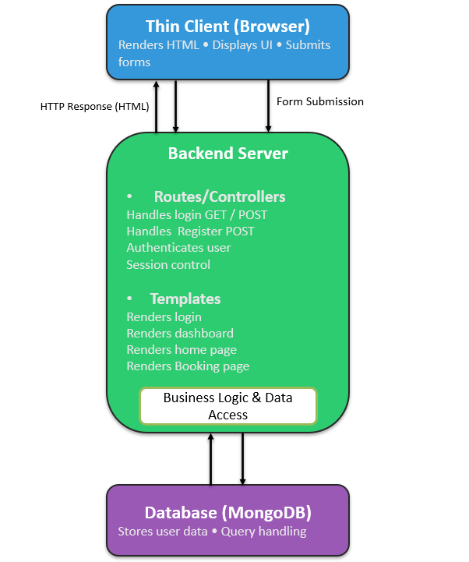

The Thin Client Architecture utilizes the user's Thin Client (Browser) primarily to display the UI and capture form submissions, minimizing the processing required on the local device. All major application work, including authentication, session control, business logic, and page rendering via templates, is handled by the central Backend Server. The server then manages data persistence by communicating with the Database (MongoDB) to store and retrieve all user and service information, creating a centralized and efficient web-based system
Use case diagram:
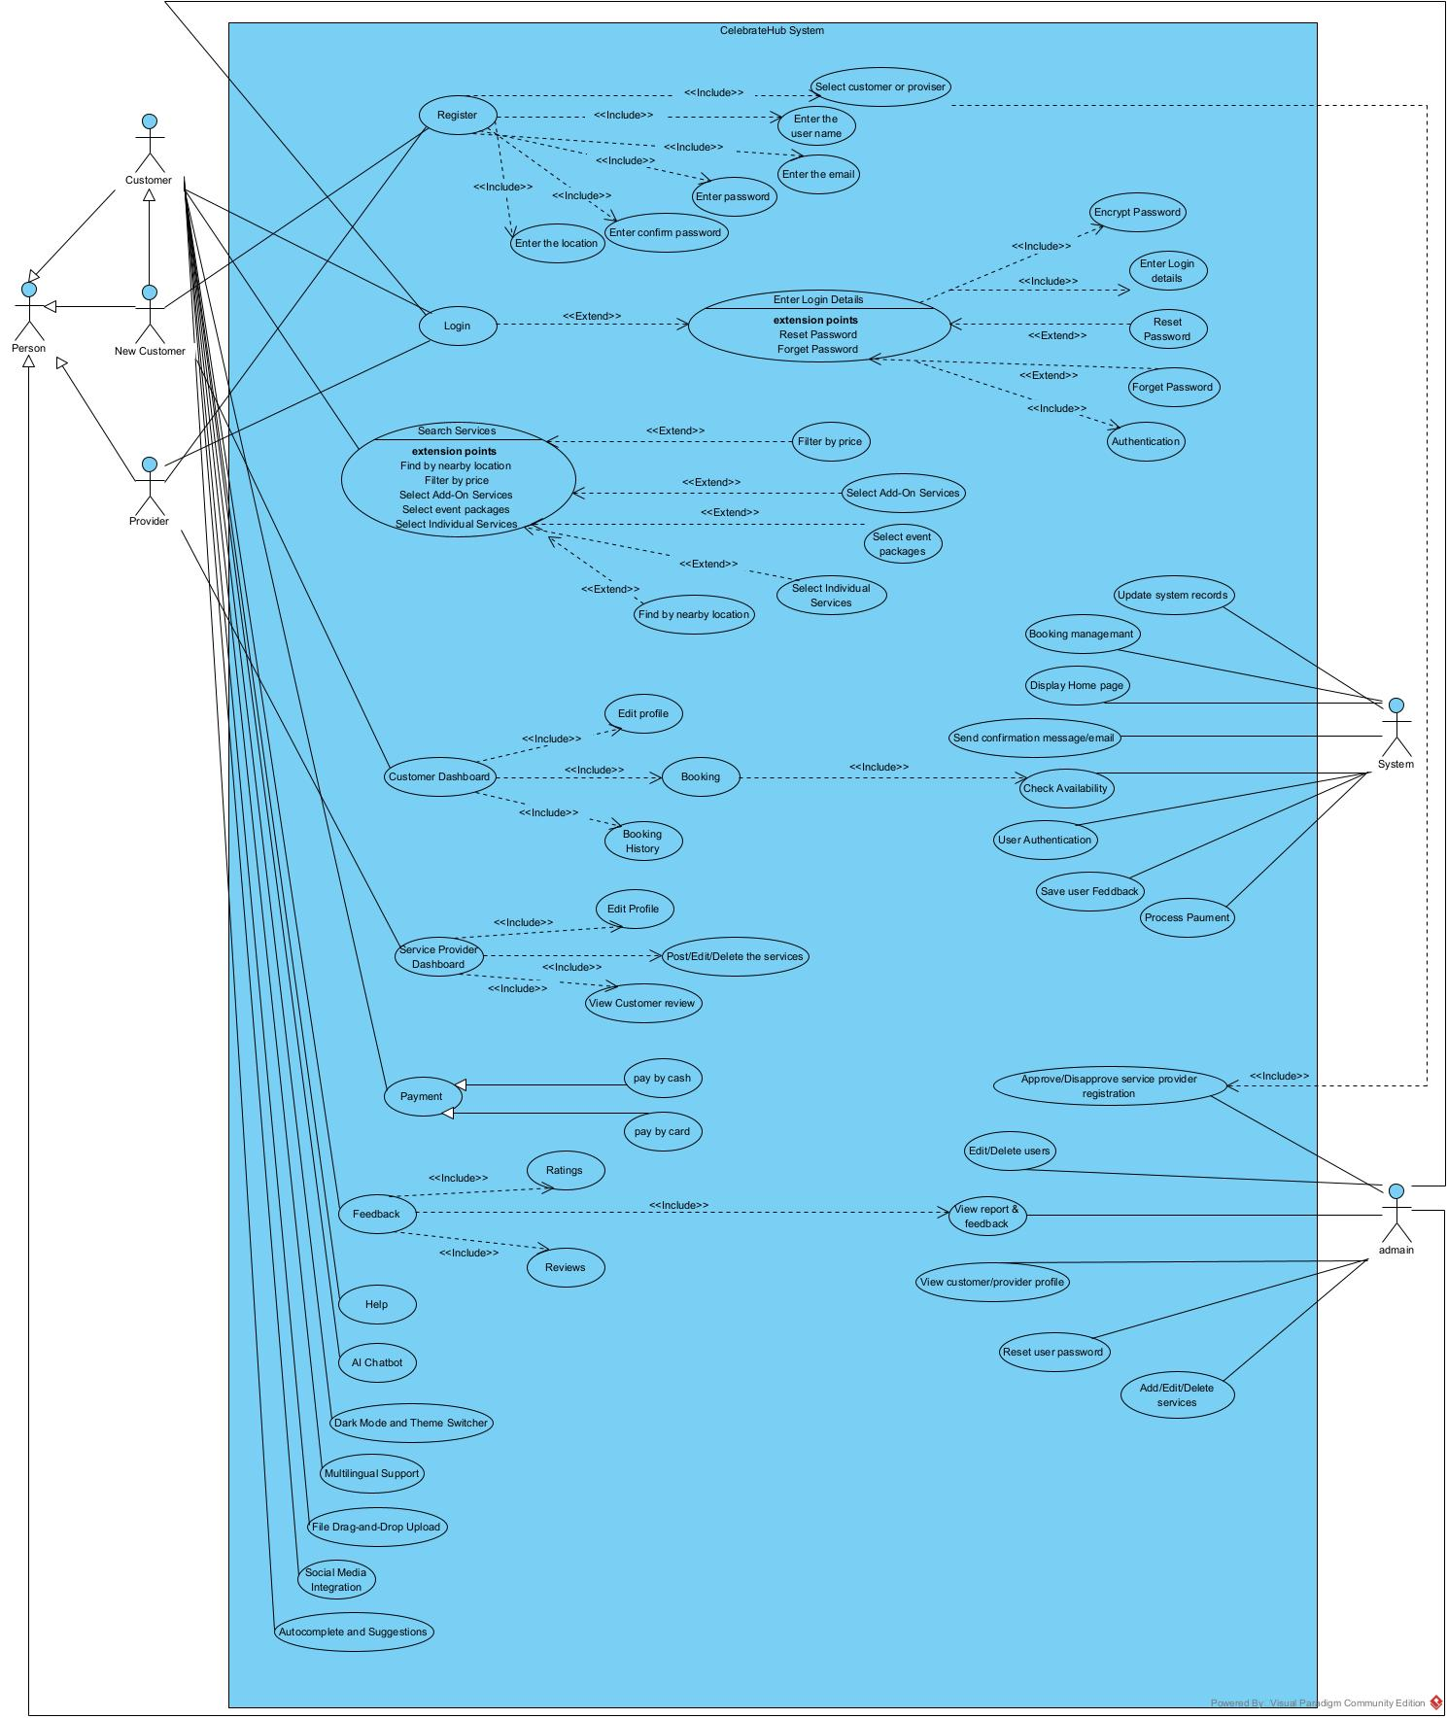

Test Plan:

Project Name: CelebrateHub
Test Case ID: 1 | Student ID and Signature:  Hassan Ali Salim Al-Siyabi -- 12S19150  Affan Obaid Said Al-Taei -- 16S20130  Supervisor Signature:
Module Name: Register | Test Executed by:
Test Title: sign up page | Test Execution date:
Description: Register by entering username, email, phone number, password, confirm password, and select register as customer or service provider.

Step | Test Steps | Expected Result | Actual Result | Status (Pass/Fail) | Notes
1 | If the fields are empty. | Please fill up the registration form | Please fill out this field | pass
2 | Password is empty | Please enter the password | Please fill in this field | pass
3 | Mismatched password and confirm password | Error: password mismatch. | Passwords do not match | pass
4 | Enter weak password (affan123) | Password must be complex | Must contain uppercase and special character | pass
5 | Entering an email without “@” symbol. | Invalid email address. | Message appears: Please include an @ in the email address | pass
6 | Enter invalid phone number (4959583) | Please enter a valid phone number | Phone number must be 8 digits and start with 7 or 9. | pass
7 | Use the already registered email | Email already exists | User with this email already exists | pass
8 | Select registration type as Customer | Role saved | Non | pass
9 | Select registration type as service provider | The “Enter business location” field will appear | “Enter business location” field appears | pass
10 | If the “location of business” field is empty | Enter business location | Please fill out this field | pass
11 | Submit valid form as a customer | Registered successfully | Redirects to the login page | pass
12 | Enter duplicate phone number already registered | Error: phone number already exists | Registration successful | fail
13 | Submit form with whitespace-only values | Error: fields cannot be blank | System trims and accepts | fail
14 | Enter phone number with letters (e.g., 98AB1234) | Error: invalid phone number | System accepts input | fail
15 | Submit a valid form as a service provider | Registered successfully | Registration successful! Your account is pending approval from the administrator. | pass

Project Name: CelebrateHub
Test Case ID: 1 | Student ID and Signature:  Hassan Ali Salim Al-Siyabi -- 12S19150  Affan Obaid Said Al-Taei -- 16S20130  Supervisor Signature:
Module Name: Sign in | Test Executed by:
Test Title: sign in page | Test Execution date:
Description: sign in by entering email and password.

Step | Test Steps | Expected Result | Actual Result | Status(Pass/Fail) | Notes
1 | If the fields are empty. | Please fill up the login form | Please fill out this field | pass
2 | Email is empty | Please enter your Email | Please fill in this field | pass
3 | Password is empty | Please enter the password | Please fill in this field | pass
4 | Login with Invalid Password | Invalid password | Invalid email or password | pass
5 | Login with Invalid email | Invalid email | Invalid email or password | pass
6 | Log in as a customer. Both email and password are correct | Success, redirect to customer dashboard | Success, redirect to customer dashboard | pass
7 | Log in as a service provider. Both email and password are correct | Success, redirect to service provider dashboard | Success, redirect to service provider dashboard | pass
8 | Log in as admin. Both email and password are correct | Success, redirect to admin dashboard | Success, redirect to admin dashboard | pass
9 | Multiple failed login attempts (5 times) | Account temporarily locked | System allows unlimited attempts | fail

Schedule and Test Allocation:
Phase | Assigned Team | Duration
Project description | Hassan & Affan | 1 Days
Architectural model and draw the diagram | Hassan & Affan | 2 Days
Test Plan | Hassan & Affan | 3 Days
Check the test case and the results | Hassan & Affan | 1 Days

Reference:
- https://www.drawio.com/
- https://www.visual-paradigm.com/download/community.jsp
- https://files.eric.ed.gov/fulltext/EJ1022988.pdf

