**Time Complexities of Sorting Algorithms**

**GUI**

**Input sample size:**

**Graph:**

**Table:**

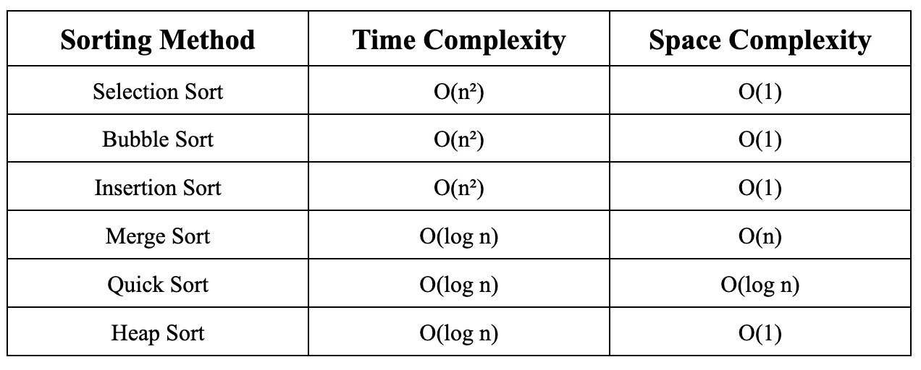

**Code:** https://github.com/affanabid/dsa/blob/main/complexities/fn.py