Hybrid GA Boids model
- Compare with base models: GA, PSO
- Compare with premature convergence mitigating models: Steady state GA, Fully informed particle swarm (FIPS)
- Continuous function optimization benchmarks:
  - Each benchmark is a mathematical function f(x) that takes a vector of real numbers and returns a singular scalar value. Find x to minimize f(x)
  - Sphere:
    - 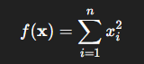
  - Rosenbrock (banana)
    - 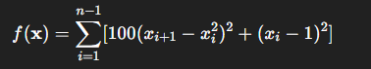
  - Rastrigin
    - 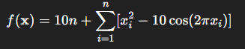
- Feature selection benchmarks:
  - Each gene represents whether a particular feature is selected or not (1/0).
  - Objective is to maximize classifier accuracy while minimizing selecting features.
  - 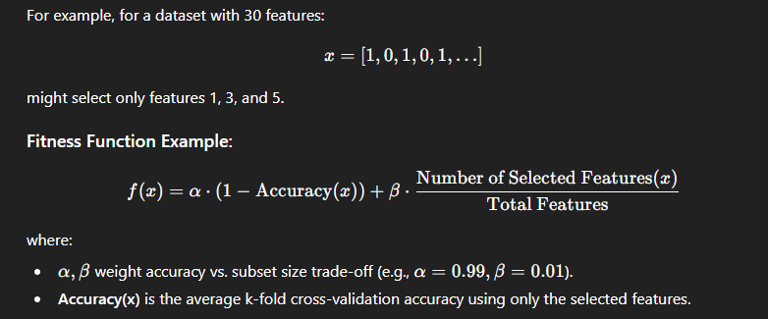
  - Breast cancer Wisconsin
    - 30 continuous features with binary labelling.
    - From 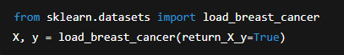
  - Sonar
    - 60 numerical features with binary labelling
    - From:
      - import pandas as pd
      - url = "https://archive.ics.uci.edu/ml/machine-learning-databases/undocumented/connectionist-bench/sonar/sonar.all-data"
      - data = pd.read_csv(url, header=None)
      - X = data.iloc[:, :-1].values
      - y = data.iloc[:, -1].map({'R': 0, 'M': 1}).values
  - Compare via kNN (?)
- Scheduling tasks
  - 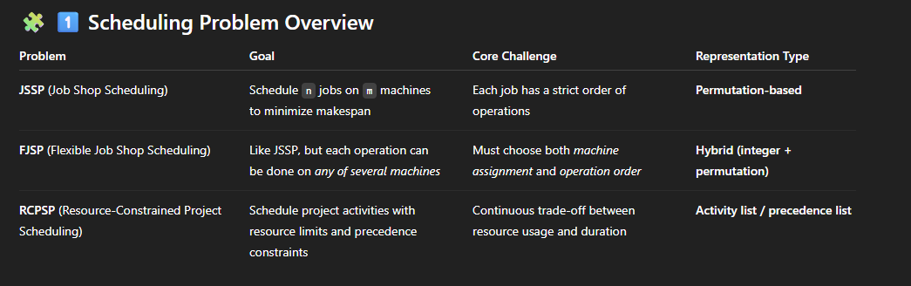
  - job shop scheduling problem (JSSP)
    - 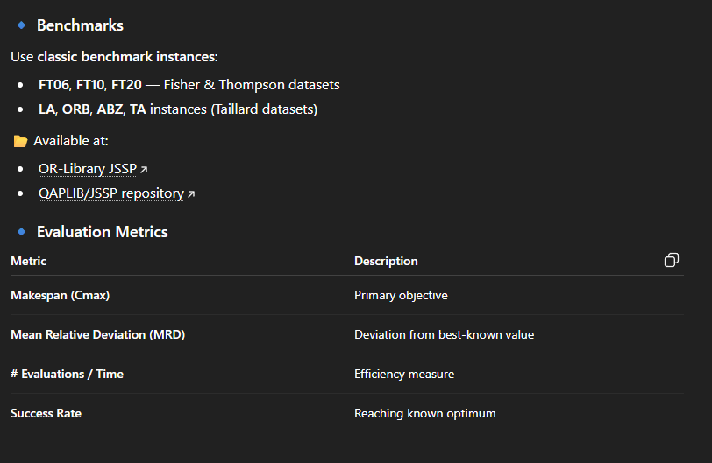
  - flexible job shop scheduling (FJSP)
    - 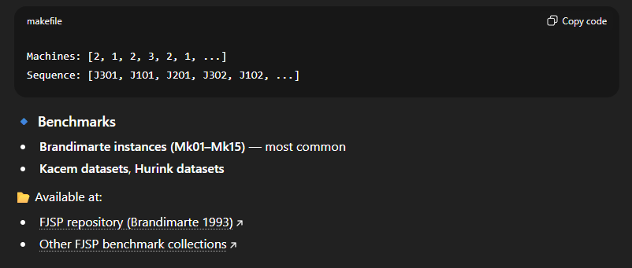
  - Resource constrained project scheduling problem (RCPSP)
    - 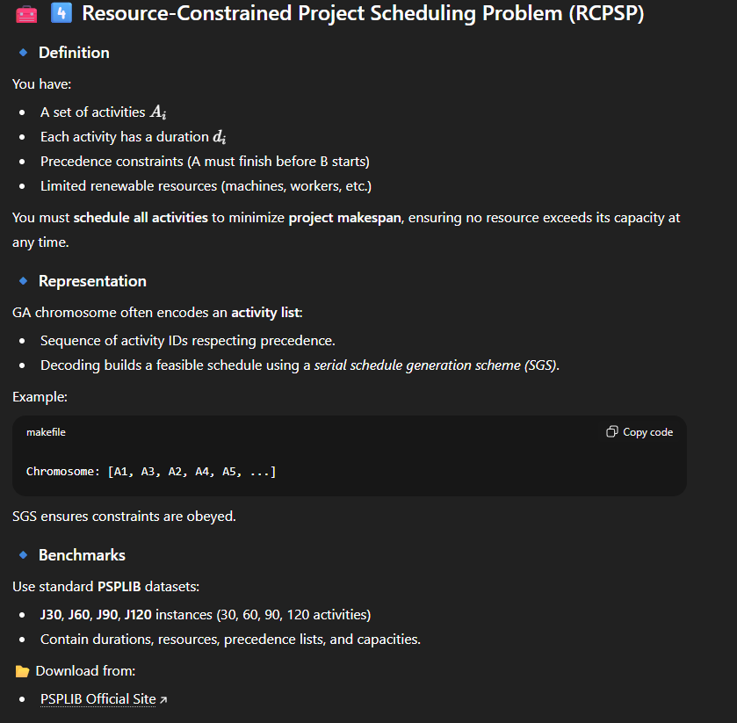
Metrics: convergence rate vs population diversity

