Software Requirements Specification
Predictive Cluster Manager
IEEE 830-Compliant Requirements Specification

Document Title | Software Requirements Specification for Predictive Cluster Manager
Version | 1.0 approved
Prepared by | 23K-0724 Roshaan Haider; 23K-0630 Moazzam Junaid; 23K-0562 Affan Rehman
Organization | Software Engineering Project
Date | May 4, 2026
Standard | IEEE 830 Software Requirements Specification structure
Document Status | Submission-ready academic and portfolio documentation

Prepared by
Roll No. | Name
23K-0724 | Roshaan Haider
23K-0630 | Moazzam Junaid
23K-0562 | Affan Rehman

Table of Contents
Revision History .................................................................. 3
1. Introduction ................................................................... 4
1.1 Purpose .................................................................. 4
1.2 Document Conventions ..................................................... 4
1.3 Intended Audience and Reading Suggestions ................................ 4
1.4 Product Scope ............................................................ 4
1.5 References ............................................................... 4
2. Overall Description ............................................................ 5
2.1 Product Perspective ...................................................... 5
2.2 Product Functions ........................................................ 5
2.3 User Classes and Characteristics ......................................... 5
2.4 Operating Environment .................................................... 6
2.5 Design and Implementation Constraints .................................... 6
2.6 User Documentation ....................................................... 6
2.7 Assumptions and Dependencies ............................................. 6
3. External Interface Requirements ................................................ 7
3.1 User Interfaces .......................................................... 7
3.2 Hardware Interfaces ...................................................... 7
3.3 Software Interfaces ...................................................... 7
3.4 Communications Interfaces ................................................ 7
4. System Features ................................................................ 8
4.1 Predictive Load Forecasting .............................................. 8
4.2 Scaling Decision Logic ................................................... 9
4.3 Cost-Optimized Scaling Planning .......................................... 10
4.4 Container Lifecycle Management ........................................... 11
4.5 REST API Control ......................................................... 11
4.6 Real-Time Monitoring Dashboard and Manual Override ....................... 12
5. Other Nonfunctional Requirements ............................................... 13
5.1 Performance Requirements ................................................. 13
5.2 Safety Requirements ...................................................... 13
5.3 Security Requirements .................................................... 14
5.4 Software Quality Attributes .............................................. 14
5.5 Business Rules ........................................................... 14
6. Other Requirements ............................................................. 14
Appendix A: Glossary .............................................................. 15
Appendix B: Analysis Models ....................................................... 16
Appendix C: To Be Determined List ................................................. 19

Revision History
Name | Date | Reason For Changes | Version
Project Team | May 4, 2026 | Initial professional IEEE 830 SRS release with integrated UML diagrams | 1.0

1. Introduction

1.1 Purpose
This Software Requirements Specification defines the functional, external interface, nonfunctional, and supporting requirements for the Predictive Cluster Manager, version 1.0. The document covers the complete system, including the FastAPI backend, LSTM-based workload prediction layer, rule-based capacity conversion, A* scaling planner, Docker-based execution layer, and real-time monitoring dashboard.
The purpose of this SRS is to establish a precise agreement between stakeholders, developers, testers, and evaluators regarding what the system shall do and the conditions under which it shall operate. It supports design review, implementation, verification, academic assessment, and future maintenance.

1.2 Document Conventions
The document follows the IEEE 830 SRS structure reflected in the supplied template. The terms SHALL, SHOULD, and MAY are used with their conventional requirements meanings. Functional and nonfunctional requirements are uniquely identified using REQ-n labels and include priority and verification guidance.

1.3 Intended Audience and Reading Suggestions
This SRS is intended for software engineering instructors, project evaluators, system architects, backend developers, DevOps engineers, cloud administrators, testers, and future maintainers. Readers seeking a high-level understanding should begin with Sections 1 and 2. Developers and testers should focus on Sections 3, 4, and 5. Evaluators should also review Appendix B, which includes the Use Case Diagram, Activity Diagram, and Class Diagram.

1.4 Product Scope
Predictive Cluster Manager is an AI-driven cloud infrastructure autoscaling system. It predicts future CPU and memory demand from workload behavior and proactively scales a simulated cluster before overload occurs. The system demonstrates an end-to-end pipeline combining deep learning, deterministic planning, infrastructure automation, REST APIs, and a dashboard interface.
The system manages lightweight Docker containers that simulate cloud server nodes. It does not provide production traffic routing, service mesh integration, public cloud billing integration, or live workload migration.

1.5 References
- Karl E. Wiegers, IEEE Software Requirements Specification Template, 1999.
- Google Cluster Data, Google Cluster Workload Traces 2019 and Google cluster-usage traces v3 documentation.
- FastAPI Documentation, https://fastapi.tiangolo.com/.
- Docker Engine SDK Documentation, https://docs.docker.com/reference/api/engine/sdk/.
- Docker SDK for Python Documentation, https://docker-py.readthedocs.io/.
- Project files: README.md, api.py, astar_scaler.py, docker_manager.py, dashboard.html, data_preprocessing.py, train_model.py, and stress_test.py.

2. Overall Description

2.1 Product Perspective
Predictive Cluster Manager is a self-contained cloud autoscaling simulation platform. It operates as a management layer above a local Docker Engine. The FastAPI backend orchestrates model inference, scaling decision logic, A* planning, and Docker lifecycle actions. The frontend dashboard communicates with the backend through REST endpoints and displays operational state to users.
The diagrams in Appendix B are formal analysis models for this system. The Activity Diagram describes the end-to-end workflow, the Class Diagram identifies the primary backend models and services, and the Use Case Diagram defines actor interaction boundaries.

2.2 Product Functions
- Predict future CPU and memory utilization using an LSTM model trained on Google Cluster Trace workload data.
- Convert predicted utilization percentages into a required node count using node capacity assumptions and safety headroom.
- Generate a cost-minimized sequence of boot and shutdown actions using A* search.
- Start, stop, and clean up Docker containers that simulate cluster nodes.
- Expose REST endpoints for health checking, status monitoring, prediction-driven scaling, stress simulation, and cleanup.
- Display real-time cluster metrics through a dashboard with Chart.js graphs and a node grid.
- Support manual override scenarios through stress simulation and cleanup controls.
- Fall back to simulation mode when Docker or the trained model is unavailable.

2.3 User Classes and Characteristics
User Class | Characteristics | Primary Responsibilities | Diagram Reference
Cloud Administrator | Runtime operator responsible for observing infrastructure state. | Monitor status, trigger demonstrations, and clean up managed nodes. | Figure B-1
DevOps Engineer | Engineering user familiar with APIs, containers, and deployment. | Validate Docker execution, inspect scaling behavior, and verify API readiness. | Figure B-1
ML Engineer | Supporting project role responsible for model preparation. | Prepare workload data and train or update LSTM model artifacts. | Figure B-1

2.4 Operating Environment
The system shall operate on Windows, Linux, or macOS environments capable of running Python and Docker Engine. The target Python environment is Python 3.8 or later, with Python 3.11 or later recommended. Docker Engine or Docker Desktop is required for physical container lifecycle execution.

2.5 Design and Implementation Constraints
- The backend shall use FastAPI for REST endpoint implementation and request/response validation.
- The execution layer shall use the Docker SDK for Python.
- Managed containers shall use the cluster-node-N naming convention and a management label.
- The trained LSTM model and scaler artifacts shall be loaded into memory during backend startup when available.
- The system shall support simulation mode when the Docker daemon is unavailable.
- The planner shall use A* search with boot cost 1.0 and shutdown cost 0.5.

2.6 User Documentation
The delivered software shall include README-based setup and usage instructions, API endpoint documentation generated by FastAPI OpenAPI support, and this SRS. The dashboard shall provide visible operational controls and status displays without requiring users to inspect source code during normal demonstrations.

2.7 Assumptions and Dependencies
- The host machine has sufficient CPU and memory to run the FastAPI backend and lightweight Docker containers.
- Docker Engine is installed and accessible to the Python process for real execution mode.
- If Docker is inaccessible, simulation mode is acceptable for functional demonstration.
- Model artifacts are available in the project directory for prediction mode.
- Users access the dashboard and API over a trusted local or controlled network during demonstration.

3. External Interface Requirements

3.1 User Interfaces
The system shall provide a browser-based dashboard for real-time monitoring and manual control. The dashboard shall display current CPU usage, current memory usage, running node count, a workload chart, and a grid of simulated cluster nodes. It shall provide controls for stress simulation and cluster cleanup.

3.2 Hardware Interfaces
The system does not directly control physical server hardware. It interfaces with host compute resources through Docker Engine, which allocates CPU and memory to containers. Each simulated node is represented by a lightweight container configured with constrained resource usage.

3.3 Software Interfaces
Interface | Direction | Data / Operation | Purpose
FastAPI REST API | Client to backend | HTTP requests and JSON responses | Expose health, status, prediction, scaling, stress simulation, and cleanup operations.
Docker SDK for Python | Backend to Docker Engine | Container list, create, start, stop, and remove operations | Execute lifecycle operations for simulated cluster nodes.
TensorFlow / Keras model | Backend to model artifact | Feature window and predicted CPU/memory values | Predict future resource demand.
Pickle scaler artifacts | Backend to local files | Input and target scaling transformations | Normalize model inputs and inverse-transform outputs.
Chart.js | Dashboard browser runtime | Time-series CPU and memory values | Render monitoring graphs.

3.4 Communications Interfaces
The dashboard and external clients shall communicate with the backend using HTTP and JSON. The backend shall support GET /health, GET /status, POST /predict-and-scale, POST /simulate-stress, and POST /cleanup. During local demonstrations, the expected base URL is http://localhost:8000 unless configured otherwise.

4. System Features
This section organizes functional requirements by major system feature. The Use Case Diagram in Appendix B identifies the user-facing capabilities and actor interactions. The Activity Diagram shows operational flow, and the Class Diagram shows the software structure that supports these features.

4.1 Predictive Load Forecasting

4.1.1 Description and Priority
This feature estimates near-future CPU and memory demand from workload history using an LSTM model and supporting scaler artifacts.
Priority: High. This feature is required for acceptance of the version 1.0 project scope.

4.1.2 Stimulus/Response Sequences
- A user or dashboard submits a prediction-and-scale request.
- The backend constructs a workload input window.
- The backend performs model inference or fallback prediction.
- The predicted CPU and memory values are returned in the scaling response.

4.1.3 Functional Requirements
ID | Requirement Statement | Priority | Verification
REQ-1 | The system SHALL accept current average CPU and memory values for prediction-driven scaling requests. | High | API test
REQ-2 | The system SHALL generate a synthetic workload window of 60 time steps when an external workload sequence is not supplied. | High | Unit test
REQ-3 | The system SHALL load the trained Keras LSTM model and scaler artifacts during startup when present. | High | Startup test
REQ-4 | The system SHALL scale model inputs before inference and inverse-transform outputs before capacity planning. | High | Unit test
REQ-5 | The system SHALL use a fallback synthetic prediction when model or scaler artifacts are unavailable. | High | Fault test

4.2 Scaling Decision Logic

4.2.1 Description and Priority
This feature converts predicted utilization into a required node count by applying configured node capacity assumptions and safety headroom.
Priority: High. This feature is required for acceptance of the version 1.0 project scope.

4.2.2 Stimulus/Response Sequences
- The backend receives predicted CPU and memory values.
- The rule engine calculates CPU-based and memory-based node counts.
- The rule engine applies safety headroom and selects the larger count.
- The backend labels direction as UP, DOWN, or STABLE.

4.2.3 Functional Requirements
ID | Requirement Statement | Priority | Verification
REQ-6 | The system SHALL convert predicted CPU utilization into a CPU-based node count. | High | Unit test
REQ-7 | The system SHALL convert predicted memory utilization into a memory-based node count. | High | Unit test
REQ-8 | The system SHALL apply default safety headroom of 1.2 unless a valid request value is supplied. | High | API test
REQ-9 | The system SHALL select the maximum of CPU-based and memory-based node counts. | High | Unit test
REQ-10 | The system SHALL enforce configured minimum and maximum node limits. | High | Boundary test
REQ-11 | The system SHALL report scaling direction as UP, DOWN, or STABLE. | Medium | API test

4.3 Cost-Optimized Scaling Planning

4.3.1 Description and Priority
This feature computes the cost-minimized sequence of cluster transitions required to move from the current node count to the required node count.
Priority: High. This feature is required for acceptance of the version 1.0 project scope.

4.3.2 Stimulus/Response Sequences
- The backend reads current running node count and names.
- The planner receives current and target state.
- The planner evaluates valid boot or shutdown transitions.
- The planner returns ordered actions and total cost.

4.3.3 Functional Requirements
ID | Requirement Statement | Priority | Verification
REQ-12 | The system SHALL compute a scaling plan using A* search. | High | Unit test
REQ-13 | The system SHALL assign boot cost 1.0 and shutdown cost 0.5. | High | Unit test
REQ-14 | The system SHALL use an admissible heuristic based on node-count distance and minimum action cost. | High | Code review
REQ-15 | The system SHALL return an empty action list and zero cost when already at target. | High | Unit test
REQ-16 | The system SHALL generate boot actions using the cluster-node-N naming convention. | Medium | Unit test

4.4 Container Lifecycle Management

4.4.1 Description and Priority
This feature translates scaling plan actions into Docker container lifecycle operations or simulation-mode updates.
Priority: High. This feature is required for acceptance of the version 1.0 project scope.

4.4.2 Stimulus/Response Sequences
- The backend receives a scaling plan.
- The Docker manager iterates through boot and shutdown lists.
- Docker SDK operations are issued when available.
- Simulation state is updated when Docker is unavailable.
- Operation results are returned.

4.4.3 Functional Requirements
ID | Requirement Statement | Priority | Verification
REQ-17 | The system SHALL initialize a Docker client from the host environment during startup. | High | Startup test
REQ-18 | The system SHALL detect Docker unavailability and enter simulation mode without terminating. | High | Fault test
REQ-19 | The system SHALL create managed node containers using the Alpine image and persistent sleep command. | High | Integration test
REQ-20 | The system SHALL label all managed containers with a project-specific management label. | High | Integration test
REQ-21 | The system SHALL stop and remove a managed container when executing shutdown. | High | Integration test
REQ-22 | The system SHALL provide cleanup that removes all managed real or simulated nodes. | High | Integration test

4.5 REST API Control

4.5.1 Description and Priority
This feature exposes system operations to the dashboard, test clients, and manual users through structured JSON endpoints.
Priority: High. This feature is required for acceptance of the version 1.0 project scope.

4.5.2 Stimulus/Response Sequences
- A client sends an HTTP request.
- FastAPI validates the request model.
- The backend executes the selected workflow.
- The backend returns JSON or an appropriate error response.

4.5.3 Functional Requirements
ID | Requirement Statement | Priority | Verification
REQ-23 | The system SHALL expose GET /health for service, model, and Docker status. | High | API test
REQ-24 | The system SHALL expose GET /status for node count, current CPU, memory, and node details. | High | API test
REQ-25 | The system SHALL expose POST /predict-and-scale to perform prediction, planning, execution, and reporting. | High | End-to-end test
REQ-26 | The system SHALL expose POST /simulate-stress to bypass model inference and use supplied spike values. | High | API test
REQ-27 | The system SHALL expose POST /cleanup to remove all project-managed nodes. | High | API test
REQ-28 | The system SHALL return HTTP 503 when required backend managers are not initialized. | High | Fault test

4.6 Real-Time Monitoring Dashboard and Manual Override

4.6.1 Description and Priority
This feature provides operational visibility and manual demonstration controls.
Priority: High. This feature is required for acceptance of the version 1.0 project scope.

4.6.2 Stimulus/Response Sequences
- The user opens the dashboard.
- The dashboard periodically requests status.
- The dashboard updates metrics, chart, and node grid.
- The user may trigger stress simulation or cleanup.
- The dashboard displays updated results.

4.6.3 Functional Requirements
ID | Requirement Statement | Priority | Verification
REQ-29 | The dashboard SHALL display current CPU percentage, memory percentage, and running node count. | High | UI test
REQ-30 | The dashboard SHALL display a time-series chart for CPU and memory monitoring. | High | UI test
REQ-31 | The dashboard SHALL display a visual node grid representing managed nodes. | High | UI test
REQ-32 | The dashboard SHALL poll the status endpoint at an interval not greater than approximately 1.2 seconds. | Medium | UI test
REQ-33 | The dashboard SHALL provide controls for stress simulation and cleanup. | High | UI/API test

5. Other Nonfunctional Requirements

5.1 Performance Requirements
ID | Requirement Statement | Priority | Verification
REQ-34 | The A* planner SHALL compute a scaling plan for target ranges up to approximately 100 nodes in less than 500 milliseconds. | High | Performance test
REQ-35 | The dashboard SHALL refresh visible status within approximately 1.2 seconds of a successful polling cycle. | Medium | UI timing test
REQ-36 | The backend SHOULD complete prediction-and-scale within 3 seconds when Docker image pulls are not required. | Medium | End-to-end test
REQ-37 | The backend SHALL load model and scaler artifacts during startup rather than during each scaling request. | High | Startup test

5.2 Safety Requirements
ID | Requirement Statement | Priority | Verification
REQ-38 | The system SHALL manage only containers carrying the project naming convention or management label. | High | Integration test
REQ-39 | The system SHALL enforce a maximum node count to prevent uncontrolled container creation. | High | Boundary test
REQ-40 | The system SHALL NOT manage host services, physical machines, or containers outside its ownership boundary. | High | Code review

5.3 Security Requirements
ID | Requirement Statement | Priority | Verification
REQ-41 | The REST API SHALL be treated as an administrative interface for trusted local or controlled-network access. | High | Deployment review
REQ-42 | The system SHALL avoid executing arbitrary user-supplied shell commands through API inputs. | High | Security test
REQ-43 | The system SHALL isolate simulated nodes inside containers with bounded resources where Docker supports it. | High | Integration test
REQ-44 | The system SHOULD restrict permissive CORS settings before deployment beyond local demonstration. | Medium | Security review

5.4 Software Quality Attributes
ID | Requirement Statement | Priority | Verification
REQ-45 | The system SHALL preserve modular separation between prediction, rule conversion, planning, execution, API, and dashboard concerns. | High | Architecture review
REQ-46 | The system SHALL remain testable through component-level functions and API endpoint tests. | High | Test review
REQ-47 | The system SHALL continue operating in degraded simulation mode when Docker is unavailable. | High | Reliability test
REQ-48 | The system SHOULD support replacement of trained model artifacts without redesigning the planner or Docker manager. | Medium | Maintainability review

5.5 Business Rules
ID | Requirement Statement | Priority | Verification
REQ-49 | Cloud Administrator and DevOps Engineer SHALL be considered authorized runtime user classes for version 1.0. | High | Requirements review
REQ-50 | The system SHALL prefer proactive scale-up when predicted demand exceeds capacity after headroom. | High | Functional test
REQ-51 | The system SHALL consider shutdown less costly than boot using the defined cost ratio of 0.5 to 1.0. | High | Unit test
REQ-52 | Simulation mode SHALL be accepted as a demonstration substitute when Docker is unavailable and health status reports that condition. | High | Fault test

6. Other Requirements
The system shall maintain project artifacts in a reproducible structure so that model files, scaler files, backend code, dashboard code, Docker deployment files, and documentation can be reviewed together. The system shall not require an external database for version 1.0, because runtime state is derived from Docker-managed containers or the in-memory simulation registry.
Internationalization, multi-tenant authentication, public cloud provisioning, billing integration, and production traffic routing are outside the scope of version 1.0.

Appendix A: Glossary
Term | Definition
A* Algorithm | Graph search algorithm used to find a low-cost path from an initial state to a goal state.
ASGI | Asynchronous Server Gateway Interface used by FastAPI applications.
Container | Lightweight isolated runtime unit used to simulate a cloud node.
Docker Engine | Container runtime service that creates, starts, stops, and removes containers.
FastAPI | Python web framework used to implement the REST backend.
Headroom | Safety multiplier applied to predicted demand before node calculation.
LSTM | Long Short-Term Memory neural network architecture used for time-series workload prediction.
Node | A simulated server represented by a Docker container named cluster-node-N.
Scaling Plan | Ordered boot and shutdown action sequence generated by the A* planner.
Simulation Mode | Fallback mode in which node state is maintained in memory rather than through Docker.

Appendix B: Analysis Models
This appendix contains the UML analysis diagrams supplied for the Predictive Cluster Manager. The diagrams are integrated as formal figures and referenced throughout the SRS.
Figure B-1. Use Case Diagram for Predictive Cluster Manager
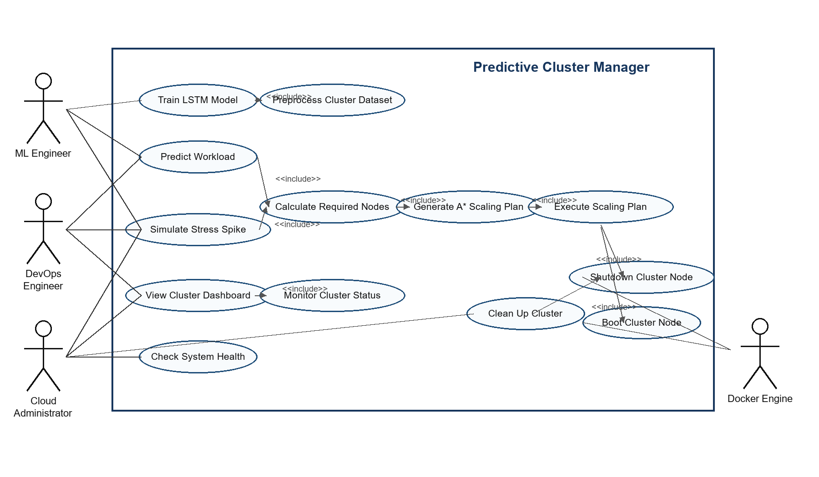

Figure B-2. Activity Diagram for Predictive Cluster Manager Runtime Workflow
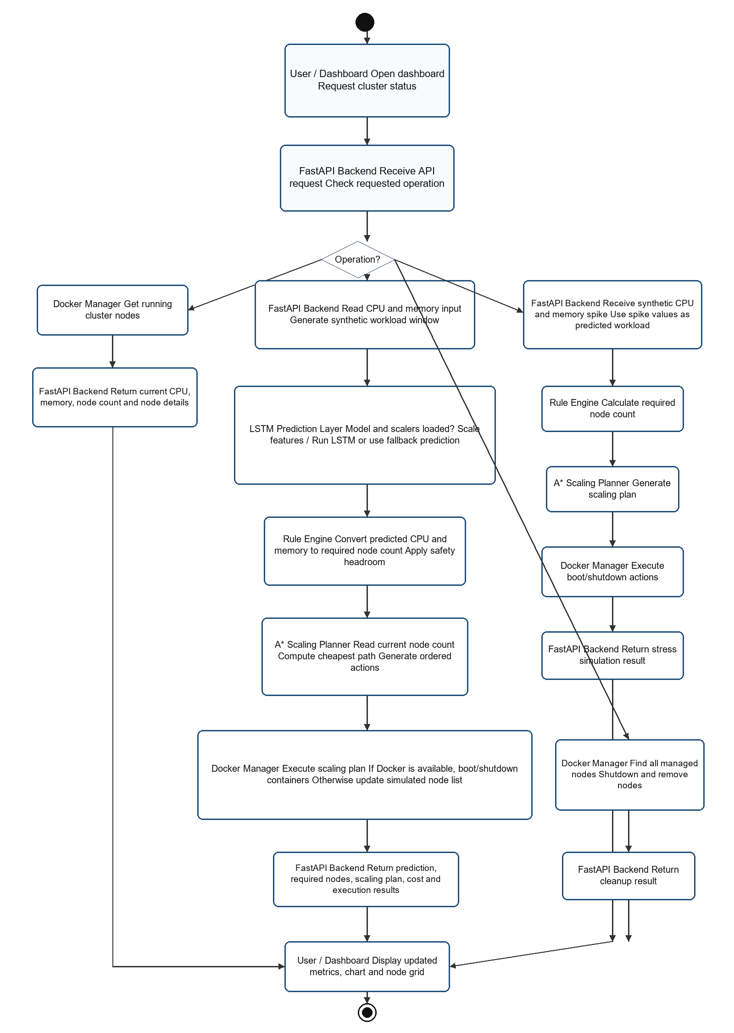

Figure B-3. Class Diagram for Predictive Cluster Manager Software Structure
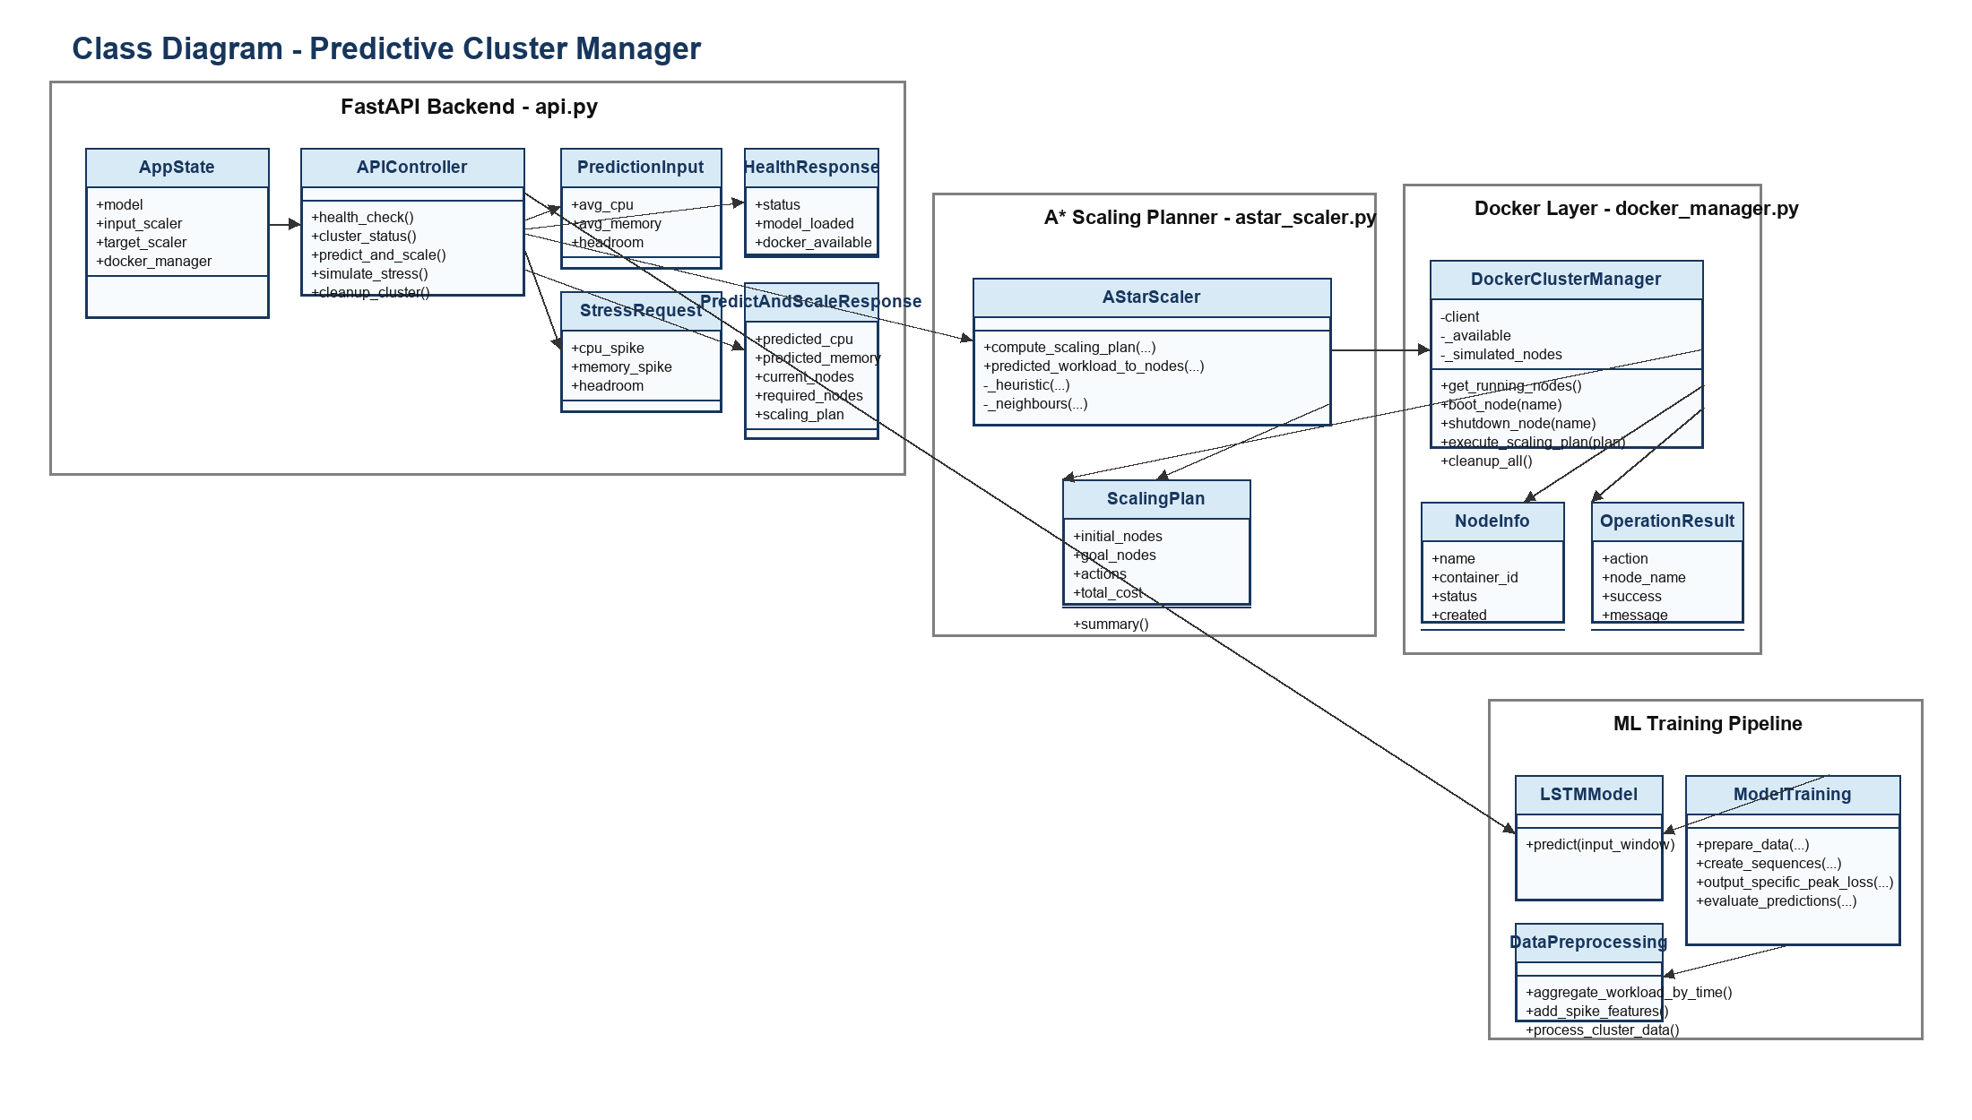

Appendix C: To Be Determined List
No unresolved TBD items remain in this SRS for version 1.0. Future releases may add TBD entries for production authentication design, public cloud provider integration, and external traffic-routing support if those capabilities are added to project scope.

