Website Pre-Design

**What sort of website will this be? Store, blog, informational website**

Informational website, it will have articles and images on the businesses for online foraging. It will have an about article, explaining the websites’ purpose and information. There will be then a list of businesses that are ideal for sharing with their information, links, and delivery charges.

**What is the websites story? Purpose and message**

Provide information on businesses that are worth to check out during COVID 19. Inform about each business as well.

**What will website contain?**

Written articles, visual media, links to each business websites, extra info such as delivery charges.

**Who is target audience?**

Anyone bored during this pandemic and looking for some food to spice up their quarantine.

**Will there be a brand or logo?**



**Scope of the project?**

Small project, one page long, inform 2 businesses, and a small article on each one.

**What will people do on the website?**

Learn and explore the businesses, potentially buy food from them.

**Will imagery be used?**

yes, pictures of the foods of each business.

**I there a particular style?**

Minimalistic

**Is social media to be used?**

No.

**How will the website be laid out?**

1st Article with pictures

about

Footer with contact info and links

Main

Header title and logo

Navigation links

Main stock image photo

2nd Article with pictures

# Header and Navigation Links



 The name of this websites brand will be FORAGERS with its main logo as a tasty cartoon burger. The header will include the navigation links as shown above with the following navigational options:

* Home
* About
* Reviews
* Contact

# Main Stock Image

The website will have a main background wallpaper that will bring the entire color palette together. The picture includes a small abstract structure with delicious assorted brown cookies. The reason I want to include this in my design is so it has a more modern and aesthetic feel to it.

The picture as shown left, fits the overall message of this website, to deliver good quality produce to customers online. The link to the picture is here: <https://unsplash.com/photos/Hyl-LtxUa3E>

# About

This section introduces the website page to customers. The colour fits the palette and the words are easily readable:

# Food Products to Forage Online

  Our new social distancing world has made shopping in groceries from a luxury to a near-essential. The virus not only infected us, but businesses as well, many small retailers had to remain closed. Some businesses have started offering home delivery of fresh quality food products safely. Here are some businesses to buy some local food products safely.

# 1st Article

The first article is about a Japanese-French dessert catering shop that I have grown to love over the quarantine. They offer delivery and a very specific niche of desserts that are worth checking out. The article follows the same color palette and some words are bolded or in the color green to stand out.

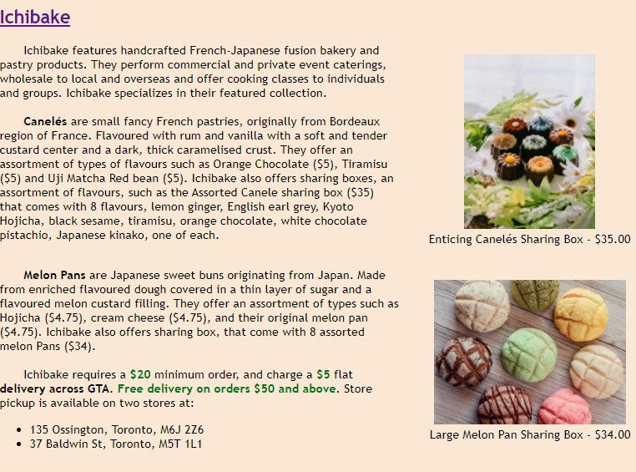

The article is over 200 words and the pictures shown are some of their featured collections they offer. The links to these pictures are:

* <https://ichibake.com/collections/melon-pan/products/large-melon-pan-sharing-box>
* <https://ichibake.com/collections/canele-1/products/thanksgiving-sharing-box8pcs>

# 2nd Article

The second article is about a virtual farmers market that I have grown to love:

## [Graze and Gather](https://grazeandgatherfood.ca/)

  Graze and Gather is a large farmers market featuring local, fresh produce such as meats, baked goods, vegetables/fruits and much more. Graze and Gather is the best virtual farmer’s market to shop from as they offer a variety of foods and choices from several different local farms.  
  
  Some of the favourite dishes are the Tajine, Chicken and Mixed Grains ($50) which is from the company Constantine. The dish serves 2-3 people and is a perfect choice for a dinner date at home.  
  
  The produce cheese from Ontario Cheese Union is also a must buy. The cheese is handpicked and is easily one of the best family owned dairy farm producer. The 18 month aged Paermesan cheese is filled with nutty falvours and grassy undertones giving away a creamy mouth to savour. This is the BEST cheese to try out, especially for pizza. It is good quality and supports local businesses!  
  
  **Delivery** is a flat **$4.50** rate with all orders paid for in advance. Delivery is around 1pm to 9pm, with confirmation emails, and a text notification when the **driver is 15 minutes away**. To know if you are eligible for delivery, Graze and Gather provides postal codes to which they deliver [here](https://grazeandgatherfood.ca/pages/delivery-area) pickup options timings and places [here](https://grazeandgatherfood.ca/pages/delivery-area) as well.

The pictures used in this article will be added from these links:

* <https://grazeandgatherfood.ca/collections/eggs-dairy/products/fifth-town-cow-parmesan?variant=32043361566838>
* <https://grazeandgatherfood.ca/collections/prepared-foods/products/tajine-kendal-hills-chicken?variant=39359024922814>

# Footer

This will include info on how to Contact Us

