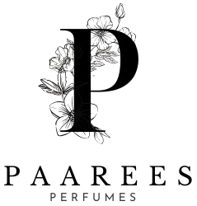

**Calvin Klein (CK) Perfume**

### ****The Modern Minimalist****

Calvin Klein defines modern sophistication with simplicity and boldness. CK perfumes blend freshness and sensuality, creating fragrances that feel effortlessly stylish and unisex — a true reflection of contemporary spirit.

**CALVIN KLEIN PERFUME COLLECTION AND DESCRIPTION**

Contents

The Modern Minimalist 1

Calvin Klein Perfume Collection 4

CK ETERNITY 4

Fragrance Type 4

Fragrance Description 4

Fragrance Notes 4

Key Features 4

Usage Tips 4

About The Brand 4

CK IN2U 5

Fragrance Type 5

Fragrance Description 5

Fragrance Notes 5

Key Features 5

Usage Tips 5

About the Brand 5

CK OBSESSION 6

Fragrance Type 6

Fragrance Description 6

Fragrance Notes: 6

Key Features: 6

Usage Tips 6

About the Brand: 6

CK ONE 7

Fragrance Type 7

Fragrance Description 7

Fragrance Notes: 7

Key Features: 7

Usage Tips 7

About the Brand: 7

Fragrance Type 8

Fragrance Description 8

Fragrance Notes: 8

Key Features: 8

Usage Tips 8

About the Brand: 8

CK SHOCK 9

Fragrance Type 9

Fragrance Description 9

Fragrance Notes: 9

Key Features: 9

Usage Tips 9

About the Brand: 9

# Calvin Klein Perfume Collection

## CK ETERNITY

1

### ****Fragrance Type****

Classic romantic perfume

**Price** : $139

### ****Fragrance Description****

A timeless fragrance that blends floral and spicy notes with a base of sandalwood and amber for lasting elegance.

### ****Fragrance Notes****

Top Notes: Citrus, Floral Accents

Heart Notes: Jasmine, Lily, Spice

Base Notes: Musk, Amber, Cedarwood

### ****Key Features****

• Modern and timeless scent profile  
• Long-lasting freshness  
• Elegant bottle design  
• Suitable for any occasion

### ****Usage Tips****

Spray on wrists and neck for daily freshness.

### ****About The Brand****

Calvin Klein is a pioneer in modern fragrance, known for minimalist yet expressive scents that reflect individuality, confidence, and timeless appeal.

────────────────────────────

## 

## CK IN2U

2

## ****Fragrance Type****

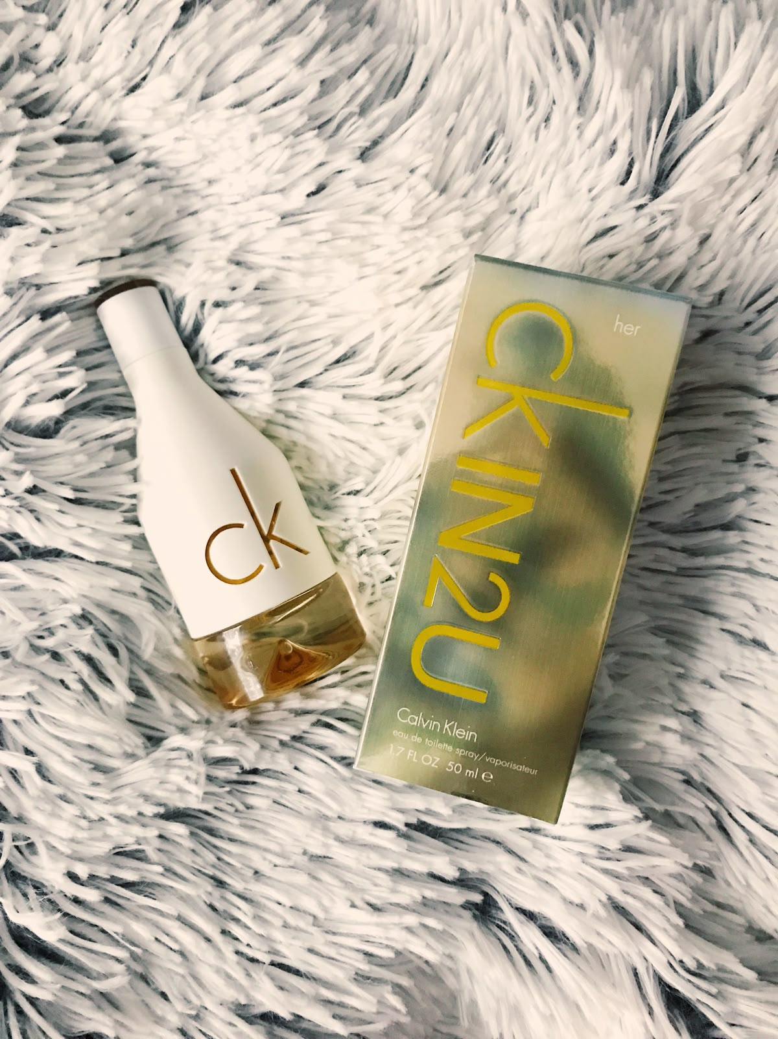 Youthful and energetic scent

**Price:**  $110

## ****Fragrance Description****

A youthful and energetic scent featuring citrus and woody notes that evoke freedom and spontaneity.

## ****Fragrance Notes****

Top Notes: Citrus, Floral Accents

Heart Notes: Jasmine, Lily, Spice

Base Notes: Musk, Amber, Cedarwood

## ****Key Features****

• Modern and timeless scent profile  
• Long-lasting freshness  
• Elegant bottle design  
• Suitable for any occasion

## ****Usage Tips****

Spray on chest and arms for a lively fragrance.

## ****About the Brand****

Calvin Klein is a pioneer in modern fragrance, known for minimalist yet expressive scents that reflect individuality, confidence, and timeless appeal.

────────────────────────────

## CK OBSESSION

3

## ****Fragrance Type****

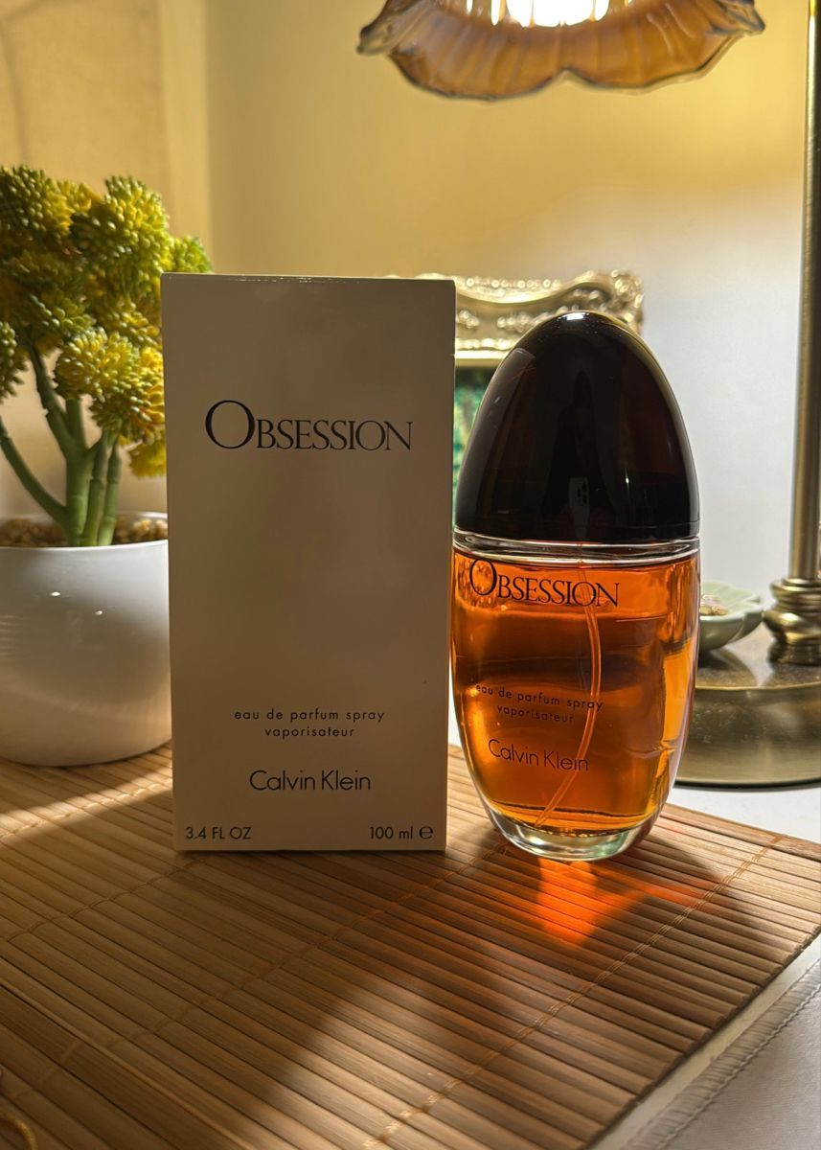 Warm and spicy perfume

**Price:** $99

### ****Fragrance Description****

Rich and sensual with spicy amber and vanilla tones that capture deep passion and allure.

### ****Fragrance Notes:****

Top Notes: Citrus, Floral Accents

Heart Notes: Jasmine, Lily, Spice

Base Notes: Musk, Amber, Cedarwood

### ****Key Features:****

• Modern and timeless scent profile  
• Long-lasting freshness  
• Elegant bottle design  
• Suitable for any occasion

### ****Usage Tips****

Use one spray on wrists and collar for a lasting scent.

### ****About the Brand:****

Calvin Klein is a pioneer in modern fragrance, known for minimalist yet expressive scents that reflect individuality, confidence, and timeless appeal.

────────────────────────────

## CK ONE

4

### ****Fragrance Type****

Clean unisex perfume (for men and women)

**Price**: $140

### ****Fragrance Description****

An iconic unisex fragrance offering fresh green tea, papaya, and musk for a clean, universal scent.

### ****Fragrance Notes:****

Top Notes: Citrus, Floral Accents

Heart Notes: Jasmine, Lily, Spice

Base Notes: Musk, Amber, Cedarwood

### ****Key Features:****

• Modern and timeless scent profile  
• Long-lasting freshness  
• Elegant bottle design  
• Suitable for any occasion

### ****Usage Tips****

Spray on clothes or skin for a fresh citrus feel.

### ****About the Brand:****

Calvin Klein is a pioneer in modern fragrance, known for minimalist yet expressive scents that reflect individuality, confidence, and timeless appeal.

────────────────────────────

**CK SHEER BEAUTY**

5

### ****Fragrance Type****

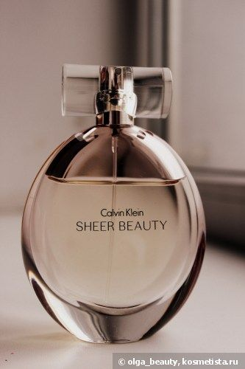 Soft and delicate floral scent

**Price**: $111

### ****Fragrance Description****

A soft, feminine fragrance with notes of peach blossom, jasmine, and pink lily symbolizing grace and confidence.

### ****Fragrance Notes:****

Top Notes: Citrus, Floral Accents

Heart Notes: Jasmine, Lily, Spice

Base Notes: Musk, Amber, Cedarwood

### ****Key Features:****

• Modern and timeless scent profile  
• Long-lasting freshness  
• Elegant bottle design  
• Suitable for any occasion

### ****Usage Tips****

Apply on neck and inner arms for a gentle fragrance.

### ****About the Brand:****

Calvin Klein is a pioneer in modern fragrance, known for minimalist yet expressive scents that reflect individuality, confidence, and timeless appeal.

────────────────────────────

6

## CK SHOCK

### ****Fragrance Type****

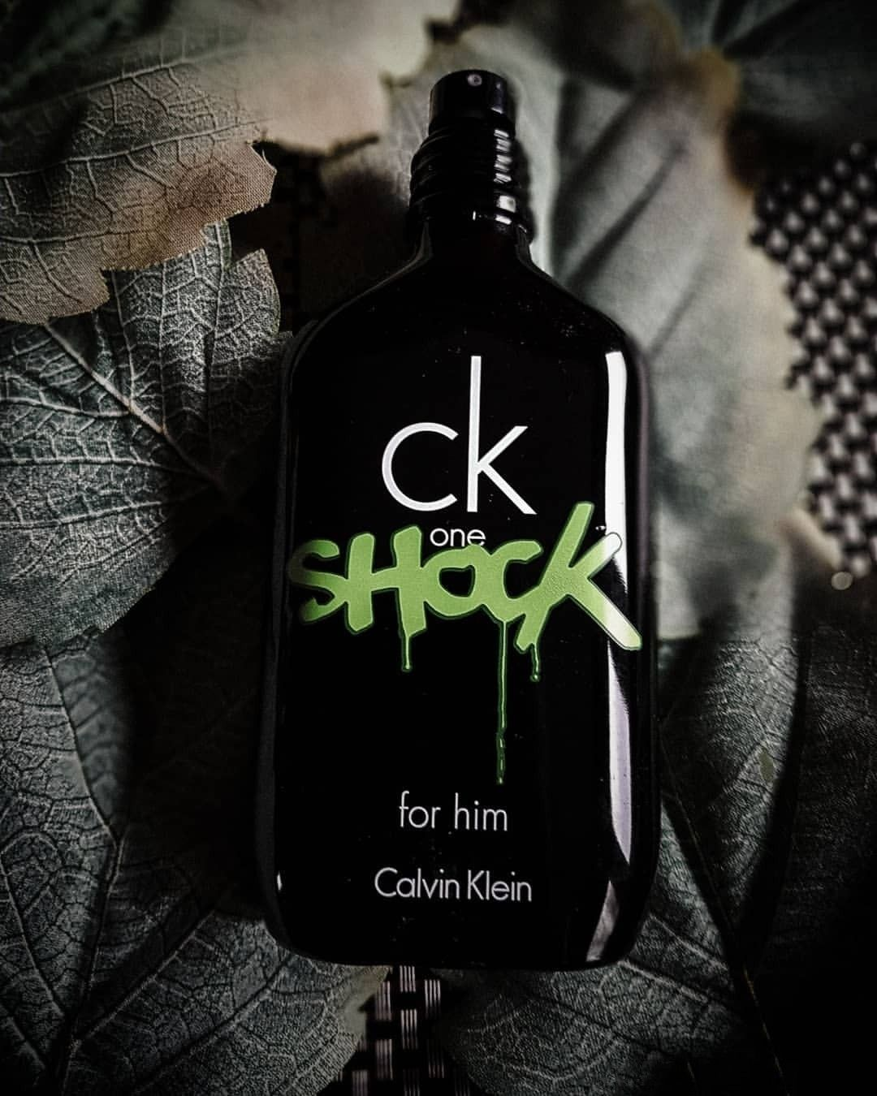 Bold and trendy perfume

**Price**: $120

### ****Fragrance Description****

A bold and edgy scent combining passionflower, blackberry, and amber for a daring, youthful vibe.

### ****Fragrance Notes:****

Top Notes: Citrus, Floral Accents

Heart Notes: Jasmine, Lily, Spice

Base Notes: Musk, Amber, Cedarwood

### ****Key Features:****

• Modern and timeless scent profile  
• Long-lasting freshness  
• Elegant bottle design  
• Suitable for any occasion

### ****Usage Tips****

Best for night outs — spray on chest and wrists.

### ****About the Brand:****

Calvin Klein is a pioneer in modern fragrance, known for minimalist yet expressive scents that reflect individuality, confidence, and timeless appeal.

────────────────────────────