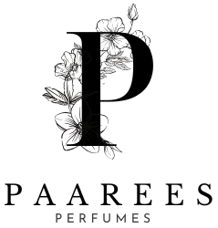

**DAVIDOFF PERFUME COLLECTION AND DESCRIPTION**

**DAVIDOFF PERFUME**

**The Spirit of Adventure**

Davidoff fragrances are inspired by the energy of life — from ocean waves to mountain air. Each scent brings a refreshing sense of freedom, confidence, and exploration, perfect for those who dare to live boldly.

Contents

Davidoff Perfume Collection 3

3

DAVIDOFF CHAMPION 3

Fragrance Type: 3

Fragrance Description: 3

Fragrance Notes: 3

Key Features: 3

Usage Tips: 3

About the Brand: 3

COOL ELIXIR 4

Fragrance Type: 4

Fragrance Description: 4

Fragrance Notes: 4

Key Features: 4

Usage Tips: 4

About the Brand: 4

COOL WATER 5

Fragrance Type: 5

Fragrance Description: 5

Fragrance Notes: 5

Key Features: 5

Usage Tips: 5

About the Brand: 5

ZINO 6

Fragrance Type: 6

Fragrance Description: 6

Fragrance Notes: 6

Key Features: 6

Usage Tips: 6

About the Brand: 6

ADVENTURE 7

Fragrance Type: 7

Fragrance Description: 7

Fragrance Notes: 7

Key Features: 7

Usage Tips: 7

About the Brand: 7

RUN WILD 8

Fragrance Type: 8

Fragrance Description: 8

Fragrance Notes: 8

Key Features: 8

Usage Tips: 8

About The Brand 8

# Davidoff Perfume Collection

# 

1

## DAVIDOFF CHAMPION

### **Fragrance Type:**

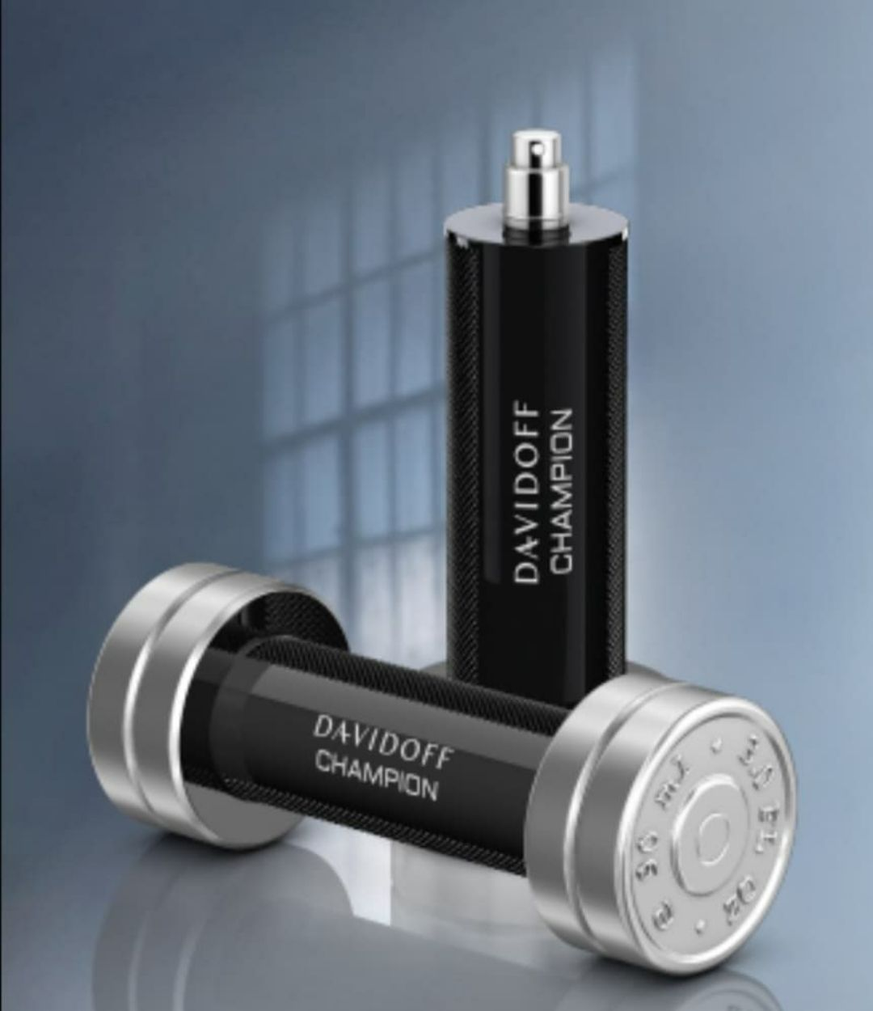Sporty and energetic scent

**Price**: $100

### **Fragrance Description:**

A bold fragrance celebrating victory, with citrus top notes and an energetic heart of galbanum and oak moss.

### **Fragrance Notes:**

Top Notes: Citrus, Aromatic Herbs

Heart Notes: Spices, Floral Accents

Base Notes: Amber, Cedar, Sandalwood

### **Key Features:**

• Energetic and refreshing compositions  
• Perfect for outdoor and casual wear  
• Distinct masculine identity  
• Excellent longevity

### **Usage Tips:**

Apply before workouts or outdoor events.

### **About the Brand:**

Davidoff embodies adventure, elegance, and vitality. Each fragrance is crafted to inspire confidence, energy, and sophistication for modern men.

────────────────────────────

2

## COOL ELIXIR

### **Fragrance Type:**

Refreshing and cool perfume

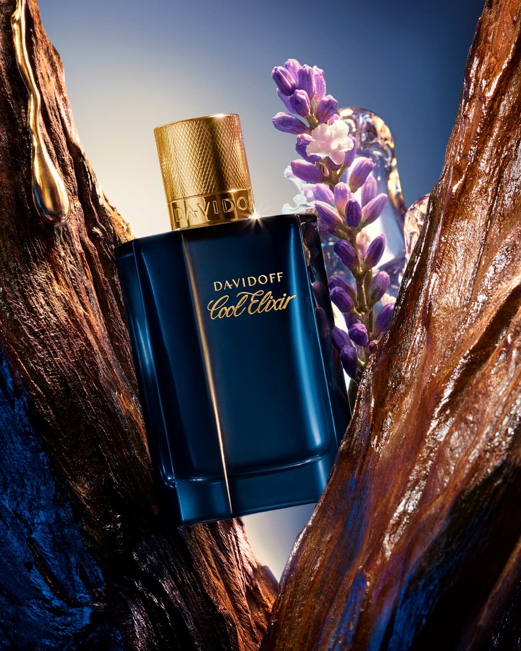**Price**: $88

### **Fragrance Description:**

A refreshing aquatic scent inspired by ocean waves, blending citrus zest with cool amber and marine accords.

### **Fragrance Notes:**

Top Notes: Citrus, Aromatic Herbs

Heart Notes: Spices, Floral Accents

Base Notes: Amber, Cedar, Sandalwood

### **Key Features:**

• Energetic and refreshing compositions  
• Perfect for outdoor and casual wear  
• Distinct masculine identity  
• Excellent longevity

### **Usage Tips:**

Spray on wrists and neck during hot days.

### **About the Brand:**

Davidoff embodies adventure, elegance, and vitality. Each fragrance is crafted to inspire confidence, energy, and sophistication for modern men.

────────────────────────────

## COOL WATER

3

### **Fragrance Type:**

Fresh ocean-style scent

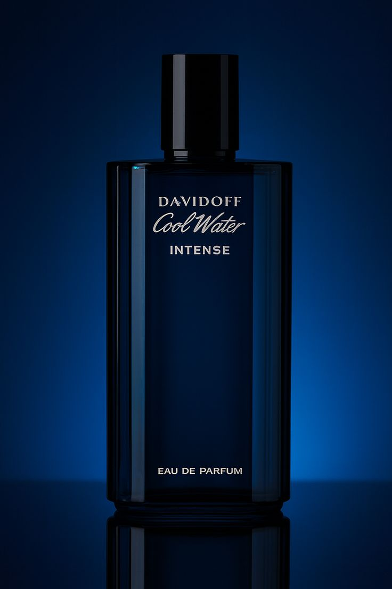**Price**: $125

### **Fragrance Description:**

An iconic fragrance combining mint, lavender, and sandalwood to evoke freshness and masculine strength.

### **Fragrance Notes:**

Top Notes: Citrus, Aromatic Herbs

Heart Notes: Spices, Floral Accents

Base Notes: Amber, Cedar, Sandalwood

### **Key Features:**

• Energetic and refreshing compositions  
• Perfect for outdoor and casual wear  
• Distinct masculine identity  
• Excellent longevity

### **Usage Tips:**

Use after shower for a clean and cool feeling.

### **About the Brand:**

Davidoff embodies adventure, elegance, and vitality. Each fragrance is crafted to inspire confidence, energy, and sophistication for modern men.

────────────────────────────

4

## ZINO

### **Fragrance Type:**

Deep woody scent

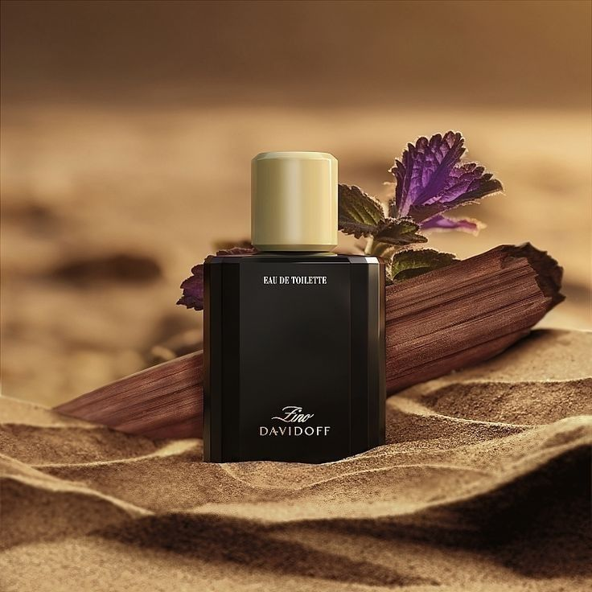**Price**: $99

### **Fragrance Description:**

Classic and intense, featuring bergamot, patchouli, and cedarwood that reflect timeless sophistication.

### **Fragrance Notes:**

Top Notes: Citrus, Aromatic Herbs

Heart Notes: Spices, Floral Accents

Base Notes: Amber, Cedar, Sandalwood

### **Key Features:**

• Energetic and refreshing compositions  
• Perfect for outdoor and casual wear  
• Distinct masculine identity  
• Excellent longevity

### **Usage Tips:**

Best for winter — spray lightly on chest and jacket.

### **About the Brand:**

Davidoff embodies adventure, elegance, and vitality. Each fragrance is crafted to inspire confidence, energy, and sophistication for modern men.

────────────────────────────

5

## ADVENTURE

### **Fragrance Type:**

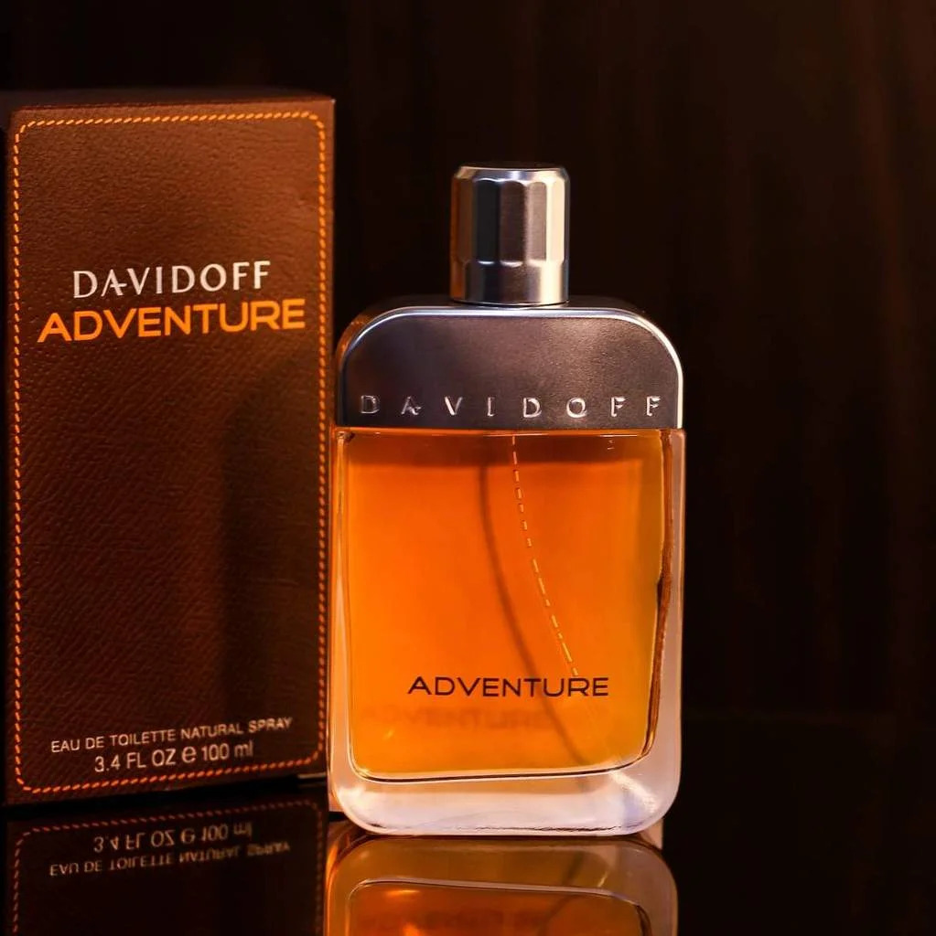Fresh outdoor fragrance

**Price**: $85

### **Fragrance Description:**

A daring and vibrant scent with spicy mandarin and sesame notes for the man who loves exploration.

### **Fragrance Notes:**

Top Notes: Citrus, Aromatic Herbs

Heart Notes: Spices, Floral Accents

Base Notes: Amber, Cedar, Sandalwood

### **Key Features:**

• Energetic and refreshing compositions  
• Perfect for outdoor and casual wear  
• Distinct masculine identity  
• Excellent longevity

### **Usage Tips:**

Apply on pulse points before travel or morning routines.

### **About the Brand:**

Davidoff embodies adventure, elegance, and vitality. Each fragrance is crafted to inspire confidence, energy, and sophistication for modern men.

────────────────────────────

6

## RUN WILD

### **Fragrance Type:**

Strong masculine perfume

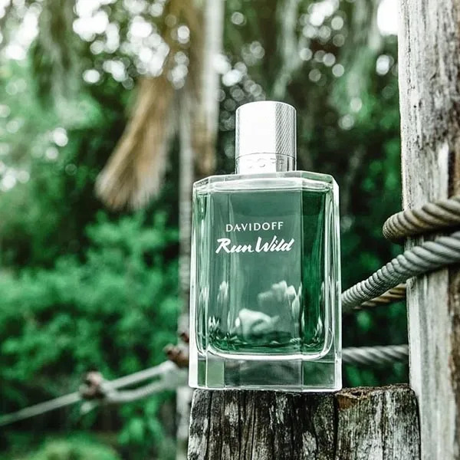**Price**: $135

### **Fragrance Description:**

A spirited blend of ginger, cinnamon, and fir balsam — symbolizing freedom and power of nature.

### **Fragrance Notes:**

Top Notes: Citrus, Aromatic Herbs

Heart Notes: Spices, Floral Accents

Base Notes: Amber, Cedar, Sandalwood

### **Key Features:**

• Energetic and refreshing compositions  
• Perfect for outdoor and casual wear  
• Distinct masculine identity  
• Excellent longevity

### **Usage Tips:**

Spray on wrists and behind neck for long-lasting power.

### **About The Brand**

Davidoff embodies adventure, elegance, and vitality. Each fragrance is crafted to inspire confidence, energy, and sophistication for modern men.

────────────────────────────