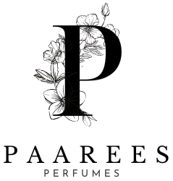

**DIOR PERFUME COLLECTION AND DESCRIPTION**

**DIOR PERFUME**

**The Art Of Timeless Elegance**

Dior is more than a fragrance — it’s a legacy of French sophistication and modern grace. Each perfume tells a story of beauty, confidence, and power. From the magnetic charm of Sauvage to the romantic bloom of J’adore, Dior captures emotions in every drop. Its perfumes celebrate individuality — bold, elegant, and unforgettable — just like the people who wear them.

Contents

Davidoff Perfume Collection 3

DIOR SAUVAGE 3

Fragrance Type: 3

Fragrance Description: 3

Fragrance Notes 3

Key Features 3

Usage Tips 3

About the Brand 3

Dior J’adore 4

Fragrance Type: 4

Fragrance Description 4

Fragrance Notes 4

Key Features 4

Usage Tips 4

About the Brand 4

Dior Addict 5

Fragrance Type: 5

Fragrance Description 5

Fragrance Notes 5

Key Features 5

Usage Tips 5

About the Brand 5

Dior Homme 6

Fragrance Type: 6

Fragrance Description 6

Fragrance Notes 6

Key Features 6

Usage Tips 6

About the Brand 6

Miss Dior 7

Fragrance Type: 7

Fragrance Description 7

Fragrance Notes 7

Key Features 7

Usage Tips 7

About the Brand 7

Dior Poison 8

Fragrance Type: 8

Fragrance Description 8

Fragrance Notes 8

Key Features 8

Usage Tips 8

About the Brand 8

# Davidoff Perfume Collection

## DIOR SAUVAGE

### **Fragrance Type:**

Strong long-lasting perfume

**Price**: $160.00

### **Fragrance Description:**

A bold, magnetic fragrance inspired by open landscapes and raw elegance. Opens with fresh bergamot and spicy Sichuan pepper, settling into woody amber and musk. Symbolizes masculine confidence and sophistication.

### **Fragrance Notes**

Top Notes: Calabrian Bergamot, Sichuan Pepper

Heart Notes: Lavender, Star Anise, Nutmeg

Base Notes: Ambroxan, Cedarwood, Vanilla

### **Key Features**

• Long-lasting projection

• Modern and masculine

• Iconic bottle design

• Perfect for day or night

### **Usage Tips**

Spray on wrists, neck, and behind ears for a long-lasting scent trail.

### **About the Brand**

Christian Dior represents timeless French craftsmanship and luxury. Each fragrance embodies elegance, passion, and individuality.

## Dior J’adore

### **Fragrance Type:**

Elegant floral perfume

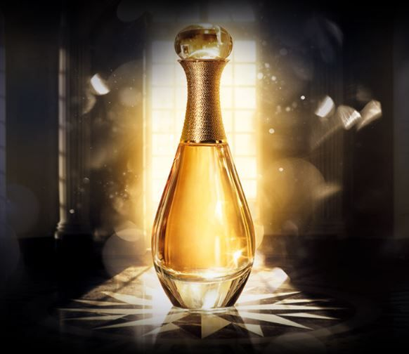**Price**: $155.00

### **Fragrance Description**

An icon of femininity, J’adore is a radiant floral bouquet that celebrates the beauty of women. It blends jasmine, rose, and ylang-ylang with a sensual fruity undertone.

### **Fragrance Notes**

Top Notes: Ylang-Ylang, Mandarin, Peach

Heart Notes: Jasmine, Rose, Lily-of-the-Valley

Base Notes: Vanilla, Musk, Cedar

### **Key Features**

• Elegant and graceful

• Perfect for special occasions

• Symbol of modern femininity

### **Usage Tips**

Apply on pulse points for a luxurious floral trail.

### **About the Brand**

J’adore captures Dior’s devotion to celebrating feminine beauty and luxury craftsmanship.

___________________________

## 

## Dior Addict

### **Fragrance Type:**

Deep and sensual perfume

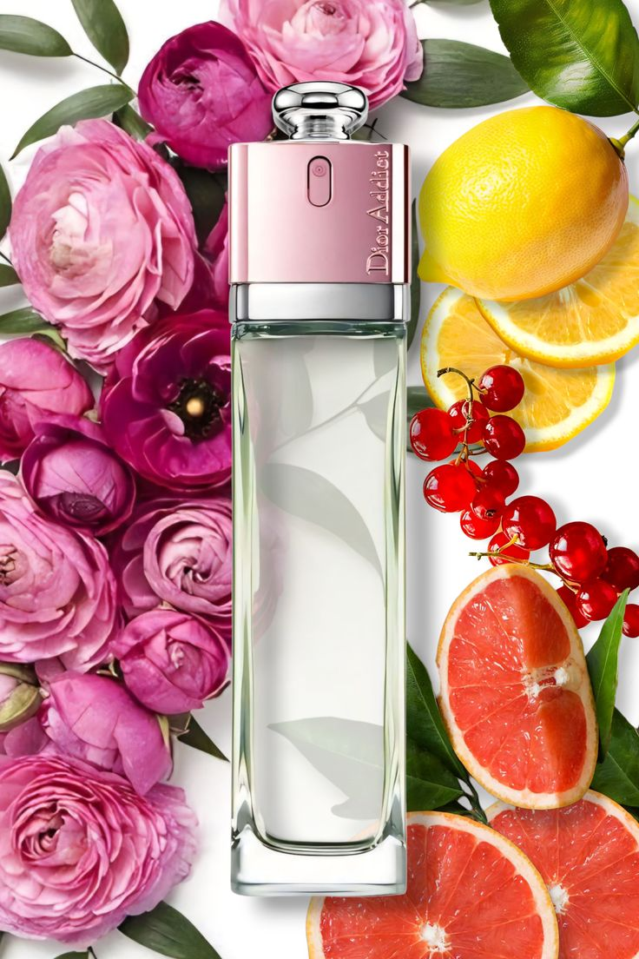**Price:** $150.00

### **Fragrance Description**

A sensual, addictive fragrance with notes of vanilla and tonka bean. It radiates warmth and sophistication, ideal for confident women who embrace their individuality.

### **Fragrance Notes**

Top Notes: Mandarin Leaf, Orange Blossom

Heart Notes: Jasmine Sambac, Rose

Base Notes: Vanilla, Sandalwood, Tonka Bean

### **Key Features**

• Warm and sensual

• Long-lasting fragrance

• Ideal for evening wear

### **Usage Tips**

Spray lightly on pulse points for an alluring scent.

### **About the Brand**

Dior Addict is a tribute to bold women who express confidence and freedom.

___________________________

## Dior Homme

### **Fragrance Type:**

Fresh and masculine scent

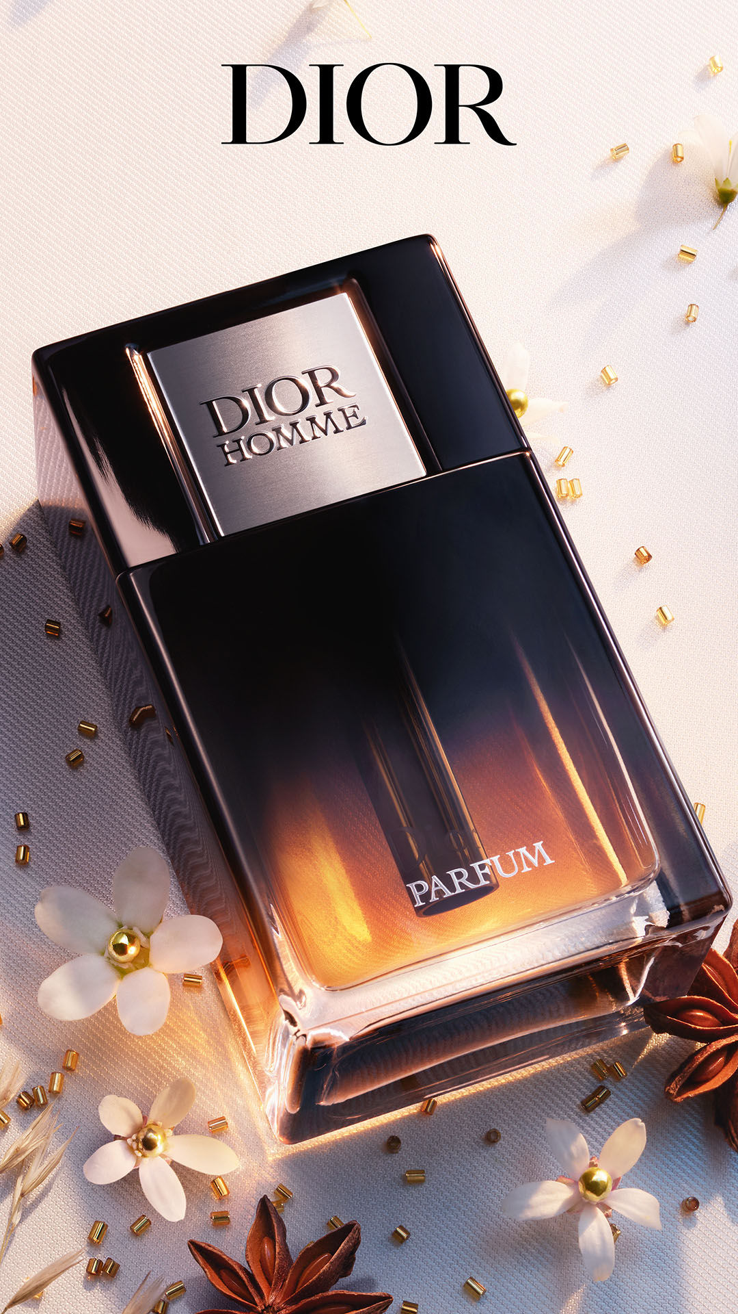**Price:** $145.00

### **Fragrance Description**

Dior Homme is refined and modern, blending iris and vetiver with amber and leather. A symbol of understated elegance for men.

### **Fragrance Notes**

Top Notes: Lavender, Sage, Cardamom

Heart Notes: Iris, Cocoa, Amber

Base Notes: Vetiver, Leather, Patchouli

### **Key Features**

• Sophisticated and fresh

• Perfect balance of wood and floral

• Versatile for daily wear

### **Usage Tips**

Use daily after showering for a clean, confident scent.

### **About the Brand**

Dior Homme redefines masculinity with a blend of sophistication and modernity.

____________________________________

## Miss Dior

### **Fragrance Type:**

Romantic floral perfume

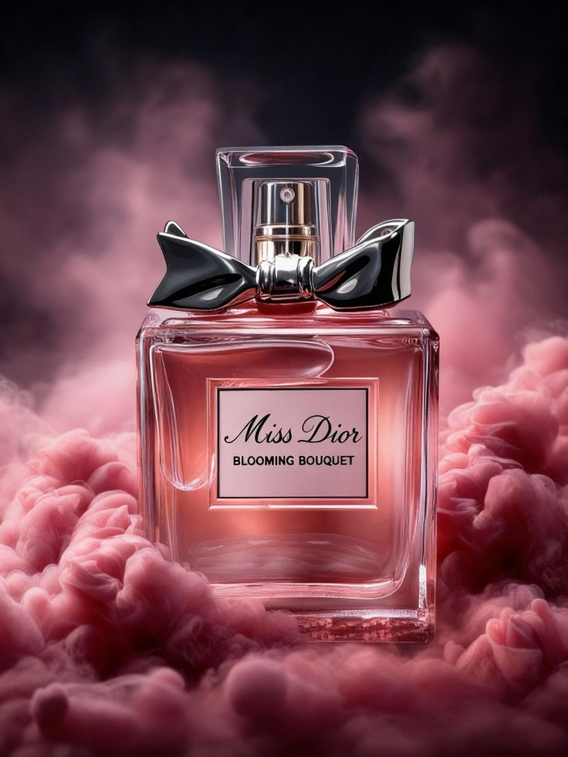**Price:** $155.00

### **Fragrance Description**

A romantic and youthful fragrance with floral heart and a touch of patchouli. It embodies the essence of love and elegance.

### **Fragrance Notes**

Top Notes: Blood Orange, Mandarin

Heart Notes: Grasse Rose, Jasmine

Base Notes: Patchouli, Musk, Amber

### **Key Features**

• Romantic and youthful

• Elegant and bright

• Signature Dior femininity

### **Usage Tips**

Apply to neck and wrists to reveal its romantic notes.

### **About the Brand**

Miss Dior celebrates youthful energy and the beauty of modern romance.

________________________________

## Dior Poison

### **Fragrance Type:**

Strong and rich evening perfume

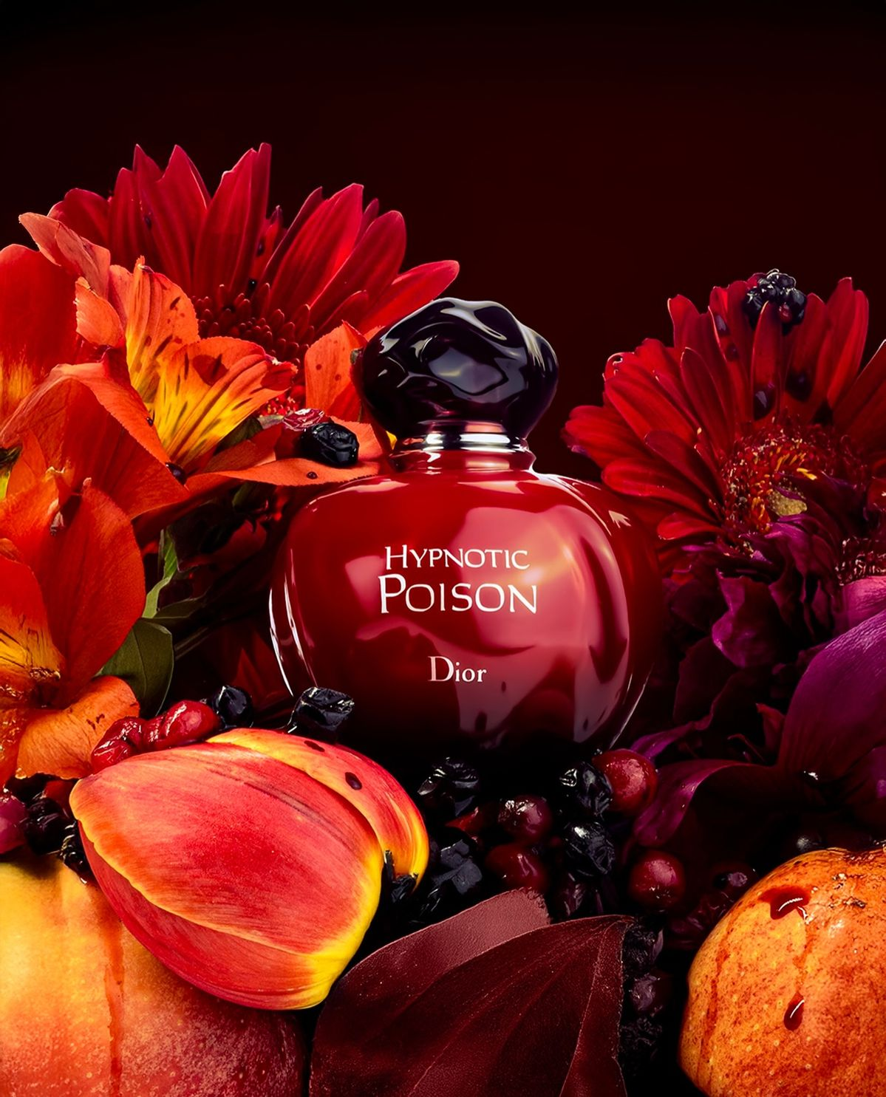**Price:** $160.00

### **Fragrance Description**

Mysterious and seductive, Poison is an unforgettable oriental floral scent blending tuberose, amber, and honey. It’s bold, confident, and timeless.

### **Fragrance Notes**

Top Notes: Coriander, Wild Berries, Plum

Heart Notes: Tuberose, Jasmine, Rose

Base Notes: Amber, Honey, Musk

### **Key Features**

• Intense and seductive

• Oriental floral masterpiece

• Long-lasting luxury scent

### **Usage Tips**

Spray sparingly; its deep notes evolve beautifully through the day.

### **About the Brand**

Poison embodies Dior’s daring creativity and passion for bold, captivating scents.

_____________________________________