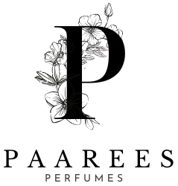

**PAAREES PERFUME COLLECTION AND DESCRIPTION**

**PAAREES PERFUME**

**The Essence Of Elegance**

Born from the heart of luxury, Paarees Perfume celebrates timeless beauty and sophistication. Each fragrance captures a unique story — from floral dreams to golden warmth — made for those who believe that scent is not just a touch, but a signature of personality.

Contents

AMBER LUXE 3

Fragrance Description: 3

Fragrance Notes: 3

Key Features: 3

About the Brand: 3

VELVET ROSE 4

Fragrance Description: 4

Fragrance Notes: 4

Key Features: 4

About the Brand: 4

MIDNIGHT BLOOM 5

Fragrance Description: 5

Fragrance Notes: 5

Key Features: 5

About the Brand: 5

GOLDEN AURA 6

Fragrance Description: 6

Fragrance Notes: 6

Key Features: 6

About the Brand: 6

MYSTIC NOIR 7

Fragrance Description: 7

Fragrance Notes: 7

Key Features: 7

About the Brand: 7

AZURE BLOOM 8

Fragrance Description: 8

Fragrance Notes: 8

Key Features: 8

About the Brand: 8

ROSE ELIXIR 9

Fragrance Description: 9

Fragrance Notes: 9

Key Features: 9

About the Brand: 9

CITRUS CHARM 10

Fragrance Description: 10

Fragrance Notes: 10

Key Features: 10

About the Brand: 10

MIDNIGHT OUD 11

Fragrance Description: 11

Fragrance Notes: 11

Key Features: 11

About the Brand: 11

GREEN SERENITY 12

Price: 12

Fragrance Description: 12

Fragrance Notes: 12

Key Features: 12

About the Brand: 12

CLOUD MIST 13

Fragrance Description: 13

Fragrance Notes: 13

Key Features: 13

About the Brand: 13

ROYAL ESSENCE 14

Fragrance Description: 14

Fragrance Notes: 14

Key Features: 14

About the Brand: 14

GOLDEN DESIRE 15

Fragrance Description: 15

Fragrance Notes: 15

Key Features: 15

About the Brand: 15

LOST CHERRY 16

Price: 16

Fragrance Description: 16

Fragrance Notes: 16

Key Features: 16

About the Brand: 16

Other Luxury Perfume Collection

## AMBER LUXE

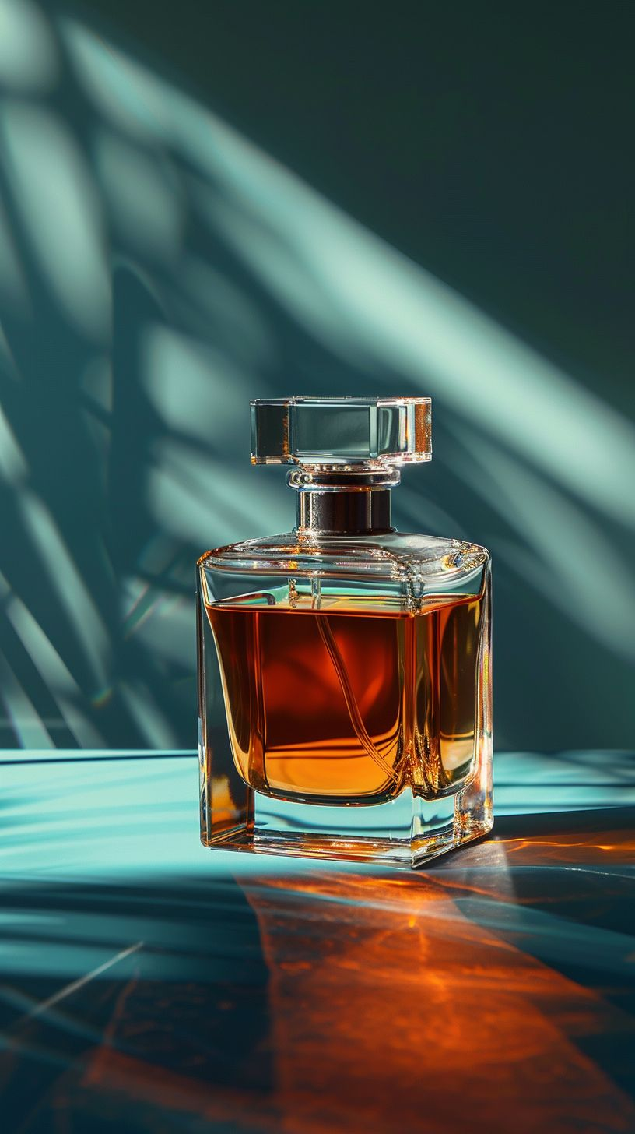**Price**:

$120

### **Fragrance Description:**

A rich oriental fragrance with notes of amber, sandalwood

, and vanilla, exuding timeless luxury.

### **Fragrance Notes:**

Top Notes: Citrus, Floral Accents

Heart Notes: Jasmine, Peony, Amber

Base Notes: Musk, Vanilla, Sandalwood

### **Key Features:**

• Elegant, long-lasting luxury scent

• Perfect for day or night wear

• Refined design and craftsmanship

• A blend of modern and classic sophistication

### **About the Brand:**

Each luxury perfume represents artistry, emotion, and excellence — created for individuals who seek elegance, uniqueness, and unforgettable allure.

────────────────────────────

## VELVET ROSE

**Price**:

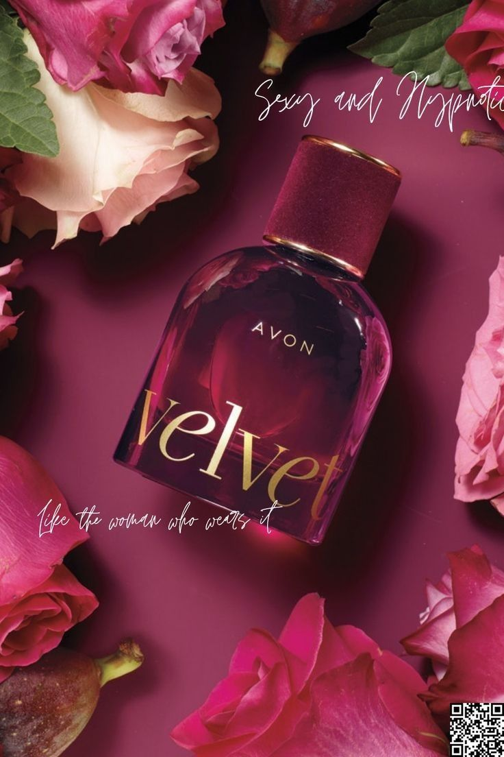$95

### **Fragrance Description:**

A romantic floral scent that captures the beauty of blooming roses with soft musk undertones.

### **Fragrance Notes:**

Top Notes: Citrus, Floral Accents

Heart Notes: Jasmine, Peony, Amber

Base Notes: Musk, Vanilla, Sandalwood

### **Key Features:**

• Elegant, long-lasting luxury scent

• Perfect for day or night wear

• Refined design and craftsmanship

• A blend of modern and classic sophistication

### **About the Brand:**

Each luxury perfume represents artistry, emotion, and excellence — created for individuals who seek elegance, uniqueness, and unforgettable allure.

────────────────────────────

## MIDNIGHT BLOOM

**Price**:

$110

### **Fragrance Description:**

Elegant and mysterious with jasmine, amber, and a hint of patchouli for evening sophistication.

### **Fragrance Notes:**

Top Notes: Citrus, Floral Accents

Heart Notes: Jasmine, Peony, Amber

Base Notes: Musk, Vanilla, Sandalwood

### **Key Features:**

• Elegant, long-lasting luxury scent

• Perfect for day or night wear

• Refined design and craftsmanship

• A blend of modern and classic sophistication

### **About the Brand:**

Each luxury perfume represents artistry, emotion, and excellence — created for individuals who seek elegance, uniqueness, and unforgettable allure.

────────────────────────────

## GOLDEN AURA

**Price**:

$105

### **Fragrance Description:**

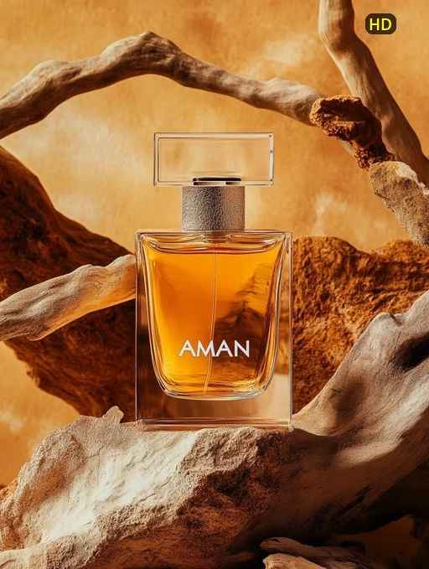A luminous blend of citrus, amber, and vanilla that radiates elegance and charm.

### **Fragrance Notes:**

Top Notes: Citrus, Floral Accents

Heart Notes: Jasmine, Peony, Amber

Base Notes: Musk, Vanilla, Sandalwood

### **Key Features:**

• Elegant, long-lasting luxury scent

• Perfect for day or night wear

• Refined design and craftsmanship

• A blend of modern and classic sophistication

### **About the Brand:**

Each luxury perfume represents artistry, emotion, and excellence — created for individuals who seek elegance, uniqueness, and unforgettable allure.

────────────────────────────

## MYSTIC NOIR

**Price**:

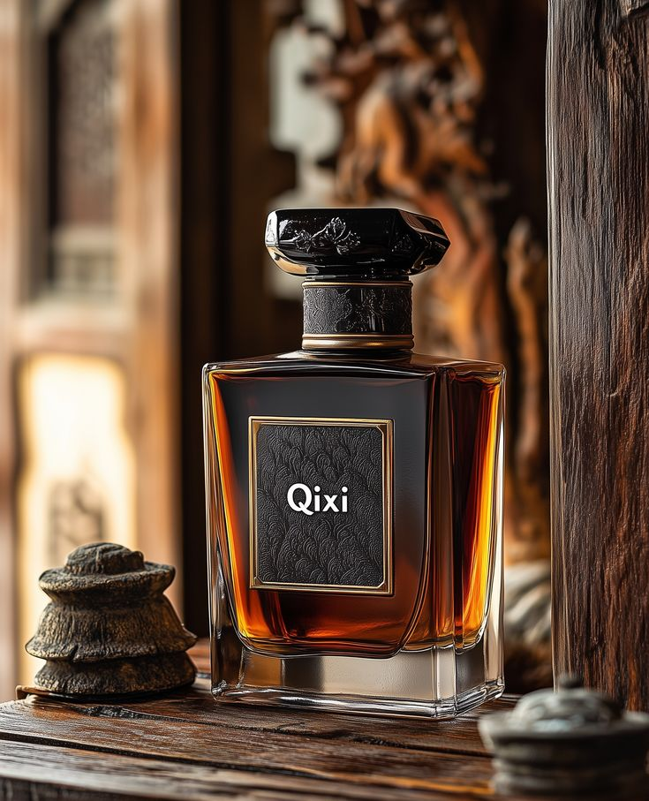$119.99

### **Fragrance Description:**

An intoxicating dark fragrance with blackcurrant, amber, and smoky vanilla for a mysterious allure.

### **Fragrance Notes:**

Top Notes: Citrus, Floral Accents

Heart Notes: Jasmine, Peony, Amber

Base Notes: Musk, Vanilla, Sandalwood

### **Key Features:**

• Elegant, long-lasting luxury scent

• Perfect for day or night wear

• Refined design and craftsmanship

• A blend of modern and classic sophistication

### **About the Brand:**

Each luxury perfume represents artistry, emotion, and excellence — created for individuals who seek elegance, uniqueness, and unforgettable allure.

────────────────────────────

## AZURE BLOOM

**Price**:

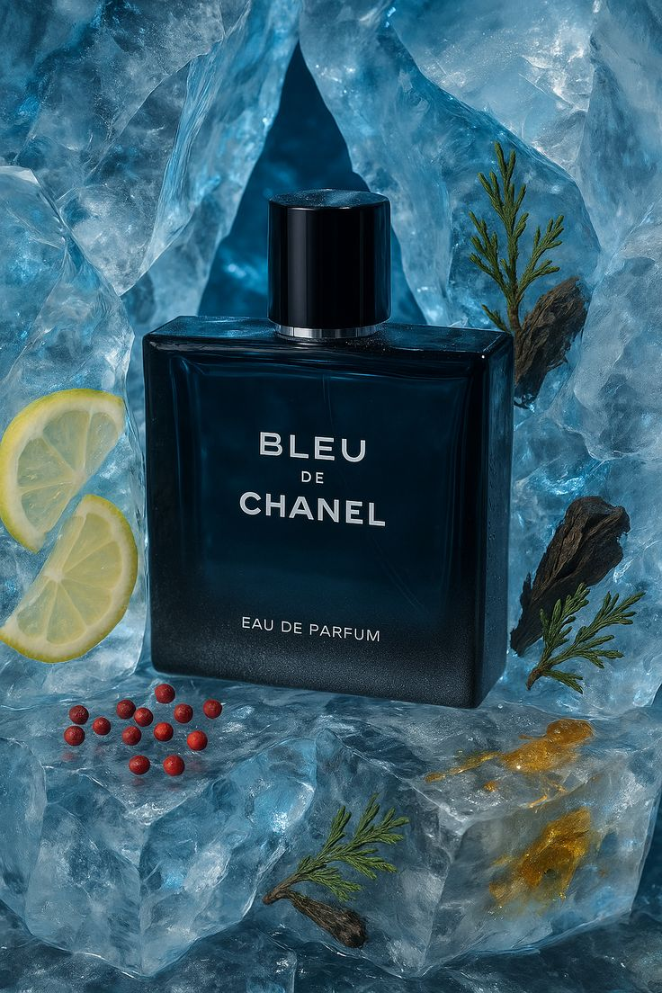 $125

### **Fragrance Description:**

Fresh and breezy with aquatic florals and sea breeze accords inspired by ocean serenity.

### **Fragrance Notes:**

Top Notes: Citrus, Floral Accents

Heart Notes: Jasmine, Peony, Amber

Base Notes: Musk, Vanilla, Sandalwood

### **Key Features:**

• Elegant, long-lasting luxury scent

• Perfect for day or night wear

• Refined design and craftsmanship

• A blend of modern and classic sophistication

### **About the Brand:**

Each luxury perfume represents artistry, emotion, and excellence — created for individuals who seek elegance, uniqueness, and unforgettable allure.

────────────────────────────

## ROSE ELIXIR

**Price**:

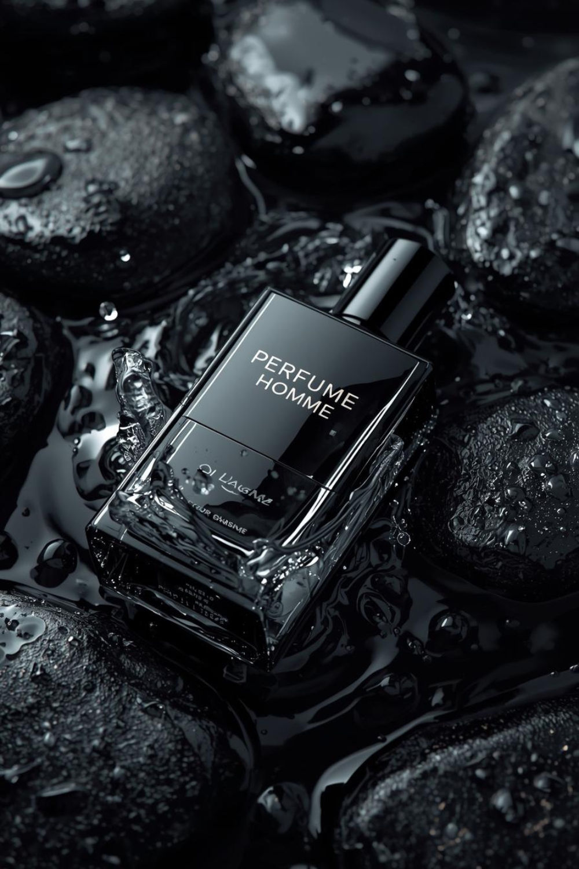 $109.99

### **Fragrance Description:**

A luxurious floral potion combining rose petals, amber, and musk for a modern romantic touch.

### **Fragrance Notes:**

Top Notes: Citrus, Floral Accents

Heart Notes: Jasmine, Peony, Amber

Base Notes: Musk, Vanilla, Sandalwood

### **Key Features:**

• Elegant, long-lasting luxury scent

• Perfect for day or night wear

• Refined design and craftsmanship

• A blend of modern and classic sophistication

### **About the Brand:**

Each luxury perfume represents artistry, emotion, and excellence — created for individuals who seek elegance, uniqueness, and unforgettable allure.

────────────────────────────

## CITRUS CHARM

**Price**:

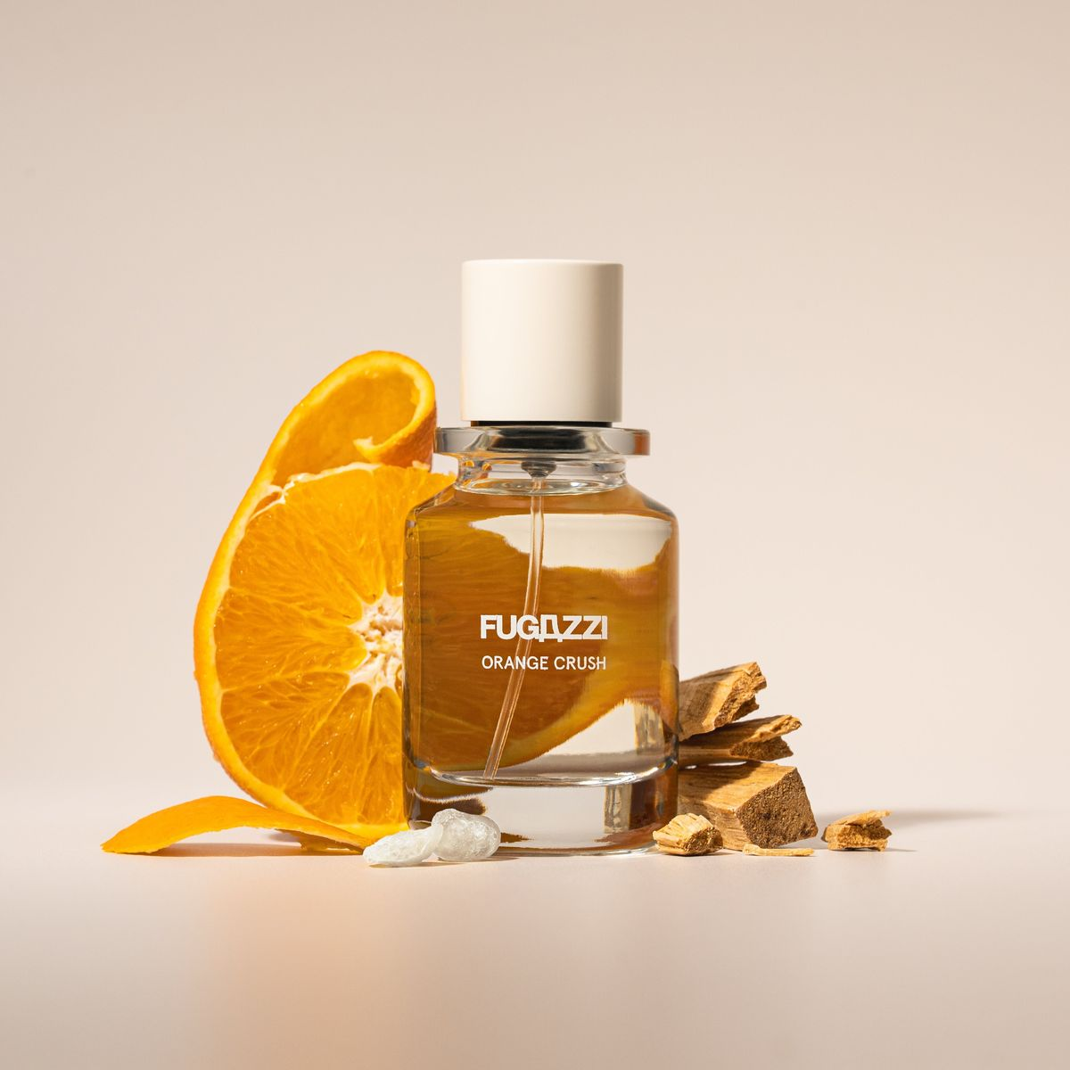$89.99

### **Fragrance Description:**

Bright and sparkling with lemon, orange blossom, and white musk — pure sunshine in a bottle.

### **Fragrance Notes:**

Top Notes: Citrus, Floral Accents

Heart Notes: Jasmine, Peony, Amber

Base Notes: Musk, Vanilla, Sandalwood

### **Key Features:**

• Elegant, long-lasting luxury scent

• Perfect for day or night wear

• Refined design and craftsmanship

• A blend of modern and classic sophistication

### **About the Brand:**

Each luxury perfume represents artistry, emotion, and excellence — created for individuals who seek elegance, uniqueness, and unforgettable allure.

────────────────────────────

## MIDNIGHT OUD

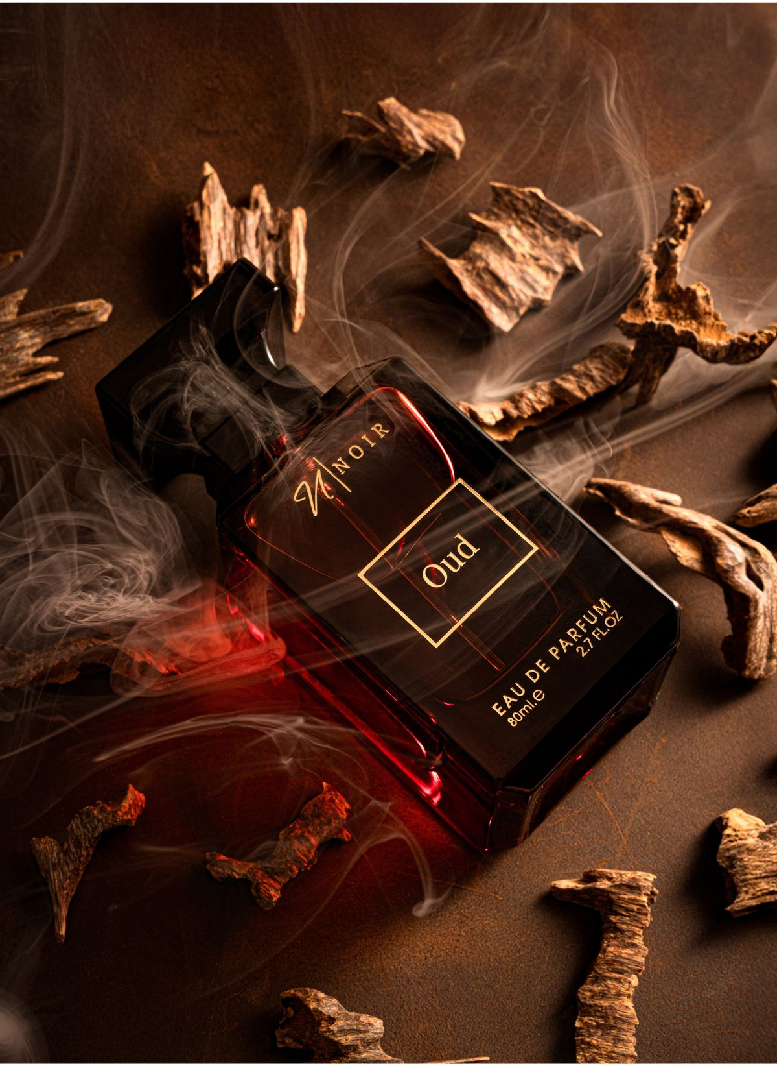**Price**:

$139.99

### **Fragrance Description:**

A luxurious oriental fragrance with spicy saffron and deep oud for evening sophistication.

### **Fragrance Notes:**

Top Notes: Citrus, Floral Accents

Heart Notes: Jasmine, Peony, Amber

Base Notes: Musk, Vanilla, Sandalwood

### **Key Features:**

• Elegant, long-lasting luxury scent

• Perfect for day or night wear

• Refined design and craftsmanship

• A blend of modern and classic sophistication

### **About the Brand:**

Each luxury perfume represents artistry, emotion, and excellence — created for individuals who seek elegance, uniqueness, and unforgettable allure.

────────────────────────────

## GREEN SERENITY

### **Price:**

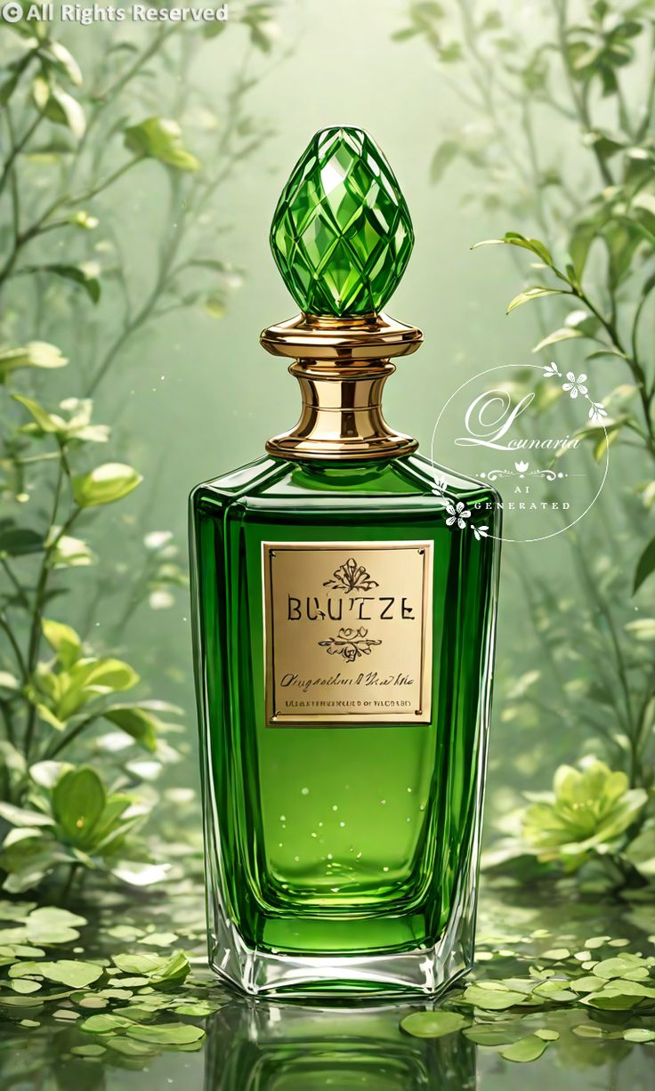$89.99

### **Fragrance Description:**

A calming green fragrance with notes of bamboo, citrus leaves, and soft white musk.

### **Fragrance Notes:**

Top Notes: Citrus, Floral Accents

Heart Notes: Jasmine, Peony, Amber

Base Notes: Musk, Vanilla, Sandalwood

### **Key Features:**

• Elegant, long-lasting luxury scent

• Perfect for day or night wear

• Refined design and craftsmanship

• A blend of modern and classic sophistication

### **About the Brand:**

Each luxury perfume represents artistry, emotion, and excellence — created for individuals who seek elegance, uniqueness, and unforgettable allure.

────────────────────────────

## CLOUD MIST

**Price**:

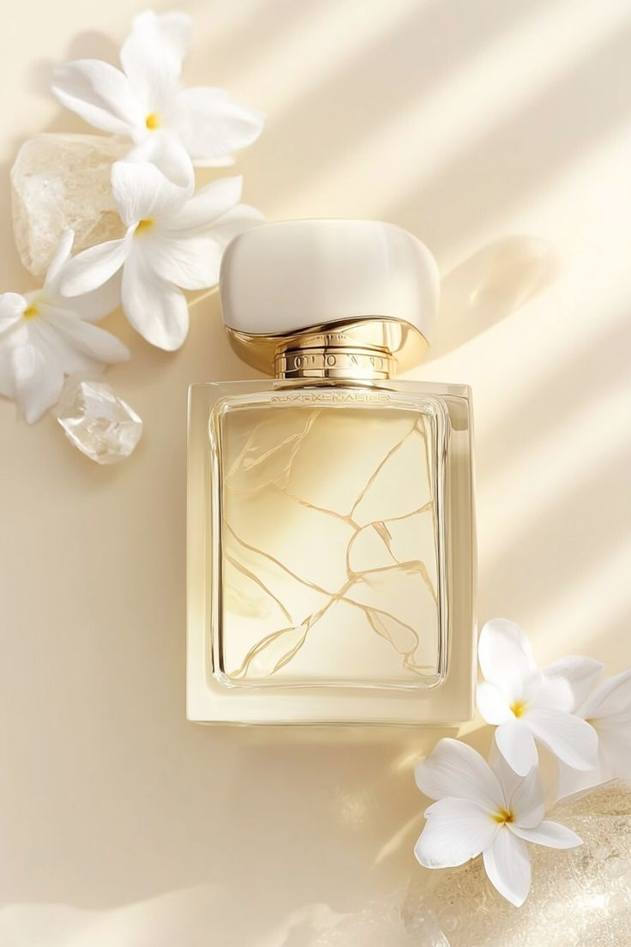 $94.99

### **Fragrance Description:**

Light and dreamy, blending pear blossom, vanilla, and musk for a delicate aura.

### **Fragrance Notes:**

Top Notes: Citrus, Floral Accents

Heart Notes: Jasmine, Peony, Amber

Base Notes: Musk, Vanilla, Sandalwood

### **Key Features:**

• Elegant, long-lasting luxury scent

• Perfect for day or night wear

• Refined design and craftsmanship

• A blend of modern and classic sophistication

### **About the Brand:**

Each luxury perfume represents artistry, emotion, and excellence — created for individuals who seek elegance, uniqueness, and unforgettable allure.

────────────────────────────

## ROYAL ESSENCE

**Price**:

$149.99

### **Fragrance Description:**

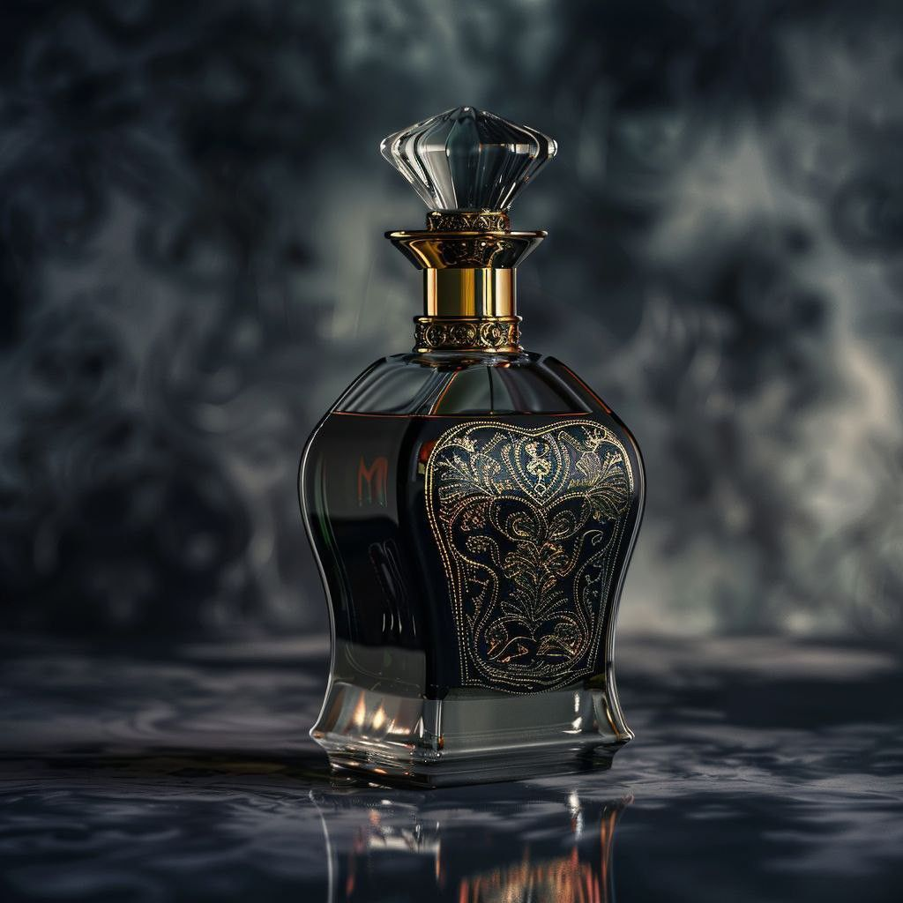Majestic and refined with amber, tonka bean, and sandalwood representing noble grace.

### **Fragrance Notes:**

Top Notes: Citrus, Floral Accents

Heart Notes: Jasmine, Peony, Amber

Base Notes: Musk, Vanilla, Sandalwood

### **Key Features:**

• Elegant, long-lasting luxury scent

• Perfect for day or night wear

• Refined design and craftsmanship

• A blend of modern and classic sophistication

### **About the Brand:**

Each luxury perfume represents artistry, emotion, and excellence — created for individuals who seek elegance, uniqueness, and unforgettable allure.

────────────────────────────

## GOLDEN DESIRE

**Price**:

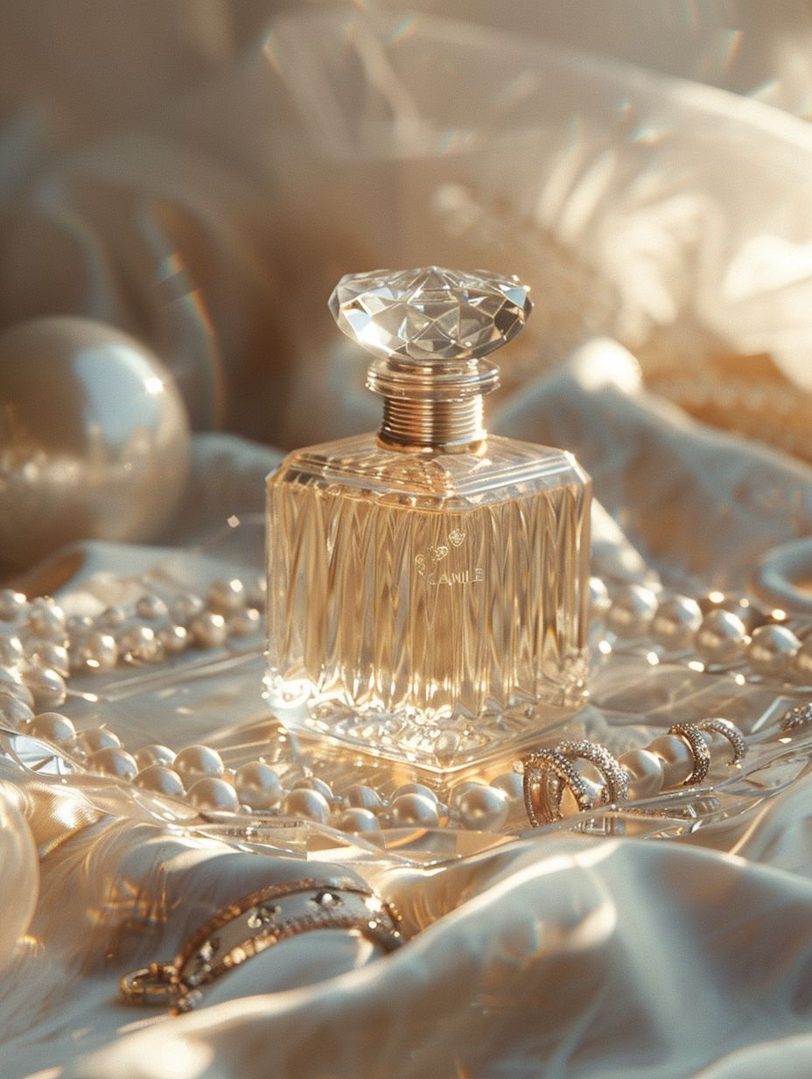 $129.99

### **Fragrance Description:**

A warm and seductive scent with honeyed amber, rose, and patchouli.

### **Fragrance Notes:**

Top Notes: Citrus, Floral Accents

Heart Notes: Jasmine, Peony, Amber

Base Notes: Musk, Vanilla, Sandalwood

### **Key Features:**

• Elegant, long-lasting luxury scent

• Perfect for day or night wear

• Refined design and craftsmanship

• A blend of modern and classic sophistication

### **About the Brand:**

Each luxury perfume represents artistry, emotion, and excellence — created for individuals who seek elegance, uniqueness, and unforgettable allure.

────────────────────────────

## 

## LOST CHERRY

### **Price:**

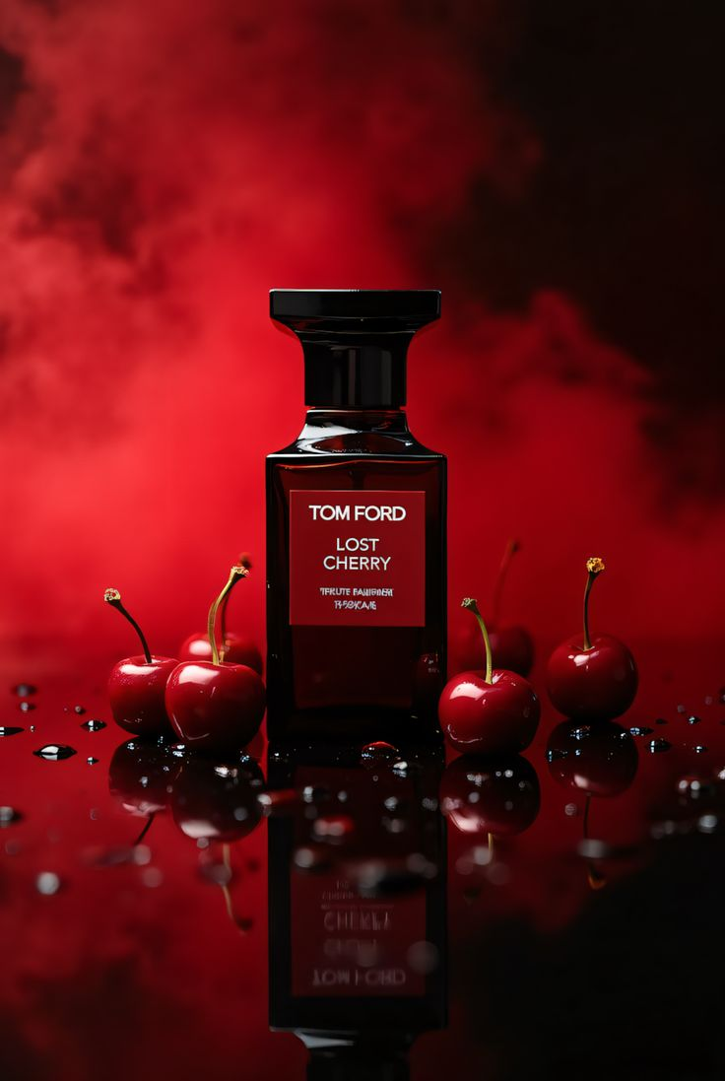$150

### **Fragrance Description:**

Sweet and provocative with black cherry, almond, and Turkish rose — irresistibly bold.

### **Fragrance Notes:**

Top Notes: Citrus, Floral Accents

Heart Notes: Jasmine, Peony, Amber

Base Notes: Musk, Vanilla, Sandalwood

### **Key Features:**

• Elegant, long-lasting luxury scent

• Perfect for day or night wear

• Refined design and craftsmanship

• A blend of modern and classic sophistication

### **About the Brand:**

Each luxury perfume represents artistry, emotion, and excellence — created for individuals who seek elegance, uniqueness, and unforgettable allure.

────────────────────────────