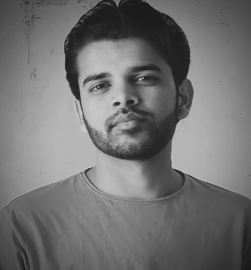**RESUME**

**AFFAN WASI**

+91 95087 42198

Email Id: [affan2939@gmail.com](mailto:affan2939@gmail.com)

**OBJECTIVE**

To work for a company where I can develop new skills and my capacity for both organizational and personal activities.

**SKILLS**

**JAVA**  **JavaScript** **CSS**  **HTML**  **SQL**

**PROJECT**

Personal Portfolio Website [www.affanwasi.netlify.app](http://www.affanwasi.netlify.app).

**QUALIFICATION**

* Third-year BCA student at CCSU.
* Passed 12th from BSEB with 72.8%.
* Passed 10th from CBSE with 8.2 CGPA.

**STRENGTH & HOBBIES**

* Unflappable & Diligent.
* Good communication skills.
* Writing poetries.

**PERSONAL DETAIL**

Father’s Name : Wasiullah Khan

Date of Birth : 01-09-2001

Address : Bettiah, West Champaran, Bihar -845453

Date………. (Affan Wasi)