**RESUME**

**N** 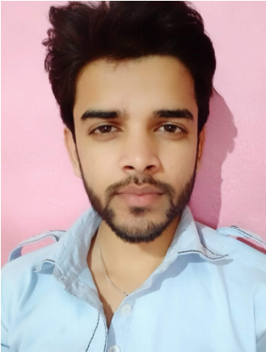

***AFFAN WASI***

ADDRESS - New Ashok Nagar, Block - D, Delhi - 110096

Contact No- 9508742198

E-mail- affan2939@gmail.com

# Carrier Objective

To be part of a progressive organization that provides continuous learning & career growth opportunities where my skills can be enhanced for the company’s growth and my personal capabilities.

***Educational Qualifications***

|  |  |
| --- | --- |
| ● | Pursuing BCA from Chaudhary Charan Singh University |
| ● | **HSC (**CBSE 8.2 CGPA in 2016). |
| ● | **SSC** (BSEB (72.8% in 2019) |

# Computer skills

|  |  |  |
| --- | --- | --- |
| **Operating system(OS)**  ▪ Microsoft window 7,8.  **Programming language** ▪ C, C++, Java  **Web Designing**  ▪ HTML, CSS, Basic knowledge of JS.  **Database** | | |
|  | |  |
| **MS Office**  ▪ | MS-word, MS-excel, MS-Power. | |

**Personal Skills**

|  |  |
| --- | --- |
| ● | Good communication skill |
| ● | Positive attitude |
| ● | Positive thinking |
| ● | Good listener |

# Personal Details

Father Name :Wasiullah Khan

Date of Birth :01/Sep/2001

Marital Status :Unmarried

Nationality : Indian

Language Know :Hindi, English

# Hobbies and interest

|  |  |
| --- | --- |
| ● | Playing cricket |
| ● | Learning new things |

# Declaration:-

It is to certify that all information given above is true to the best of my knowledge and belief.

Date: ………..

Place: **Delhi**

***AFFAN WASI***