**COMSATS University Islamabad, Abbottabad Campus**

**Department of Computer Science**

**Project Proposal**

**School Management System**

**CSC392 Object Oriented Software Engineering**

Submitted on: <23-APR-2022>

Group Members:

Afaq (FA20-BSE-057)

Ali Said(FA20-BSE-4B-165)

Muhammad Nawaz Khan (FA20-BSE-073)

Abdullah Javed (FA20-BSE-052)

Ehsanullah (FA20-BSE-068-4B)

Faizan Zaheer (FA20-BSE-045)

Irfan Khan (FA20-BSE-070)

Table of Contents

[CHAPTER 1 PROJECT PROPOSAL 3](#_Toc101427096)

[Introduction 3](#_Toc101427097)

[Vision and Business Case 3](#_Toc101427098)

[Use-Case Model 3](#_Toc101427099)

[Supplementary Specification 3](#_Toc101427100)

[Glossary 3](#_Toc101427101)

[Risk List & Risk Management Plan 3](#_Toc101427102)

[CHAPTER 2 USE CASES 4](#_Toc101427103)

[Use Case Diagram 4](#_Toc101427104)

[Brief Level Use Cases 4](#_Toc101427105)

[Student Name 1 (Registration Number 1) 4](#_Toc101427106)

[Student Name 1 (Registration Number 1) 5](#_Toc101427107)

# CHAPTER 1 PROJECT PROPOSAL

## Introduction

School Management system, required for effective software development, to manage the overall data of a school

## Vision and Business Case

In the offline system, it is an overhead to keep the records related to faculty, student, parents, and other school staff on the papers. Everything related to their progress in the system is marked manually. For example A report of a student’s attendance is generated monthly is shown to his/her parents. Now, a regular student, going to school every day, is marked absent for a day by mistake.

It is a burden to take out the register and view the records. As you can see, it is a very time-consuming process and it costs much. So, I thought why I should not help these young guns of the nations to help them to have a bright future and to make an online centralized platform that can be accessed from anywhere in the world.

My other aim is to minimize the paperwork as minimum as I can so that there is no need to cut more and more trees. Indirectly, I will be helping Mother Nature.

## Use-Case Model

The functional requirements of school management system are:

1. Multi-User Account System
2. Student Fee Management
3. Parent Monitoring Feature
4. Homework Document
5. Class Routine Schedule
6. Profile System
7. Exam Marks Management
8. Chart & Graph Analysis of Exams
9. Daily Attendance
10. Internal Messaging

## Supplementary Specification

1. Events management

## Glossary

## Having a dynamic system with a bird view of data and reports can give next level of power and quickness in decision-making for principal or management person. School management System provides extra ordinary Management Dashboard and data reporting functions along with dynamic access rights mechanism which becomes a blessing for management personnel.

## Risk List & Risk Management Plan

***Describes the risks (business, technical, resource, schedule) and ideas for their mitigation or response.***

**1. Malware**

Digital hackers are watching your every move and trick you to download malware and take control of your computer remotely. They use malware to attack computer networks to perpetrate crimes.  Fraudsters use virus, malware, spyware, spams, and phishing to gain access to your sensitive personal information and commit financial crimes. Defend your data against malware through secure servers, whether physical or in cloud, and shield against vulnerabilities.

**2. Theft & Loss**

Unauthorized users without permissions who have access to sensitive data can cause harm to educational institutions as a result of theft. There is a risk of the sensitive academic data will be leaked by staff. It becomes easy to lose your storage media with backup data due to misplacement or theft. When you suffer data loss due to various incidents such as mechanical damage, power failure, software crash, disasters or loss of your laptops and mobile devices, it is another way of inadvertent data exposure. Keep all your data safe and secure using role-based access control to ensure confidentiality and privacy.

**3. Unsafe data**

If adequate safety precautions are not taken when files and documents are shared in website, smartphones and tablets via internet networks, the information contained on them might gain access to the devices and get exposed to risks. We can make use of cloud deployments to manage the education system better and better.

**4. Negligence**

When data is stored in computers or laptops, it has become so natural that people lose the information when files are accidentally deleted or even it could fall into the wrong hands. Ensure a proper backup strategy to keep your data on important devices and run them smoothly without hassles.

CHAPTER 2 USE CASES

Use Case Diagram of School Management System

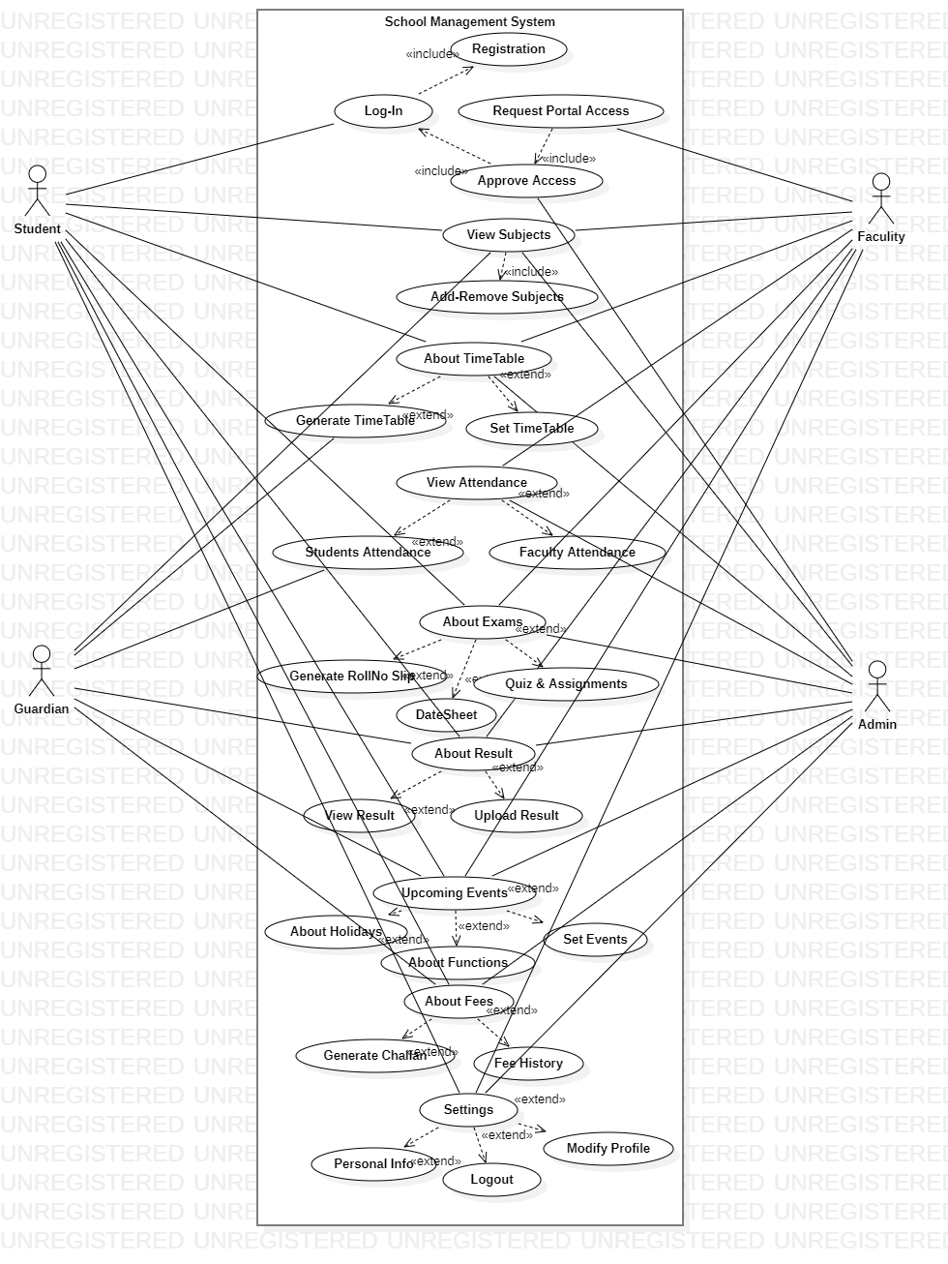

## Brief level use case:

Muhammad Nawaz Khan(FA20-BSE-073)

#### Use case: Add faculty attendance:

The faculty mark their attendance using biometric or by entering their id no the real time attendance saved in the database and updated and the system.

#### Use case: Add student attendance:

The teacher can mark the attendance of the student using the system and the real time attendance can be updated in the system.

#### Use case: view student attendance:

The student teacher and faculty can view the real time attendance by using the system.

The system generates the attendance list of student and faculty for admin.

### Ali Said(FA20-BSE-165)

#### Use Case: Take Quiz

Teacher can take quiz and students can give quiz without any physical presence and teacher will also not mark the quiz. The system will automatically marks the quizzes.

#### Use Case: Take Assignment

Teacher can take assignment and students can give assignment solution without any physical presence and teacher will download the submitted solutions of assignments and mark them and upload their marks.

### Afaq (FA20-BSE-057)

#### Use Case: Time Table

In school management system time table is necessary so it is strong entity. From time table students can see their time table and takes classes according to their time table slot. Faculty can also take classes according to their time table. Guardians able to see their children time table and keep eye on their class’s times. School administration will set time and classes to each and every class from first grade to matric level. Every class has unique time table and subjects.

### Abdullah Javed (FA20-BSE-052)

#### Use Case: Subjects Management

### In this use case students will be asked by the administrators to add class. After adding class there are certain subjects that are taught in that particular class added by student. Administrator is allowed to add or remove subjects from class, while students are bound to see only the subjects list. On the basis of subjects admin can assign instructor in each subjects. Faculty members can also list down the subjects they want to teach. Guardians are also eligible to see the subjects of student.

### **Ehsanullah (FA20-BSE-068)**

#### Use Case: About Result

About Result use case will generate the result for student based on their request for view the result for the subjects. The results of student will be taken by teachers and the record will be submitted on system. The admin and teacher can modify and view the result of student. The guardian and student can only view the result.

### **Faizan Zaheer (FA20-BSE-045)**

#### Use Case: Events

In Events Usecase Event Manager Will Add the Event,View events,delete events,monitor events status online,manage series and schedules of events ,monitor Venue and Parcipants records and show the list of parcipants and release the schedules of events and events detail.Event Manager make changes or modify the events and parcipants view the Events and schedule of events.

### Irfan khan FA20-BSE-070

#### Use Case: register account

User opens the School management system and clicks on the register button. The system takes the user to the registration page. The user is required to enter information asked by the system. The user then enters his full name, email, address, phone number and password. The system then checks if the user is already registered or not. If he is not registered the system validates and registers him as a Student.

## Brief Level Use Cases

### Irfan khan FA20-BSE-070

#### Use Case: login

User opens the School management system and clicks on the login button. The system takes the user to the login page. The user is required to enter information asked by the system which is the username and the password. The system then checks if the user is already registered or not. If he is registered the system validates and logs him in.

## **Brief Level Use Cases**

### **Irfan khan FA20-BSE-070**

#### **Use Case UC3: Request portal Access**

User opens the School management system and clicks on the register button. The system takes the user to the registration page. The user is required to enter information asked by the system. The user then enters his full name, email, address, phone number and password. The System gives to access to log in to System if the user is enter correct and valid information for registration of a user account. If he is register to the system. The System validates and registers him as a User.

Fully dressed use case:

### Muhammad Nawaz Khan (FA20-BSE-073)

| Use Case UC1: Add faculty attendance |
| --- |

**scope**: mark faculty attendance

**primary Actors**: faculty, admin.

**Stake holder and interest:**

Faculty: it is easy for faculty to mark attendance using biometric and the attendance is updated directly

In the system and there is less chance of errors to forgot attendance.

Admin: managing the teacher’s attendance without this system is very difficult for admin.

The system generates attendance lists and inform the admin that which faculty member is absent.

**Preconditions:** faculty must be authorized through biometric or thorough id no.

**Success guarantee** (or Postconditions): marking the attendance for faculty become easy.

**Main success scenario or Basic flow:**

* Faculty marks their attendance through biometric.
* Teacher marks their attendance system and records is saved in the database.
* The system generates attendance report for admin.
* Admin can view the real time attendance.

**Extension or alternative flows:**

At any time, fingerprint can’t be registered:

* During marking attendance, the fingerprint may not work every time.
* If the fingerprint can’t work teacher should use their ID NO for attendance.

If system does not recover:

* The user will suspend the operation and the system will show an error message.
* The user starts a new operation and continue to his work.

**Special requirements:**

* There should be a biometric attendance machine for faculty attendance.
* The machine should be connected to system

**Technology and Data Variations List**:

The biometric attendance machine should be connected to the system.

| Use Case UC1: Add student Attendance |
| --- |

**scope**: mark student attendance

**primary Actors**: faculty, student.

**Stake holder and interest:**

Teacher: Teacher wants to take attendance easily without any error and don’t want to carry extra register to mark students’ attendance.

In the system and there is less chance of errors to forgot attendance.

Student: students want to get rid of traditional list to check their attendance and the system is very useful to for student to view their updated attendance.

**Preconditions:** Teacher must be identified and authenticated.

**Success guarantee** (or Postconditions): The process of Taking attendance become easy and the real time attendance can be updated in the system.

**Main success scenario or Basic flow:**

* Teacher marks attendance of students using the system and records is saved in the database.
* The system generates attendance report for admin.

**Extension or alternative flows:**

At any time, the internet can be gone:

* During the marking or updating attendance any time the internet connection may be gone.
* The system will be interrupted, and the teacher will not be able to use the system.
* After the fixing the internet, the user will login and continue back to his work.

At any time, system fails:

* The system can fail any time. The system it will save the work.
* User will restart the system and request for recovery the system will start from the prior state.

If system does not recover:

* The user will suspend the operation and the system will show an error message.
* The user starts a new operation and continue to his work.

**Special requirements:**

* The user should have the computer to use the system.
* The internet must be connected.
* The user should be authorized and authenticated.

**Technology and Data Variations List**:

The must have computer connected to internet.

| Use Case UC1: View student |
| --- |

**scope**: view student attendance

**primary Actors**: faculty, admin, student.

**Stake holder and interest:**

The student can view can their real time attendance.

The system generates class wise attendance lists and inform that which faculty member is absent.

**Preconditions:** student, teacher and admin must be identified and authenticated.

**Success guarantee** (or Postconditions): View real time attendance. Accurate attendance Report for admin.

**Main success scenario or Basic flow:**

* The system generates attendance report for admin.
* Students and guardians can view the real time attendance.

**Extension or alternative flows:**

At any attendance may not updated:

Viewing the attendance if there is any error or inaccuracy.

Refresh the system or check the internet and the try again.

Contact to faculty or admin to remove error or update the record.

If system does not recover:

* The user will suspend the operation and the system will show an error message.
* The user starts a new operation and continue to his work.

**Special requirements:**

* The user should have the computer to use the system.
* The internet must be connected.
* The user should be authorized and authenticated.

**Technology and Data Variations List**:

The must have computer connected to internet.

### Ali Said (FA20-BSE-165)

| Use Case UC1:Take Quiz |
| --- |
| **Scope**: Taking quiz  **Primary** **Actor**: Student, Faculty.  **Stakeholders and Interests**:  -Teacher: Teacher will be able to get rid of traditional quizzes where teachers and students presence are mandatory. Teacher can take the quiz easily at any place at any time. It only needed the virtual presence of students. Teacher will set the deadline of quiz.  -Student: Students will also get rid of traditional quizzes and they only needed is their smart-phones, tablets or pc`s and an internet connection to give the quiz.  **Preconditions**: Students and teachers must be identified. |

**Success Guarantee** (or Postconditions): Teachers will feed questions and answers and then they will take quiz. Students have to give timeboxed quiz. After that system will automatically mark the quiz on the basis of stored answers.

**Main Success Scenario (or Basic Flow):**

1. Teacher will store the questions on the about exams section before taking quiz.
2. Teacher will set the duration of quiz.
3. Students will be notified about quiz or assignments in notification section.
4. Students will start the quiz.
5. After answering few questions their quiz will be finished.
6. After deadline there will be no option available for requiz.
7. System will automatically mark the quizzes.
8. After teacher`s review result will be sent to the result section and will be publicly available to students.

**Extensions (or Alternative Flows):**

At any time, admin requests can override operation:

1. The teacher set the exam.
2. Admin wants any other operation at that time frame.
3. The admin operation will override the teacher operation.
4. Teacher operation will be set to next timeframe available.

**Special Requirements:**

- Touch screen UI on a large flat panel monitor. Text must be visible from 1 meter.

- Page response within 3 seconds 90% of the time.

- Language internationalization on the text displayed.

**Technology and Data Variations List**:

1. Teacher can set face match feature so that it confirms that only authenticated students are taking quiz.

| Use Case UC2:Give Quiz |
| --- |
| **Scope**: Give quiz  **Primary** **Actor**: Student, Faculty.  **Stakeholders and Interests**:  -Teacher: Teacher will be able to get rid of traditional quizzes where teachers and students presence are mandatory. Teacher can take the quiz easily at any place at any time. It only needed the virtual presence of students. Teacher will set the deadline of quiz.  -Student: Students will also get rid of traditional quizzes and they only needed is their smart-phones, tablets or pc`s and an internet connection to give the quiz.  **Preconditions**: Students and teachers must be identified. |

**Success Guarantee** (or Postconditions): Teachers will feed questions and answers and then they will take quiz. Students have to give timeboxed quiz. After that system will automatically mark the quiz on the basis of stored answers.

**Main Success Scenario (or Basic Flow):**

1. Teacher will store the questions on the about exams section before taking quiz.
2. Teacher will set the duration of quiz.
3. Students will be notified about quiz or assignments in notification section.
4. Students will start the quiz.
5. After answering few questions their quiz will be finished.
6. After deadline there will be no option available for requiz.
7. System will automatically mark the quizzes.
8. After teacher`s review result will be sent to the result section and will be publicly available to students.

**Extensions (or Alternative Flows):**

At any time, admin requests can override operation:

1. The teacher set the exam.
2. Admin wants any other operation at that time frame.
3. The admin operation will override the teacher operation.
4. Teacher operation will be set to next timeframe available.

**Special Requirements:**

- Touch screen UI on a large flat panel monitor. Text must be visible from 1 meter.

- Page response within 3 seconds 90% of the time.

- Language internationalization on the text displayed.

**Technology and Data Variations List**:

1. Teacher can set face match feature so that it confirms that only authenticated students are taking quiz.

| Use Case UC3:Take Assignment |
| --- |
| **Scope**: Taking Assignments.  **Primary** **Actor**: Faculty, Students.  **Stakeholders and Interests**:  -Teacher: Teacher will be able to get rid of traditional quizzes where teachers and students presence are mandatory. Teacher can take the assignment easily at any place at any time. It only needed the virtual presence of students. Teacher will set the deadline of assignment.  -Student: Students will also get rid of traditional assignments and they only needed is their smart-phones, tablets or pc`s and an internet connection to give the quiz.  **Preconditions**: Students and teachers must be identified. |

**Success Guarantee** (or Postconditions): Teachers will feed assignment and then it will be displayed to students. Students have to submit before deadline. After that system will automatically closes the submission.

**Main Success Scenario (or Basic Flow):**

1. Teacher will store the questions on the about exams section before taking assignment.
2. Teacher will set the deadline of assignment.
3. Students will be notified about assignments in notification section.
4. Students will download the assignment file.
5. After solving assignment they have to submit it.
6. After deadline there will be no option available for submission.
7. Teacher will download the submitted solution of assignment and mark it.
8. After teacher`s review result will be sent to the result section and will be publicly available to students.

**Extensions (or Alternative Flows):**

At any time, admin requests can override operation:

1. The teacher set the exam.
2. Admin wants any other operation at that time frame.
3. The admin operation will override the teacher operation.
4. Teacher operation will be set to next timeframe available.

**Special Requirements:**

- Touch screen UI on a large flat panel monitor. Text must be visible from 1 meter.

- Page response within 3 seconds 90% of the time.

- Language internationalization on the text displayed.

**Technology and Data Variations List**:

1. Teacher will be notified whether the assignment is copied from any source or not.

| Use Case UC4:Give Assignment |
| --- |
| **Scope**:Give Assignments.  **Primary** **Actor**: Faculty, Students.  **Stakeholders and Interests**:  -Teacher: Teacher will be able to get rid of traditional quizzes where teachers and students presence are mandatory. Teacher can take the assignment easily at any place at any time. It only needed the virtual presence of students. Teacher will set the deadline of assignment.  -Student: Students will also get rid of traditional assignments and they only needed is their smart-phones, tablets or pc`s and an internet connection to give the quiz.  **Preconditions**: Students and teachers must be identified. |

**Success Guarantee** (or Postconditions): Teachers will feed assignment and then it will be displayed to students. Students have to submit before deadline. After that system will automatically closes the submission.

**Main Success Scenario (or Basic Flow):**

1. Teacher will store the questions on the about exams section before taking assignment.
2. Teacher will set the deadline of assignment.
3. Students will be notified about assignments in notification section.
4. Students will download the assignment file.
5. After solving assignment they have to submit it.
6. After deadline there will be no option available for submission.
7. Teacher will download the submitted solution of assignment and mark it.
8. After teacher`s review result will be sent to the result section and will be publicly available to students.

**Extensions (or Alternative Flows):**

At any time, admin requests can override operation:

1. The teacher set the exam.
2. Admin wants any other operation at that time frame.
3. The admin operation will override the teacher operation.
4. Teacher operation will be set to next timeframe available.

**Special Requirements:**

- Touch screen UI on a large flat panel monitor. Text must be visible from 1 meter.

- Page response within 3 seconds 90% of the time.

- Language internationalization on the text displayed.

**Technology and Data Variations List**:

1. Teacher will be notified whether the assignment is copied from any source or not.

### Abdullah Javed (FA20-BSE-052)

| Use Case UC1: Subject Management |
| --- |
| **Scope**: School Management System  **Level**: user goal  **Primary** **Actor**: Student, Admin, faculty, Guardian.  **Stakeholders and Interests**:  - Admin: Wants only eligible students to enroll for classes , want accurate records of which students are enrolled on which courses, want to know how many students are registered to each course. Admin is also responsible to assign subjects to each student of particular class.  - Student: Wants to enroll for a class and for no eligibility problems to later arise, wants proof of enrollment , wants process to be clear and simple.  - Guardian: Wants to know for his children details about subjects. Guardian is eligible only for viewing details.  - Faculty: teacher is one of the important entities for a school. The teachers are there to teach the students. The following are the features that will be available to the teachers.  **Preconditions**: Student is identified and authenticated. |

**Success Guarantee**

Student is aware of enrollment on choosen class. List of students enrolled to course is updated. Student has a proof of enrollment.

**Main Success Scenario (or Basic Flow):**

1. The user requests a list of class currently available for enrollment.
2. The system retrieves the list of courses available and displays the list to the user.
3. System provide the user with the opportunity to select a course or to exit the use case.
4. The user selects a course for which he or she wants to enroll.
5. The system retrieves the details for the chosen course, including the course outline, timetable and eligibility requirements and displays the details to the user.
6. The system checks that the user has taken and passed the pre-requisite courses forthe chosen course
7. The system checks that the user is not already enrolled on a course who setimetable clashes with the chosen course

**Extensions (or Alternative Flows):**

At any time, admin requests can override operation:

1. The teacher view its own subject list.
2. Admin wants any other operation at that time frame.
3. The admin operation will override the teacher operation.
4. Teacher operation will be set to next timeframe available.
5. Admin can change the instructor of the subject.

**Special Requirements:**

User must use computer

User must install that software for access- …

Touch screen UI on a large flat panel monitor. Text must be visible from 1 meter.

**Open Issues:**

The must have computer connected to internet.

**ScreenShot of UserInterFace:-**

**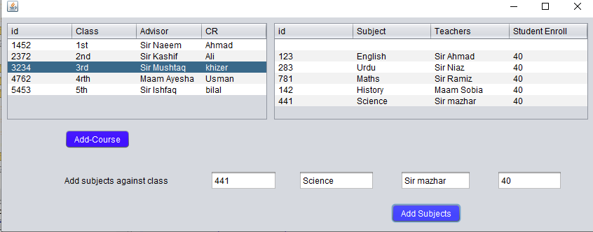**

### Ehsanullah (FA20-BSE-068-4B)

| Use Case UC1: About Result |
| --- |
| **Scope**: School Management System  **Level**: user goal  **Primary** **Actor**: Student, Guardian, Faculty, Admin.  **Stakeholders and Interests**:  - Faculty: Wants accurate, fast entry, and no text errors.  - Guardian: Wants to view his/her, son/ daughter result.  - Student: Wants easy and fast service with minimal effort. Wants easily visible display of each entered subject result.  - School Management: Wants to accurately view result records and satisfy Student, Faculty, interests.  - Admin: Wants to be able to quickly perform override operations, and easily debug About Result problems.  **Preconditions**: Student is identified and authenticated. |

**Success Guarantee** (or Postconditions): Result is saved. Result is correctly displayed. Result list are updated. Result is generated. Student authorization approvals are recorded.

**Main Success Scenario (or Basic Flow):**

* Faculty marks their result.
* Teacher marks result of students using the system and records is saved in the database.
* The system generates result report for admin.
* System alert guardian if the student is failed.
* Students and guardians can view the real time result.

**Extensions (or Alternative Flows):**

At any time, the internet can be gone:

* During the marking or updating result any time the internet connection may be gone.
* The system will be interrupted, and the teacher will not be able to use the system.
* After the fixing the internet, the user will login and continue back to his work.

At any time, system fails:

* The system can fail any time. The system it will save the work.
* User will restart the system and request for recovery the system will start from the prior state.

If system does not recover:

* The user will suspend the operation and the system will show an error message.
* The user starts a new operation and continue to his work.

**Special requirements:**

* The user should have the computer to use the system.
* The internet must be connected.
* The user should be authorized and authenticated.
* - Touch screen UI on a large flat panel monitor. Text must be visible from 1 meter.
* - Page response within 3 seconds 90% of the time.
* - Language internationalization on the text displayed.

**Technology and Data Variations List**:

The primary actors must have computer connected to internet.

### **Faizan Zaheer (FA20-BSE-045)**

| Use Case UC1: Events |
| --- |
| **Scope**: School Management System  **Level**: user goal  **Primary** **Actor**: Event Manager,Parcipants.  **Stakeholders and Interests**:  - Event Manager: Wants to add events and Manages the all the events in school.  -Event manager: are responsible for planning events and ensuring that they run as smoothly as possible.  -Produce detailed proposals for events (for example, time lines,venues, suppliers, legal obligations, staffing and budgets.  - Parcipants: Wants to register and parcipate in events .  - School Management: Wants to give facilities to parcipants for achieving their goals and easly parcipate in events.  **Preconditions**: Event Manager and Parcipants is identified and authenticated. |

**Success Guarantee** (or Postconditions): Information about Events is saved. Events is correctly managed. Schedule and Venue are updated.Clear Objectives, Location of Venue, Financial Resources, Code of Conduct, Marketing and Promotion and lastly, Sponsorship of Event.

**Main Success Scenario (or Basic Flow):**

1. Event manager Add the Events.
2. Students will register in events.
3. Students take parcipate in events.
4. Manager monitor the events status online and update the changes.
5. Parcipants monitor venue and parcipants records.
6. System will Automaticaly send the notifications about events to all Students.

**Extensions (or Alternative Flows):**

**a.At any time, the internet can be gone:**

1. The Event manager add the event.
2. Manager wants any other operation at that time frame.
3. The manager operation will override the parcipant operation.
4. parcipants operation will be set to next timeframe available.

**b. At any time, System fails:**

1. The system can fail any time. The system it will save the work.
2. User will restart the system and request for recovery the system will start from the prior state.

If system does not recover:

* The user will suspend the operation and the system will show an error message.
* The user starts a new operation and continue to his work.

**Special Requirements:**

* The user should have the computer to use the system.
* The internet must be connected.
* The user should be authorized and authenticated.
* Touch screen UI on a large flat panel monitor. Text must be visible from 1 meter.
* Page response within 30 seconds 90% of the time.
* Language internationalization on the text displayed.

**Technology and Data Variations List**:

1. Admin can set up fingerprint or face unlock.
2. The primary actors must have computer connected to internet.

**Fully Dressed Use Cases**

Irfan khan FA20-BSE-070

| Use Case UC1: register account |
| --- |
| **Scope**: School management system  **Level**: user goal  **Primary** **Actor**: Student  **Stakeholders and Interests**:   * Student: want to register an account in the School management system. * Faculty: want to register an account in the School management system.   **Preconditions**:   * The System is running correctly. * User is not registered. |

**Success Guarantee** (or Post conditions):

* Username is not available and account is registered.
* User is registered and Account is created Successfully

**Main Success Scenario (or Basic Flow):**

1. User wants to open the School management system to register an account.
2. System redirects him to the registration page
3. System asks him to provide the details.
4. The user enters username, password, email and address
5. System then checks if the account is already registered or not.
6. If the account is registered the system asks to provide new information or to login
7. If the account is not registered then the system registers the account.
8. System then takes the user to his dashboard where he can access his own profile.

**Extensions (or Alternative Flows):**

\*a. At any time when the user tries signing up:

1. User enter all required information for registration in School management System.
2. User enters the First name, last name, username email address and password is used when registering his account.
3. The system then verifies his credentials when he clicks on the register button.
4. When the credentials matches then he is redirected to his profile.

\*b. At any time when the user tries signing up:

1. User enters the password and username he used when registering his account.
2. The system then verifies his credentials.
3. If the credentials don’t match, then the system displays an error either his password or username is incorrect.
4. If the user not entered credential while registration, then the System displays an error that “enter valid information.”

**Special Requirements:**

* + - Text should be visible from 2 meters.
    - Color scheme should be used which is clearly visible.
    - Special characters should be used in username and password.
    - It should take less than 30 second to register an account.
    - Password should be display as \*\*\*\*.

**Technology and Data Variations List**:

1. Languages used is java.
2. Software used to design interface is net beans, Gui Swing.
3. Mouse and keyboard are required.

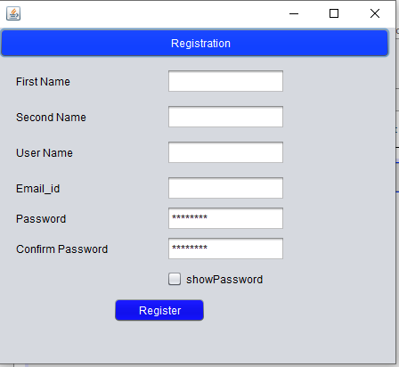

Fully Dressed Use Cases

### Irfan khan FA20-BSE-070

| Use Case UC2: login |
| --- |
| **Scope**: School management system  **Level**: user goal  **Primary** **Actor**: Student, admin, Faculty  **Stakeholders and Interests**:  - Student: want to login in the School management system.  -Faculty: want to login in the School management system.  **Preconditions**:   * User is identified and authenticated. * User is registered and account is exist in System. * User credentials must entered correctly. |

**Success Guarantee** (or Post conditions):

* Username and password are valid, and account is registered.
* User must be able to login.
* User is successfully login to the system.
* System shall redirect to User profile

**Main Success Scenario (or Basic Flow):**

1. User opens the School management system to log in into his account.
2. System redirects him to the log in page
3. System asks him to provide the details.
4. The user enters username, and password
5. System then checks if the account is already registered or not.
6. If the account is registered the system verifies the account.
7. If the account is not registered, then the system asks to register the account.
8. System then takes the user to his dashboard where he can access the System and his own profile.

**Extensions (or Alternative Flows):**

\*a. At any time when the user tries to login:

1. User enters the username and password he used when log in to his account.
2. The system then verifies his credentials when he clicks on the log in button.
3. When the credentials matches then he is redirected to his profile.

\*b. At any time when the user tries to login:

1. User enters the password and username he used when log in his account.
2. The system then verifies his credentials.
3. If the credentials don’t match, then the system displays an error either his password or username is incorrect.
4. If the user not put information in his login id and password, the system should diplay an error message “Enter valid details”.

**Special Requirements:**

* + - Text should be visible from 3 meters.
    - Color scheme should be used which is clearly visible.
    - Special characters should be used in username and password.
    - It should take less than 30 second minutes to register an account.
    - Password should be display as \*\*\*\*.

**Technology and Data Variations List**:

1. Languages used is java.
2. Software used to design interface is netbeans, Gui Swing.
3. Mouse and keyboard are required .

**Screen Shots:**

**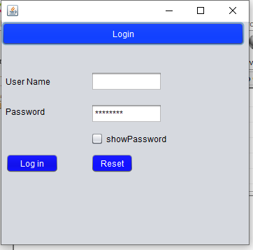**

**Fully Dressed Use Cases**

### **Irfan khan FA20-BSE-070**

| **Use Case UC1: Request portal Access** |
| --- |
| **Scope**: School management system  **Level**: user goal  **Primary** **Actor**: Student, teacher, admin.  **Stakeholders and Interests**:   * + - Student want to register an account in the School management system.     - The system must approve his registration of an account to access School System.     - Faculty: want to register an account in the School management system.     - The system must approve his registration of an account to access School System.   **Preconditions**:   * User is not registered before and User have no Access to the System. * User must enter correct and valid credential to access the System. |

**Success Guarantee** (or Post conditions):

* The system gives Access to User for log in to the system.
* User is redirect to the login page after Successful access and registration of an Account.
* Account is not already registered with the same User name before.

**Main Success Scenario (or Basic Flow):**

* + User wants to open the School management system to Access an account to register to the System.
  + The System redirects him to the registration page to provide accessibility.
  + System asks him to provide the details for Access the System.
  + The user enters username, password, email and address for the creation of an account in System.
  + System then checks if the account is already registered or not.
  + If the account is registered the system asks to provide new information or to login again.
  + If the account is not registered then the system registers the account and provide access to the user.
  + System then takes the user to his dashboard where he can access his own profile.

**Extensions (or Alternative Flows):**

\*a. At any time when the user tries to access for the System:

* User enter all required information for registration to get Account access in School management System.
* User enters the First name, last name, username email address and password is used when registering his account for the Access of School system.
* The system verifies his credentials for accessibility to System when he clicks on the register button.
* When the credentials matches then he is redirected to his login to the System.
* User enters the password and username to use for login when he get access to an account.
* The system then verifies his credentials.
* If the credentials don’t match, then the system displays an error either his password or username is incorrect.
* If the user not entered credential while registration to access the system, then the System displays an error that “enter valid information.”
* While registration and login user must enter correct and valid information.

**Special Requirements:**

* Text should be visible from 2 meters.
* Color scheme should be used which is clearly visible.
* Special characters should be used in username and password.
* It should take less than 30 second to access the system to register an account.

**Technology and Data Variations List**:

* Languages used is java.
* Software used to design interface is netbeans, Gui Swing.
* Mouse and keyboard are required.

**Screen Shots:**

**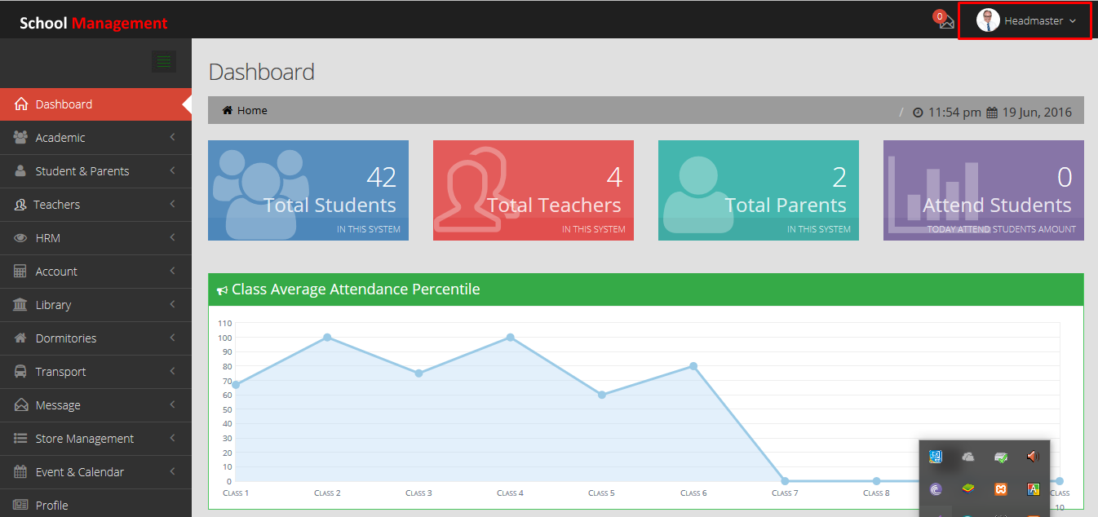**

# CHAPTER 3 SSD

## SSD Diagram

**Afaq(FA20-BSE-057):**

| Use Case UC1:Generate TimeTable. |
| --- |

**Abdullah Javed(FA20-BSE-052):**

| Use Case UC1:create or modify course: |
| --- |

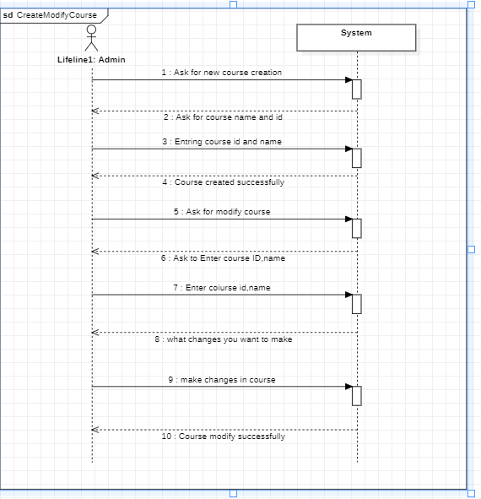

| Use Case UC 2:Student course info: About_course.PNG |
| --- |

Use Case UC 3 :Assign subjects to instructor:

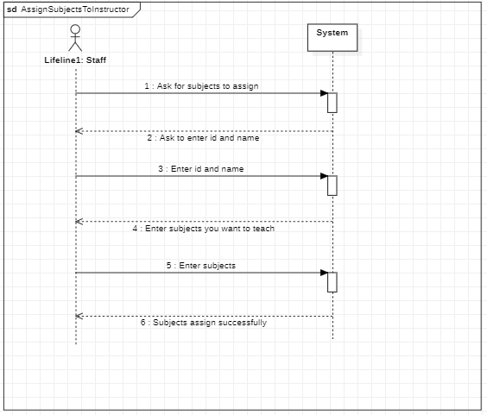

Use Case UC 4:Assign subjects to student:

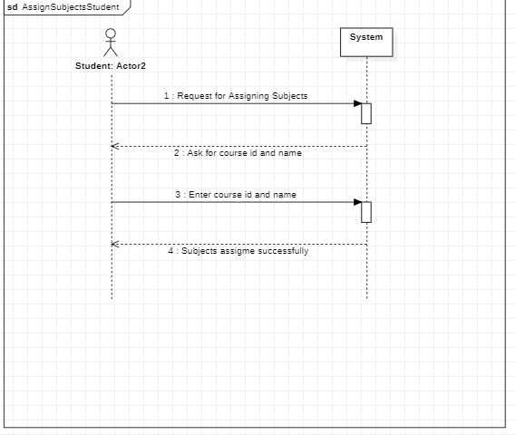

### Ali Said (FA20-BSE-165)

| Use Case UC1:Take Quiz |
| --- |

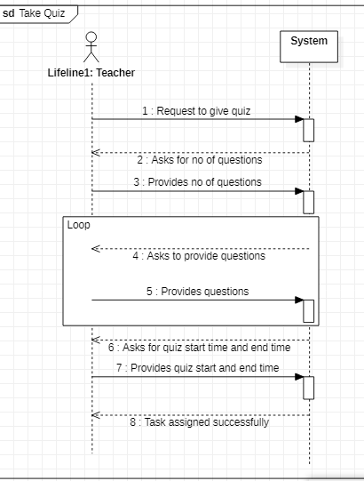

| Use Case UC1:Give Quiz |
| --- |

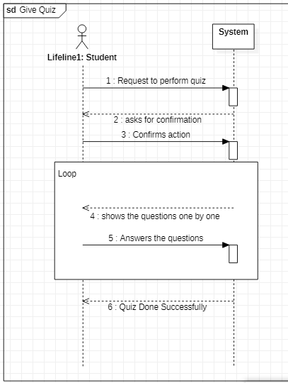

#### Use Case UC1:Take Assignment

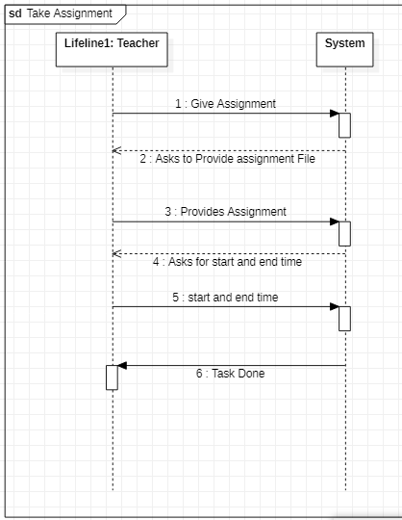

#### Use Case UC1:Give Assignment

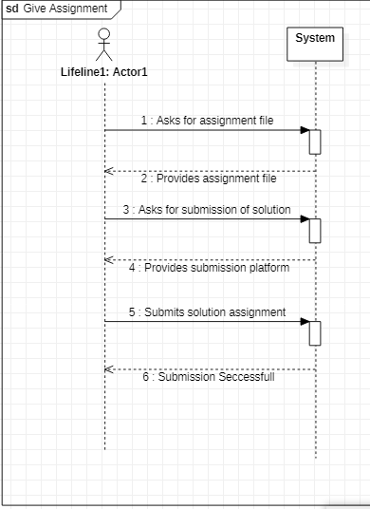

Irfan khan FA20-BSE-070

| Use Case UC1: register account |
| --- |

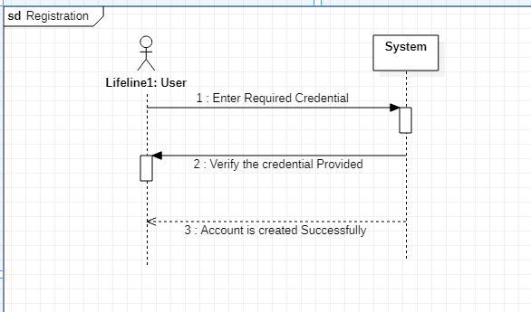

## SSD Diagram

Irfan khan FA20-BSE-070

| Use Case UC2: Log in |
| --- |

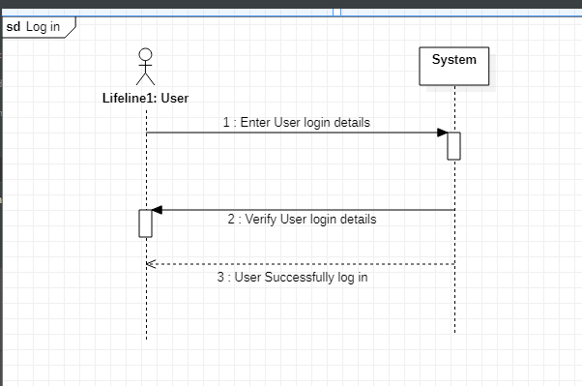

### **Faizan Zaheer (FA20-BSE-045)**

| Use Case UC1: Add Events |
| --- |

**SSD OF ADD EVENT:**

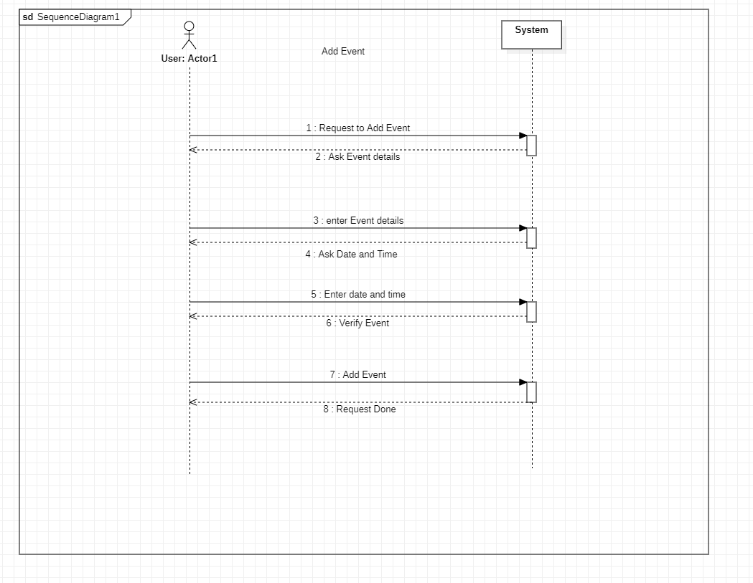

### Ahsan Ali

### SP20-BSE-060

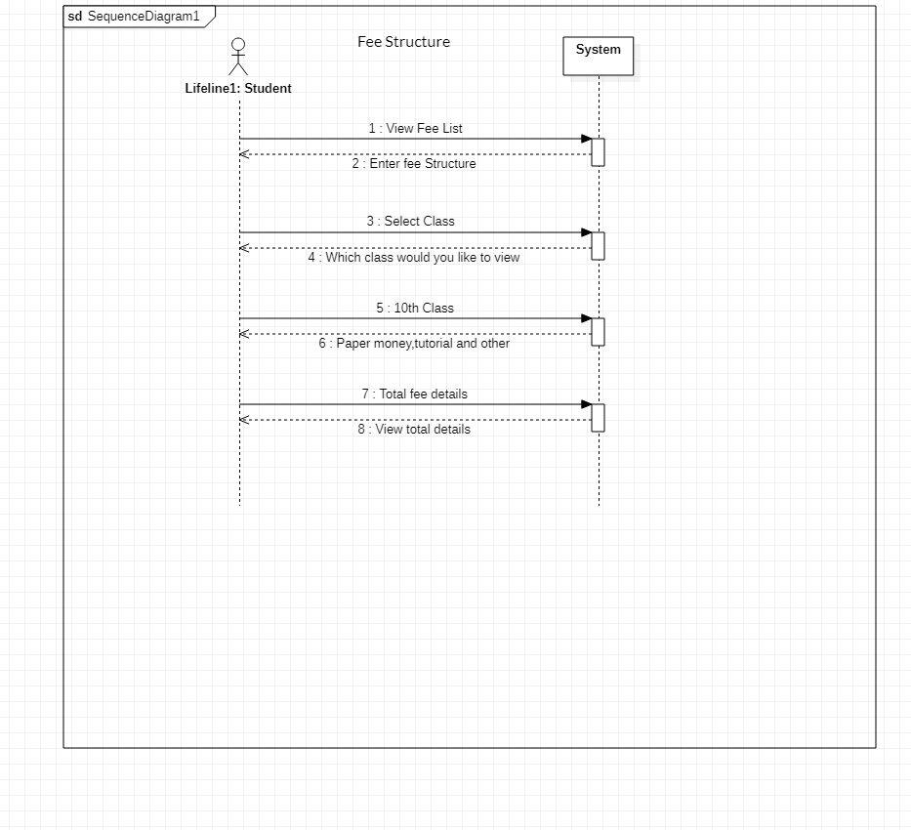

Draw your SSD against each use case. And paste Screen shot in this chapter 3 with registration and use case number.

Ehsanullah

FA20-BSE-068

VIEW RESULT:

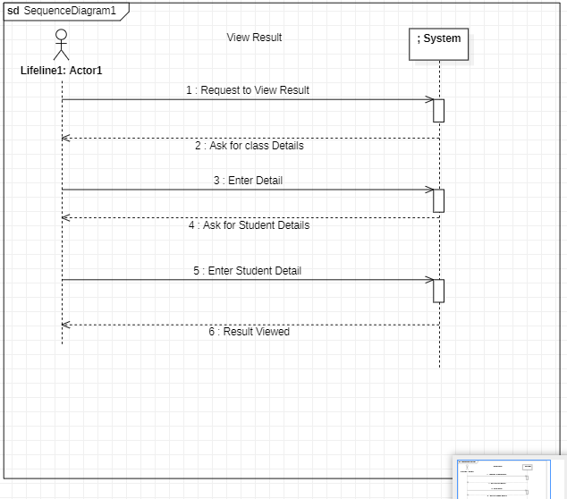

ADD RESULT:

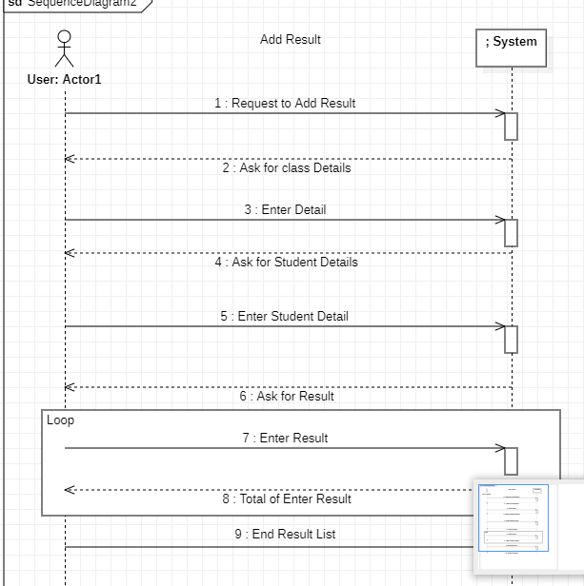

# CHAPTER 4

Operation Contracts - Sections

Irfan khan FA20-BSE-070

| Use Case UC1: register account |
| --- |

**Contract ID**: Enter User required credential

**Operation:** Enter user information (Name, Email, User-name, and password: String)

**Cross References:** Use cases: Register account

**Pre-conditions:**

* User is not registered.
* The System is running correctly.

**Post-conditions:**

* User is registered and Account is created successfully.

| Use Case UC2: Log in |
| --- |

**Contract ID**: Enter User required Login details

**Operation:** Enter user log in details (Name, User-name, and password: String)

**Cross References:** Use cases: Log in

**Pre-conditions:**

* User is registered and account is exist in System.
* User credentials must entered correctly.

**Post-conditions:**

* User is successfully login to the system.
* System shall redirect to User profile

Note: kindly add your operation contacts against your use cases here

*Ehsanullah*

*FA20-BSE-068*

|  |  |
| --- | --- |
| Contract CO2: Request to View Result | |
| **Operation** | Request to View Result |
| **Cross References:** | Use Cases: View Result |
| **Preconditions:** | The Result is uploaded |
| **Postconditions:** | The Result is Displayed |
| Contract CO2: Request to Add Result | |
| **Operation** | Request to Add Result |
| **Cross References:** | Use Cases: Add Result |
| **Preconditions:** | No |
| **Postconditions:** | The Result is Added |

### Ali Said (FA20-BSE-165)

| Use Case UC1: Take Quiz |
| --- |

**Contract ID**: Request to take quiz

**Operation:** Teacher provides the questions

**Cross References:** Use cases: Take quiz

**Pre-conditions:**

* Teacher must provide no of questions
* Teacher must add questions
* Teacher must provide start and end time

**Post-conditions:**

* Teacher have to confirm task after taking quiz

| Use Case UC2: Give Quiz |
| --- |

**Contract ID**: Requests to give quiz

**Operation:** Student will choose one of the answer in MCQS form

**Cross References:** Use cases: Give quiz

**Pre-conditions:**

* Student must agree to start quiz
* Student must ensure that internet connection is stable

**Post-conditions:**

* Student successfully attempted the quiz
* System shall redirect to User profile

| Use Case UC3: Take Assignment |
| --- |

**Contract ID**: Requests to take assignment

**Operation:** Teacher will provide the file of assignment

**Cross References:** Use cases: Take assignment

**Pre-conditions:**

* Teacher have to provide any type of file containing the assignment.
* Teacher must ensure deadline of assignment

**Post-conditions:**

* After successfully uploading the assignment
* System shall redirect to User profile

| Use Case UC4: give Assignment |
| --- |

**Contract ID**: Requests to submit assignment

**Operation:** Student have to provide the solution file of assignment

**Cross References:** Use cases: Give assignment

**Pre-conditions:**

* Students must select solution file to submit
* Student must submit before the deadline of assignment

**Post-conditions:**

* Student successfully submitted the assignment
* Student is returned to home page.

### Afaq(FA20-BSE-057)

| Use Case UC1:Generate TimeTable |
| --- |

**Contract ID**: Request to generate timetable

**Operation: Administartion** provides the timetable

**Cross References:** Use cases: Generate Timetable

**Pre-conditions:**

* Teacher must provide no of questions
* Teacher must add questions
* Teacher must provide start and end time

**Post-conditions:**

* Teacher have to confirm task after taking quiz

| Use Case UC1:View Timetable |
| --- |

**Contract ID**: Request to view timetable

**Operation: Administartion** provides the timetable

**Cross References:** Use cases: Generate Timetable

**Pre-conditions:**

* Teacher and students can view the timetable

**Post-conditions:**

* Teacher must be knowing graph to understand timetable

### Abdullah (FA20-BSE-052)

| Use Case UC1: Assign Subjects |
| --- |

**Contract ID**: Admin assign subjects to faculty

**Operation: Admin assign subjects**

**Cross References:** Use cases: Assign Subjects

**Pre-conditions:**

* Courses must be registered
* Teachers must be registered

**Post-conditions:**

* All subjects must be assigned to teachers.