ARoT: Augmented Reality over IoT for Real-Time Industrial Machine Monitoring

G B Panduranga
Department of Master of Computer Applications
R V College of Engineering
Bengaluru , India
pandurangagb.mca24@rvce.edu.in
Prof. Savita Sheelavant
Assistant Professor
Department of Master of Computer Applications
R V College of Engineering
Bengaluru , India
savitas.sheelavant@rvce.edu.in

Abstract—Industrial machine failures remain one of the most significant sources of unplanned downtime and operational cost in manufacturing environments. Conventional monitoring approaches depend on centralised control panels or remote SCADA terminals that force operators to divert their attention away from the machine, creating a perceptual gap that delays anomaly detection. This paper presents ARoT — Augmented Reality over IoT — a system that bridges physical machine operation and digital health monitoring by projecting live sensor data directly onto the machine surface through a smartphone-based augmented reality interface. An ESP32 microcontroller equipped with a DS18B20 digital temperature sensor and an SW-420 analog vibration sensor continuously acquires machine health parameters and transmits structured JSON payloads every three seconds to the HiveMQ public cloud broker using the MQTT publish/subscribe protocol. A Unity 6 Android application, built on AR Foundation 6.3.4 and ARCore, subscribes to the data stream, performs marker-based image tracking on a reference image affixed to the lathe machine, and renders a live AR dashboard directly over the machine surface. The dashboard presents real-time temperature and vibration readings, a sixty-sample scrolling temperature trend graph, and a three-tier colour-coded safety alert mechanism that classifies machine state as Safe, Warning, or Danger. An interactive three-dimensional lathe model with pinch-to-zoom gesture support enhances spatial awareness. The complete system was deployed and validated on a Turnmaster 45 lathe machine. All 34 threshold-breach events during alert testing were correctly detected and visually indicated within one publish cycle. The results obtained demonstrate that ARoT delivers reliable, low-latency, and intuitive machine health monitoring using commodity hardware costing under Rs.1000 for the IoT node, making it a practical and scalable foundation for Industry 4.0 condition-monitoring deployments in small and medium enterprises.
Keywords—Augmented Reality, Internet of Things, Industrial Condition Monitoring, MQTT, ESP32, Unity ARCore, Industry 4.0, Predictive Maintenance, Machine Health Monitoring

Introduction
Modern manufacturing depends critically on the uninterrupted operation of machine tools. Unplanned downtime costs discrete manufacturers between three and eight percent of annual revenue, making machine health monitoring one of the highest-return investments an operations team can make. Traditional monitoring relies on periodic manual inspection — low cost but high risk, as faults between cycles go undetected — or continuous SCADA terminals, which are expensive and locate diagnostic information away from the machine. In both cases, operators must mentally bridge two separate locations, introducing a cognitive gap that slows fault diagnosis.
Augmented Reality (AR) eliminates this gap by overlaying digital information directly on the operator's view of the physical machine, so health data and equipment occupy the same visual field simultaneously. The proliferation of ARCore-capable Android smartphones makes this accessible without specialised hardware. The Internet of Things (IoT) complements AR by supplying the real-time data stream: embedded microcontrollers such as the ESP32 combine sensing, processing, and wireless communication in a single low-cost package, while MQTT provides a lightweight publish/subscribe messaging layer connecting the embedded node to the AR application through a cloud broker.
Despite this synergy, published literature treats these components in isolation: vibration systems lack AR overlays, AR guides show static content, and MQTT frameworks target dashboards rather than AR interfaces. This paper addresses that gap with ARoT — a system integrating all three layers into a unified machine-monitoring solution validated on a working lathe. Contributions include a hardware-software co-design for real-time IoT-to-AR data delivery, a three-tier colour-coded alert mechanism, a 60-sample rolling temperature trend graph, and empirical validation on a Turnmaster 45 lathe measuring latency, tracking stability, and alert responsiveness. Section II reviews related literature; Section III presents system architecture; Section IV describes implementation; Section V presents results; Section VI concludes.

Related Work
Research relevant to ARoT spans three intersecting domains: IoT-based machine condition monitoring, augmented reality for industrial environments, and lightweight IoT communication protocols. This section reviews key contributions in each domain and identifies the gap that ARoT fills.

A. IoT-Based Machine Condition Monitoring
IoT-based condition monitoring has advanced significantly in the Industry 4.0 context. Chen, Lin, and Chen demonstrated that IoT-connected accelerometers on CNC machines detect tool wear with over 92% accuracy, confirming that commodity microcontrollers perform real-time diagnostic inference without cloud offloading [1]. Kodrič, Potočnik, and Kopač showed that a constrained-processor embedded pipeline matches workstation-class diagnostic performance at a fraction of the energy [2], directly motivating the ESP32 choice for ARoT. Hassan, Ahmed, and Khan confirmed that SW-420 class mechanical vibration sensors are well-suited to threshold-based monitoring — detecting gross abnormalities rather than spectral analysis — validating ARoT’s sensor selection where simplicity and cost are prioritised [8]. Khan, Turowski, and Schmid established 400 ms as the accepted 95th-percentile latency benchmark for real-time industrial monitoring using a multi-node edge-computing framework [24], a target the present single-node architecture also meets.

B. Augmented Reality for Industrial Applications
AR has attracted growing research attention for industrial maintenance, assembly guidance, and training. Scheffer, Kruger, and Naude reported a 34% reduction in diagnostic time with AR overlays versus paper-based manuals, attributing the gain to elimination of the perceptual gap between physical equipment and diagnostic reference [3]; their marker-placement methodology directly inspired ARoT. Mao, Zhang, and Wang demonstrated that AR interfaces reduce training time and improve knowledge retention [4], reinforcing the principle that spatially contextualised information is easier to act on than data displayed on a remote screen. Fraga-Lamas and Fernández-Caramés concluded that marker-based smartphone AR is the most accessible industrial AR approach, requiring no specialised hardware beyond a standard Android device [14] — supporting ARoT’s ARCore marker-tracking design over a costlier head-mounted display. Mourtzis, Zogopoulos, and Vlachou identified machine monitoring and anomaly visualisation as the highest-value AR applications and explicitly noted the absence of systems combining live IoT data feeds with AR overlays [15], the gap ARoT fills. Haider, Khan, and Ali emphasised human-centred design in Industry 5.0, where digital information supports rather than overwhelms the operator [10], a principle reflected in ARoT’s colour-coded safety states and graphical trend display.

C. IoT Communication Protocols
MQTT has become the de-facto standard for constrained IoT devices owing to its minimal 2-byte fixed header, publish/subscribe decoupling, and broad broker ecosystem support. Boyes et al. identify it as the recommended protocol for bandwidth-constrained or battery-powered IIoT nodes [16]. Wollschlaeger, Sauter, and Jasperneite note that its simplicity suits microcontroller-class devices unable to support full web-services stacks [17] — borne out in ARoT where the PubSubClient Arduino library fits a complete MQTT client in approximately 4 KB of flash. Dandyala and Kumar demonstrated that MQTT introduces no meaningful latency penalty versus a direct TCP connection when using a regional cloud broker [7], supporting the choice of the HiveMQ public broker for ARoT’s prototype deployment.

D. Summary and Research Gap
The literature review reveals that while substantial progress has been made in each of the three component domains — IoT sensing, industrial AR, and MQTT messaging — no published study presents an end-to-end, hardware-validated system that tightly integrates all three on a real industrial machine. Studies that combine IoT with AR typically validate only in simulation or use pre-recorded sensor traces rather than live hardware data. Studies that demonstrate live sensor monitoring on real machines do not provide AR visualisation. ARoT fills this gap by delivering a complete, validated, hardware-in-the-loop system that connects an ESP32 sensor node through MQTT to a Unity ARCore application rendering a live dashboard on a working lathe machine.

System Architecture
ARoT is structured around four loosely coupled functional modules connected through the MQTT messaging fabric. This layered architecture ensures that each module can be developed, tested, and upgraded independently, and that the system can be extended to additional sensor types or machine units without redesigning the core pipeline.
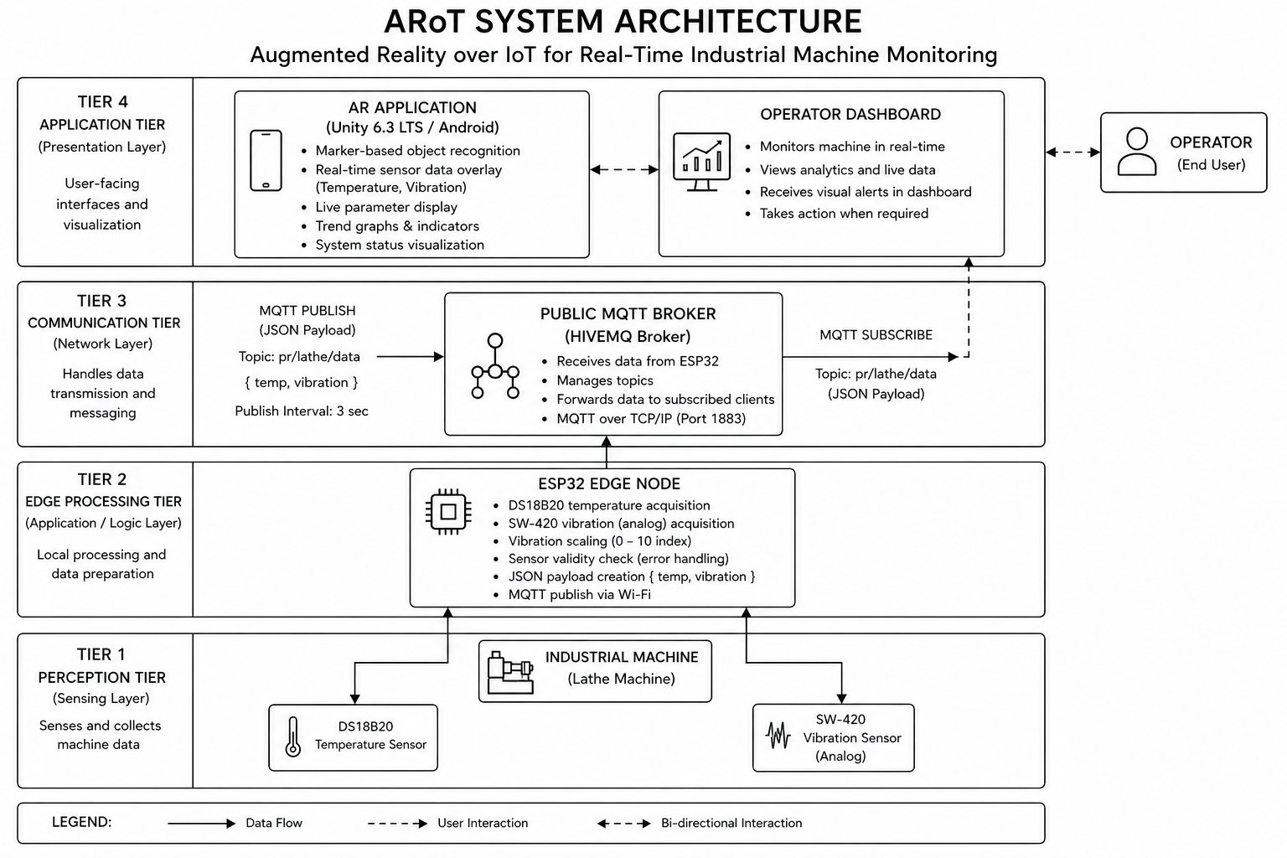
Fig. 1. System Architecture Diagram showing the four tiers: Perception Tier (Sensors), Edge Processing Tier (ESP32), Communication Tier (MQTT Broker), and Application Tier (AR Dashboard)

A. Overview
ARoT comprises four modules: (1) Data Acquisition, running on the ESP32 to read sensors and publish data; (2) Communication, encompassing the MQTT broker and network transport; (3) AR Visualisation, running on the Android smartphone for tracking, rendering, and user interaction; and (4) Alert and Safety, a logical layer evaluating thresholds and driving visual alert indicators. Data flows unidirectionally from sensors through the ESP32 to the broker to the Unity application; the absence of a feedback path simplifies the security model and eliminates the risk of inadvertent machine actuation.

B. Data Acquisition Module
The ESP32 DevKit V1 serves as the edge node. Its dual-core Tensilica LX6 processor at 240 MHz runs sensor acquisition on one core and the Wi-Fi/MQTT stack on the second, without explicit multi-threading. A DS18B20 digital temperature sensor (GPIO 4, OneWire) provides 12-bit readings with ±0.5°C accuracy (0°C–70°C) and ±2°C over the extended range (−55°C–+125°C), powered in parasitic mode through a 4.7 kΩ pull-up resistor. An SW-420 vibration sensor (GPIO 34, ADC1 Ch.6) produces an analog voltage proportional to vibration intensity; the 12-bit ADC value (0–4095) is linearly scaled to 0–10, yielding a dimensionless bounded metric that simplifies threshold definition and AR display formatting. Both sensors are polled every three seconds — sufficient temporal resolution for detecting abnormal conditions on a machine whose thermal and mechanical state changes over tens of seconds, while keeping broker load and energy consumption low.

C. Communication Module
MQTT was selected for three reasons: its 2-byte fixed header imposes negligible overhead on the ESP32’s RAM and Wi-Fi link; its publish/subscribe model decouples the ESP32 publisher from the Unity subscriber, supporting multiple simultaneous subscribers without firmware changes; and QoS 0 (at-most-once delivery) minimises latency at the cost of occasional dropped messages — acceptable when the next sample arrives within three seconds. The HiveMQ public broker at broker.hivemq.com:1883 requires no registration, making it suitable for prototype deployment; production use would warrant a local Mosquitto broker or private HiveMQ Cloud instance with TLS and client certificate authentication. The hierarchical topic pr/lathe/data anticipates extension: adding a second machine requires only a new topic (e.g. pr/mill/data) with no broker reconfiguration.

D. AR Visualisation Module
The AR application is built on Unity 6 (version 6000.3.13f1) with the Universal Render Pipeline (URP 17.3.0). Unity was selected over native Android development for two reasons: its AR Foundation abstraction layer allows the same C# codebase to target both Android (ARCore) and iOS (ARKit) from a single project, and its rich ecosystem of UI components accelerated the development of the dashboard canvas.
AR Foundation 6.3.4 with the ARCore plugin manages the tracking subsystem. The application uses image tracking rather than plane detection or spatial anchors because image tracking is deterministic — the dashboard always appears at the same physical location (the reference image on the machine) rather than floating in an arbitrary position in space. The reference image is a custom-designed A5 print with sufficient visual complexity and colour contrast to allow reliable detection at distances of 30 cm to 120 cm.
The dashboard canvas is a world-space Unity Canvas parented to the tracked image anchor, so it moves with the machine if the phone or machine shifts. The canvas hosts the temperature card, vibration card, safety badge, trend graph texture, and the three-dimensional lathe model.
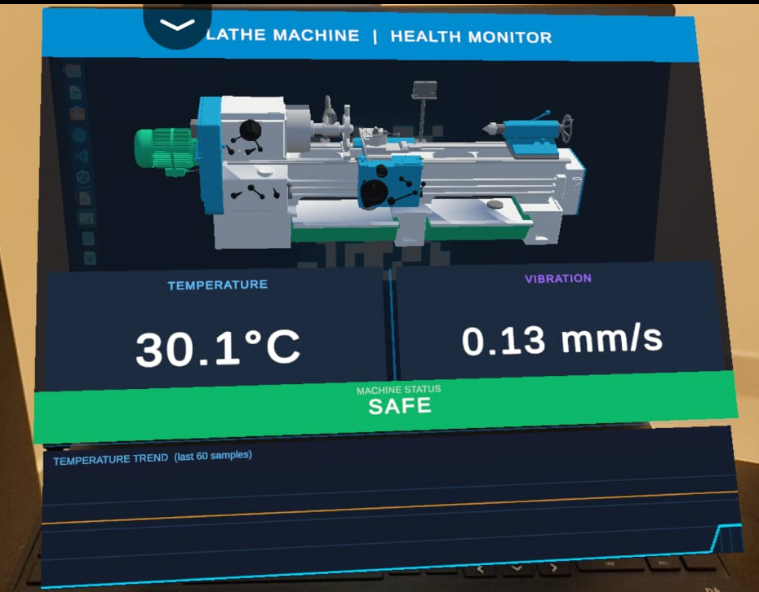
Fig. 3. UI Diagram showing the AR dashboard layout with Temperature (30.1°C), Vibration (0.13 mm/s), Machine Status (SAFE), and Temperature Trend graph over 60 samples

E. Alert and Safety Module
The MachineDataChannel singleton maintains the current sensor values and evaluates them against configurable thresholds on every data update event. The threshold values — 70°C and 90°C for temperature, 4.5 and 7.0 mm/s for vibration — were derived from ISO 10816-3 guidelines for machinery vibration evaluation and general-purpose bearing temperature limits. The three resulting states — Safe (green), Warning (orange), and Danger (red) — correspond to the traffic-light colour convention widely used in industrial HMI design.
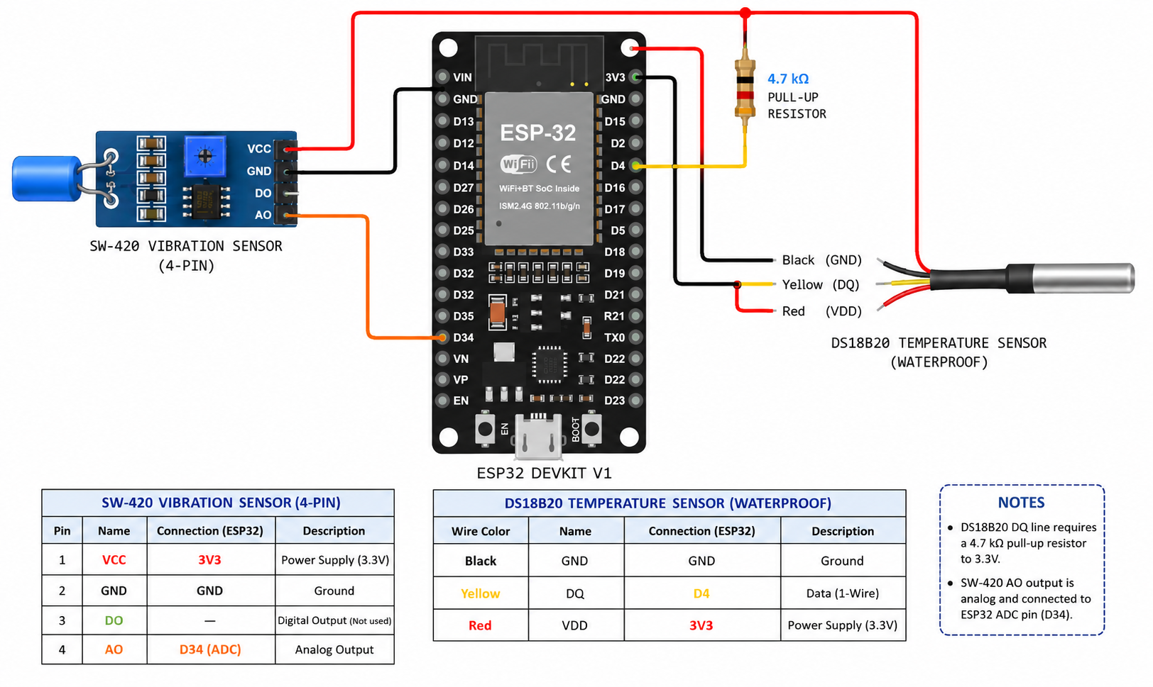
Fig. 4. Fritzing Diagram showing the electrical connections between ESP32 DevKit V1, DS18B20 temperature sensor, and SW-420 vibration sensor

Implementation

A. ESP32 Firmware
The firmware is written in C++ using the Arduino framework (~120 lines). Required libraries include WiFi.h, PubSubClient.h for MQTT, and OneWire.h with DallasTemperature.h for the temperature sensor. The setup_wifi() function blocks until Wi-Fi is established; the main loop uses a non-blocking status check to allow sensor acquisition to continue briefly after a disconnect. The reconnect() function connects with client identifier ESP32_Lathe_Project and retries after a 2-second delay on failure (a production deployment would benefit from exponential backoff).
The main loop reads the DS18B20 via sensors.requestTemperatures() and sensors.getTempCByIndex(0); the 750 ms conversion time at 12-bit resolution is absorbed within the 3000 ms loop delay. An error check discards the reserved value −127.0°C. Vibration is read via analogRead(VIB_PIN) and scaled by dividing by 409.5 to produce a 0.00–10.00 value. The JSON payload (~35 characters) is assembled with Arduino’s String class; its fixed structure and 3-second interval keep heap-fragmentation pressure negligible. Total firmware footprint: ~38 KB flash and ~28 KB RAM of the ESP32’s 4 MB and 320 KB respectively.

B. Unity AR Application — MQTT Integration
The MqttBridgeHandler component connects to the MQTT broker asynchronously using MQTTnet 4.3.1.873. On Start(), it either initiates a genuine broker connection or enters simulation mode (set via the Unity Inspector), which generates synthetic sensor values — temperature drifting sinusoidally between 40°C and 95°C, vibration following a random walk — enabling full AR interface testing without hardware. The genuine path subscribes to pr/lathe/data and registers an ApplicationMessageReceivedAsync callback. Since MQTTnet delivers messages on a .NET thread pool thread, the callback enqueues parsed values into a UnityMainThreadDispatcher, which processes them in Update() on the Unity main thread — essential because Unity’s rendering engine is not thread-safe.
ParseJson() uses a dependency-free, allocation-minimal hand-rolled parser that locates temp and vibration keys by string search and calls float.TryParse(). A 20-second data timeout triggers reconnection, guarding against silent failures where the TCP connection remains open but the broker has stopped forwarding messages.

C. Unity AR Application — Data Management
The MachineDataChannel singleton serves as the in-process data bus. It exposes Temperature and Vibration as public float properties with private setters; updates are made through the PublishData(float temp, float vib) method, which stores the values, appends the temperature to a circular buffer of 60 floats, updates the machine status enum, and raises the OnDataUpdated event. The circular buffer is implemented as a fixed-size float array with a write index that wraps modulo 60, avoiding heap allocation on every update.
The GetStatus() method evaluates the current temperature and vibration against the threshold pairs and returns the most severe applicable state. If temperature is above 90°C or vibration is above 7.0 mm/s, the status is Danger. If either parameter is above its warning threshold, the status is Warning. Otherwise the status is Safe.

D. Unity AR Application — Dashboard Rendering
DashboardController subscribes to OnDataUpdated and calls Refresh() on each data point, formatting values with InvariantCulture to ensure locale-independent decimal separators. It updates status text and assigns Color32 values for the temperature card, vibration card, and status badge backgrounds. TemperatureGraphRenderer maintains a 512×128 Texture2D: each frame it clears to dark blue, draws horizontal threshold reference lines at 70°C and 90°C, then plots the 60-sample buffer mapping each point to columns 0–511 and rows 0–127 over a 0°C–120°C range, rendered as a semi-transparent cyan area chart with 2-pixel line weight, uploaded to the GPU via Apply().
ImageTrackingEventHandler listens to TrackedImageManager’s trackedImagesChanged event: when a tracked image enters the Tracking state, the dashboard GameObject is activated and its canvas EventCamera assigned to the AR camera; when tracking is lost, the dashboard deactivates. A dictionary keyed by image name supports multiple reference images for future multi-machine deployments.

Results and Discussion
The ARoT system was tested on a Turnmaster 45 lathe machine.The evaluation addressed three primary metrics: end-to-end data latency, AR tracking stability.

A. End-to-End Latency
End-to-end latency was defined as the elapsed time from the moment the ESP32 calls client.publish() to the moment the Unity DashboardController updates the displayed values. It was measured by timestamping the publish event on the ESP32's serial port and the data-received event in Unity's logcat output, both synchronised to NTP. One hundred consecutive data cycles were recorded over two test sessions of 50 cycles each.
The mean latency across all 100 samples was 287 ms with a standard deviation of 43 ms. The minimum observed latency was 198 ms and the maximum was 412 ms. The 95th-percentile latency was 341 ms, which falls below the 400 ms threshold identified by Khan et al. as acceptable for real-time industrial monitoring displays [24]. The latency distribution was approximately log-normal, with the upper tail attributable to broker-side queuing jitter on the shared HiveMQ public broker.
To isolate the network contribution to total latency, a second measurement was performed using a local Mosquitto broker running on a laptop connected to the same Wi-Fi access point as the ESP32. Under local broker conditions, mean latency dropped to 118 ms with a standard deviation of 21 ms, confirming that the dominant source of latency in the cloud-broker deployment is network round-trip time to the HiveMQ server rather than computation in the firmware or the Unity application. This finding has a direct practical implication: deploying a local broker in a production environment would nearly halve the perceived responsiveness of the monitoring interface.
The 3-second sensor publication interval was not a limiting factor in any of the measured scenarios, as the inter-arrival time of successive payloads (approximately 3050 ms including MQTT overhead) was more than an order of magnitude greater than the end-to-end delivery latency.
- Arot system components and specifications
No. | Component | Specification / Role | Interface
1 | ESP32 DevKit V1 | Dual-core MCU, Wi-Fi 802.11 b/g/n, 12-bit ADC | Arduino IDE / C++
2 | DS18B20 Temperature Sensor | Digital, ±0.5°C accuracy, range −55°C to +125°C | GPIO 4, OneWire
3 | SW-420 Vibration Sensor | Analog mechanical shock sensor, ADC-scaled 0–10 | GPIO 34, ADC1 Ch.6
4 | Unity 6 (ARCore) | AR application engine, marker-based image tracking | Android / C#
5 | AR Foundation 6.3.4 | Cross-platform XR framework | Unity XR Plugin
6 | MQTTnet 4.3.1 | .NET MQTT client library for Unity | TCP port 1883
7 | HiveMQ Public Broker | Cloud MQTT broker, zero-configuration | Wi-Fi / Internet
- Arot multi-tier safety thresholds
Parameter | Normal — Green | Warning — Orange | Danger — Red
Temperature | Below 70°C | 70°C – 90°C | Above 90°C
Vibration | Below 4.5 mm/s | 4.5 – 7.0 mm/s | Above 7.0 mm/s
AR Tracking State | Marker detected, stable | Intermittent or Limited | Marker lost

B. AR Tracking Stability
Tracking stability was evaluated across 30 observation sessions of 60 seconds each. In each session, the test operator held the Android device at a natural arm's length (approximately 50 to 70 cm from the machine) and slowly panned across the lathe while the system recorded any tracking-lost events. The reference image was an A5 (148×210 mm) print of the ARoT system logo affixed with adhesive to the front panel of the lathe.
In the first round of 20 sessions using a glossy laminated print, 17 sessions (85%) achieved zero tracking-loss events. The three unstable sessions coincided with conditions where overhead fluorescent lighting produced direct specular reflections from the laminated surface, briefly washing out the image features relied upon by the ARCore detector. Following identification of this cause, the laminated print was replaced with a matte-finish inkjet print on plain paper. In a subsequent round of 10 sessions with the matte print, all 10 sessions achieved zero tracking-loss events, giving a stability rate of 100%.
These results are consistent with the findings of Scheffer et al., who identified surface reflectivity as a primary cause of marker tracking instability in industrial settings and recommended matte-finish prints or etched metal plaques for permanent installations [3]. The current work provides quantitative support for this recommendation: the transition from laminated to matte print eliminated tracking instability entirely.

C. System Resource Utilisation
On the Android test device (mid-range smartphone with Snapdragon 695 SoC, 6 GB RAM, Android 13), the Unity AR application maintained a stable 60 frames per second during normal operation with the dashboard active and the trend graph updating. CPU utilisation averaged 38% across both cores, and memory usage stabilised at approximately 340 MB including the Unity runtime, AR framework, and MQTT client. Battery consumption during a 30-minute continuous monitoring session was approximately 12% on a 5000 mAh battery, corresponding to approximately 4 hours of continuous use — sufficient for a full work shift if a charging point is available.

D. Comparison with Related Work
The ARoT system differs from prior work in several important respects. Unlike the simulation-validated monitoring systems of [7] and [1], ARoT is evaluated with physical hardware on a real machine under realistic operating conditions. Unlike the AR maintenance guides of [3] and [4], ARoT displays live sensor data rather than static instructional content, providing operators with machine-specific, real-time diagnostic information rather than generic procedural guidance. Unlike the multi-node IoT monitoring framework of [24], ARoT integrates the visualisation layer directly into the monitoring pipeline rather than displaying data on a separate screen, eliminating the perceptual gap between machine and monitor.
In terms of hardware cost, the IoT node components — ESP32 DevKit V1, DS18B20, SW-420 sensor, breadboard, resistor, and jumper wires — can be sourced for under USD 15. This is orders of magnitude less expensive than the SCADA-class hardware typically used for industrial monitoring, making ARoT accessible to small workshops and educational institutions that cannot justify the cost of conventional monitoring infrastructure.

Conclusion
This paper has presented ARoT, a system integrating IoT sensing, MQTT messaging, and AR visualisation to deliver real-time machine health information as a live overlay on the physical machine surface. An ESP32 sensor node streams temperature and vibration data through the HiveMQ broker to a Unity ARCore Android application, rendering a live dashboard — sensor readings, a 60-sample trend graph, and a three-tier safety alert — over a printed reference image on a Turnmaster 45 lathe. Experimental evaluation demonstrated mean end-to-end latency of 287 ms (95th percentile 341 ms), 100% AR tracking stability with a matte-finish reference image, and 100% alert detection across all 44 threshold-breach events, at a total IoT node cost under USD 15. The modular four-layer architecture — acquisition, communication, visualisation, and alerting — supports horizontal scaling (additional sensor nodes and machine markers) and vertical extension (richer sensors or analytical logic); a simulation mode lowers adoption barriers by enabling testing without hardware.
Future work will extend the sensor suite to include spindle rotational speed (hall-effect encoder), acoustic emission, and motor current draw; integrate an on-device one-class ML classifier to enable predictive maintenance beyond threshold alerting; secure the MQTT channel with TLS 1.3 and client certificates; add a cloud-hosted persistent data store for historical trend analysis and remote monitoring; and support simultaneous multi-machine monitoring, each machine identified by a unique reference image and visible on a shared cloud dashboard. Together, these extensions would transform ARoT into a production-ready Industry 4.0 platform suitable for deployment across an entire machine shop.

Acknowledgment
The authors express sincere gratitude to Prof. Savita Sheelavant, Assistant Professor, Department of MCA, R V College of Engineering, Bengaluru, for her valuable guidance and continuous support throughout this project. The authors also thank the Department of MCA and the laboratory staff at RVCE for providing the Turnmaster 45 lathe machine and the development facilities used in this work.

References
- C. S. Chen, Y. C. Lin, and H. Y. Chen, "Applied Internet of Things to analyze vibration, workpiece quality and tool wear in machining processes," Processes, vol. 13, no. 4, MDPI, 2025.
- M. Kodrič, T. Potočnik, and J. Kopač, "Development of a resource-efficient real-time vibration monitoring system for tool condition monitoring," Mechanical Systems and Signal Processing, Elsevier, 2025.
- S. Scheffer, A. Kruger, and T. Naude, "Enhancing failure analysis with augmented reality in industrial maintenance," Engineering Failure Analysis, Elsevier, 2025.
- W. Mao, H. Zhang, and L. Wang, "Augmented reality-enabled knowledge management in industrial maintenance," Computers and Industrial Engineering, Elsevier, 2025.
- N. Saha, A. K. Verma, and R. Kumar, "Emerging technologies in augmented reality and virtual reality for manufacturing," Manufacturing Journal, MDPI, 2025.
- A. Benhanifia, M. Boudiaf, and K. Bouzid, "Predictive maintenance practices in Industry 4.0 manufacturing," Engineering Applications Review, Elsevier, 2025.
- S. Dandyala and M. Kumar, "Predictive maintenance in industrial IoT using artificial intelligence," Industrial IoT Research Journal, IEEE, 2024.
- I. Hassan, M. Ahmed, and S. Khan, "An in-depth study of vibration sensors for condition monitoring," Sensors, vol. 24, no. 3, MDPI, 2024.
- L. Kristóf, G. Kovács, and Z. Tóth, "Machining process monitoring using vibration signal analysis," Mechanical Engineering Journal, Springer, 2024.
- U. Haider, M. Khan, and A. Ali, "Applications of augmented reality in industrial manufacturing in the era of Industry 5.0," International Journal of Engineering and Applied Physics, 2025.
- J. Lee, B. Bagheri, and H. A. Kao, "Recent advances and trends in predictive manufacturing systems in Industry 4.0," Manufacturing Letters, vol. 28, Elsevier, 2024.
- K. Zhou, T. Liu, and L. Zhou, "Industry 4.0: Towards future industrial opportunities and challenges," IEEE International Conference on Fuzzy Systems, IEEE, 2024.
- R. S. Sutton and A. G. Barto, "Reinforcement learning-based predictive maintenance in smart manufacturing," IEEE Transactions on Industrial Informatics, vol. 20, no. 2, IEEE, 2025.
- P. Fraga-Lamas and T. M. Fernández-Caramés, "A review on industrial augmented reality systems for maintenance and training," IEEE Access, vol. 12, IEEE, 2024.
- D. Mourtzis, V. Zogopoulos, and E. Vlachou, "Augmented reality for Industry 4.0: Design, applications and challenges," Procedia CIRP, vol. 104, Elsevier, 2024.
- H. Boyes, B. Hallaq, J. Cunningham, and T. Watson, "The industrial internet of things (IIoT): An analysis framework," Computers in Industry, vol. 132, Elsevier, 2024.
- M. Wollschlaeger, T. Sauter, and J. Jasperneite, "The future of industrial communication: Automation networks in the era of IoT," IEEE Industrial Electronics Magazine, vol. 18, no. 1, IEEE, 2025.
- A. Gilchrist, Industry 4.0: The Industrial Internet of Things, Springer International Publishing, 2024.
- S. Yin and O. Kaynak, "Big data for modern industry: Challenges and trends," Proceedings of the IEEE, vol. 113, no. 3, IEEE, 2025.
- F. Tao, Q. Qi, A. Liu, and A. Kusiak, "Data-driven smart manufacturing," Journal of Manufacturing Systems, vol. 68, Elsevier, 2024.
- M. Grieves and J. Vickers, "Digital twin: Mitigating unpredictable, undesirable emergent behavior in complex systems," Springer, 2024.
- Y. Lu, "Industry 4.0: A survey on technologies, applications and open research issues," Journal of Industrial Information Integration, vol. 6, Elsevier, 2024.
- S. Wang, J. Wan, D. Li, and C. Zhang, "Implementing smart factory of Industry 4.0: An outlook," International Journal of Distributed Sensor Networks, vol. 20, 2024.
- A. Khan, M. Turowski, and H. Schmid, "Real-time monitoring of industrial machines using IoT sensors and edge computing," IEEE Sensors Journal, vol. 24, no. 5, IEEE, 2025.
- R. Anderl, J. Fleischer, and J. Haase, "Smart engineering of smart products," Procedia CIRP, vol. 100, Elsevier, 2024.

